Design to create, fashion, execute, or construct according to plan : devise, contrive design a system for tracking inventory.

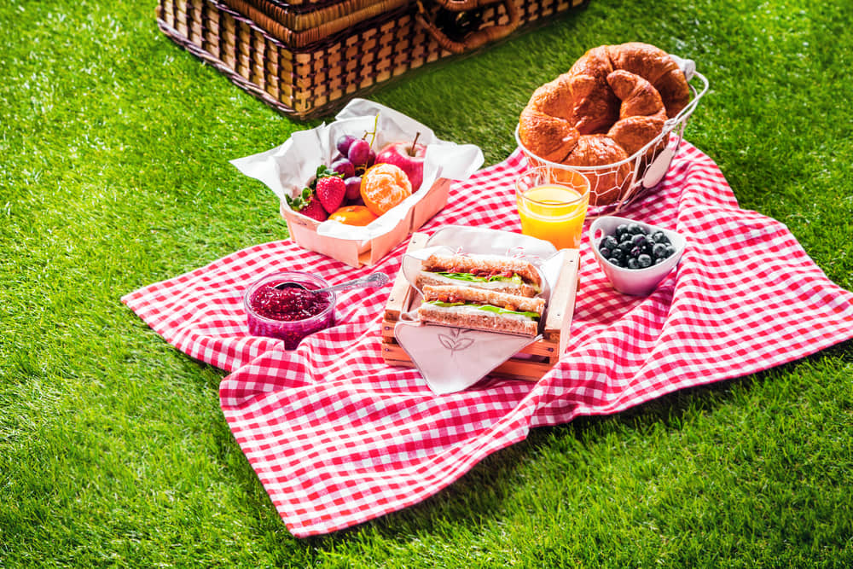Picnic a meal you take to a place outside to be eaten there in an informal way, or an occasion on which such a meal is eaten