Supplementary Material
1. Supplementary 1- Detailed clinical acquisition and MALDI-TOF MS procedures
Strain culturing was performed using standard methods [s1]. The bacterial strains were rapidly identified using MALDI-TOF MS. Protein fingerprint spectra were acquired following target-plate spotting, instrument operation, and calibration in accordance with the research use only (RUO) Standard Operating Procedure for the VITEK MS system (bioMérieux, Marcy-l’Étoile, France) and expert consensus [s2]. The spectra were exported in mzXML, an Extensible Markup Language (XML)-based format for mass-spectrometry data, using VITEK MS LaunchPad software (Shimadzu Corporation, Kyoto, Japan). Species identification and antimicrobial susceptibility testing were performed using the VITEK 2 Compact system (bioMérieux, Marcy-l’Étoile, France). This study was approved by the Ethics Committee of the Second Hospital of Tianjin Medical University (Approval No. KY2025K281). The requirement for written informed consent was waived by the Ethics Committee because this retrospective study used exclusively de-identified data.
2. Supplementary 2- MALDI-TOF MS preprocessing and GraSPECT-AMR representation workflow
Supplementary Figure S1 illustrates the preprocessing workflow [s3, s4] applied to the raw MALDI-TOF MS data, using a single sample as an example.
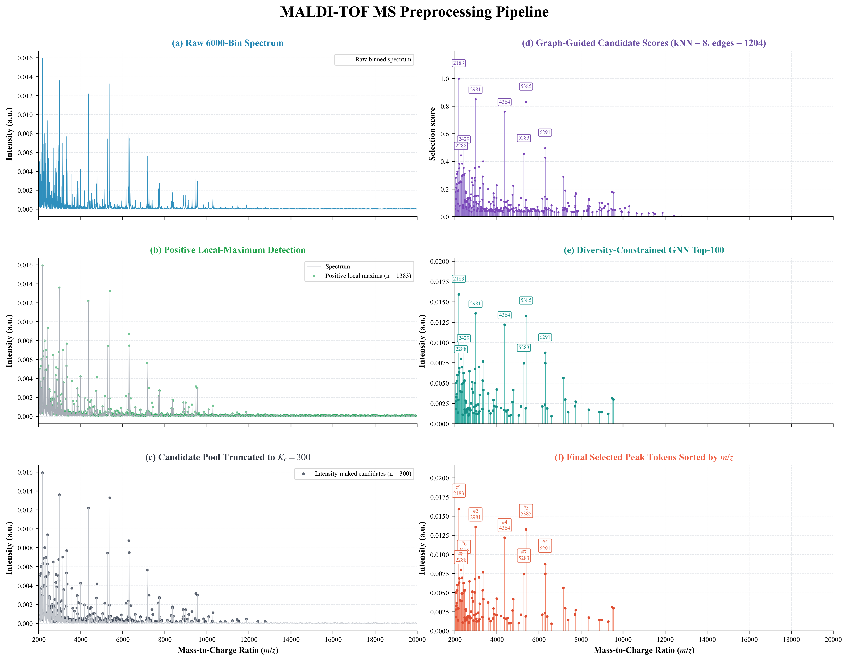
Supplementary Figure S1. MALDI-TOF MS preprocessing and graph-guided peak selection for a representative spectrum: (a) raw 6000-bin spectrum; (b) positive local-maximum detection; (c) candidate pool truncated to K_c = 300; (d) graph-guided candidate scoring based on the peak kNN graph; (e) diversity-constrained Top-100 peak selection; and (f) final selected peak tokens ordered by m/z.
Supplementary Figure S2 links the laboratory label space to the GraSPECT-AMR modeling route. Supplementary Figure S2(a) shows the original laboratory susceptibility categories (S/I/R), whereas the implemented prediction head outputs binary susceptible/resistant probabilities. Supplementary Figure S2(b) marks candidate local maxima in a representative 6000-bin spectrum. Supplementary Figure S2(c) shows the local preprocessing and candidate-extraction procedure. Supplementary Figure S2(d) summarizes graph-guided scoring, diversity-constrained Top-K selection, hybrid tokenization, and CNN–Transformer encoding.
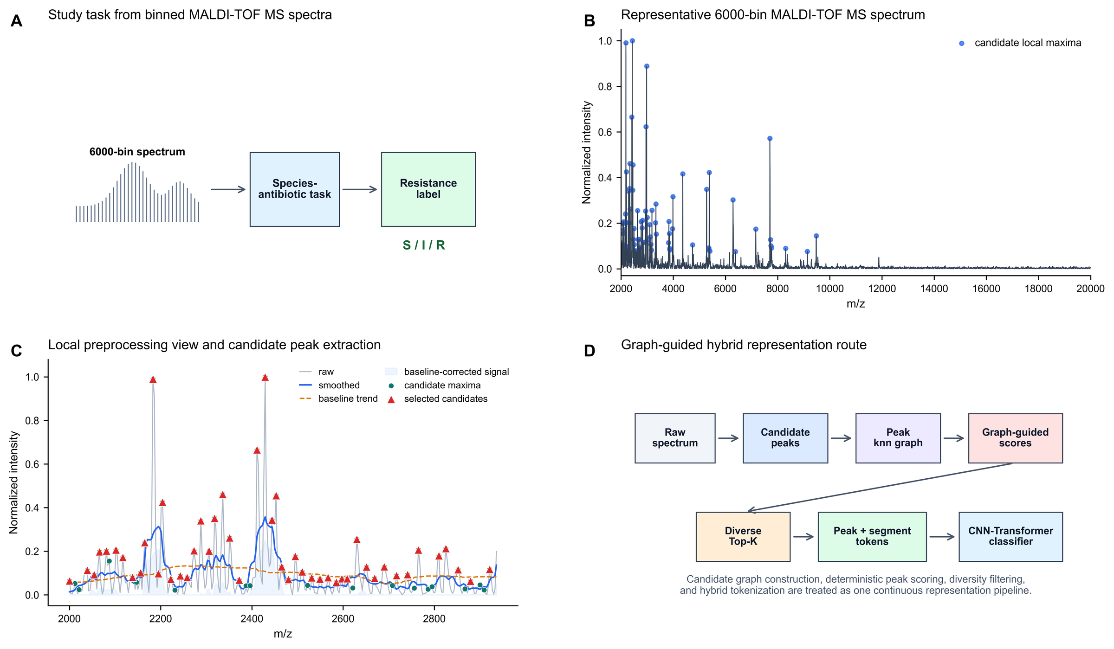
Supplementary Figure S2. Study task and GraSPECT-AMR representation route from standardized MALDI-TOF MS spectra: (a) species–antibiotic resistance prediction with the original laboratory S/I/R categories and a binary susceptible/resistant output; (b) representative 6000-bin spectrum with candidate local maxima; (c) local spectral preprocessing and candidate-peak extraction; and (d) graph-guided peak scoring, diversity-constrained Top-K selection, hybrid tokenization, and CNN–Transformer encoding.
3. Supplementary 3- Core notation and notation conventions
Supplementary Table S1.
Core notation used throughout the method description
Symbol | Definition
x ∈ $R^{6000}$ | Non-negative binned MALDI-TOF MS spectrum vector over the 2,000–20,000 m/z range
$x_{j}$, $m_{j}$ | Intensity value and m/z coordinate of bin j
$$C$$ | Candidate-peak index set after local-maximum filtering and candidate-pool truncation
$K_{c}$, $K$ | Number of retained candidate peaks before graph construction and number of selected peak tokens
$A$, $A_{norm}$ | Candidate-peak adjacency matrix and its degree-normalized form used for graph propagation
$H^{\left(l\right)}$, $L$ | Propagated candidate-feature matrix at graph layer $l$ and the number of propagation layers
$$s_{graph},s_{final},α$$ | Graph-derived score, final graph–intensity fused score, and score-fusion sensitivity parameter
$$T_{peak},T_{seg},T$$ | Selected peak–token matrix, segment-token matrix, and final hybrid token matrix
$$d_{tok},d_{model}$$ | Raw token-feature dimension before projection and model-embedding dimension after projection
Notation convention: Supplementary Table S1 lists only symbols reused across multiple method subsections. Equation-specific symbols are defined beside their corresponding equations. Bold lowercase symbols denote vectors, bold uppercase symbols denote matrices, and non-bold symbols denote scalars, indices, sets, or functions. To avoid ambiguity, graph density is denoted as $g_{graph}$ rather than $d$, whereas the raw token-feature dimension and model-embedding dimension are denoted as $d_{tok} and d_{model}$, respectively.
4. Supplementary 4- CNN–Transformer spectral encoder implementation details
The encoder first applied a three-block one-dimensional convolutional front end to the normalized m/z and intensity channels. Kernel sizes of 3, 5, and 3, with channel widths of 2, 64, 64, and 256, were used to capture local spectral patterns. Continuous raw m/z positional encoding and learned peak/segment type embeddings were then added. A learned [CLS] token and the 160 spectral tokens subsequently entered three Transformer layers in a local–global–local order [s5]. The two local layers used non-overlapping windows of 16 tokens, whereas the middle layer permitted global interaction. All layers used eight attention heads, a 256-dimensional model width, 1024-dimensional feed-forward sublayers, pre-normalization, residual connections, and a dropout rate of 0.1. The normalized [CLS] vector served as the shared spectrum representation supplied to the projection head in Section II-D and the classifier in Section II-E.
5. Supplementary 5- Contrastive pretraining objective and optimization settings
The pretraining objective combined supervised contrastive loss for labeled examples [s6], InfoNCE for available unlabeled examples [s7], an intensity–consistency mean-squared-error term between augmented and original token intensities, and a representation–consistency term. The weights of the combined contrastive, intensity–consistency, and representation–consistency terms were 1.0, 0.01, and 0.1, respectively. The unlabeled InfoNCE contribution was weighted by 0.5, and the contrastive temperature was 0.2. Pretraining used AdamW [s8] with a learning rate of $5 × {10}^{-4}$, weight decay of 0.01, cosine warm-up scheduling, gradient clipping at 1.0, a batch size of 128, and 100 epochs. This stage optimized the shared representation without fitting a graph classifier within GNNPeakSelector.
6. Supplementary 6- Imbalance-aware fine-tuning details
Fine-tuning was performed using a binary classification head with dimensions 256–128–2. The encoder was frozen for the first 20 epochs and then unfrozen using one-tenth of the classification-head learning rate; the batch size was 64, and training ran for at most 80 epochs. Minority-class balancing was restricted to the training subset and used mixup, bounded Gaussian perturbation, and a convex denoising step toward the source sample; no diffusion network was fitted. The supervised objective combined class-weighted focal loss [s9] and an AUC-margin term with weights of 0.7 and 0.3, respectively, together with label smoothing of 0.1. An exponential moving average of model parameters with a decay of 0.999 was maintained during fine-tuning.
7. Supplementary 7- Benchmark models, ablation protocol, and logistic-regression baseline
The baseline and ablation experiments included conventional Top-N hybrid peak selection, GNNPeakSelector-based hybrid selection, removal of continuous m/z positional encoding, removal of advanced augmentation, removal of the diversity constraint, peak-only and segment-only representations, different Top-K settings, sensitivity analysis of the score-fusion coefficient $α$, and a whole-spectrum logistic-regression baseline. For the logistic-regression baseline, each raw 6000-bin spectrum in $R^{6000}$ was standardized using statistics estimated exclusively from the training subset. The 1000 most informative features were then selected using SelectKBest, followed by an $L_{2}$-regularized logistic-regression classifier. Supplementary Equations (S1)–(S3)define the weighted objective, sample-wise logistic loss, and parameter-optimization problem, respectively:
 | $$J\left(w,b\right)=\frac{1}{n}\sum_{i=1}^{n}{ω_{y_{i}}}l_{i}+\frac{λ_{reg}}{2}∥w∥_{2}^{2},$$ | (S1)
 | $$l_{i}=log\left[1+exp\left\{-y_{i}\left(w^{T}x_{i}+b\right)\right\}\right]$$ | (S2)
 | $$\left(w_{opt},b_{opt}\right)=arg\min_{w,b}J\left(w,b\right)$$ | (S3)
where $n$ is the number of training spectra; $x_{i}∈R¹⁰⁰⁰$ is the selected feature vector; $y_{i}∈\{-1,+1\}$is the class label; $w$ and $b$ are the classifier parameters; $l_{i}$ is the sample-wise logistic loss; $ω_{y_{i}}$ is the class-dependent weight; and $λ_{reg}$ is the $L_{2}$-regularization coefficient. The inverse regularization parameter was set to $C = 0.1$, class weights were determined using the balanced strategy, and the liblinear solver used a maximum of 2000 iterations with a fixed random seed of 42. Feature selection and standardization were fitted independently within each training fold and then applied to the corresponding validation and held-out test subsets, thereby preventing information leakage.
8. Supplementary 8- Additional label-ratio sensitivity results
Supplementary Table S2.
Label-ratio sensitivity on DRIAMS S. aureus/oxacillin resistance ($n = 3790$)
Label ratio (%) | Model | Accuracy | AUROC | F1 score
20 | GraSPECT-AMR | 0.86 ± 0.06 | 0.69 ± 0.09 | 0.62 ± 0.09
20 | SimCLR [s10] | 0.81 ± 0.04 | 0.58 ± 0.06 | 0.60 ± 0.04
20 | MoCo [s11] | 0.83 ± 0.04 | 0.64 ± 0.08 | 0.61 ± 0.07
20 | DINOv2 [s12] | 0.81 ± 0.06 | 0.54 ± 0.07 | 0.58 ± 0.05
20 | Random forest [s13] | 0.82 ± 0.04 | 0.63 ± 0.06 | 0.58 ± 0.05
20 | SVM [s14] | 0.83 ± 0.02 | 0.59 ± 0.08 | 0.57 ± 0.05
20 | XGBoost [s15] | 0.82 ± 0.04 | 0.59 ± 0.07 | 0.55 ± 0.04
30 | GraSPECT-AMR | 0.84 ± 0.03 | 0.72 ± 0.05 | 0.69 ± 0.03
30 | SimCLR [s10] | 0.80 ± 0.05 | 0.63 ± 0.06 | 0.61 ± 0.03
30 | MoCo [s11] | 0.84 ± 0.02 | 0.64 ± 0.06 | 0.63 ± 0.05
30 | DINOv2 [s12] | 0.82 ± 0.03 | 0.59 ± 0.07 | 0.57 ± 0.06
30 | Random forest [s13] | 0.80 ± 0.03 | 0.62 ± 0.07 | 0.60 ± 0.05
30 | SVM [s14] | 0.81 ± 0.03 | 0.60 ± 0.07 | 0.57 ± 0.07
30 | XGBoost [s15] | 0.82 ± 0.04 | 0.59 ± 0.05 | 0.58 ± 0.05
50 | GraSPECT-AMR | 0.86 ± 0.03 | 0.79 ± 0.03 | 0.73 ± 0.03
50 | SimCLR [s10] | 0.83 ± 0.02 | 0.64 ± 0.07 | 0.58 ± 0.07
50 | MoCo [s11] | 0.84 ± 0.01 | 0.71 ± 0.04 | 0.67 ± 0.03
50 | DINOv2 [s12] | 0.84 ± 0.03 | 0.58 ± 0.07 | 0.57 ± 0.08
50 | Random forest [s13] | 0.80 ± 0.02 | 0.64 ± 0.05 | 0.62 ± 0.05
50 | SVM [s14] | 0.85 ± 0.02 | 0.61 ± 0.04 | 0.60 ± 0.05
50 | XGBoost [s15] | 0.81 ± 0.06 | 0.63 ± 0.03 | 0.62 ± 0.04
100 | GraSPECT-AMR | 0.88 ± 0.01 | 0.90 ± 0.02 | 0.80 ± 0.03
100 | SimCLR [s10] | 0.83 ± 0.02 | 0.70 ± 0.01 | 0.65 ± 0.02
100 | MoCo [s11] | 0.83 ± 0.03 | 0.74 ± 0.03 | 0.67 ± 0.03
100 | DINOv2 [s12] | 0.83 ± 0.01 | 0.65 ± 0.06 | 0.63 ± 0.03
100 | Random forest [s13] | 0.81 ± 0.04 | 0.66 ± 0.05 | 0.60 ± 0.06
100 | SVM [s14] | 0.83 ± 0.05 | 0.62 ± 0.03 | 0.62 ± 0.03
100 | XGBoost [s15] | 0.80 ± 0.07 | 0.64 ± 0.04 | 0.63 ± 0.04
The bold number is the maximum value of the column, and the underlined number is the second-largest value of the column.
For S. aureus/oxacillin (Supplementary Table S2), GraSPECT-AMR achieved the highest reported AUROC and F1 score at every label ratio: 0.69 ± 0.09 and 0.62 ± 0.09 at 20%, 0.72 ± 0.05 and 0.69 ± 0.03 at 30%, 0.79 ± 0.03 and 0.73 ± 0.03 at 50%, and 0.90 ± 0.02 and 0.80 ± 0.03 at 100%, respectively. Its 30% accuracy (0.84 ± 0.03) tied MoCo, whereas the 100% configuration reached the highest accuracy (0.88 ± 0.01).
Supplementary Table S3.
Label-ratio sensitivity on DRIAMS K. pneumoniae/ceftriaxone resistance ($n = 2860$)
Label ratio (%) | Model | Accuracy | AUROC | F1 score
20 | GraSPECT-AMR | 0.80 ± 0.06 | 0.75 ± 0.04 | 0.66 ± 0.04
20 | SimCLR [s10] | 0.77 ± 0.08 | 0.69 ± 0.05 | 0.63 ± 0.06
20 | MoCo [s11] | 0.77 ± 0.09 | 0.65 ± 0.07 | 0.61 ± 0.05
20 | DINOv2 [s12] | 0.82 ± 0.03 | 0.66 ± 0.08 | 0.58 ± 0.07
20 | Random forest [s13] | 0.82 ± 0.04 | 0.61 ± 0.07 | 0.57 ± 0.06
20 | SVM [s14] | 0.82 ± 0.06 | 0.52 ± 0.15 | 0.56 ± 0.07
20 | XGBoost [s15] | 0.85 ± 0.01 | 0.61 ± 0.07 | 0.61 ± 0.05
30 | GraSPECT-AMR | 0.85 ± 0.04 | 0.70 ± 0.09 | 0.64 ± 0.07
30 | SimCLR [s10] | 0.81 ± 0.02 | 0.69 ± 0.08 | 0.63 ± 0.06
30 | MoCo [s11] | 0.83 ± 0.03 | 0.68 ± 0.07 | 0.60 ± 0.07
30 | DINOv2 [s12] | 0.75 ± 0.08 | 0.65 ± 0.05 | 0.59 ± 0.03
30 | Random forest [s13] | 0.80 ± 0.03 | 0.64 ± 0.07 | 0.62 ± 0.03
30 | SVM [s14] | 0.83 ± 0.04 | 0.58 ± 0.16 | 0.58 ± 0.06
30 | XGBoost [s15] | 0.81 ± 0.05 | 0.66 ± 0.10 | 0.61 ± 0.08
50 | GraSPECT-AMR | 0.88 ± 0.03 | 0.78 ± 0.06 | 0.75 ± 0.06
50 | SimCLR [s10] | 0.84 ± 0.05 | 0.70 ± 0.06 | 0.68 ± 0.05
50 | MoCo [s11] | 0.85 ± 0.02 | 0.69 ± 0.07 | 0.66 ± 0.04
50 | DINOv2 [s12] | 0.78 ± 0.06 | 0.65 ± 0.06 | 0.57 ± 0.06
50 | Random forest [s13] | 0.83 ± 0.06 | 0.70 ± 0.08 | 0.65 ± 0.05
50 | SVM [s14] | 0.80 ± 0.04 | 0.68 ± 0.05 | 0.64 ± 0.02
50 | XGBoost [s15] | 0.85 ± 0.03 | 0.70 ± 0.05 | 0.69 ± 0.02
100 | GraSPECT-AMR | 0.85 ± 0.01 | 0.80 ± 0.05 | 0.80 ± 0.06
100 | SimCLR [s10] | 0.84 ± 0.04 | 0.71 ± 0.08 | 0.68 ± 0.06
100 | MoCo [s11] | 0.86 ± 0.03 | 0.73 ± 0.05 | 0.72 ± 0.02
100 | DINOv2 [s12] | 0.78 ± 0.05 | 0.67 ± 0.08 | 0.59 ± 0.06
100 | Random forest [s13] | 0.83 ± 0.05 | 0.72 ± 0.09 | 0.70 ± 0.06
100 | SVM [s14] | 0.85 ± 0.05 | 0.69 ± 0.05 | 0.67 ± 0.03
100 | XGBoost [s15] | 0.86 ± 0.03 | 0.72 ± 0.05 | 0.71 ± 0.05
The bold number is the maximum value of the column, and the underlined number is the second-largest value of the column.
For K. pneumoniae/ceftriaxone (Supplementary Table S3), GraSPECT-AMR increased from 0.80 ± 0.06 accuracy, 0.75 ± 0.04 AUROC, and 0.66 ± 0.04 F1 at 20% labels to 0.85 ± 0.01, 0.80 ± 0.05, and 0.80 ± 0.06 at 100%, respectively. At 20%, XGBoost had higher accuracy (0.85 ± 0.01), but GraSPECT-AMR had the highest AUROC and F1. From 50% labels onward, it led all three reported metrics.

9. Supplementary 9- Computational complexity definitions and extended comparison

In this subsection, we analyze the computational cost (time complexity) and parameter count (space complexity) of the GraSPECT-AMR configurations (Models A–F) introduced in Section III-E.

1) Computational Cost Analysis
The computational cost of one forward inference is reported in giga floating-point operations (GFLOPs), where $1 GFLOP = {10}^{9} FLOPs$ GFLOPs provide a hardware-independent estimate of the theoretical operation count and facilitate comparisons among various network configurations. For a one-dimensional convolutional layer, the floating-point operation count can be calculated as:
 | $${FLOPs}_{Conv1D} = 2 C_{in} C_{out} k L_{out}$$ | (S4)
where $C_{in}$ and $C_{out}$ are the numbers of input and output channels, respectively; $k$ is the kernel size; and $L_{out}$ is the output sequence length. The model-level neural GFLOPs also include dense linear, attention-score, attention-value, and feed-forward operations, with one multiply–accumulate operation counted as two FLOPs. Besides the theoretical operation count, inference efficiency was evaluated using end-to-end latency and throughput. The end-to-end median latency, $T_{E2E,median}$, is the median time required to process one in-memory spectrum from feature construction to the model output and represents typical single-sample latency; the P95 latency characterizes the upper-tail latency. Throughput measures the number of spectra processed per second and was calculated from the mean end-to-end latency as $Q = \frac{1000}{\underline{T_{E2E}}}$ when latency is measured in milliseconds per spectrum.

2) Parameter-Count Analysis
The parameter count reflects model size and the memory required to store model weights during inference. For a one-dimensional convolutional layer with a bias term, the parameter count is:
 | $${Params}_{Conv1D} = C_{out}(C_{in} k + 1)$$ | (S5)
where $C_{in}$, $C_{out}$, and $k$ have the same meanings as earlier, and the constant term represents the bias of each output channel. The total model parameter count is obtained by summing the parameters of all instantiated layers.

3) Network Complexity Comparison
Neural GFLOPs, total and inference-used parameter counts, end-to-end latency, and throughput were calculated for Models A–F to evaluate computational and deployment characteristics. Models A, B, C, and F used 160 tokens, Model D used 100 peak tokens, and Model E used 60 segment tokens. Although Model B changed only the positional-encoding component and Model C changed only training-time augmentation, both configurations were retained for completeness. The results are shown in Supplementary Table S4.

Supplementary Table S4.
Comparison of computational complexity and inference efficiency for Models A–F
Configuration | Neural GFLOPs | Total params (M) | Inference params (M) | End-to-end median/P95 (ms) | Throughput (spectra/s)
Model A | 0.225 | 0.696 | 0.650 | 10.387/11.032 | 95.77
Model B | 0.225 | 0.695 | 0.670 | 62.143/65.254 | 15.97
Model C | 0.225 | 0.696 | 0.650 | 62.455/64.701 | 15.93
Model D | 0.138 | 0.688 | 0.650 | 59.918/62.491 | 16.63
Model E | 0.081 | 0.683 | 0.650 | 5.363/6.022 | 183.91
Model F | 0.225 | 0.696 | 0.650 | 62.314/65.494 | 15.95
As shown in Supplementary Table S4, Models A and F required the same 0.225 GFLOPs and the same 0.650 M inference–used parameters because they shared the 160-token CNN–Transformer inference path. The improvement in Model F over Model A, therefore, cannot be attributed to a larger dense neural network. Model F contained 0.696 M total parameters, had an end-to-end median/P95 latency of 62.314/65.494 ms, and processed 15.95 spectra/s on a single CPU logical core. The difference from Model A (10.387/11.032 ms; 95.77 spectra/s) quantified the preprocessing cost introduced by parameter-free GNNPeakSelector and hybrid token construction. Although Models D and E reduced computational cost using shorter token sequences, their simplified spectral representations still yielded lower overall predictive performance than the complete Model F, as shown in Table VI.
Supplementary References
[s1] K. C. Carroll, M. A. Pfaller, M. L. Landry, A. J. McAdam, R. Patel, S. S. Richter, and D. W. Warnock, Eds., Manual of Clinical Microbiology, 12th ed. Washington, DC, USA: ASM Press, 2019.
[s2] R. Patel, “MALDI-TOF MS for the diagnosis of infectious diseases,” Clin. Chem., vol. 61, no. 1, Jan. 2015, pp. 100–111.
[s3] A. Savitzky and M. J. E. Golay, “Smoothing and differentiation of data by simplified least squares procedures,” Anal. Chem., vol. 36, no. 8, Jul. 1964, pp. 1627–1639.
[s4] S.-J. Baek, A. Park, Y.-J. Ahn, and J. Choo, “Baseline correction using asymmetrically reweighted penalized least squares smoothing,” Analyst, vol. 140, no. 1, Jan. 2015, pp. 250–257.
[s5] A. Vaswani, N. Shazeer, N. Parmar, et al., “Attention is all you need,” in Proc. Adv. Neural Inf. Process. Syst., vol. 30, 2017, pp. 5998–6008.
[s6] P. Khosla, P. Teterwak, C. Wang, et al., “Supervised contrastive learning,” in Proc. Adv. Neural Inf. Process. Syst., vol. 33, 2020, pp. 18661–18673.
[s7] A. van den Oord, Y. Li, and O. Vinyals, “Representation learning with contrastive predictive coding,” arXiv preprint arXiv:1807.03748, 2018.
[s8] I. Loshchilov and F. Hutter, “Decoupled weight decay regularization,” in Proc. Int. Conf. Learn. Represent., 2019.
[s9] T.-Y. Lin, P. Goyal, R. Girshick, K. He, and P. Dollár, “Focal loss for dense object detection,” in Proc. IEEE Int. Conf. Comput. Vis., 2017, pp. 2980–2988.
[s10] T. Chen, S. Kornblith, M. Norouzi, and G. Hinton, “A simple framework for contrastive learning of visual representations,” in Proc. 37th Int. Conf. Mach. Learn., vol. 119, 2020, pp. 1597–1607.
[s11] K. He, H. Fan, Y. Wu, S. Xie, and R. Girshick, “Momentum contrast for unsupervised visual representation learning,” in Proc. IEEE/CVF Conf. Comput. Vis. Pattern Recognit., 2020, pp. 9729–9738.
[s12] M. Oquab, T. Darcet, T. Moutakanni, et al., “DINOv2: Learning robust visual features without supervision,” Trans. Mach. Learn. Res., Jan. 2024.
[s13] L. Breiman, “Random forests,” Mach. Learn., vol. 45, no. 1, Oct. 2001, pp. 5–32.
[s14] C. Cortes and V. Vapnik, “Support-vector networks,” Mach. Learn., vol. 20, no. 3, Sep. 1995, pp. 273–297.
[s15] T. Chen and C. Guestrin, “XGBoost: A scalable tree boosting system,” in Proc. 22nd ACM SIGKDD Int. Conf. Knowl. Discov. Data Min., 2016, pp. 785–794.

