- 检测框图
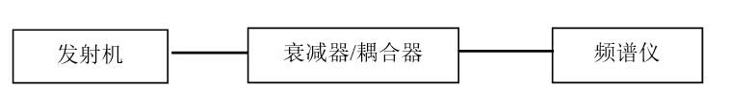

图5-1

检测框图 | 对应检测项目
图5-1 | ${eirp}
图5-1 | ${maxpow}
图5-1 | ${oob}
图5-1 | ${freq}
图5-1 | ${obw}
图5-1 | ${cft}
图5-1 | ${se}
图5-1 | ${tp}
图5-1 | ${mp}

