Nicholas Ciesla 9/8/2022 CS-330-T1187

M2 Project Proposal:

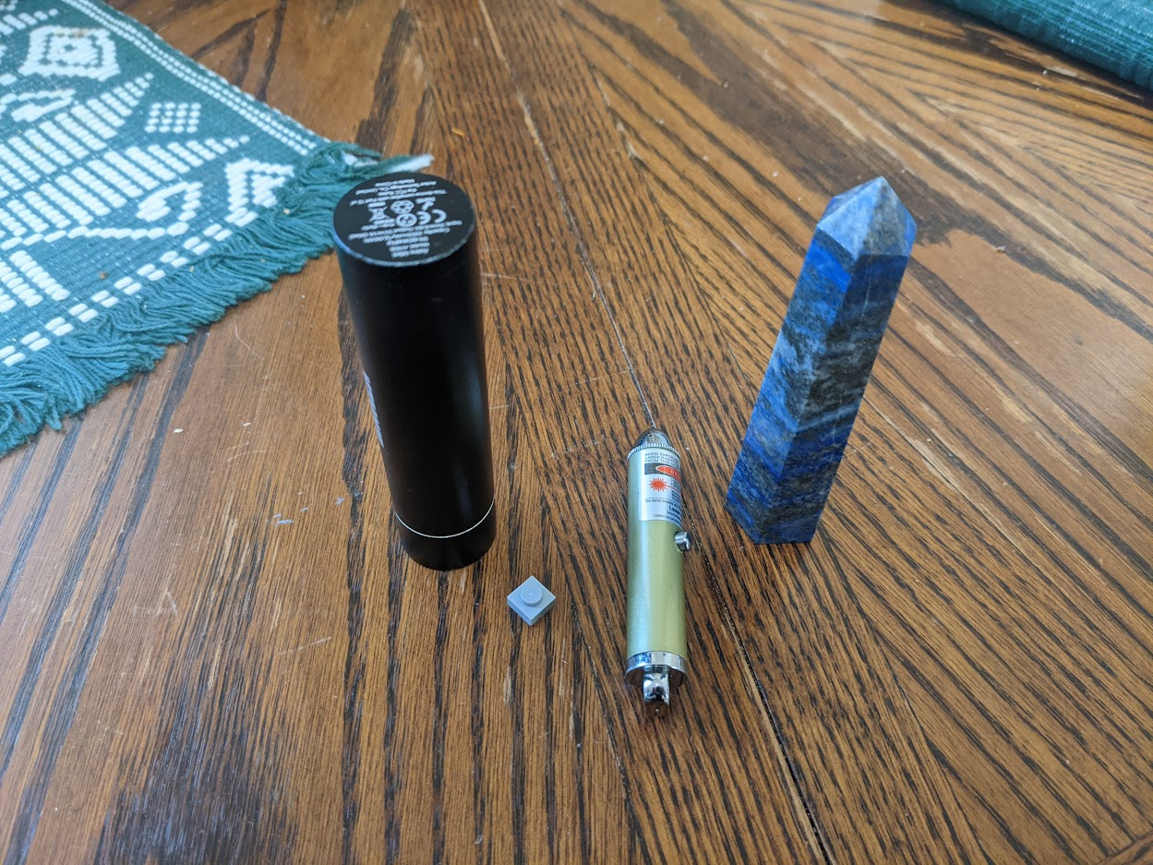

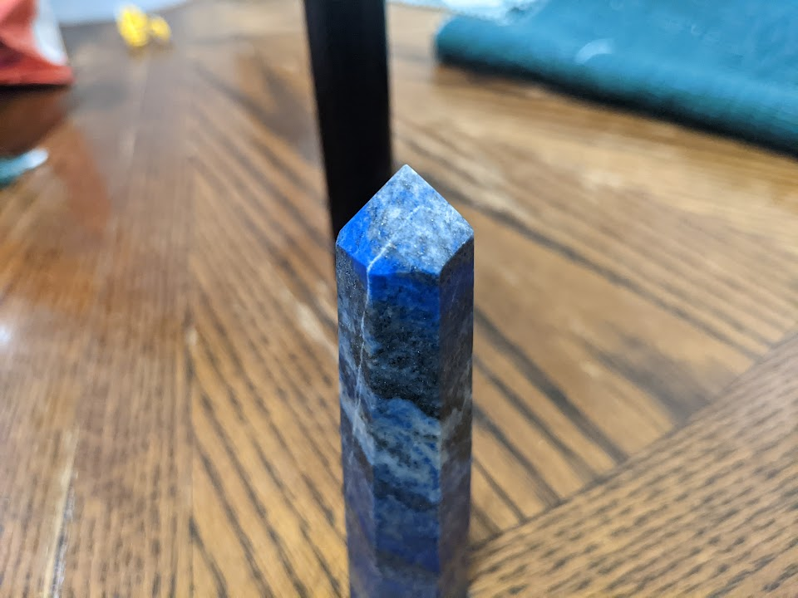

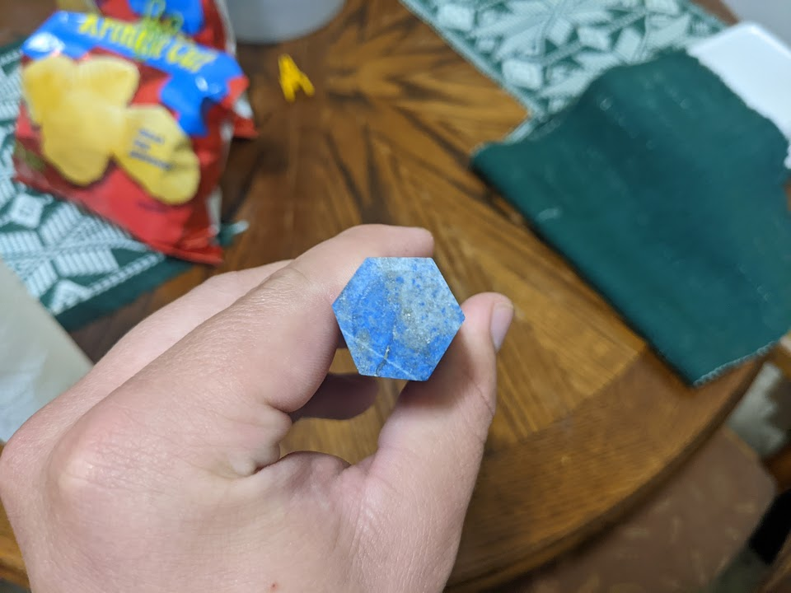

The objects that will be created in 3D are a small Lego piece, a portable charger (black cylinder), a laser pointer, and a lapis crystal. These objects are good choices for this project as they are all rather simple, yet with some details that leave room for creativity.

The portable charger can be represented with a cylinder. The laser pointer can be represented with one cylinder as the body and one as the button. Also, the tip can be represented with a sphere. The loop on the end can be removed for simplification, but it could also be represented with a torus. The lapis crystal is slightly askew in shape, but it can be made straight for this project. It can be represented with a hexagonal prism comprised of panes and a hexagonal pyramid as the tip. The Lego piece can be represented with a cube and a cylinder. The table will be a plane, but I’m not sure if that can be considered an object.

If I chose shapes that were too complicated, I could simplify the lapis and the pointer to just be cylinders and make the Lego the only shape made up of more than one shape. I realize that I may have bitten off more than I could chew with shapes that are a bit complex.