PROJECT DOCUMENTATION
Local Services Booking Platform
A Full-Stack MERN Application
ITSimplera Solutions
Full Stack Web Development Internship — Week 4 Task
Prepared by: Sudais Shah

1. Project Overview
This project is a full-stack, production-ready Local Services Booking Platform that connects Customers with independent Service Providers (e.g. home repair technicians, tutors, fitness trainers) for bookable, time-slot-based appointments.
The platform allows:
- Customers to search, browse, and book services from available providers
- Providers to manage their services, set weekly availability, and handle incoming booking requests
- Both parties to track booking status through a defined lifecycle
- Customers to leave reviews after completed bookings
- Real-time in-app notifications for booking status changes

2. Tech Stack
Layer | Technology
Frontend | React (Vite), React Router, Axios
Backend | Node.js, Express.js
Database | MongoDB with Mongoose
Authentication | JWT & bcrypt
API Testing | Postman
Version Control | Git & GitHub

3. Core Features Implemented

3.1 Authentication & Users
- User registration and login with bcrypt password hashing
- JWT-based authentication with protected routes
- Two roles: Provider and Customer, each with role-specific dashboards and permissions
- Profile view/update functionality

3.2 Services & Availability
- Providers can create, update, and deactivate services (title, description, category, duration, price)
- Providers set weekly availability slots
- Server-side double-booking prevention — a slot is locked (isBooked: true) the moment a booking is created

3.3 Booking Lifecycle
- Bookings move through defined statuses: pending → confirmed → completed, or pending → declined / cancelled
- Only the relevant party can change each status (provider confirms/declines/completes; customer cancels)
- Declined or cancelled bookings automatically free up the associated slot

3.4 Reviews
- Customers can leave a rating (1–5) and comment after a booking is marked completed
- A customer can only review a provider they actually booked and completed a session with
- Public provider profiles display aggregate rating and all reviews

3.5 Notification Center (Advanced Feature)
- Dedicated Notification model, triggered automatically on booking creation and status changes
- Frontend polls for new notifications every 30 seconds
- Unread count badge, dropdown list, mark-as-read and mark-all-as-read functionality

3.6 Other Advanced Features
- Search providers by name/category
- Sorting by price (low to high / high to low)
- Provider dashboard statistics (response time, completion rate) with visual charts
- Favorite/save provider list for customers

4. Security Implementation
- Password hashing: bcrypt used for all stored passwords
- Authentication: JWT tokens verified via Express middleware on all protected routes
- Environment variables: JWT_SECRET, MONGO_URI, and PORT stored in .env, excluded from version control via .gitignore
- CORS: restricted to the frontend's origin rather than left open to all origins
- Server-side booking integrity: slot availability checked and locked on the server, never trusted from the frontend

5. Database Schema
Collection | Key Fields
users | name, email, passwordHash, profilePicUrl, role
services | providerId, title, description, category, durationMinutes, price, isActive
availabilitySlots | providerId, dayOfWeek, startTime, endTime, isBooked
bookings | customerId, providerId, serviceId, slotId, status, createdAt, updatedAt
reviews | bookingId, customerId, providerId, rating, comment
notifications | userId, bookingId, message, type, isRead

See the ER-DIAGRAM.md file in the repository for the full entity-relationship diagram.

6. API Endpoints
Endpoint | Description
POST /api/auth/register | Register a new user
POST /api/auth/login | Login
POST /api/auth/logout | Logout
GET /api/users/profile | Get logged-in user's profile
PUT /api/users/profile | Update profile
PUT /api/users/change-password | Change password
POST /api/services | Create a service (provider)
GET /api/services | List all services
GET /api/services/:id | Get a single service
PUT /api/services/:id | Update a service
DELETE /api/services/:id | Delete a service
POST /api/availability | Create availability slot (provider)
GET /api/availability/:providerId | Get a provider's availability
POST /api/bookings | Create a booking (customer)
GET /api/bookings/me | Get logged-in user's bookings
PUT /api/bookings/:id/status | Update a booking's status
POST /api/reviews | Create a review
GET /api/reviews/:providerId | Get a provider's reviews
GET /api/notifications | Get logged-in user's notifications
PUT /api/notifications/:id/read | Mark a notification as read
PUT /api/notifications/read-all | Mark all notifications as read

7. Implementation Walkthrough (Screenshots)
Insert a screenshot from your own project under each heading below before final submission.

7.1 Customer — Find a Service Page

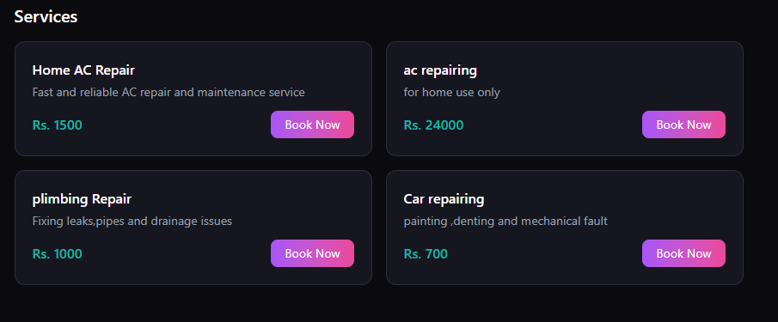

7.2 Customer — Booking Checkout

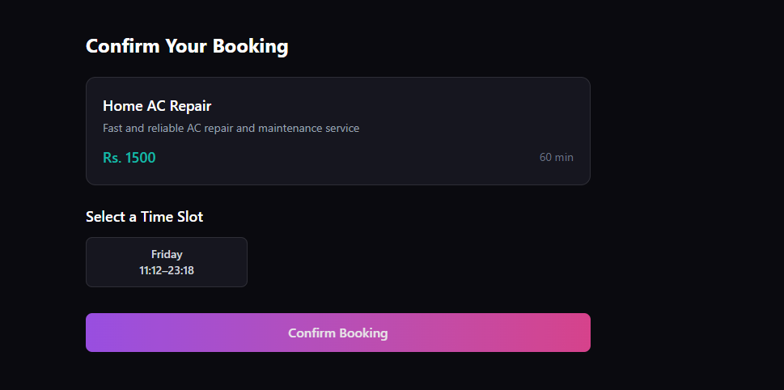

7.3 Provider — Dashboard
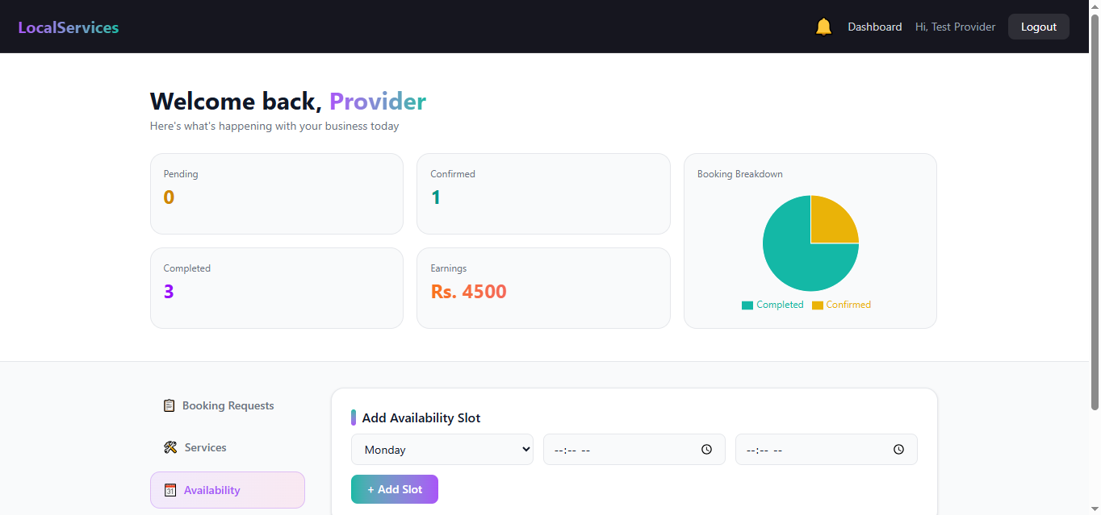

7.4 Provider — Managing Services & Availability

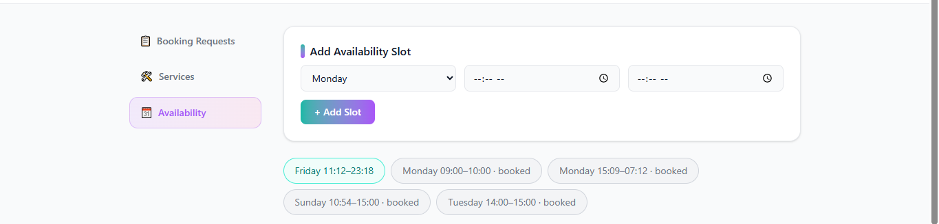

7.5 Booking Status Lifecycle

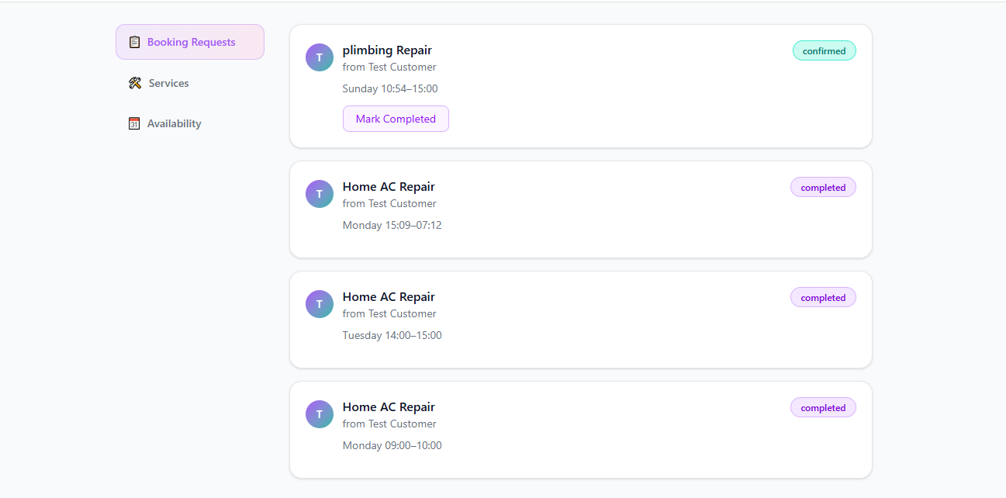

7.6 Notification Center

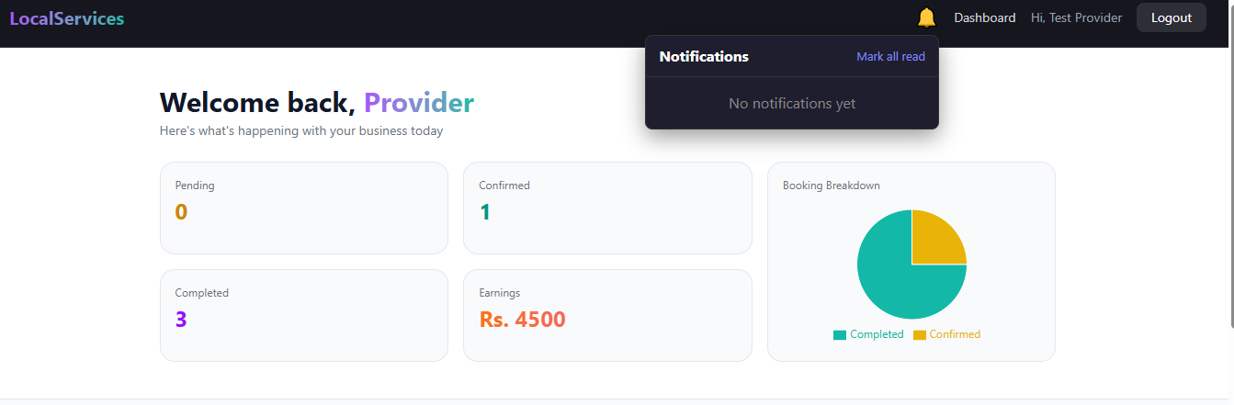

7.7 Reviews
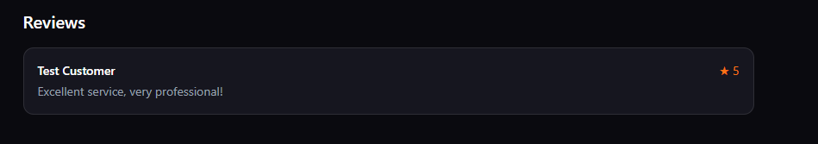

7.8 Postman — API Testing
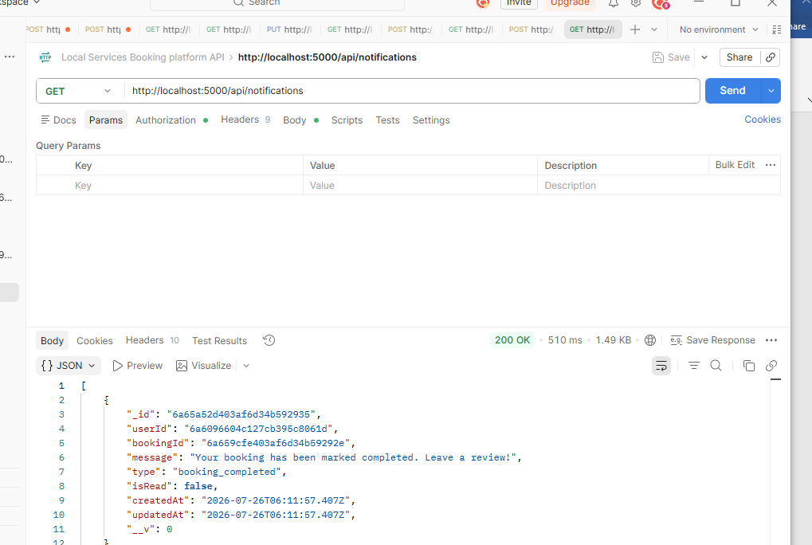

8. Challenges & Solutions
Challenge | Solution
ISP blocked MongoDB SRV connection strings | Used a non-SRV MongoDB Atlas connection string instead
Windows path issues with spaces during setup | Kept project structure under a path without spaces where possible
Duplicate/misplaced code when wiring notification triggers into existing controllers | Isolated the Notification.create() call to run once, immediately after the relevant booking.save(), and verified before committing
Ensuring .env was never pushed to GitHub | Verified with git status | findstr .env before every commit, and used .gitignore from the first commit

9. Repository Links
GitHub Repository: github.com/sudaisshah1111-sudo/Local-Services-Booking-platform
Postman Collection: included in the repository root (.postman_collection.json)
ER Diagram: ER-DIAGRAM.md in the repository

10. Conclusion
This project demonstrates a complete, secure, role-based full-stack booking platform built with the MERN stack, covering authentication, multi-party workflows, real-time-feeling notifications, and a tested REST API — fulfilling the Week 4 task requirements for ITSimplera Solutions' Full Stack Web Development Internship.

