Phaser 3 2D – Test  
ROAD CONNECT GAME

 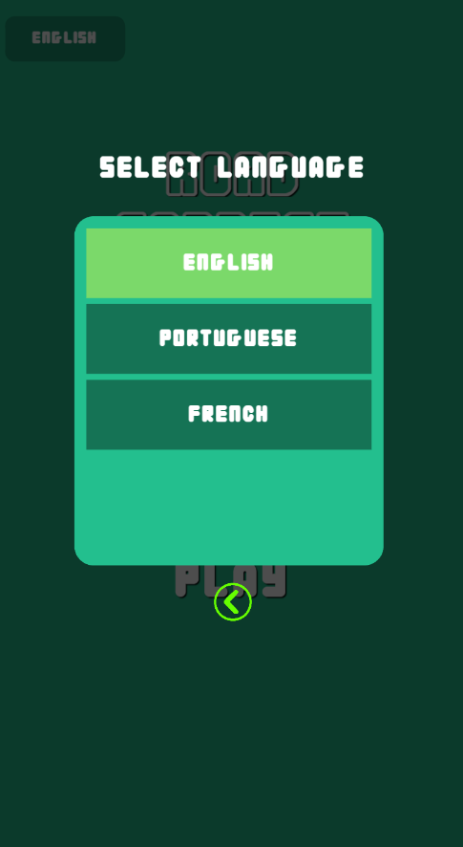  

Project Details:  
1. Replication Fidelity: All game functionalities and visual elements from the original game replicated.

2. Optional Enhancements: For additional points have implemented, as per your requirement:

● Multi-resolution support has implemented to seamlessly switch between landscape and portrait orientations. (But I am not sure with this, your requirement is full fill)

● Localization support has implemented with three languages.  
Localization: I have used “LabelTranslatePlugin” for localization.  
I have added 2 more languages- Portuguese and French, in both languages have some symbols which not available in original Unity project’s font. In both languages can be have some spelling issues.  
I have added 3 languages (English, Portuguese, French) JSON files (en.json, fr.json, pt.json) in “assets/local” folder with .csv file and one python csv converter.

Level management:

[4,"_C","_C","_C","_C"] For total shapes and id name

[[90,0],[0,90],[0,-90],[0,180]] For shape start and end angle  
[[232,512],[360,512],[232,640],[360,640]] For shape position (this method only temporary based later I can use ‘Grid mapping’ method)

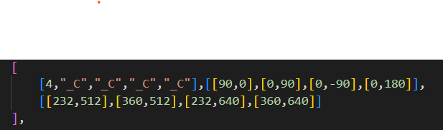

Two errors show in original Unity project:  
● When we click on level 1, its show level 0.  
● When we rotate the shape, in some place overlapping the shape corners.

I am sharing a tutorial video file, please ignore sounds in this video which is not have synced during recording.

Warm Regards  
SUDAMA CHANDER PRADHAN  
+91-8076439657, +91-9891849677