SUDAM MONDAL
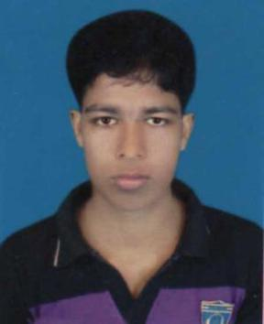
Mobile: 01737870781, 01518404335
Email:sudammondal55@gmail.com

OBJECTIVE |  | EDUCATION
A full-time position as a Front-end |  | Secondary School Certificate • 2010 • Khalishkhali High School
developer where I can prove me |  | Jessore Board, GPA – 2.31
proudly as a web designer

MY WORK HISTORY

- https://sudammondal.github.io/canvas/
- https://sudammondal.github.io/astute/
- https://sudammondal.github.io/pofo/
- https://sudammondal.github.io/bolby/
- https://sudammondal.github.io/appland/
- https://sudammondal.github.io/sstech/
- https://sudammondal.github.io/biznes/
- https://sudammondal.github.io/bolbyhome/
- https://sudammondal.github.io/demo/

SKILLS

- HTML5, CSS3, Bootstrap, Photoshop, SASS, jQuery, JavaScript, GitHub.

- Pixel Perfect Design, Convert PSD to HTML5, CSS3.

- Responsive Design with Bootstrap Framework.

- Follow envato product development coding structure KEY QUALIFICATIONS.

- Confident and efficient with the quality of my work and can meet or exceed platform requirements.

- Following the latest principles and industry best-practices in the area of UX/UI with front-end development.

- Try to contribute open source technology and love it.

- Highly creative Passionate about web design and development Strong work ethics.

- Strong written & oral communication ability.

PERSONAL DETAILS

Name | : | Sudam Mondal.
Father’s name | : | Norenthronath Mondal.
Mother’s name | : | Kamola Rani Mondal.
Permanent address | : | Vill: Pakshia, Post: Khalishkhali, P.S: Tala, Dis: Satkhira.
Present address | : | H: #515, South Monipur, Mirpur-2, Dhaka-1216.
Nationality | : | Bangladeshi (By birth).
Religion | : | Sonaton (Hindu).
Marital status | : | Single.
Date of birth | : | 13/ 11/ 1994.
Sexual status | : | Male.
Health | : | Good.
Blood group | : | A⁺ .

LANGUAGESKILL

- Fluent in both written & spoken English.

ONLINE RESOURCES

❖ Facebook | facebook.com/sudammondal55
❖ Skype | live:sudammondal02
❖ Google | sudammondal55@gmail.com
❖ Github | https://github.com/sudammondal

TRAINING & WORKSHOPS & SEMINARS

- Certified Web Design and Development at RB IT Institute 2020.

HIGHLIGHTS OF STRENGTH

The driving forces, which I consider my value-enthusiasm, commitment, simplicity are never apart from my activities. Other people will find me.

- Communicative and Friendly.

- Ready to work with a stress worthy environment.

- Adaptive to new technology.

- Quick learner and self-motivated.

Date: 30/ 01/ 2021 Signature

