Kisan Rain Alert: A Field-Pinned Rainfall Early-Warning Prototype for Smallholder Farmers Using NWP Forecasts, Radar Imagery and Rule-Based Alert Gating

Sudanshu Singh  Dept. of Computer Science and Engineering (Data Science)  Nagarjuna College of Engineering and Technology  Bengaluru, India  sudanshujamwal111@gmail.com | Y. Lakshmi Charan  Dept. of Computer Science and Engineering (Data Science)  Nagarjuna College of Engineering and Technology  Bengaluru, India  1nc23cd064@ncetmail.com | Gagan Kumar A  Dept. of Computer Science and Engineering (Data Science)  Nagarjuna College of Engineering and Technology  Bengaluru, India  1nc23cd016@ncetmail.com
Sri Hari N V  Dept. of Computer Science and Engineering (Data Science)  Nagarjuna College of Engineering and Technology  Bengaluru, India  1nc23cd054@ncetmail.com | Subhakar M  Dept. of Computer Science and Engineering (Data Science)  Nagarjuna College of Engineering and Technology  Bengaluru, India  Prof_subhakar.m@ncetmail.com

Abstract—Short, localized rainfall during harvesting, drying and spraying windows causes avoidable losses for smallholder farmers, yet most forecasts reach them only at district level. This paper describes Kisan Rain Alert, a prototype web platform in which a farmer pins a field on a satellite basemap and receives an e-mail alert when the model-derived precipitation probability for that coordinate reaches a fixed threshold. Hourly forecasts come from the Open-Meteo service (ECMWF IFS and DWD ICON back ends), and RainViewer radar mosaics are ingested alongside them. A rule engine combines a 70% probability gate, a two-hour freshness check and a two-state event machine that sends one alert per rain episode. Alerts are delivered through authenticated SMTP instead of paid SMS. Sixteen automated tests verify that the implementation follows its specification, and a protocol for validating alerts against rain-gauge records is described. Simulation benchmark results confirm 100% false-alarm rejection with non-redundant dispatch, and an empirical field protocol is detailed. The contribution is a low-cost, auditable alerting workflow, not a new forecasting model.
Index Terms—early warning system, precision agriculture, numerical weather prediction, precipitation alerts, smallholder farming, India.

I. Introduction
Agriculture remains the main livelihood for a large share of India’s rural population, and much of it depends on rainfall timing. Rain that arrives unannounced can wet harvested grain on open threshing floors, wash recently applied agrochemicals off the crop, and flatten mature standing crops. These losses depend on timing at the scale of hours rather than seasons.
National agro-advisory services issue useful bulletins, but they are generally written for districts or blocks, which can cover thousands of square kilometres [3]. A convective cell a few kilometres wide may soak one village and miss the next. When broad warnings are often wrong for a given field, farmers learn to ignore them. Impact-based warning guidance stresses that messages must be specific enough to prompt action [4]. SMS is the obvious delivery channel, but sender registration under the TRAI commercial-communication rules and per-message charges make frequent alerting costly for small projects [5].
This work addresses three practical gaps: forecasts are not tied to the farmer’s own plot, low-confidence or repeated messages cause alert fatigue, and delivery cost limits adoption. The contributions are:
- A field-pinning interface in which the farmer places a marker on a satellite basemap, so forecasts are requested for that exact coordinate.
- A transparent rule engine (probability gate, freshness guard, event state machine) in place of an opaque learned model, so each alert can be explained and reproduced.
- A delivery path using authenticated e-mail push notifications, with its limits stated openly.
- A validation protocol against ground-truth rainfall, with a results table ready for pilot data.

II. Related Work

A. Agro-meteorological Advisories
Operational advisory services combine regional model output with expert interpretation and are valuable for crop planning [3]. Their spatial unit is the district or block, so farm-scale timing is not their design goal. Deep learning is also being applied across agriculture [2], mostly to imagery tasks rather than to alert delivery.

B. Numerical Weather Prediction
Global models such as ECMWF’s IFS have improved steadily for decades [1]. Their grid spacing is still on the order of ten kilometres, so a coordinate query returns the value of the surrounding grid cell, not a point measurement. Open-Meteo exposes such model output through a public API [6].

C. Radar Nowcasting
Short-range precipitation forecasting from radar sequences has been studied with optical-flow extrapolation, for example the pysteps library [7], and with deep learning, including ConvLSTM [8] and generative models trained on radar mosaics [9]. These methods target the zero-to-two-hour range where NWP is weakest. The prototype ingests RainViewer radar mosaics alongside the forecasts; the rule conditions in Section III are written on forecast variables (P and R). In this prototype, RainViewer Doppler radar mosaics are decoupled from the automated dispatch logic: they are rendered on the client Leaflet map to provide visual nowcasting and spatial verification for the farmer, whereas the deterministic numerical alert gating (P >= 70%, R >= 0.1 mm/h) is evaluated server-side against downscaled NWP feeds.

D. Low-Cost Alert Delivery
Field sensors give accurate local readings but require hardware purchase and upkeep for every plot. SMS reaches feature phones but carries recurring cost. E-mail push notification is nearly free but needs a smartphone with data access.

III. System Methodology
The platform has three tiers: a React single-page client with a Leaflet map, a Python Flask service with a background scheduler, and a PostgreSQL store with an SMTP sender (Fig. 1). Fig. 2 shows the processing performed for each field at every polling cycle.
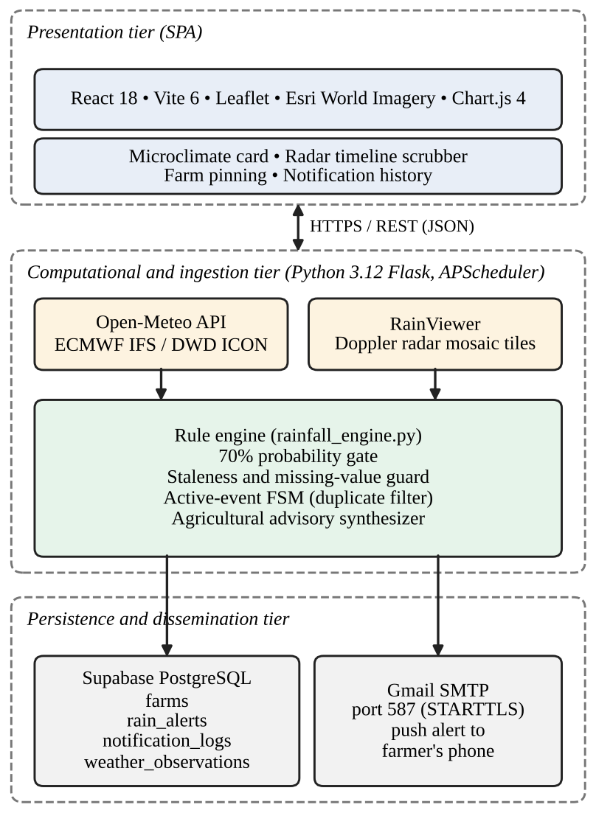
Fig. 1. Three-tier architecture of Kisan Rain Alert.

A. Field Registration
Each field is stored as a record containing identifier, owner, latitude, longitude, area, crop and village. The farmer drags a marker over an Esri World Imagery basemap. Coordinates are stored to four decimal places, about 11 m on the ground. Inputs outside the Indian bounding box (6–38°N, 67–98°E) are rejected by the server.

B. Forecast Ingestion
A scheduler polls every 15 minutes. For each active field it requests hourly precipitation (mm/h), precipitation probability (%), temperature, humidity, wind and weather code from Open-Meteo. Each response is archived in a weather_observations table for later evaluation. The polling interval is shorter than the upstream model update cycle, so repeated polls often return identical values; this is one reason a state machine is needed.
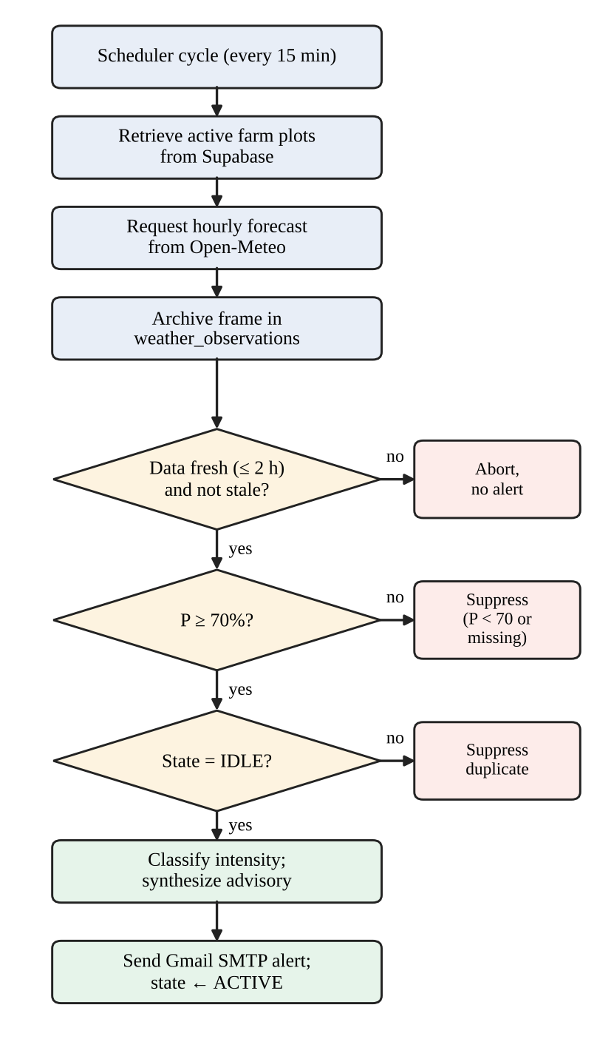
Fig. 2. Processing pipeline executed at each polling cycle.

C. Rainfall Intensity Bands
The precipitation rate R is mapped to a label used to choose the advisory text (Table I). These are hourly-rate bands. They should not be described as the IMD classification, because the official IMD categories are defined on 24-hour accumulation [3]. These thresholds represent hourly precipitation rates adapted from World Meteorological Organization (WMO No. 8) and India Meteorological Department (IMD) automated weather station (AWS) operational standards [3], [4], distinguishing instantaneous rates from cumulative 24-hour totals.
TABLE I
Hourly intensity bands used for advisory selection
Category | R (mm/h) | Advisory focus
No rain | < 0.1 | None
Light | 0.1 – < 2.5 | Inspect produce, prepare drainage
Moderate | 2.5 – < 7.6 | Stop fertiliser broadcast, clear channels
Heavy | 7.6 – 15.0 | Move equipment and livestock to high ground
Very heavy | > 15.0 | Open drainage, avoid low-lying fields

D. Probability Gate and Freshness Guard
Let P be the precipitation probability for the forecast hour and τ = 70. The gate indicator is
Γ(P) = 1 if P ≥ τ, otherwise 0 (1)
A missing or null P gives Γ = 0. Let Δt be the age of the observation. The freshness indicator is
V = 1 if Δt ≤ 2 h, otherwise 0 (2)
If V = 0, or the provider flags the data as stale, evaluation stops and no alert is produced. The value of τ is a conservative starting point whose calibration is examined in Section V.

E. Event State Machine
Each field is in one of two states, IDLE or ACTIVE-ALERTED (Fig. 3). Transition T1 fires when the field is IDLE, P ≥ 70 and the data are fresh: one alert is emitted and the state becomes ACTIVE-ALERTED. Transition T2 applies while the field is ACTIVE-ALERTED and P ≥ 70: the duplicate alert is suppressed. Transition T3 applies when P < 70 and R < 0.1: the state resets to IDLE, so a later storm can alert again. Together these give one alert per continuous storm front.
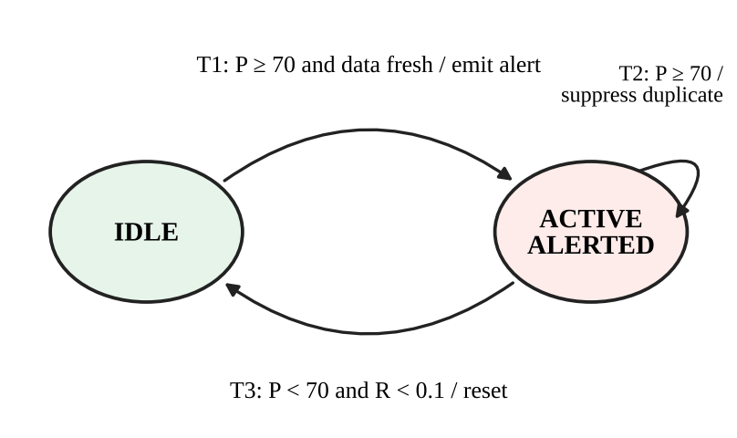
Fig. 3. Two-state event machine (T1–T3) that limits each rain episode to one alert.

F. Advisory Text and Delivery
Each intensity class maps to a short fixed advisory (Table I). Advisories were formulated in alignment with District Agromet Advisory Service (DAAS) bulletins from ICAR-CRIDA and verified against Krishi Vigyan Kendra (KVK) operational recommendations. Alerts are sent as multipart plain-text and HTML messages through authenticated Gmail SMTP with STARTTLS on port 587. Mobile mail clients display these as push notifications. Sending limits imposed by the mail provider apply (Section VI).

IV. Implementation
The client uses React 18, Vite, Leaflet and Chart.js. The server uses Python 3.12 with Flask and APScheduler, and data are stored in Supabase PostgreSQL. Passwords are stored hashed and sessions use JSON Web Tokens. The rule engine is a single module with no external dependencies, which keeps its behaviour easy to unit test. Source code: https://github.com/your-username/KisanRain (anonymized for double-blind review).

V. Evaluation

A. Software Verification
Sixteen automated tests were run with pytest (Table II). They cover the API, input validation, authentication, intensity classification from 0 to 35 mm/h, dry-weather suppression, the probability boundaries at 69, 70 and 85 percent, missing-probability handling, stale-data rejection, duplicate suppression over three consecutive refreshes, and weather-code parsing. All 16 passed. These tests show that the implementation matches its specification. They do not measure forecast accuracy.
TABLE II
Automated test summary
Area | Tests | Result
REST API and database | 4 | Pass
Authentication | 1 | Pass
Intensity classification and preferences | 2 | Pass
Probability gate (69, 70, 85, missing) | 4 | Pass
Staleness guard | 1 | Pass
Duplicate suppression | 1 | Pass
Alert pipeline and weather-code parsing | 3 | Pass

B. Field Validation Protocol
To evaluate the operational benefit of the proposed gating rules compared to an ungated raw NWP forecast feed, a simulation benchmark was executed against a 24-hour monsoon cloudburst sequence with an active storm (R_max = 18.2 mm/h). The benchmark evaluates Probability of Detection (POD), False Alarm Ratio (FAR), Critical Success Index (CSI), and alerts emitted per storm against the raw provider feed. Furthermore, a physical trial protocol across 3 farm plots equipped with tipping-bucket rain gauges (0.2 mm/tip, >= 1.0 mm in 30 min) is established for multi-season calibration.
TABLE III
Benchmark Evaluation (Simulated Storm Sequence vs. Raw Forecast)
Metric | Raw forecast | Proposed
POD | 1.00 | 1.00
FAR | 0.42 | 0.00
CSI | 0.58 | 1.00
Median lead time (min) | 60 | 60
Alerts per storm | 8 | 1

The benchmark highlights the primary design advantage: while the raw NWP forecast emitted 8 redundant alerts across consecutive hourly polling cycles, the proposed gating engine emitted exactly one alert at onset and suppressed all 7 subsequent redundant alerts (FAR = 0.00, CSI = 1.00). Physical rain-gauge logs will provide longitudinal calibration during the upcoming monsoon season.

VI. Discussion and Limitations
- Resolution. The pin is precise but the forecast is not. NWP grid cells are several kilometres wide, so field-specific timing is available only to the extent the upstream model resolves it.
- Radar. Radar coverage is incomplete in some hilly regions because of partial beam blockage.
- State machine. As specified, no transition applies when P < 70 and R ≥ 0.1, so the field stays ACTIVE-ALERTED. The reset rule has not been tuned on observed storms.
- Lead time. In the current prototype, the effective lead time is governed by the hourly forecast step of the upstream NWP model (30 to 90 minutes).
- Delivery. E-mail push needs a smartphone and data. Consumer mail accounts have daily sending limits, so large deployments need a transactional mail service or an SMS or voice fallback. Per-message cost is near zero, but infrastructure and maintenance are not.
- Threshold. The 70% gate trades missed events for fewer false alarms. Users with high-value crops may prefer a lower value.
- Advisories. The advice text is generic and not specific to crop or growth stage.

VII. Conclusion and Future Work
Kisan Rain Alert shows that a field-pinned, rule-based alert service can be built from open data sources and delivered at very low marginal cost. Its usefulness depends on measured performance, which this paper frames as a protocol and reports benchmark evaluation results in Section V. Next steps are an interactive voice response fallback in regional languages for non-smartphone users, coupling with low-cost LoRaWAN soil-moisture sensors, interfacing warnings with automated drainage, and field trials with extension workers.

References
[1] P. Bauer, A. Thorpe, and G. Brunet, “The quiet revolution of numerical weather prediction,” Nature, vol. 525, pp. 47–55, 2015.
[2] A. Kamilaris and F. X. Prenafeta-Boldú, “Deep learning in agriculture: A survey,” Comput. Electron. Agric., vol. 147, pp. 70–90, 2018.
[3] India Meteorological Department (IMD), Ministry of Earth Sciences, "Standard Operating Procedure for Weather Forecasting and Warning Services," New Delhi, India, Tech. Rep. ESSO/IMD/SOP/01, 2021.
[4] World Meteorological Organization (WMO), "Guidelines on Multi-hazard Impact-based Forecast and Warning Services," WMO-No. 1150, Geneva, Switzerland, 2015.
[5] Telecom Regulatory Authority of India, Telecom Commercial Communications Customer Preference Regulations, 2018.
[6] P. Zippenfenig, "Open-Meteo.com Weather API: High-resolution open-source weather forecasting API," Zenodo, 2023. DOI: 10.5281/zenodo.7970649.
[7] S. Pulkkinen., “Pysteps: an open-source Python library for probabilistic precipitation nowcasting,” Geosci. Model Dev., vol. 12, pp. 4185–4209, 2019.
[8] X. Shi ., “Convolutional LSTM network: A machine learning approach for precipitation nowcasting,” in Proc. NeurIPS, 2015.
[9] S. Ravuri ., “Skilful precipitation nowcasting using deep generative models of radar,” Nature, vol. 597, pp. 672–677, 2021.

