WEEK – 5
REACT

Name: SUDARMANI V
Superset ID: 6737805

Experiment: Create a React application and display the heading "Welcome to the first session of React".
Status: Completed Successfully

Objective
- Install Node.js and npm.
- Create a React application using Create React App.
- Modify App.js.
- Run the application using npm start.
- Verify the output in the browser.

Steps Performed
- Installed Node.js (LTS) and verified installation using node -v and npm -v.
- Installed create-react-app.
- Created the React project named myfirstreact.
- Opened the project in Visual Studio Code.
- Modified App.js to display the required heading.
- Executed npm start and verified successful compilation.

Screenshot 1 - VS Code Project and Terminal
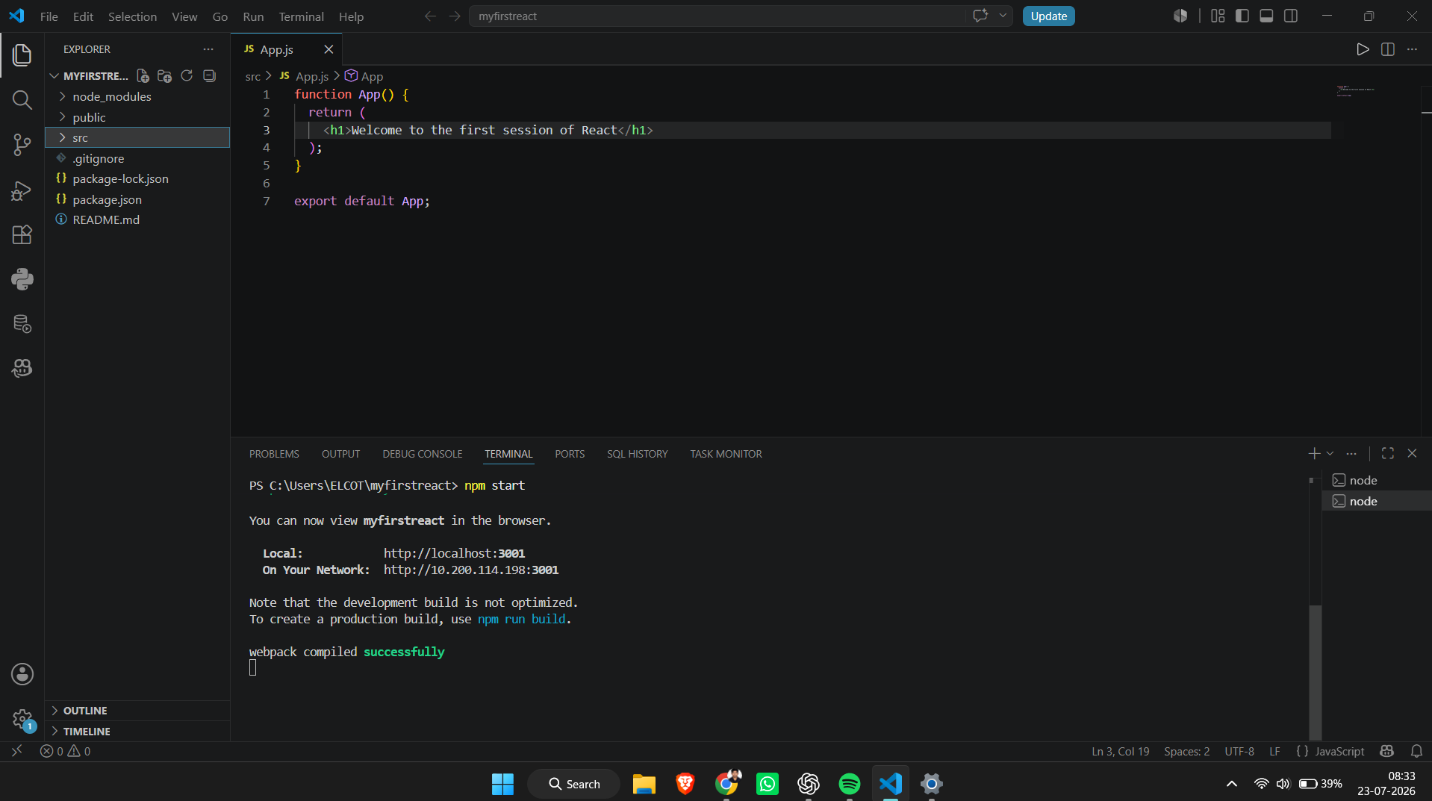
Figure 1: Visual Studio Code showing the React project with App.js edited and the integrated terminal displaying "webpack compiled successfully".

Screenshot 2 - Browser Output
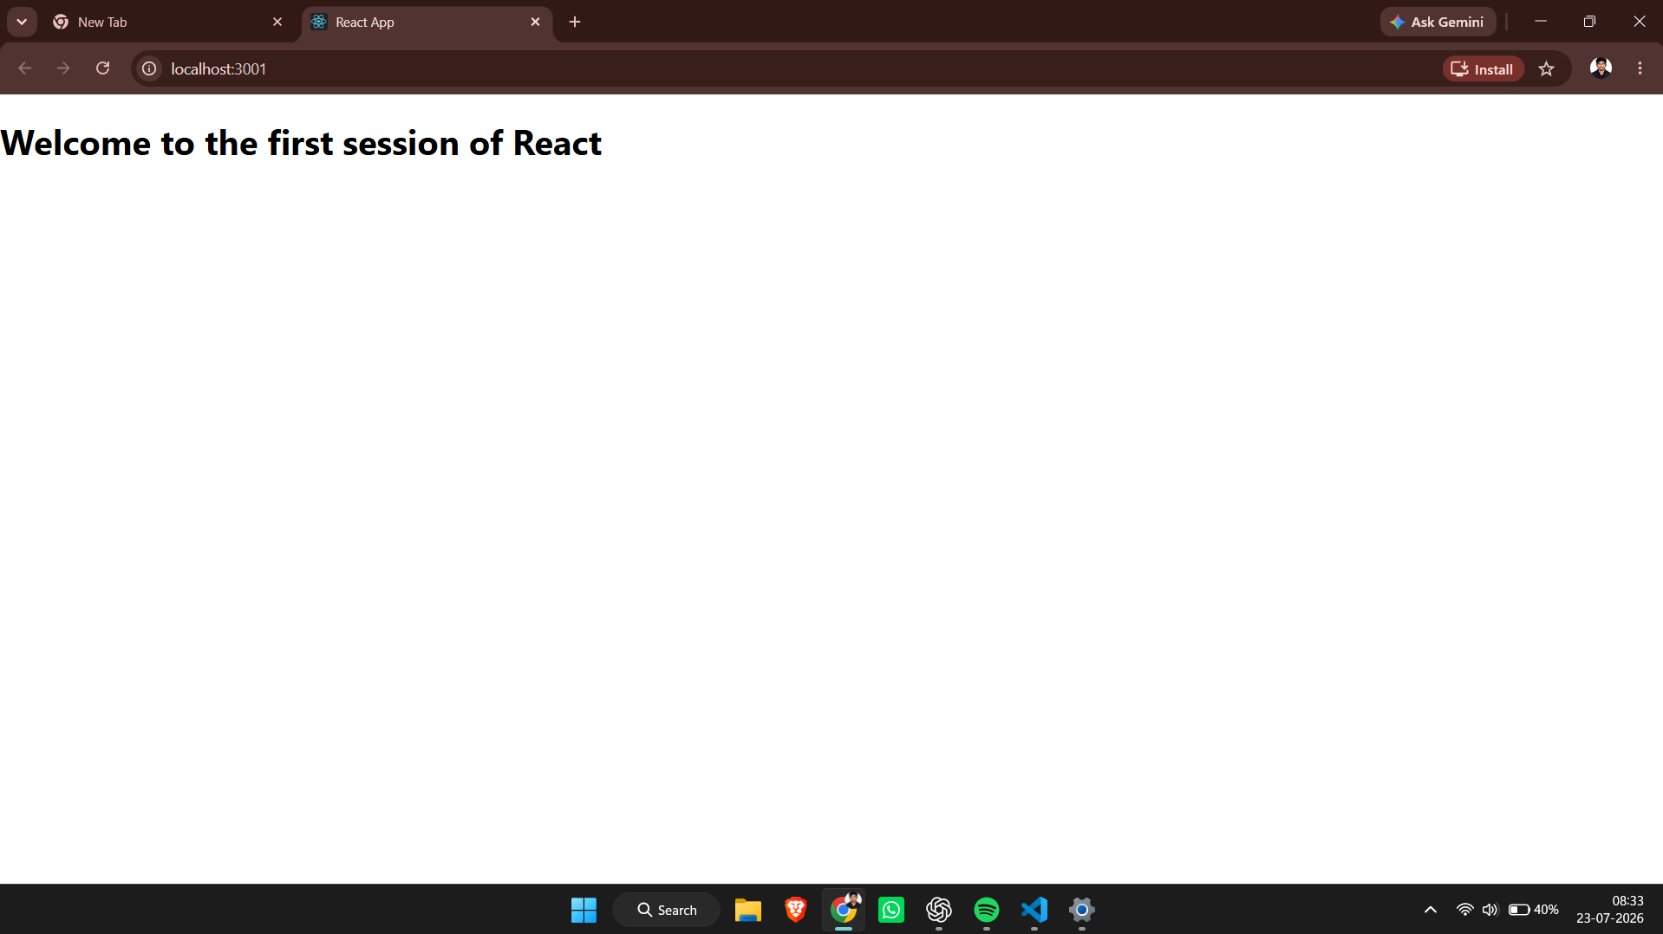
Figure 2: Browser output displaying "Welcome to the first session of React".

Result
The ReactJS-HOL-1 experiment was completed successfully. The application compiled without errors and displayed the required output in the browser. The objectives of the lab were achieved successfully.

