WEEK – 5
REACT
Name: SUDARMANI V
Superset ID: 6737805

Experiment
Exercise 10 – Office Space Rental Application

Status
The experiment was completed successfully. The React application executed without errors and displayed office space details by rendering data dynamically from an array using JSX and conditional styling.

Objective
To develop a React application that displays office space rental information using arrays, JSX expressions, conditional formatting, and image rendering.

Steps Performed
A React project named officespacerentalapp was created. Office space details were stored in an array of objects. JSX was used to display the office image, name, rent, and address. Conditional styling was applied to the rent value based on the amount. The application was executed using npm start and the output was verified in the browser.

VS Code Screenshot
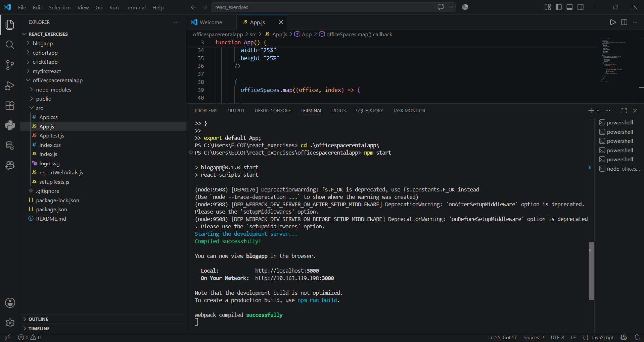
Figure 1: VS Code project structure and successful execution.

Browser Output Screenshot
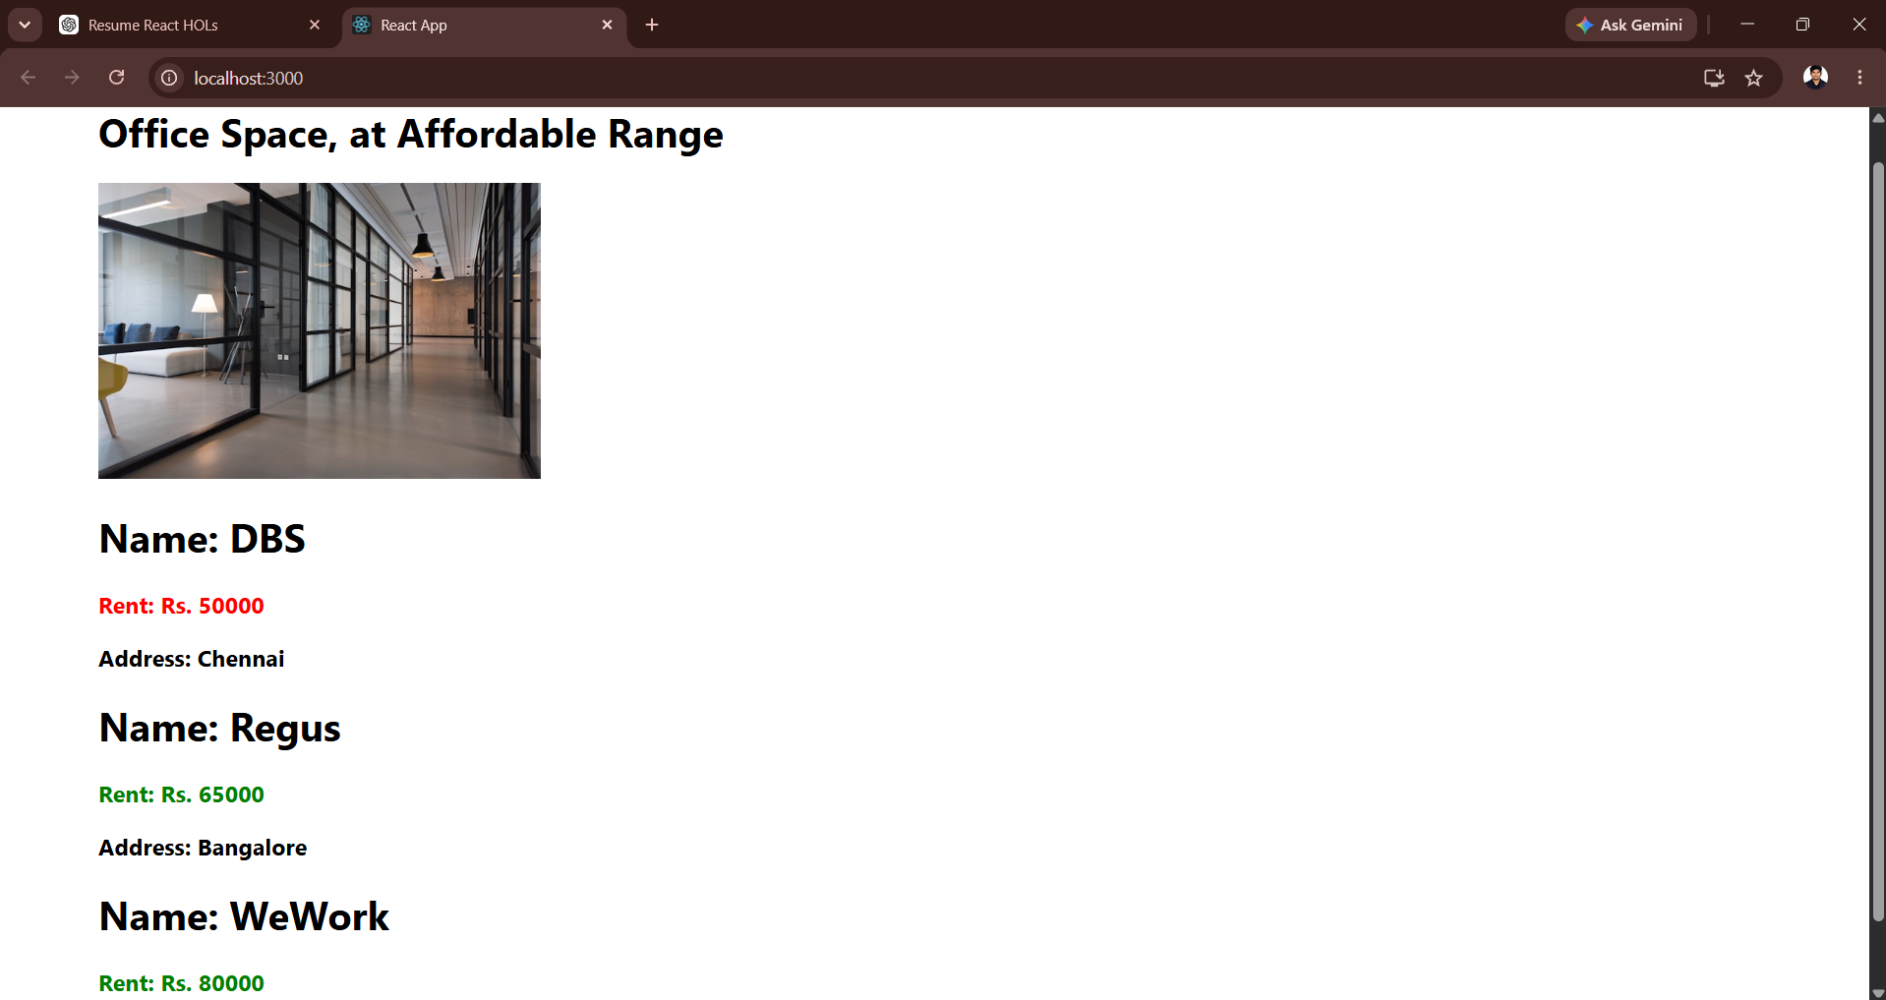
Figure 2: Browser output displaying office space rental details.

Result
Thus, the Office Space Rental React application was successfully developed and executed using JSX, arrays, conditional rendering, and dynamic styling.

