WEEK – 5
REACT
Name: SUDARMANI V
Superset ID: 6737805

Experiment
Exercise 11 – Event Examples Application

Status
The experiment was completed successfully. The React application demonstrated event handling, state updates, and a currency converter. The application compiled successfully and produced the expected output.

Objective
To implement event handling in React using button events, state management, and form controls.

Steps Performed
A React project named eventexamplesapp was developed. Event handlers for increment, decrement, welcome message, click event, and currency conversion were implemented. The application was executed using npm start and the output was verified.

VS Code Screenshot
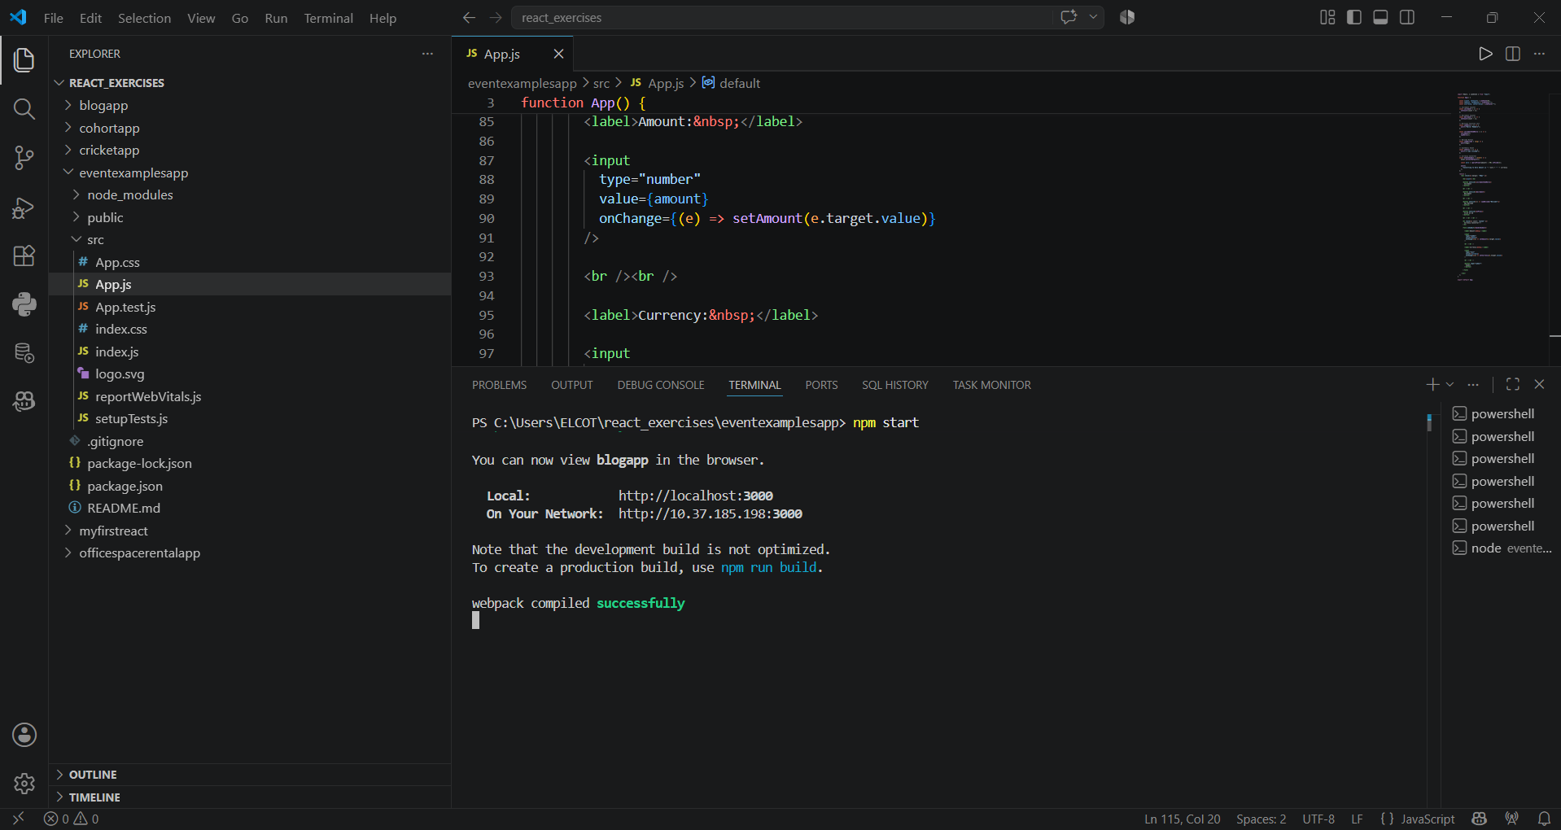
Figure 1: VS Code project structure and successful execution.

Browser Output Screenshot
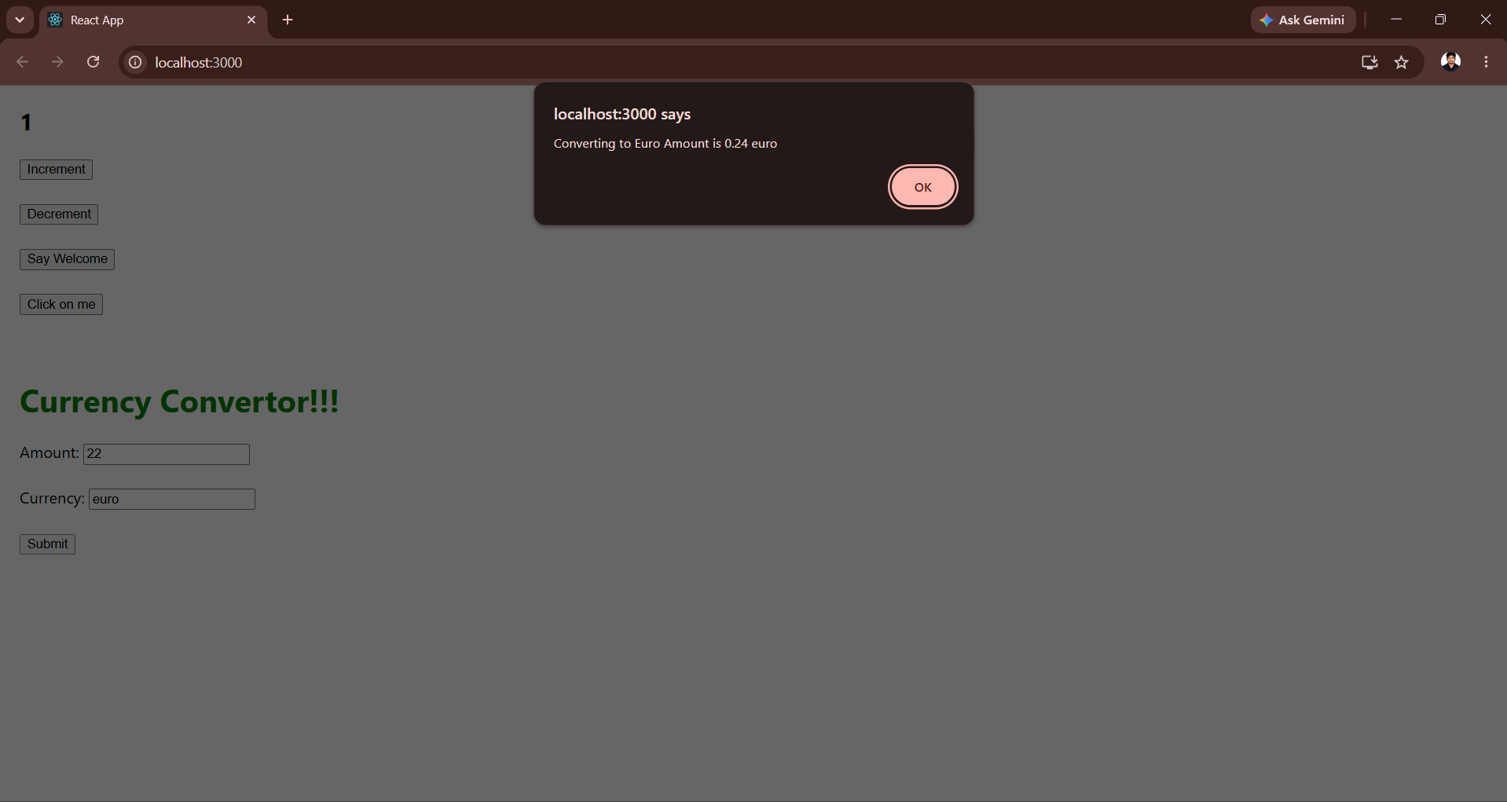
Figure 2: Browser output demonstrating event handling.

Result
Thus, the Event Examples React application was successfully developed and executed.

