ReactJS Hands-On Lab
Week : 5
Exercise : 12 – Ticket Booking App
Name :Sudarmani
Superset ID : 6737805

Experiment
Exercise 12 – Ticket Booking App

Status
The Ticket Booking App was implemented successfully using React. The application compiled without errors and demonstrated conditional rendering based on the login state. Initially, the application displayed a sign-up screen with a Login button. After clicking the Login button, the application displayed a welcome screen with a Logout button, confirming that the state management worked correctly.

Objective
To develop a React application that demonstrates conditional rendering using component state. The application should display different user interfaces before and after login, allowing users to switch between Login and Logout states.

Steps Performed
Created a new React application and opened it in Visual Studio Code. Implemented the Ticket Booking App by maintaining the login status using React state. Added Login and Logout buttons to update the state and used conditional rendering to display either the sign-up page or the welcome page. Executed the application using npm start and verified the output in the browser.

Screenshots
Figure 1: VS Code showing project structure and successful compilation.
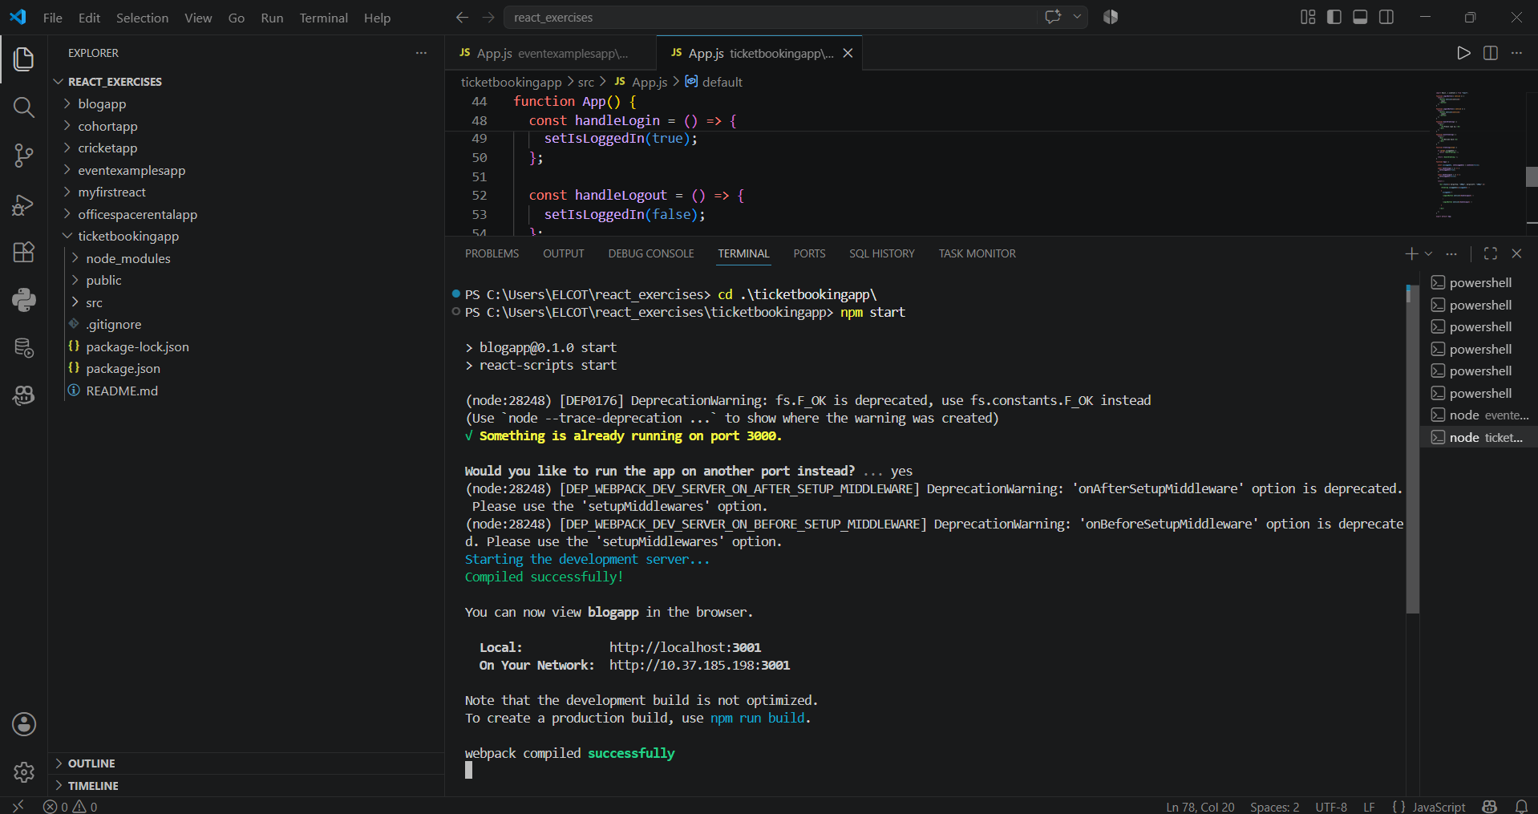
Figure 2: Initial application displaying 'Please sign up.' with Login button.
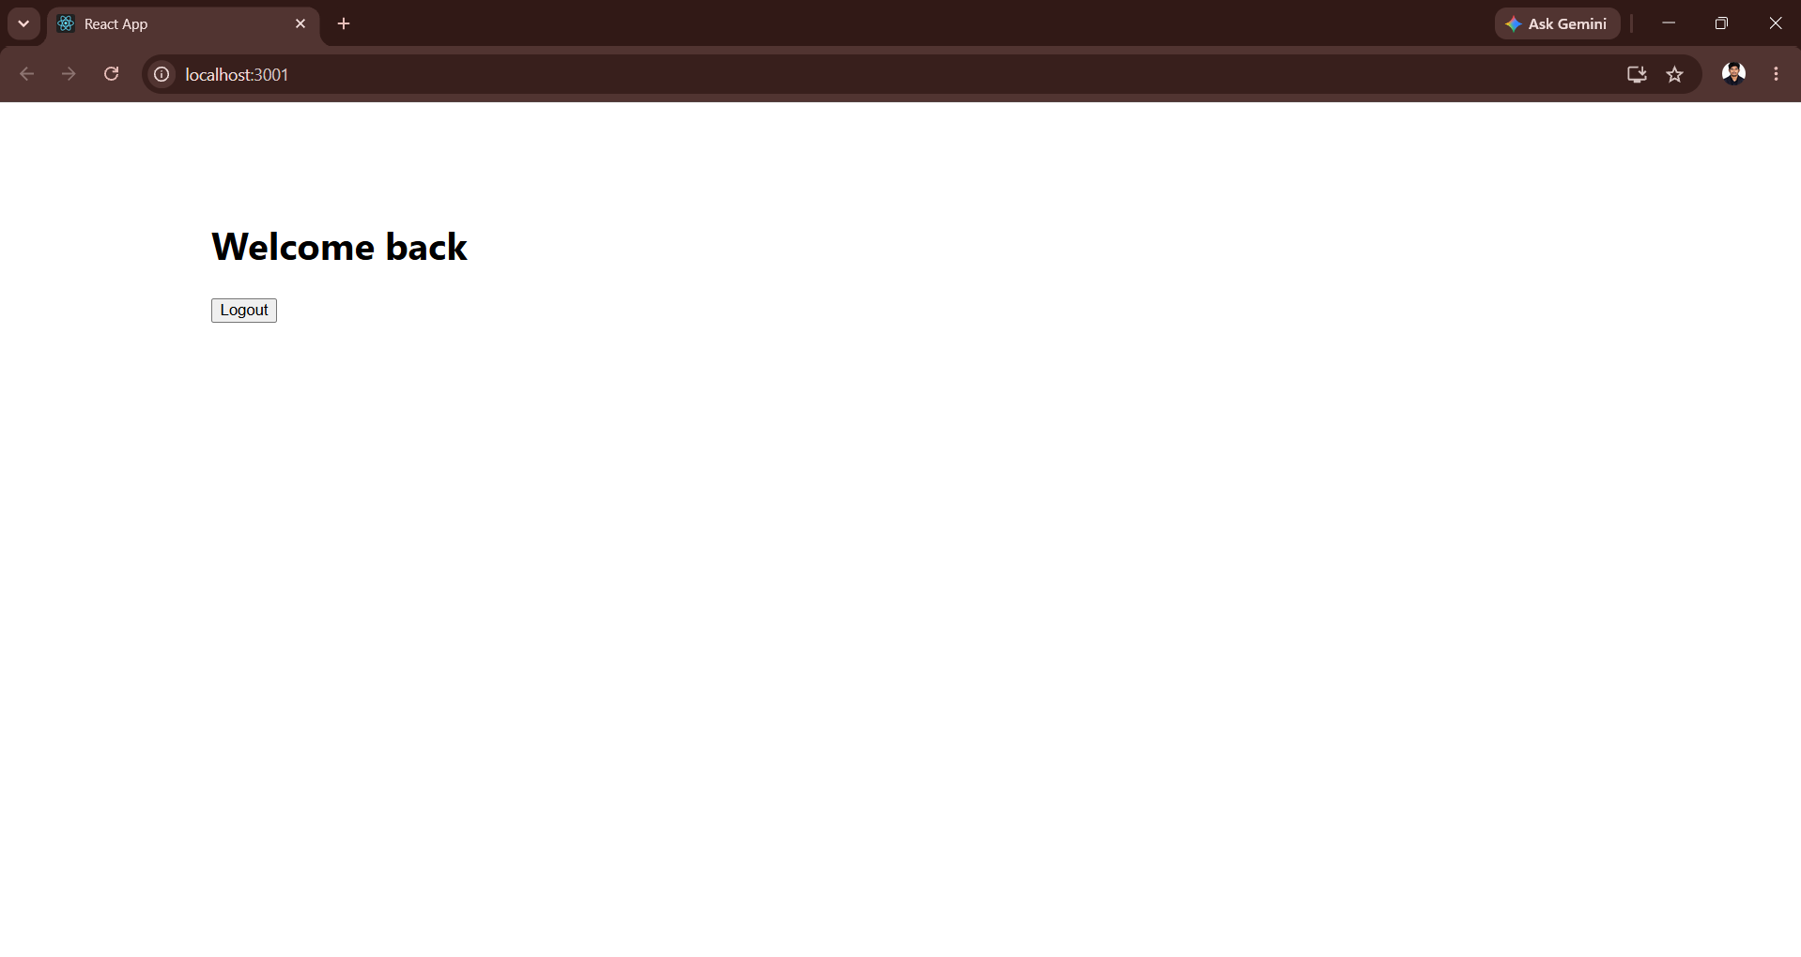
Figure 3: Application after login displaying 'Welcome back' with Logout button.
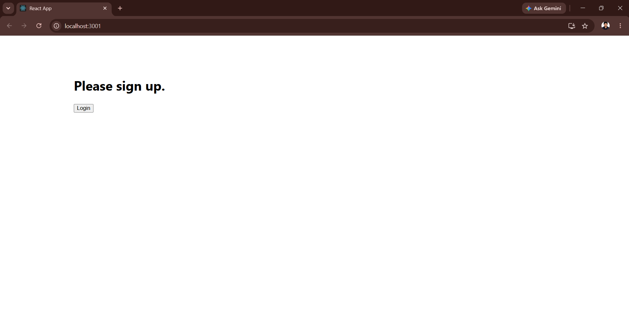

Result
The Ticket Booking App was implemented successfully. The application correctly demonstrated React state management and conditional rendering by switching between the login and welcome screens based on user interaction.

