ReactJS Hands-On Lab
Week : 5
Exercise : 13 – Blogger App using Multiple Components
Name : Sudarmani
Superset ID :6737805

Experiment
Exercise 13 – Blogger Application using Multiple Components

Status
The Blogger application was implemented successfully using React functional components. Separate components were created to display Course Details, Book Details and Blog Details. The project compiled successfully and the browser displayed all three sections in a responsive layout.

Objective
To develop a React application that demonstrates component-based architecture by creating multiple reusable components and rendering them together in a single application.

Steps Performed
A new React project was created and opened in Visual Studio Code. Three components namely CourseDetails, BookDetails and BlogDetails were created inside the components folder. The components were imported into App.js and rendered together. CSS styling was added to display the sections neatly. The application was executed using npm start and the output was verified in the browser.

Screenshots
Figure 1: VS Code showing the Blogger App project structure and successful compilation.
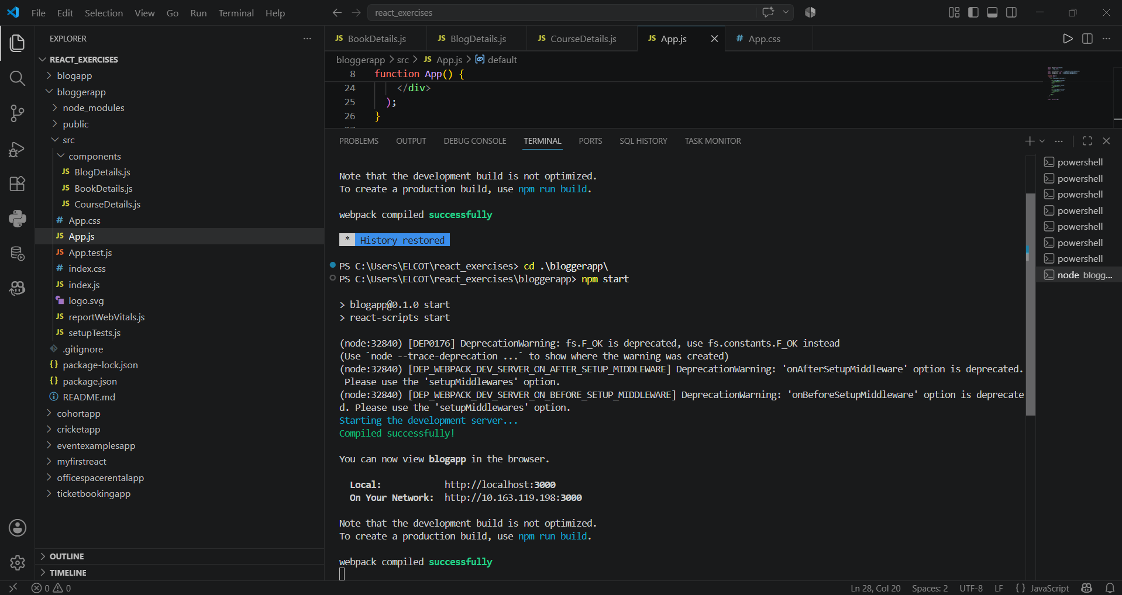
Figure 2: Browser output displaying Course Details, Book Details and Blog Details components. 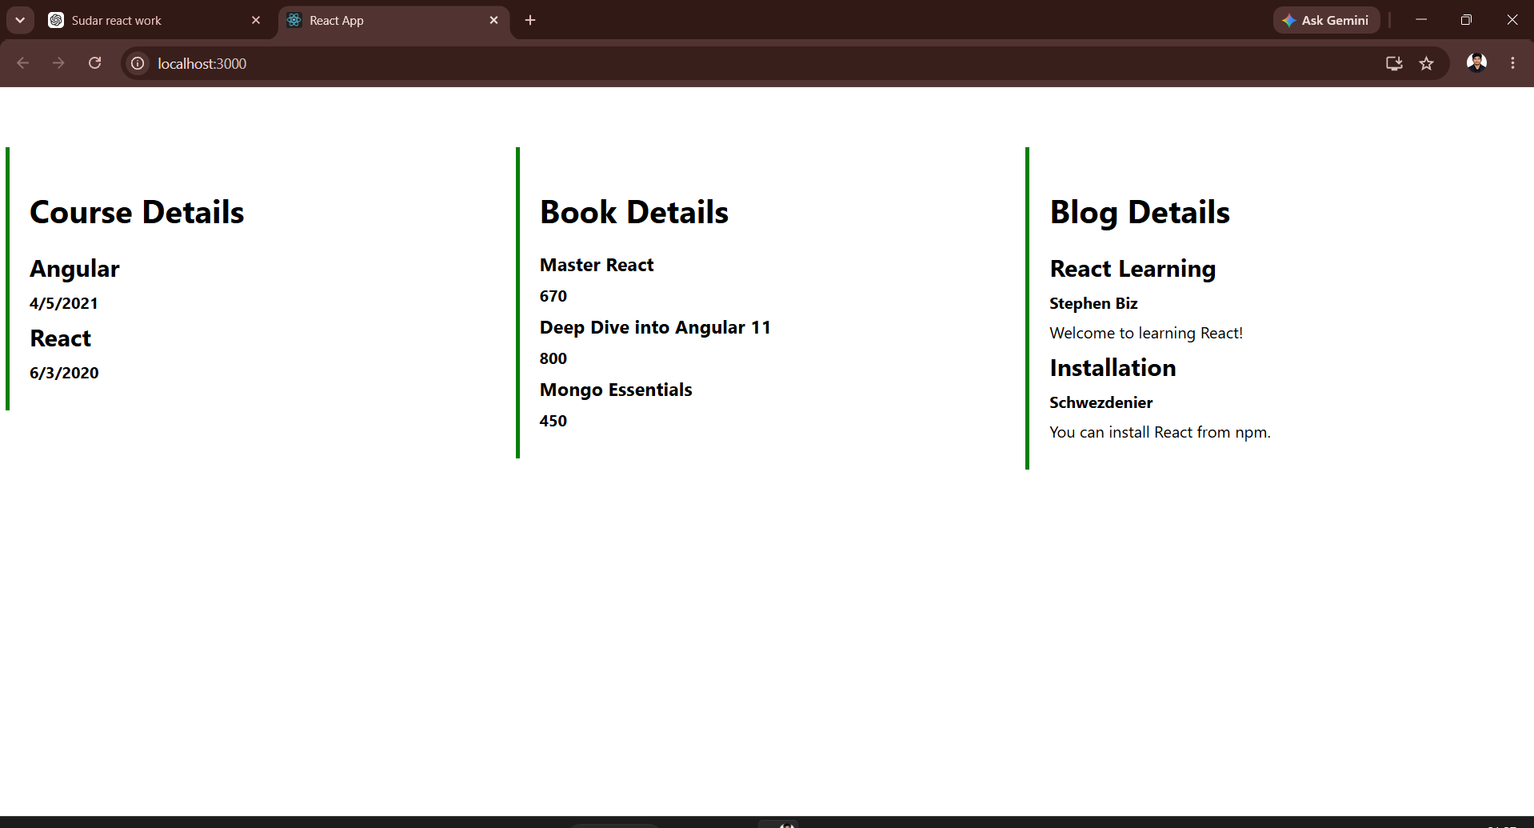

Result
The Blogger application was executed successfully. Multiple React components were created, imported and rendered together, demonstrating component reusability and modular application development.

