WEEK – 5
REACT
Name: SUDARMANI V
Superset ID: 6737805

Experiment
Create a React application for the Student Management Portal by creating Home, About and Contact class components and rendering all three components through App.js.

Status
The experiment was completed successfully. The React application executed without errors and displayed all three components in the browser.

Objective
The objective of this experiment is to create multiple React class components, render them using App.js, and verify that the Home, About and Contact pages are displayed successfully in the browser.

Steps Performed
A new React project named StudentApp was created. A Components folder was added under the src directory, and the Home, About and Contact class components were created. The App.js file was modified to import and render all three components. Finally, the application was executed using npm start and the output was verified successfully.

Screenshot 1 - VS Code Project
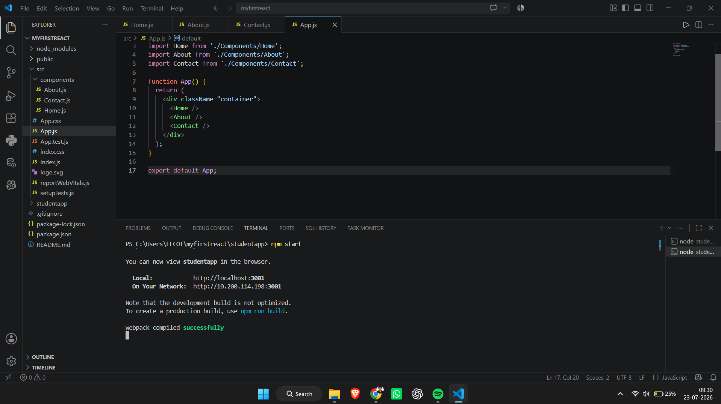
Figure 1: Visual Studio Code showing the StudentApp project, component files, App.js and successful compilation.

Screenshot 2 - Browser Output
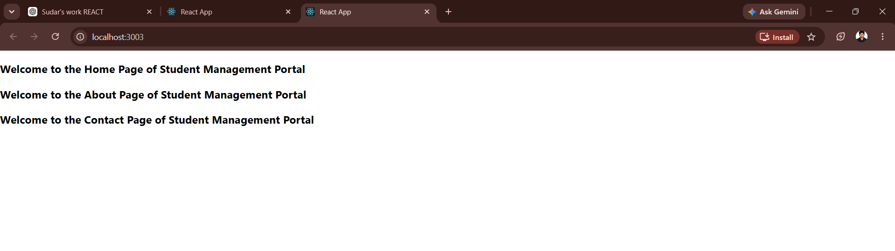
Figure 2: Browser output displaying the Home, About and Contact pages of the Student Management Portal.

Result
The ReactJS-HOL-2 experiment was completed successfully. The Home, About and Contact class components were created, rendered through App.js and displayed correctly in the browser. The objectives of the experiment were achieved.

