WEEK – 5
REACT
Name: SUDARMANI V
Superset ID: 6737805

Experiment
Create a React application named scorecalculatorapp for the Student Management Portal using a functional component called CalculateScore. The component accepts Name, School, Total and Goal as properties, calculates the score percentage and displays the result with CSS styling.

Status
The experiment was completed successfully. The functional component rendered the student details correctly, calculated the percentage score, and applied the required CSS styles.

Objective
The objective of this experiment is to create a React functional component, pass data through props, calculate the student's score percentage, apply external CSS styling, and render the formatted output in the browser.

Steps Performed
A new React project named scorecalculatorapp was created. The Components and Stylesheets folders were added under the src directory. The CalculateScore functional component and mystyle.css stylesheet were created. The App.js file was modified to invoke the CalculateScore component by passing the required properties. Finally, the application was executed using npm start and the output was verified in the browser.

Screenshot 1 - VS Code Project
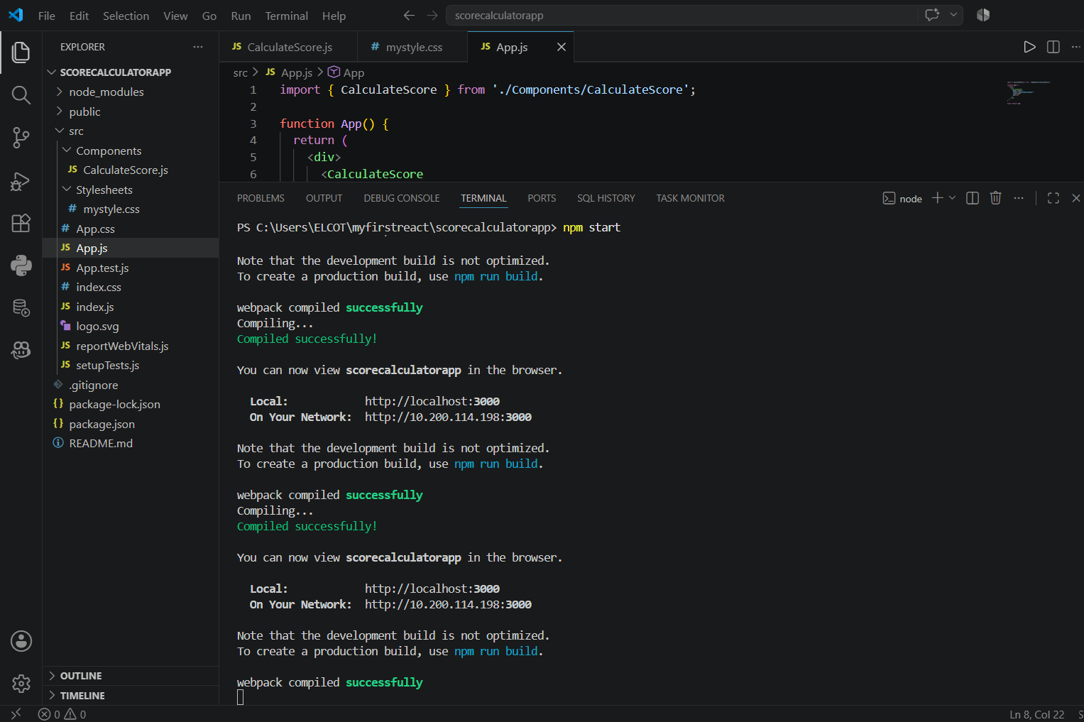
Figure 1: Visual Studio Code showing the project structure, source files and successful compilation.

Screenshot 2 - Browser Output
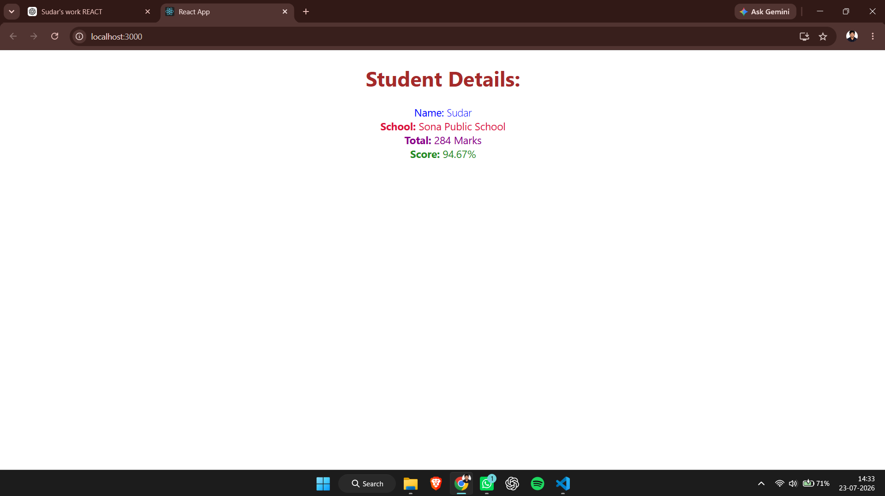
Figure 2: Browser output displaying the student details and calculated score percentage.

Result
The ReactJS-HOL-3 experiment was completed successfully. The CalculateScore functional component accepted the required properties, calculated the percentage correctly, applied the stylesheet, and displayed the formatted student details. The objectives of the experiment were achieved successfully.

