WEEK – 5
REACT
Name: SUDARMANI V
Superset ID: 6737805

Experiment
Exercise 4 – Blog Posts using Fetch API (blogapp)

Status
The experiment was completed successfully. The application fetched blog posts from an API and displayed them correctly.

Objective
To fetch blog posts using the Fetch API and render them dynamically using React components.

Steps Performed
Created the React application, implemented Post.js and Posts.js, rendered the Posts component in App.js, executed npm start, and verified the output.

VS Code Screenshot
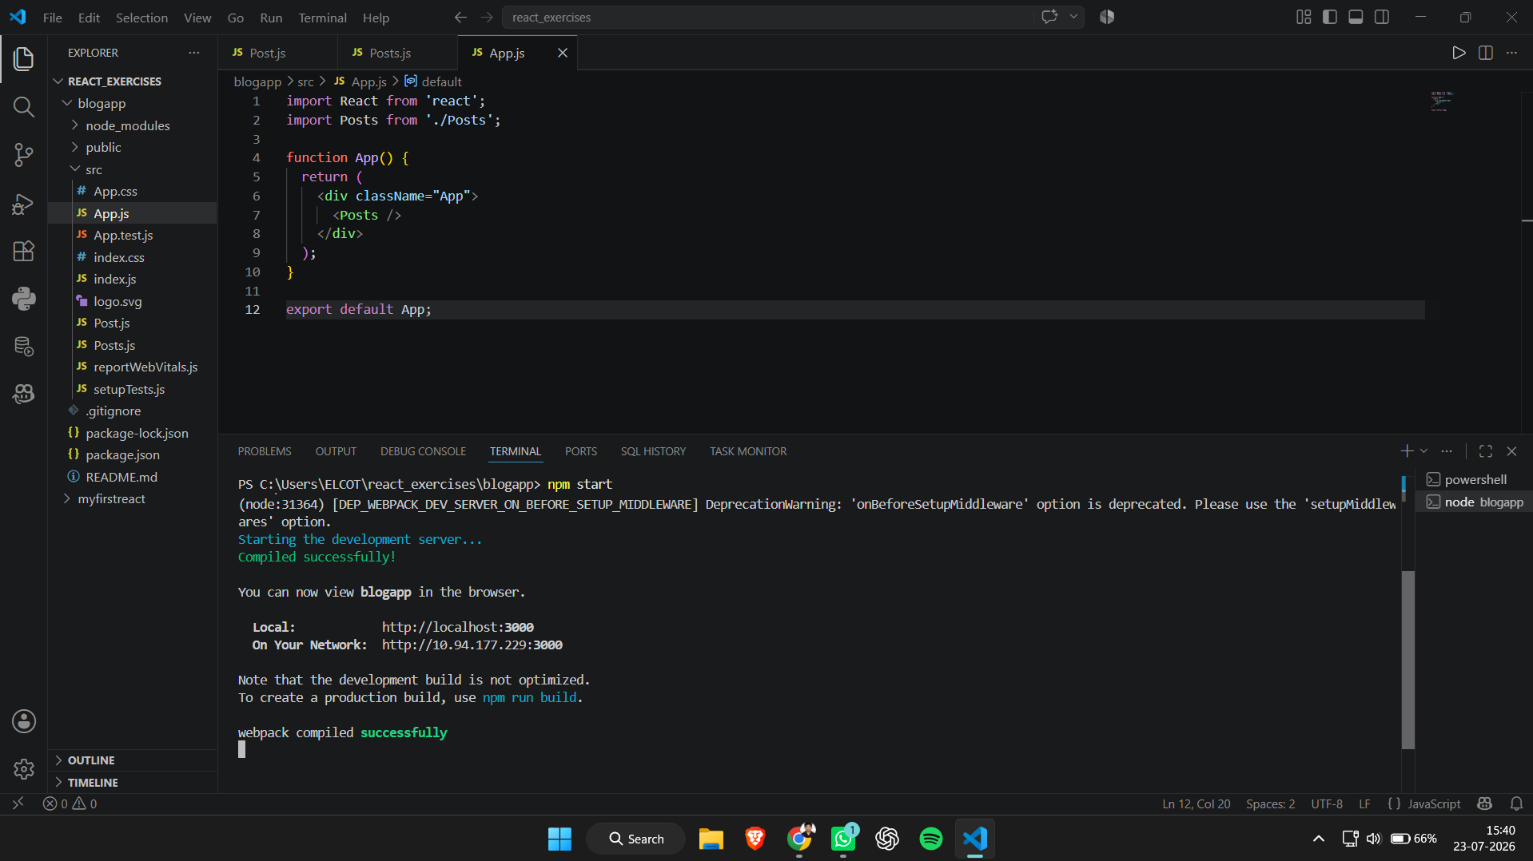
Figure 1: VS Code project structure and successful execution.

Browser Output Screenshot
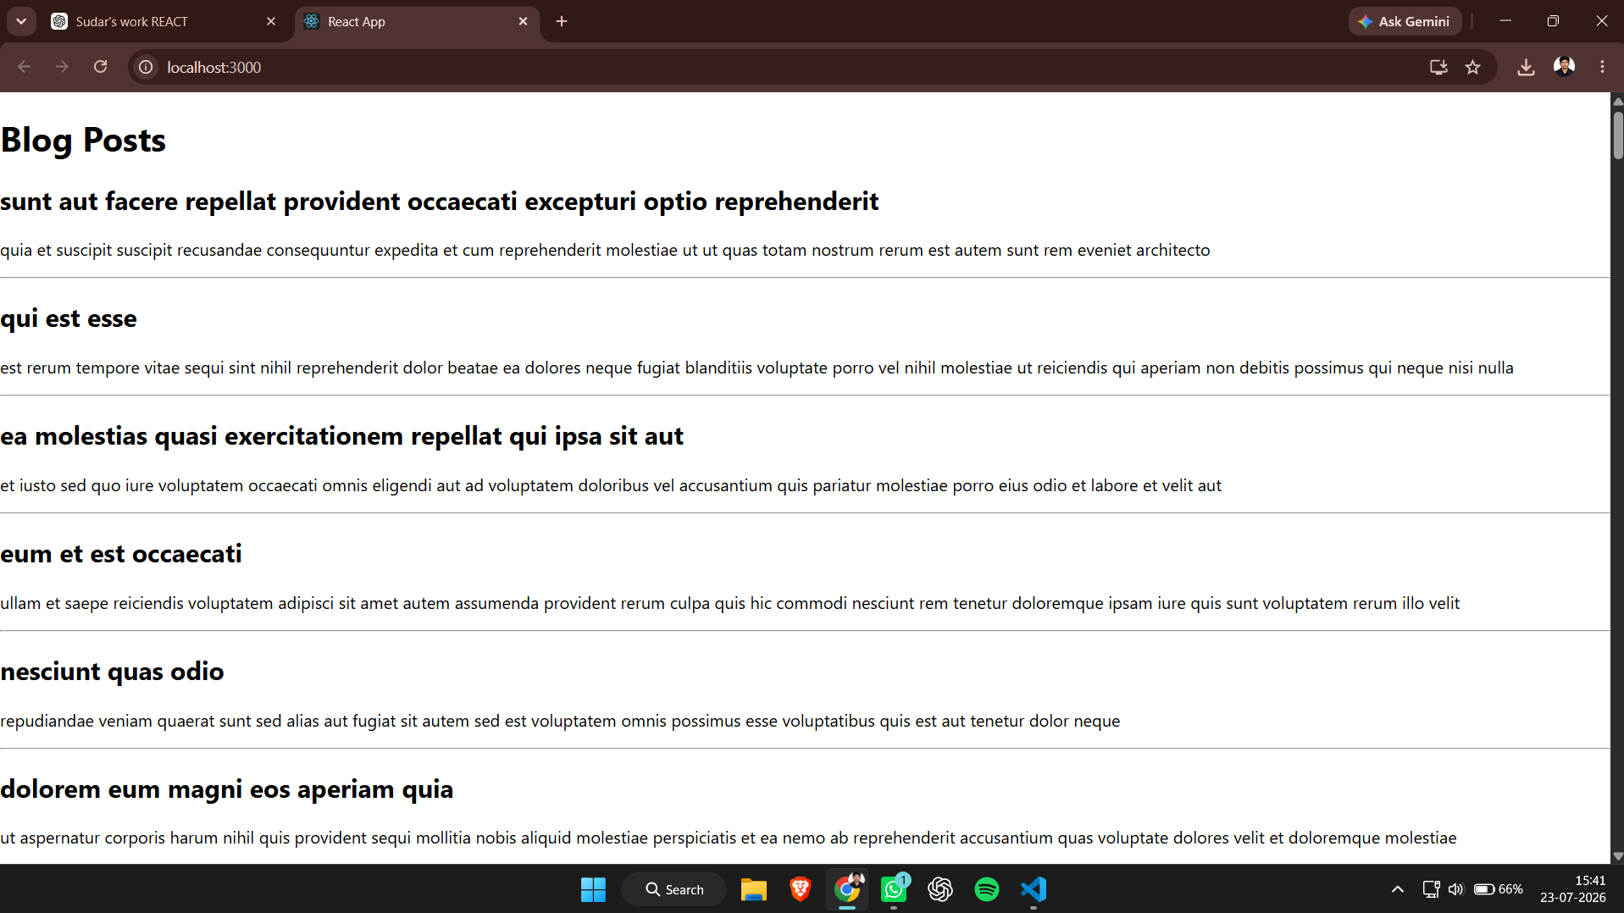
Figure 2: Browser output showing fetched blog posts.

Result
Thus, the React blog application was successfully implemented and executed.

