WEEK – 5
REACT
Name: SUDARMANI V
Superset ID: 6737805

Experiment
Exercise 5 – Styling React Components using CSS Modules (Cohort App)

Status
The experiment was completed successfully. The React application displayed cohort details using reusable components and CSS Modules without any compilation errors.

Objective
To implement component-level styling using CSS Modules in React and display cohort information in a structured layout.

Steps Performed
A React application named cohortapp was created. A coho folder containing CohortDetails.js and CohortDetails.module.css was added. Cohort information was displayed using reusable components with CSS Module styling. The application was executed using npm start and verified in the browser.

VS Code Screenshot
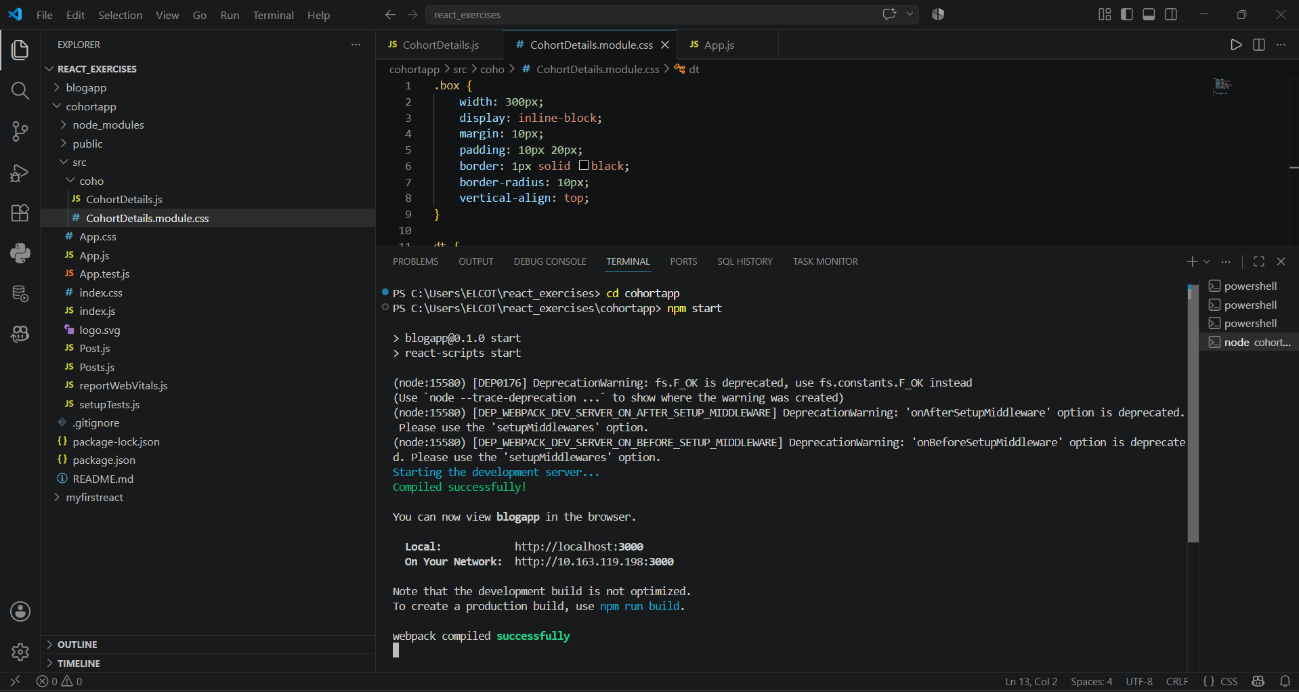
Figure 1: VS Code project structure and successful execution.

Browser Output Screenshot
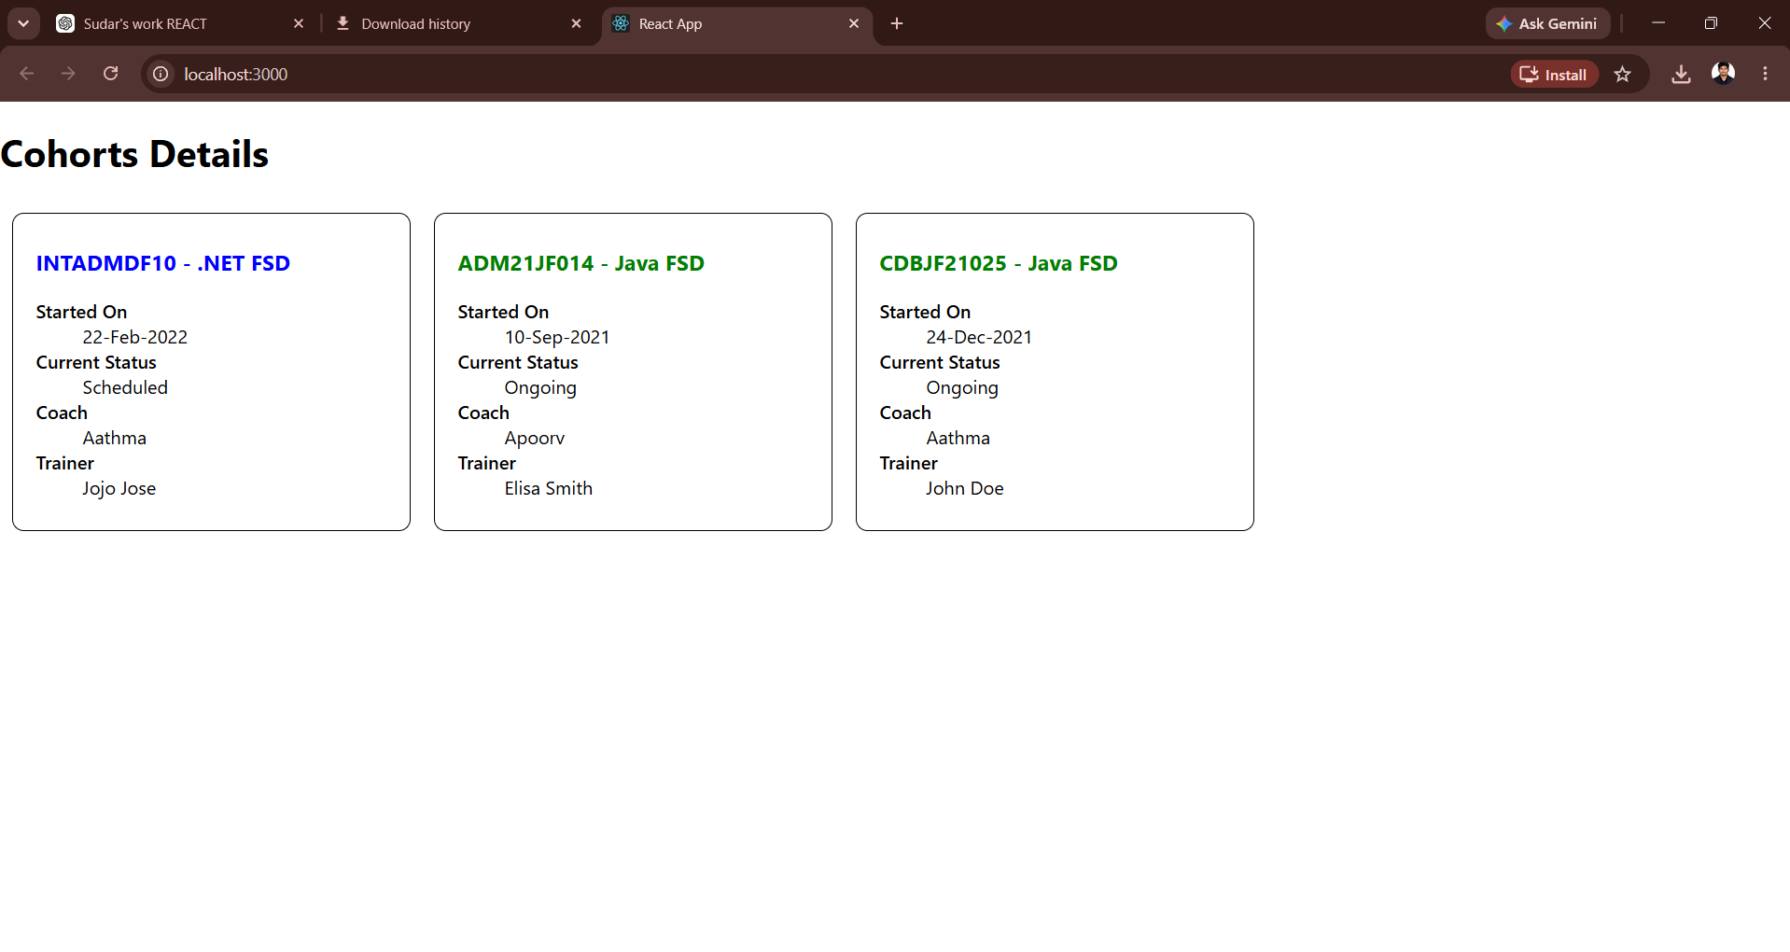
Figure 2: Browser output displaying cohort details.

Result
Thus, the React application using CSS Modules was successfully developed to display cohort details with component-based styling.

