WEEK – 5
REACT
Name: SUDARMANI V
Superset ID: 6737805

Experiment
Exercise 9 – Cricket App (Lists, Keys and ES6 Features)

Status
The experiment was completed successfully. The React application executed without errors and demonstrated list rendering, filtering and conditional rendering.

Objective
To implement React components using lists, keys, ES6 features and conditional rendering for displaying cricket player information.

Steps Performed
A React application named cricketapp was created. IndianPlayers.js and ListofPlayers.js components were implemented. App.js rendered player lists using conditional rendering. The project was executed with npm start and the output was verified.

VS Code Screenshot
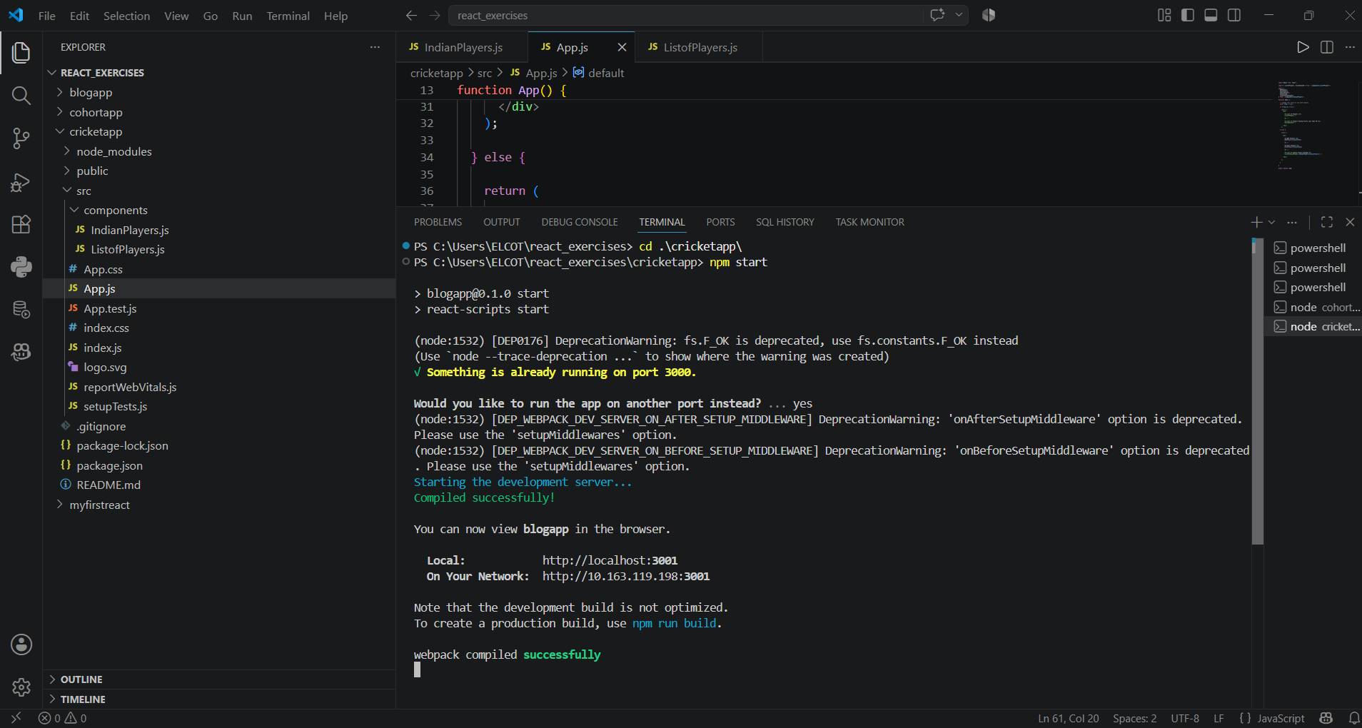
Figure 1: VS Code project structure and successful execution.

Browser Output Screenshot
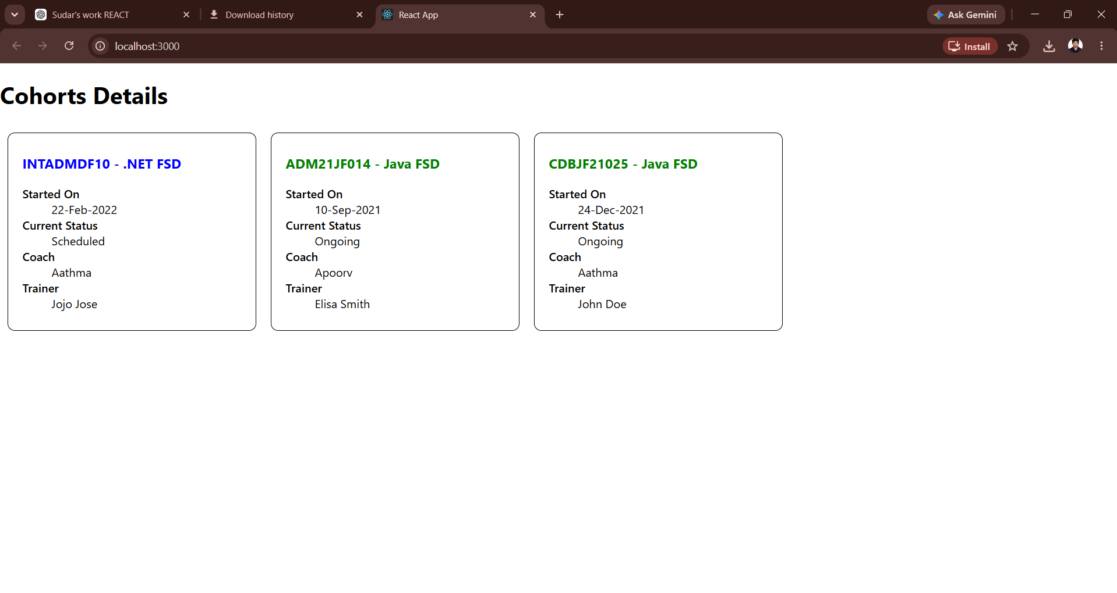
Figure 2: Browser output displaying cricket player details.

Result
Thus, the React Cricket application was successfully developed using lists, keys, ES6 features and conditional rendering.

