WEEK 1
MODULE 3 – PL SQL PROGRAMMING

NAME : SUDARMANI V
SUPERSET ID : 6737805

Exercise 1: Control Structures

Solution :
For Scenario 1: The bank wants to apply a discount to loan interest rates for customers above 60 years old.
QUERY:
BEGIN
FOR cus IN (
SELECT CUSTOMERID, DOB
FROM CUSTOMERS
) LOOP

IF MONTHS_BETWEEN(SYSDATE, cus.DOB)/12 > 60 THEN

UPDATE LOANS
SET INTERESTRATE = INTERESTRATE - 1
WHERE CUSTOMERID = cus.CUSTOMERID;

DBMS_OUTPUT.PUT_LINE(
'Discount applied for Customer ID: ' || cus.CUSTOMERID
);
END IF;

END LOOP;

COMMIT;
END;
/
OUTPUT:
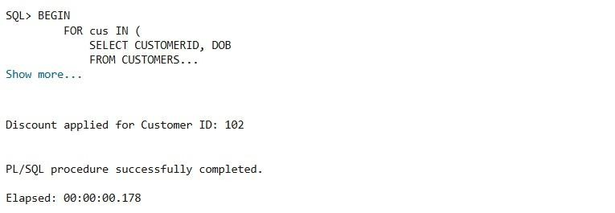
Scenario 2: A customer can be promoted to VIP status based on their balance.
QUERY:
BEGIN
FOR cus IN (
SELECT CUSTOMERID, BALANCE
FROM CUSTOMERS
) LOOP

IF cus.BALANCE > 10000 THEN

UPDATE CUSTOMERS
SET ISVIP = 'TRUE'
WHERE CUSTOMERID = cus.CUSTOMERID;

DBMS_OUTPUT.PUT_LINE(
'VIP Status Granted to Customer ID: ' ||
cus.CUSTOMERID
);

END IF;

END LOOP;

COMMIT;
END;
/
OUTPUT:
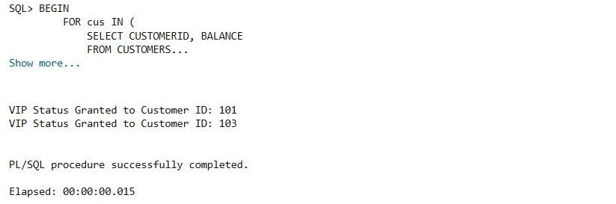
Scenario 3: The bank wants to send reminders to customers whose loans are due within the next 30 days.
QUERY:
BEGIN
FOR loan_rec IN (
SELECT LOANID,
CUSTOMERID,
DUEDATE
FROM LOANS
WHERE DUEDATE BETWEEN SYSDATE
AND SYSDATE + 30
) LOOP

DBMS_OUTPUT.PUT_LINE(
'Reminder: Loan ID ' ||
loan_rec.LOANID ||
' for Customer ID ' || loan_rec.CUSTOMERID || ' is due on ' ||
TO_CHAR(loan_rec.DUEDATE,'DD-MON-YYYY')
);

END LOOP;
END;
/
OUTPUT:
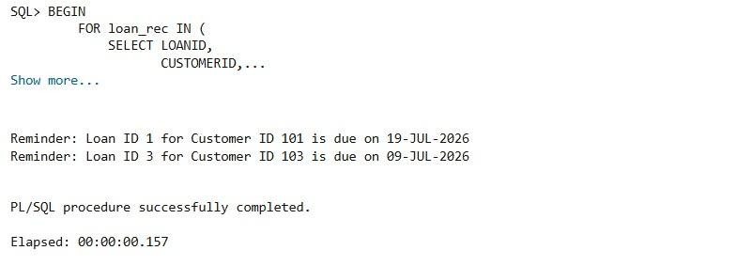

Exercise 3: Stored Procedures

Scenario 1: The bank needs to process monthly interest for all savings accounts.
QUERY:
CREATE OR REPLACE PROCEDURE ProcessMonthlyInterest
AS
BEGIN
UPDATE ACCOUNTS
SET BALANCE = BALANCE + (BALANCE * 0.01)
WHERE ACCOUNTTYPE = 'SAVINGS';

COMMIT;

DBMS_OUTPUT.PUT_LINE('Monthly interest processed successfully.');
END;
/
OUTPUT:
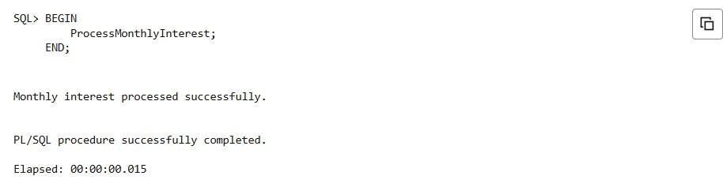
Scenario 2: The bank wants to implement a bonus scheme for employees based on their performance.
QUERY:
CREATE OR REPLACE PROCEDURE UpdateEmployeeBonus( p_department IN VARCHAR2, p_bonus_percent IN NUMBER
)
AS
BEGIN
UPDATE EMPLOYEES
SET SALARY = SALARY +
(SALARY * p_bonus_percent / 100)
WHERE DEPARTMENT = p_department;

COMMIT;

DBMS_OUTPUT.PUT_LINE(
'Bonus updated for department: ' || p_department
);
END;
/
OUTPUT:
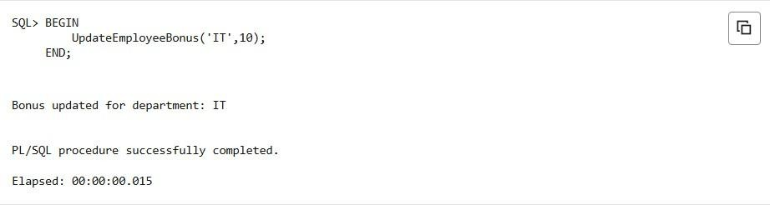
Scenario 3: Customers should be able to transfer funds between their accounts.
QUERY:
CREATE OR REPLACE PROCEDURE TransferFunds( p_from_account IN NUMBER, p_to_account IN
NUMBER, p_amount IN NUMBER
)
AS
v_balance NUMBER;
BEGIN

SELECT BALANCE
INTO v_balance
FROM ACCOUNTS
WHERE ACCOUNTID = p_from_account;

IF v_balance >= p_amount THEN

UPDATE ACCOUNTS
SET BALANCE = BALANCE - p_amount
WHERE ACCOUNTID = p_from_account;

UPDATE ACCOUNTS
SET BALANCE = BALANCE + p_amount
WHERE ACCOUNTID = p_to_account;

COMMIT;

DBMS_OUTPUT.PUT_LINE(
'Transfer Successful'
);

ELSE

DBMS_OUTPUT.PUT_LINE(
'Insufficient Balance'
);
END IF;

EXCEPTION
WHEN NO_DATA_FOUND THEN
DBMS_OUTPUT.PUT_LINE(
'Account Not Found'
);
END;
/
OUTPUT:
