WEEK 4
Microservices with Spring Boot 3 and Spring Cloud
Name : Sudarmani V
Superset Id: 6737805
2. Microservices with API gateway:
Creating Microservices for account and loan
Account-Service-Eureka:
AccountController.java:
package com.sudar.account_service_eureka.controller;

import java.util.HashMap;
import java.util.Map;

import org.springframework.web.bind.annotation.GetMapping;
import org.springframework.web.bind.annotation.PathVariable;
import org.springframework.web.bind.annotation.RestController;

@RestController
public class AccountController {

@GetMapping("/accounts/{number}")
public Map<String, Object> getAccount(@PathVariable String number) {

Map<String, Object> account = new HashMap<>();

account.put("number", number);
account.put("type", "Savings");
account.put("balance", 234343);

return account;
}
}
ApplicationProperties:
spring.application.name=ACCOUNT-SERVICE
server.port=8080
eureka.client.service-url.defaultZone=http://localhost:8761/eureka/
Loan-Service-Eureka:
package com.sudar.loanservice.controller;

import java.util.HashMap;
import java.util.Map;

import org.springframework.web.bind.annotation.GetMapping;
import org.springframework.web.bind.annotation.PathVariable;
import org.springframework.web.bind.annotation.RestController;

@RestController
public class LoanController {

@GetMapping("/loans/{number}")
public Map<String, Object> getLoan(@PathVariable String number) {

Map<String, Object> loan = new HashMap<>();

loan.put("number", number);
loan.put("type", "car");
loan.put("loan", 400000);
loan.put("emi", 3258);
loan.put("tenure", 18);

return loan;
}
}

ApplicationProperties:
spring.application.name=loanservice
server.port=8081
Eureka-discovery-server:
EurekaDiscoveryServerApplication.java:
package com.sudar.eurekaserver;

import org.springframework.boot.SpringApplication;
import org.springframework.boot.autoconfigure.SpringBootApplication;
import org.springframework.cloud.netflix.eureka.server.EnableEurekaServer;

@SpringBootApplication
@EnableEurekaServer
public class EurekaDiscoveryServerApplication {

public static void main(String[] args) {
SpringApplication.run(EurekaDiscoveryServerApplication.class, args);
}

}
ApplicationProperty:
spring.application.name=eureka-discovery-server
server.port=8761

eureka.client.register-with-eureka=false
eureka.client.fetch-registry=false

logging.level.com.netflix.eureka=OFF
logging.level.com.netflix.discovery=OFF
Greet-Service:
Greet_Service.java:
package com.sudar.greet_service.controller;

import org.springframework.web.bind.annotation.GetMapping;
import org.springframework.web.bind.annotation.RestController;

@RestController
public class Greet_service{

@GetMapping("/greet")
public String sayHello() {
return "Hello World!!";
}

}
ApplicatioProperties:
spring.application.name=GREET-SERVICE

server.port=8082

eureka.client.service-url.defaultZone=http://localhost:8761/eureka/
OUTPUT :
Account_Service:
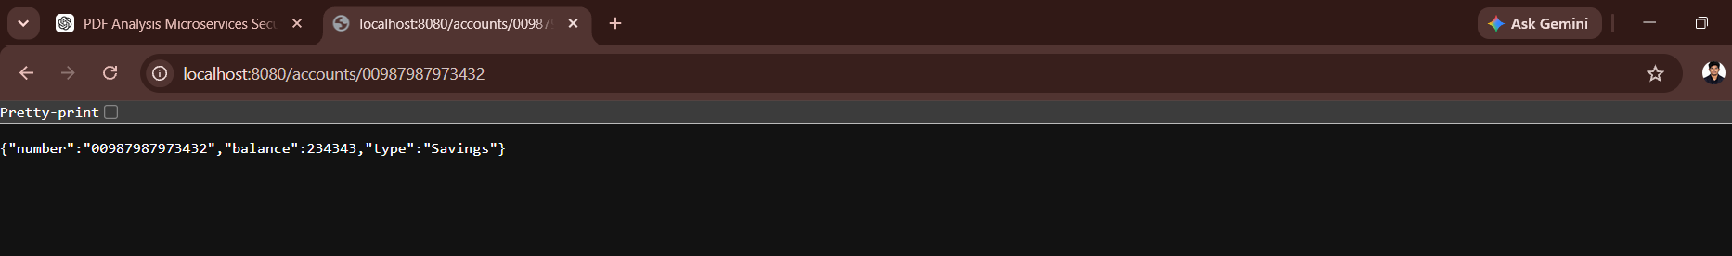
Loan_Service:
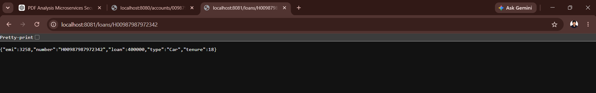
Greek_Service:
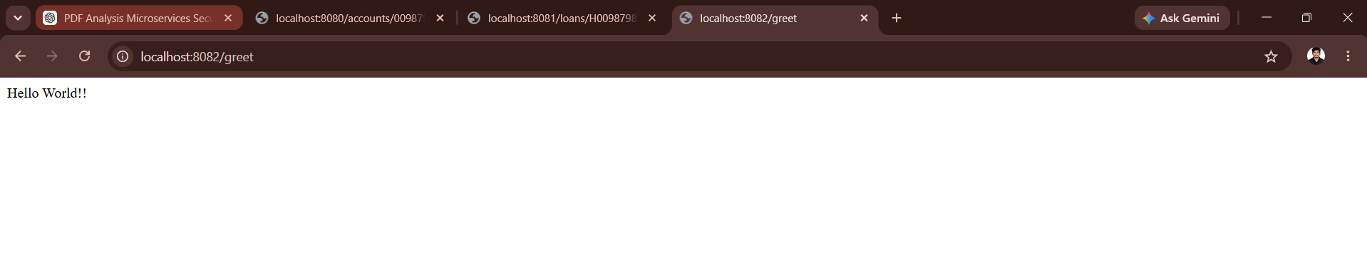
Spring_Server:
