WEEK 3
SPRING REST USING SPRING BOOT
Name: Sudarmani V
Superset Id: 6737805
Spring Rest Handson
Exercise 1: Create a Spring Web Project using Maven
Code:
SpringLearnApplication.java
package com.cognizant.spring_learn;
import org.slf4j.Logger;
import org.slf4j.LoggerFactory;
import org.springframework.boot.SpringApplication;
import org.springframework.boot.autoconfigure.SpringBootApplication;
@SpringBootApplication
public class SpringLearnApplication {
private static final Logger LOGGER =
LoggerFactory.getLogger(SpringLearnApplication.class);
public static void main(String[] args) {
LOGGER.info("Spring Boot Application Started");
SpringApplication.run(SpringLearnApplication.class, args);
LOGGER.info("Application Running Successfully");
}
}
application.properties
spring.application.name=spring-learn
# Server Configuration
server.port=8080
# Logging Configuration
logging.level.root=INFO
logging.level.com.cognizant.spring_learn=DEBUG
# Console Log Pattern
logging.pattern.console=%d{yyyy-MM-dd HH:mm:ss} %-5level %logger{36} - %msg%n
OUTPUT :
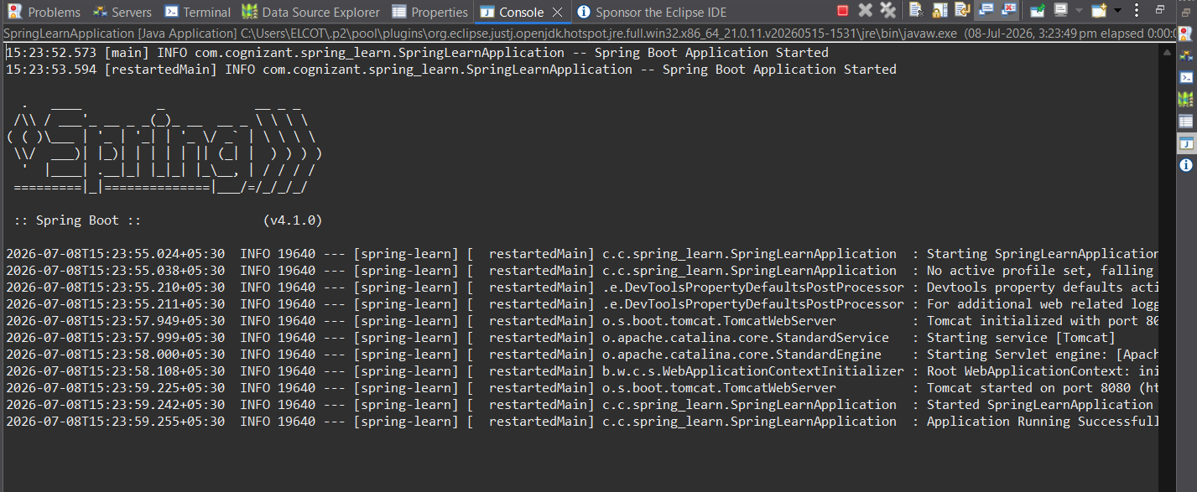
Exercise 2: Spring Core – Load SimpleDateFormat from Spring Configuration XML
Code :
date-format.xml :
<?xml version="1.0" encoding="UTF-8"?>
<beans xmlns="http://www.springframework.org/schema/beans"
xmlns:xsi="http://www.w3.org/2001/XMLSchema-instance"
xsi:schemaLocation="http://www.springframework.org/schema/beans
https://www.springframework.org/schema/beans/spring-beans.xsd">
<bean id="dateFormat" class="java.text.SimpleDateFormat">
<constructor-arg value="dd/MM/yyyy"/>
</bean>
</beans>
SpringLearnApplication.java :
package com.cognizant.spring_learn;
import java.text.SimpleDateFormat;
import java.util.Date;
import org.slf4j.Logger;
import org.slf4j.LoggerFactory;
import org.springframework.boot.SpringApplication;
import org.springframework.boot.autoconfigure.SpringBootApplication;
import org.springframework.context.ApplicationContext;
import org.springframework.context.support.ClassPathXmlApplicationContext;
@SpringBootApplication
public class SpringLearnApplication {
private static final Logger LOGGER =
LoggerFactory.getLogger(SpringLearnApplication.class);
public static void main(String[] args) {
LOGGER.info("Spring Boot Application Started");
SpringApplication.run(SpringLearnApplication.class, args);
displayDate();
LOGGER.info("Application Running Successfully");
}
public static void displayDate() {
ApplicationContext context =
new ClassPathXmlApplicationContext("date-format.xml");
SimpleDateFormat format =
context.getBean("dateFormat", SimpleDateFormat.class);
try {
Date date = format.parse("31/12/2018");
System.out.println("Parsed Date : " + date);
} catch (Exception e) {
e.printStackTrace();
}
}}
Output :
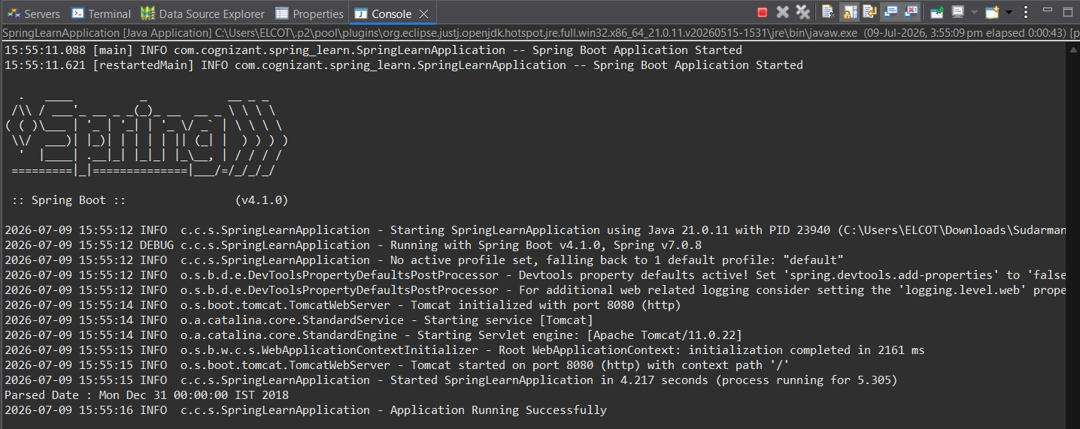
Exercise 3: Spring Core – Incorporate Logging
Code :
1. application.properties :
spring.application.name=spring-learn
server.port=8080
logging.level.org.springframework=info
logging.level.com.cognizant.springlearn=debug
logging.pattern.console=%d{yyMMdd}|%d{HH:mm:ss.SSS}|%-20.20thread|%5p|%-25.25logger{25}|%25M|%m%n
2. SpringLearnApplication.java :
package com.cognizant.spring_learn;
import java.text.SimpleDateFormat;
import java.util.Date;
import org.slf4j.Logger;
import org.slf4j.LoggerFactory;
import org.springframework.boot.SpringApplication;
import org.springframework.boot.autoconfigure.SpringBootApplication;
import org.springframework.context.ApplicationContext;
import org.springframework.context.support.ClassPathXmlApplicationContext;
@SpringBootApplication
public class SpringLearnApplication {
private static final Logger LOGGER =
LoggerFactory.getLogger(SpringLearnApplication.class);
public static void main(String[] args) {
LOGGER.info("Spring Boot Application Started");
SpringApplication.run(SpringLearnApplication.class, args);
displayDate();
LOGGER.info("Application Running Successfully");
}
public static void displayDate() {
LOGGER.info("START");
ApplicationContext context =
new ClassPathXmlApplicationContext("date-format.xml");
SimpleDateFormat format =
context.getBean("dateFormat", SimpleDateFormat.class);
try {
Date date = format.parse("31/12/2018");
LOGGER.debug("Date : {}", date);
} catch (Exception e) {
LOGGER.error("Error while parsing date", e);
}
LOGGER.info("END");
}
}

Output:
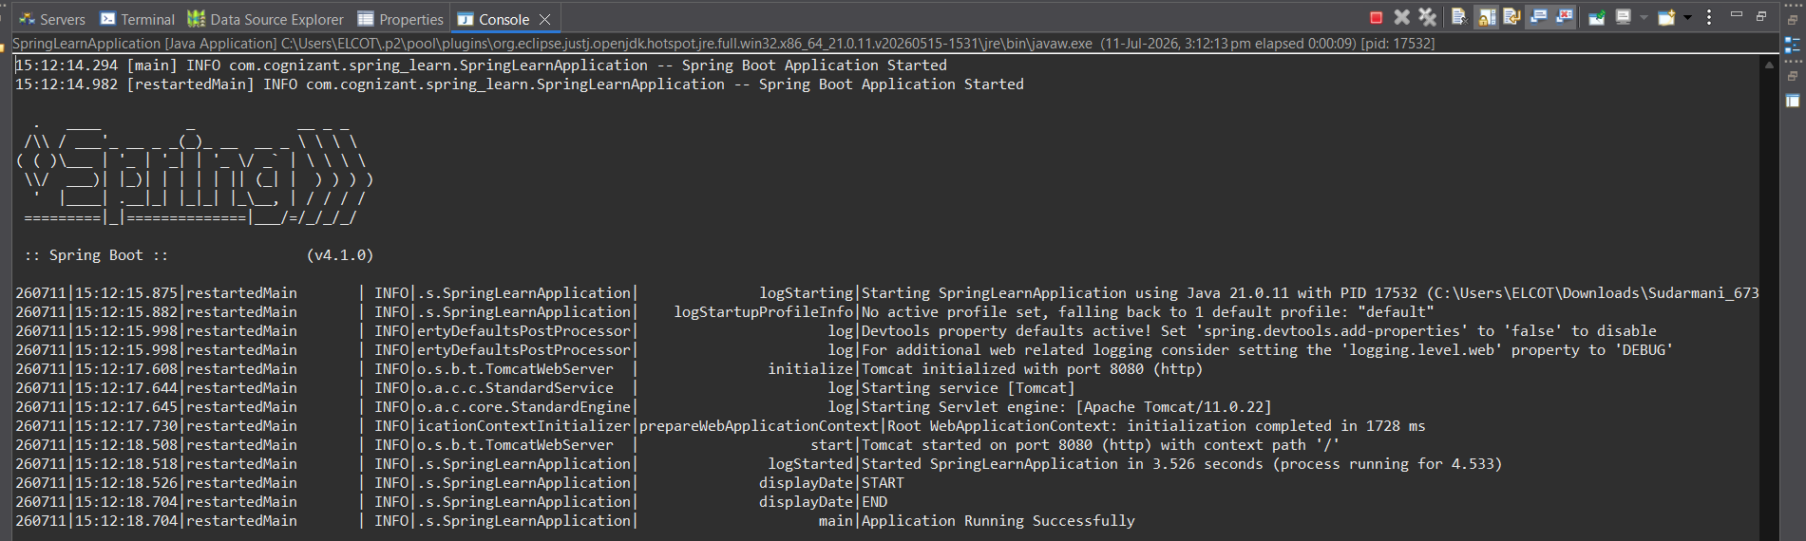
Exercise 4:
Spring Core – Load Country Bean from Spring Configuration XML
Code :
Country.java :
package com.cognizant.spring_learn;

import org.slf4j.Logger;
import org.slf4j.LoggerFactory;

public class Country {

private static final Logger LOGGER =
LoggerFactory.getLogger(Country.class);

private String code;
private String name;

public Country() {
LOGGER.debug("Inside Country Constructor.");
}

public String getCode() {
LOGGER.debug("Inside getCode.");
return code;
}

public void setCode(String code) {
LOGGER.debug("Inside setCode.");
this.code = code;
}

public String getName() {
LOGGER.debug("Inside getName.");
return name;
}

public void setName(String name) {
LOGGER.debug("Inside setName.");
this.name = name;
}

@Override
public String toString() {
return "Country [code=" + code + ", name=" + name + "]";
}
}
Country.xml :
<?xml version="1.0" encoding="UTF-8"?>

<beans xmlns="http://www.springframework.org/schema/beans"
xmlns:xsi="http://www.w3.org/2001/XMLSchema-instance"
xsi:schemaLocation="
http://www.springframework.org/schema/beans
https://www.springframework.org/schema/beans/spring-beans.xsd">

<bean id="country" class="com.cognizant.spring_learn.Country">

<property name="code" value="IN"/>

<property name="name" value="India"/>

</bean>

</beans>
SpringLearnApplication.java :
package com.cognizant.spring_learn;

import org.slf4j.Logger;
import org.slf4j.LoggerFactory;
import org.springframework.boot.SpringApplication;
import org.springframework.boot.autoconfigure.SpringBootApplication;
import org.springframework.context.support.ClassPathXmlApplicationContext;

@SpringBootApplication
public class SpringLearnApplication {

private static final Logger LOGGER =
LoggerFactory.getLogger(SpringLearnApplication.class);

public static void main(String[] args) {

SpringApplication.run(SpringLearnApplication.class, args);

displayCountry();
}

public static void displayCountry() {

LOGGER.info("START");

try (ClassPathXmlApplicationContext context =
new ClassPathXmlApplicationContext("country.xml")) {

Country country = context.getBean("country", Country.class);

LOGGER.info("Country : {}", country);

System.out.println("Country : " + country);

}

LOGGER.info("END");
}
}
Output :
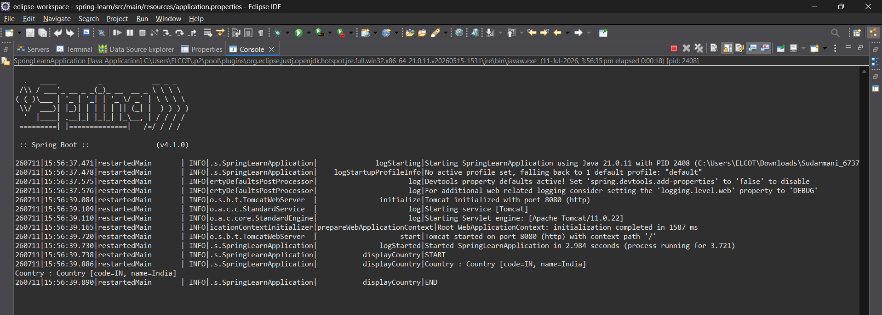
Result :
The Country bean was successfully loaded from country.xml using the Spring IoC container.
The application displayed:
Country : Country [code=IN, name=India]

Exercise 5: Demonstrate Bean Scopes (Singleton and Prototype)
Code:
Country.java:
package com.cognizant.spring_learn;

import org.slf4j.Logger;
import org.slf4j.LoggerFactory;

public class Country {

private static final Logger LOGGER =
LoggerFactory.getLogger(Country.class);

private String code;
private String name;

public Country() {
LOGGER.info("Inside Country Constructor.");
}

public String getCode() {
LOGGER.debug("Inside getCode.");
return code;
}

public void setCode(String code) {
LOGGER.debug("Inside setCode.");
this.code = code;
}

public String getName() {
LOGGER.debug("Inside getName.");
return name;
}

public void setName(String name) {
LOGGER.debug("Inside setName.");
this.name = name;
}

@Override
public String toString() {
return "Country [code=" + code + ", name=" + name + "]";
}
}
Country.xml ( without scope attribute):
<?xml version="1.0" encoding="UTF-8"?>
<beans xmlns="http://www.springframework.org/schema/beans"
xmlns:xsi="http://www.w3.org/2001/XMLSchema-instance"
xsi:schemaLocation="
http://www.springframework.org/schema/beans
https://www.springframework.org/schema/beans/spring-beans.xsd">
<bean id="country" class="com.cognizant.spring_learn.Country">
<property name="code" value="IN"/>
<property name="name" value="India"/>
</bean>
</beans>
SpringLearnApplication.java:
package com.cognizant.spring_learn;
import org.slf4j.Logger;
import org.slf4j.LoggerFactory;
import org.springframework.boot.SpringApplication;
import org.springframework.boot.autoconfigure.SpringBootApplication;
import org.springframework.context.support.ClassPathXmlApplicationContext;
@SpringBootApplication
public class SpringLearnApplication {
private static final Logger LOGGER =
LoggerFactory.getLogger(SpringLearnApplication.class);
public static void main(String[] args) {
SpringApplication.run(SpringLearnApplication.class, args);
displayCountry();
}
public static void displayCountry() {
LOGGER.info("START");
try (ClassPathXmlApplicationContext context =
new ClassPathXmlApplicationContext("country.xml")) {
Country country = context.getBean("country", Country.class);
Country anotherCountry = context.getBean("country", Country.class);
System.out.println("Country 1 : " + country);
System.out.println("Country 2 : " + anotherCountry);
System.out.println("Same Object ? " + (country == anotherCountry));
}

LOGGER.info("END");
}
}
Output:
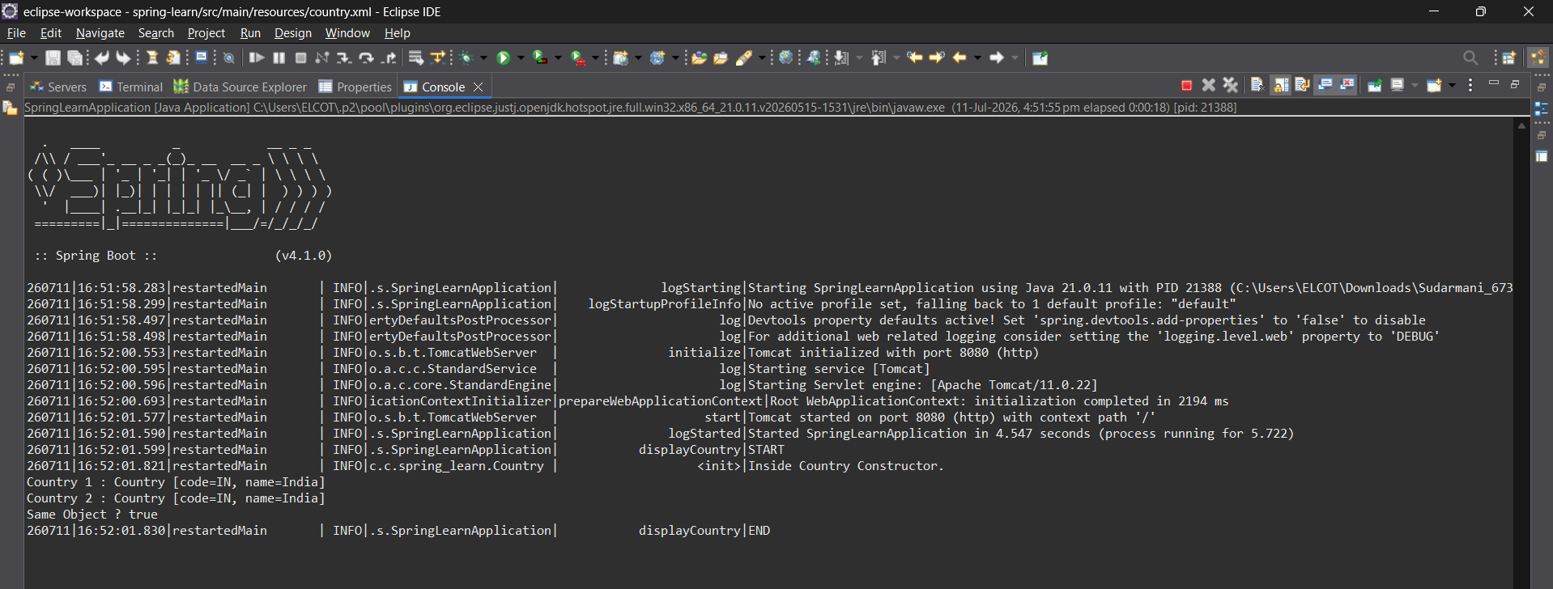
Observation:
Inside Country Constructor.
Country 1 : Country [code=IN, name=India]
Country 2 : Country [code=IN, name=India]
Same Object ? true
Conclusion:
Singleton is the default scope in Spring. Only one bean object is created and shared across all getBean() calls.
Prototype Scope:
Modification:
<bean id="country"
class="com.cognizant.spring_learn.Country"
scope="prototype">
Output:
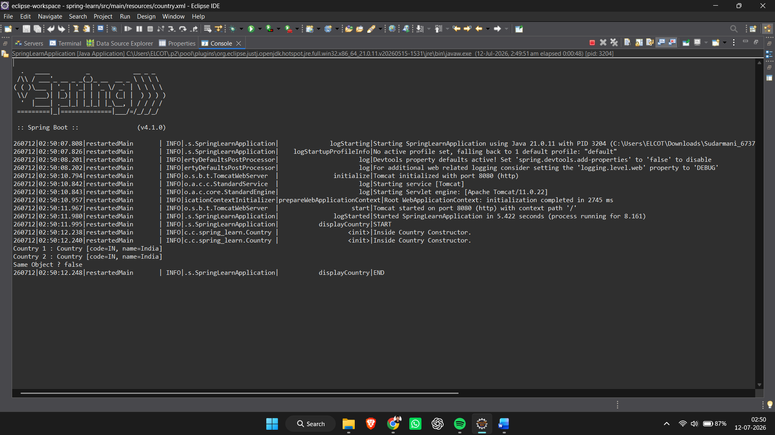
Observation:
Inside Country Constructor.
Inside Country Constructor.
Country 1 : Country [code=IN, name=India]
Country 2 : Country [code=IN, name=India]
Same Object ? false
Conclusion:
Prototype scope creates a new bean object every time getBean() is called.

Exercise 6: Spring Core – Load List of Countries from Spring Configuration XML
Country.java:
package com.cognizant.spring_learn;

import org.slf4j.Logger;
import org.slf4j.LoggerFactory;

public class Country {

private static final Logger LOGGER =
LoggerFactory.getLogger(Country.class);

private String code;
private String name;

public Country() {
LOGGER.info("Inside Country Constructor.");
}

public String getCode() {
LOGGER.debug("Inside getCode.");
return code;
}

public void setCode(String code) {
LOGGER.debug("Inside setCode.");
this.code = code;
}

public String getName() {
LOGGER.debug("Inside getName.");
return name;
}

public void setName(String name) {
LOGGER.debug("Inside setName.");
this.name = name;
}

@Override
public String toString() {
return "Country [code=" + code + ", name=" + name + "]";
}
}
Country.xml:
<?xml version="1.0" encoding="UTF-8"?>

<beans xmlns="http://www.springframework.org/schema/beans"
xmlns:xsi="http://www.w3.org/2001/XMLSchema-instance"
xsi:schemaLocation="
http://www.springframework.org/schema/beans
https://www.springframework.org/schema/beans/spring-beans.xsd">

<bean id="in" class="com.cognizant.spring_learn.Country">
<property name="code" value="IN"/>
<property name="name" value="India"/>
</bean>

<bean id="us" class="com.cognizant.spring_learn.Country">
<property name="code" value="US"/>
<property name="name" value="United States"/>
</bean>

<bean id="de" class="com.cognizant.spring_learn.Country">
<property name="code" value="DE"/>
<property name="name" value="Germany"/>
</bean>

<bean id="jp" class="com.cognizant.spring_learn.Country">
<property name="code" value="JP"/>
<property name="name" value="Japan"/>
</bean>

<bean id="countryList" class="java.util.ArrayList">
<constructor-arg>
<list>
<ref bean="in"/>
<ref bean="us"/>
<ref bean="de"/>
<ref bean="jp"/>
</list>
</constructor-arg>
</bean>

</beans>
SpringLearnApplication.java :
package com.cognizant.spring_learn;

import java.util.ArrayList;

import org.slf4j.Logger;
import org.slf4j.LoggerFactory;
import org.springframework.boot.SpringApplication;
import org.springframework.boot.autoconfigure.SpringBootApplication;
import org.springframework.context.support.ClassPathXmlApplicationContext;

@SpringBootApplication
public class SpringLearnApplication {

private static final Logger LOGGER =
LoggerFactory.getLogger(SpringLearnApplication.class);

public static void main(String[] args) {

SpringApplication.run(SpringLearnApplication.class, args);

displayCountries();
}

@SuppressWarnings("unchecked")
public static void displayCountries() {

LOGGER.info("START");

try (ClassPathXmlApplicationContext context =
new ClassPathXmlApplicationContext("country.xml")) {

ArrayList<Country> countryList =
(ArrayList<Country>) context.getBean("countryList");

for (Country country : countryList) {
LOGGER.debug("Country : {}", country);
System.out.println(country);
}
}

LOGGER.info("END");
}
}
Output:
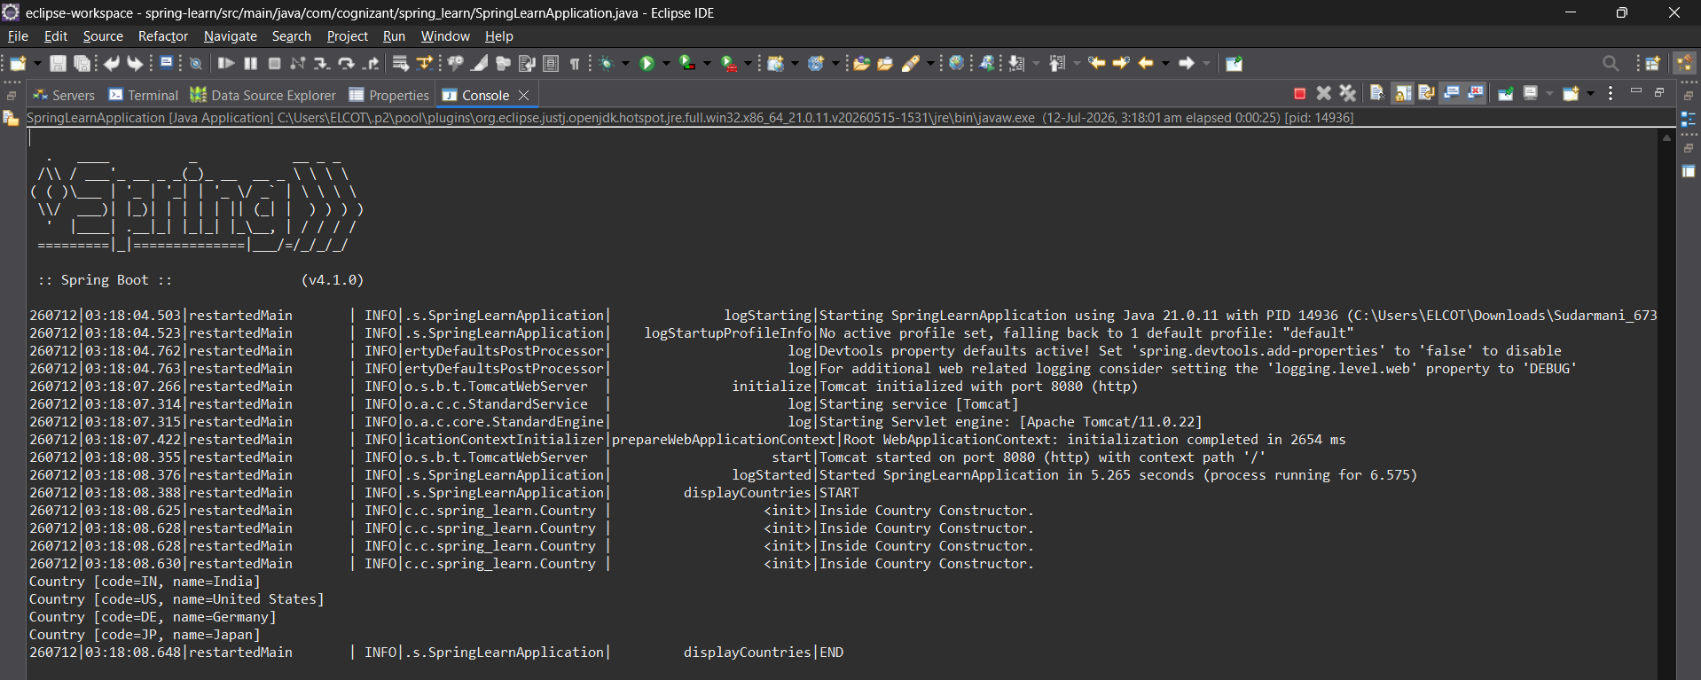

Observation:
Country [code=IN, name=India]

Country [code=US, name=United States]

Country [code=DE, name=Germany]

Country [code=JP, name=Japan]

Conclusion:
The list of Country objects was successfully created using Spring XML configuration.

The <list> tag is used to create a collection, and the <ref> tag is used to refer to existing bean objects.

Spring injects the list into the ArrayList bean, which is retrieved using getBean().

SME:
<list>
- Used to define a collection of objects in Spring XML.
- Creates a List or ArrayList bean.

<ref>
- Used to reference another bean defined in the Spring container.
- Avoids creating duplicate objects.

bean attribute
- Specifies the bean ID that should be injected.
- Example:
<ref bean="in"/>
Here, in refers to the bean with id="in".

