WEEK 6
GIT
Name: Sudarmani V
Superset ID:6737805
Exercise 1: Introduction to Git and Basic Git Operations
Objective
The objective of this exercise is to understand basic Git operations such as creating a repository, tracking files, committing changes, and connecting the local repository with a remote GitHub repository.
Description
In this exercise, Git was installed and configured in the system using Git Bash. A new repository named GitDemo was created using Git commands. A file named welcome.txt was added, committed, and pushed successfully to the GitHub remote repository. The basic Git workflow including initialization, staging, committing, and remote repository management was performed.
Code
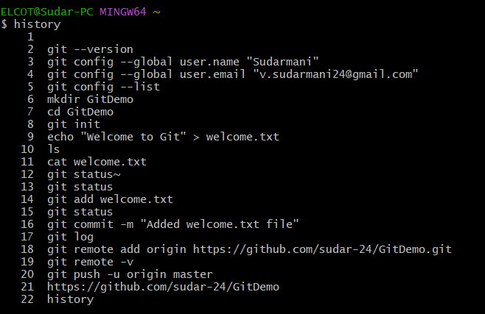
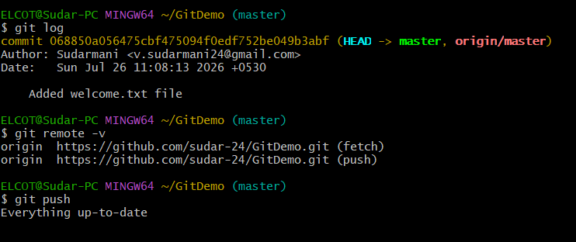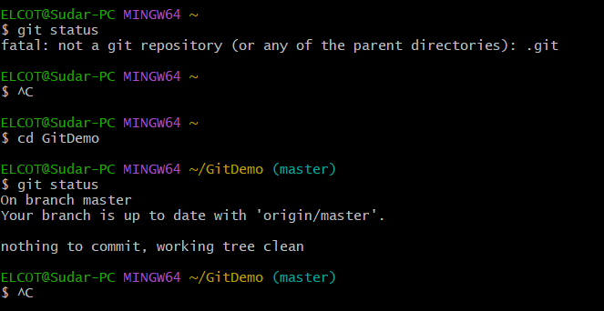
Result
The Git repository was successfully created and connected with GitHub. The file welcome.txt was added, committed, and uploaded to the remote repository successfully using Git commands.
Exercise 2: Git Ignore (.gitignore)
Objective:
To understand the concept of Git Ignore and learn how to use the .gitignore file to ignore unwanted files and folders from being tracked by Git.
Description:
In this exercise, a .gitignore file is created and configured to ignore .log files and log folders in the Git repository. The Git status is verified to ensure that unwanted files are excluded from tracking, and the changes are committed successfully.
Code Screenshots:
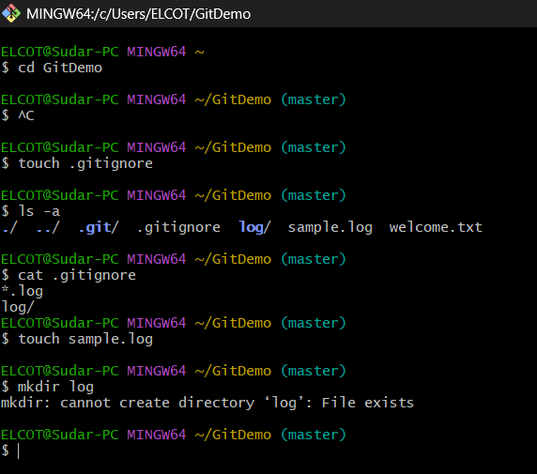
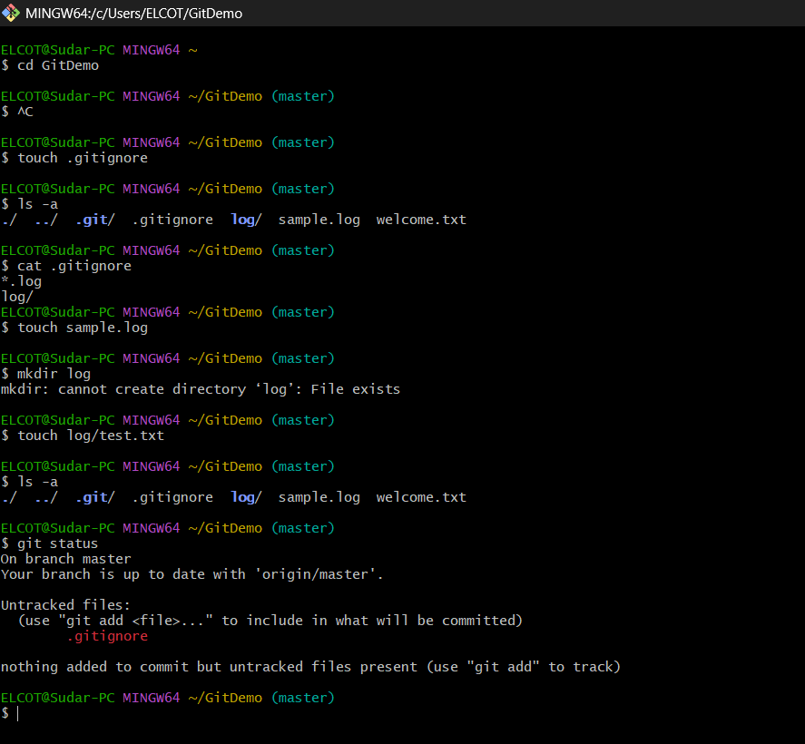
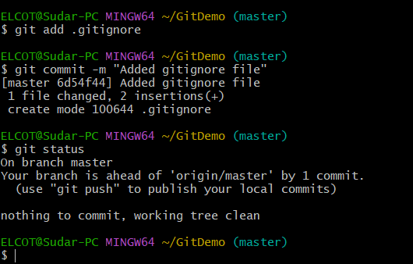
Result:
The .gitignore file was created and configured to ignore unwanted .log files and log folders. The Git status was verified, and the ignored files were successfully prevented from being tracked. The changes were committed successfully to the local repository.
Exercise 3: Git Branching and Merging
Objective:
The objective of this exercise is to understand the concepts of Git branching and merging in version control systems. It helps in learning how to create a separate branch for development, make changes without affecting the main branch, and manage multiple versions of a project efficiently. The exercise also focuses on switching between branches, committing changes, comparing branch differences, and merging the changes back into the master branch successfully.
Description:
In this hands-on exercise, a new Git branch named GitNewBranch is created from the master branch to perform independent development activities. A new file is added to the branch, changes are committed, and the differences between the branch and master branch are verified. The modified branch is then merged with the master branch to combine the changes. Finally, the merge history is checked using Git log commands, and the temporary branch is deleted after successful merging. This exercise demonstrates the complete workflow of branching and merging in Git.
Screenshots:
Screenshot 1:
Creating a new branch and switching to GitNewBranch.
Commands:
git branch GitNewBranch
git checkout GitNewBranch
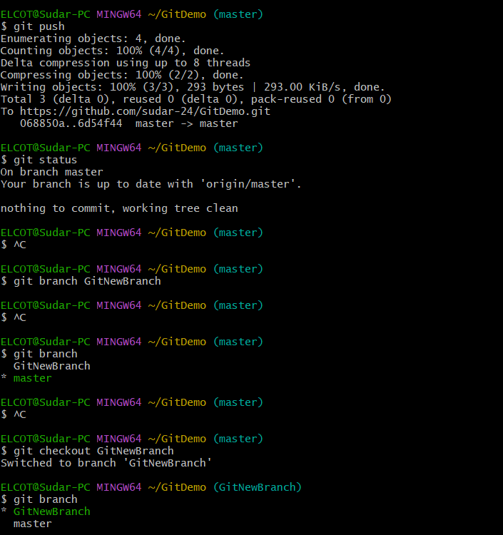
Screenshot 2:
Adding, committing, and merging branch changes.
Commands:
git add branch_file.txt
git commit -m "Added file in GitNewBranch"
git merge GitNewBranch
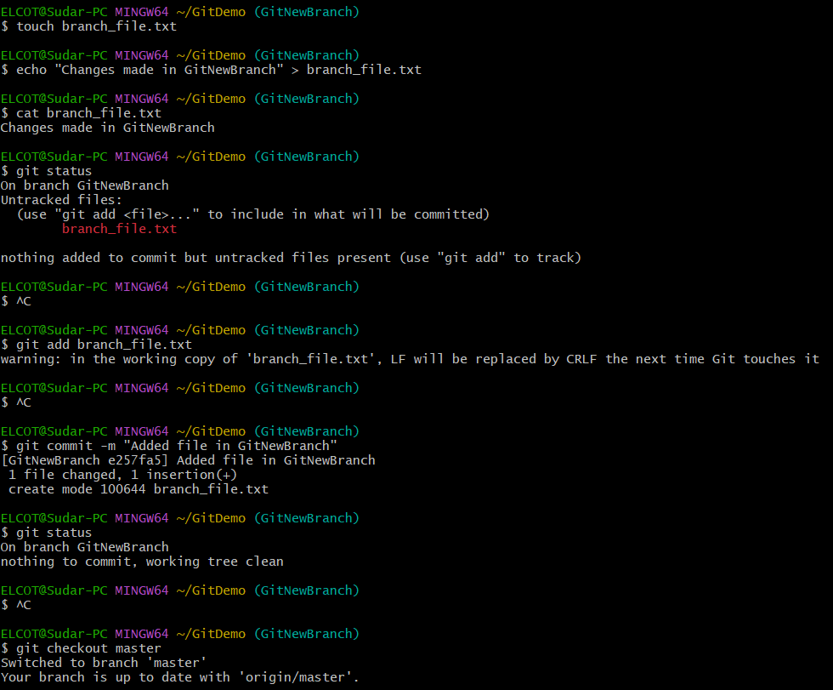
Screenshot 3:
Verifying merge history and deleting the branch.
Commands:
git log --oneline --graph --decorate
git branch -d GitNewBranch
git branch

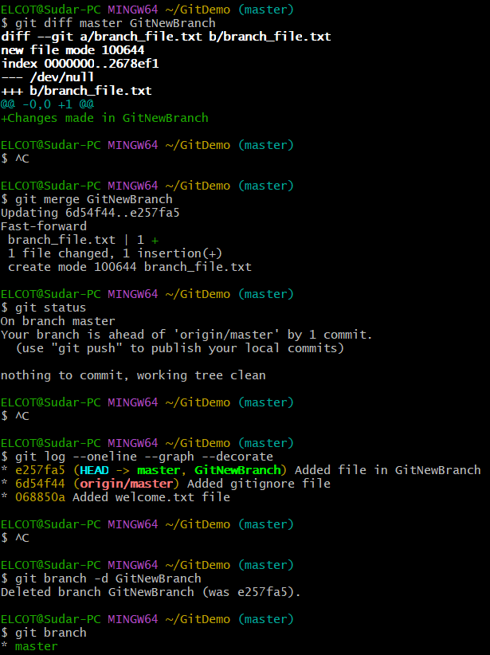
Result:
The Git branch was created successfully, changes were added and committed, and the branch was merged with the master branch. The merge history was verified, and the branch was deleted after successful merging. The repository was checked and confirmed to have a clean working status.
Exercise 4: Git Merge Conflict Resolution
Objective:
The objective of this exercise is to understand how merge conflicts occur in Git and learn how to resolve conflicts when changes are made simultaneously in different branches. It helps in managing conflicting modifications and successfully merging changes into the master branch.
Description:
In this exercise, a new branch is created and changes are made to a file. Similar changes are then made in the master branch to create a merge conflict. The conflict is identified using Git commands, resolved using merge tools, and the final changes are committed successfully. The branch status, merge history, and repository state are verified after conflict resolution.
Screenshots:
Screenshot 1: Creating a branch and making changes in hello.xml.
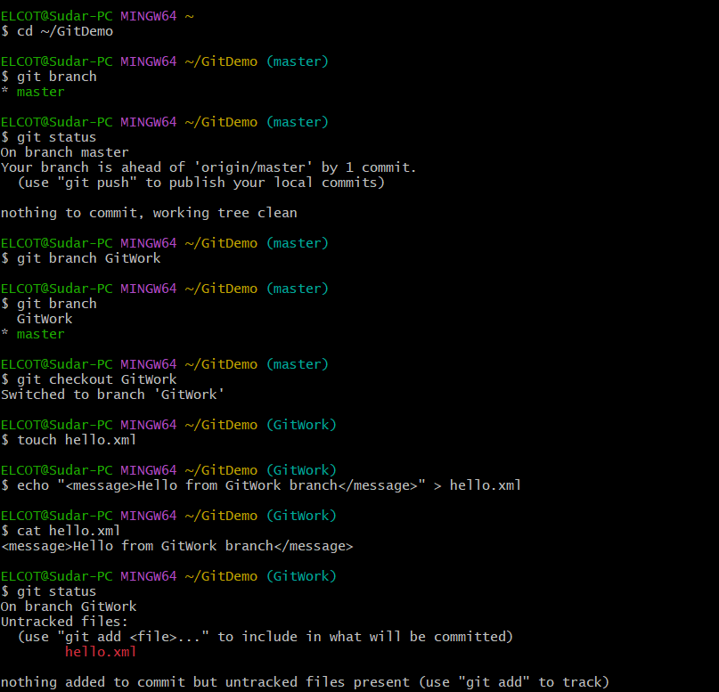
Screenshot 2: Creating conflicting changes in master branch and checking differences.
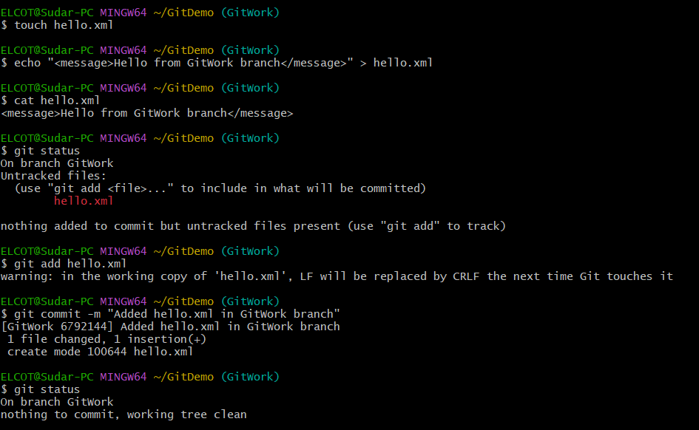
Screenshot 3: Resolving the merge conflict and committing the final changes.
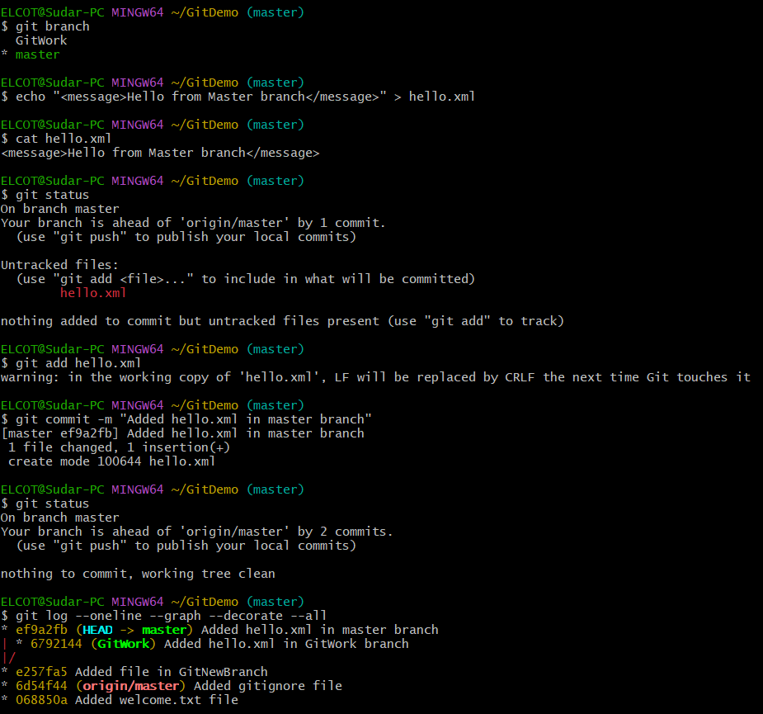
Screenshot 4: Verifying branch deletion and final Git log.
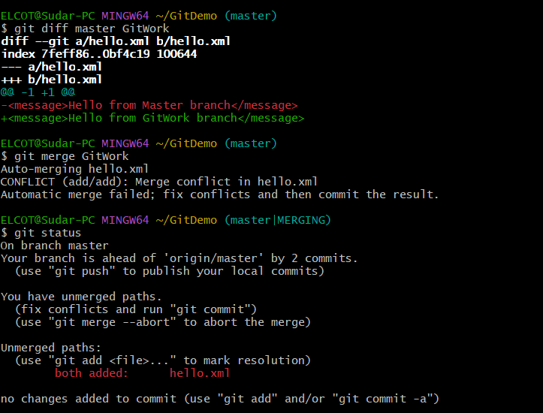
Screenshot 5: Final Branch Deletion and Repository Verification
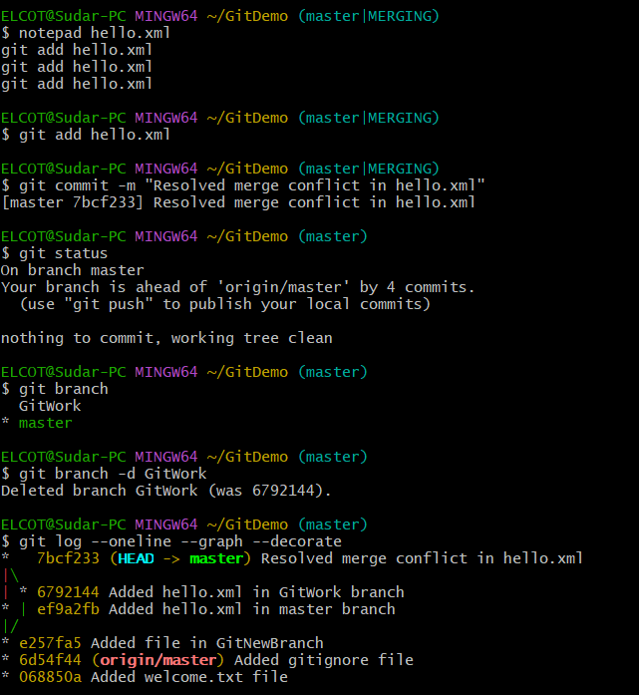
Result:
The merge conflict was successfully created and resolved by comparing changes between branches. The conflicting modifications were merged into the master branch, changes were committed successfully, and the repository was verified with a clean status.
Exercise 5: Git Cleanup and Push to Remote
Clean Up and Push Changes to Remote Git Repository
Objective:
The objective of this exercise is to understand how to clean up the local Git repository and synchronize changes with the remote repository. It helps in verifying the repository status, managing branches, pulling the latest changes from remote, and pushing local commits to the remote repository.
Description:
In this exercise, the local Git repository is checked for a clean working state before synchronizing with the remote repository. Available branches are verified, the latest changes from the remote repository are pulled into the master branch, and pending local changes are pushed back to the remote repository. Finally, the remote repository is checked to confirm that the changes are successfully reflected.
Step 1: Verify master is in clean state
Command:
git status
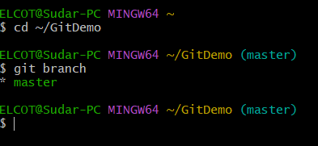

Setp 2: Pulling latest changes from remote
Command:
git pull origin master
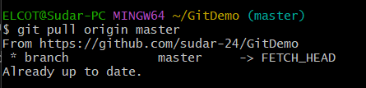
Step 3: Pushing changes successfully
Command:
git push origin master
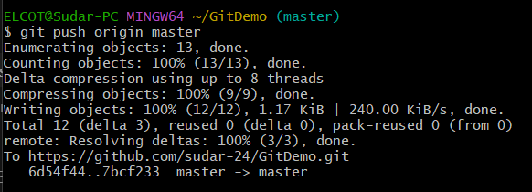
Step 4: Remote Repository Updated Successfully
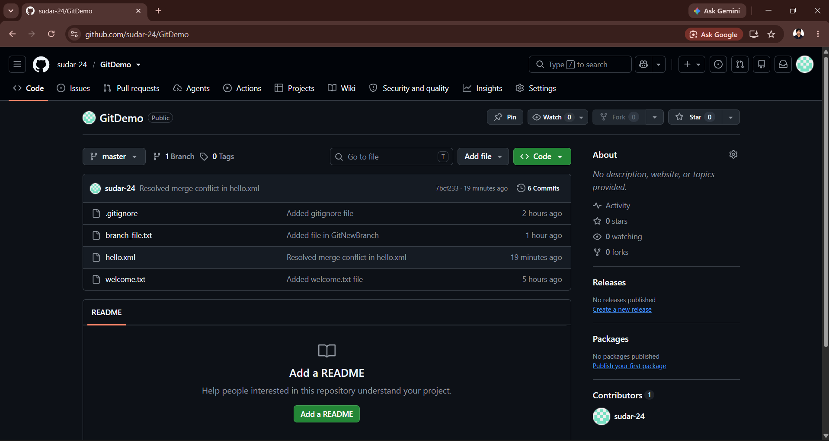
Result:
The Git hands-on exercises were completed successfully from basic repository management to remote synchronization. In Exercise 1, a Git repository was created, files were added, committed, and basic Git operations were performed to understand version control workflow. In Exercise 2, the .gitignore file was created and configured to exclude unwanted files and folders from Git tracking, and the changes were committed successfully.
In Exercise 3, Git branching and merging concepts were implemented by creating a new branch, adding changes, committing them, comparing branch differences, and merging the branch back into the master branch. In Exercise 4, merge conflict handling was practiced by creating conflicting changes in different branches, identifying the conflict, resolving it manually, committing the resolved changes, and verifying the final repository status.
Finally, in Exercise 5, the repository was cleaned and synchronized with the remote Git repository by checking the branch status, pulling the latest updates, and pushing local commits successfully to GitHub. Through these exercises, the complete Git workflow including repository management, ignoring files, branching, merging, conflict resolution, and remote repository synchronization was successfully understood and implemented.

