ReactJS Hands-On Lab
Week : 6
Exercise : 14 – Employee Management using React Context API
Name :Sudarmani
Superset ID : 6737805

Experiment
Exercise 14 – Employee Management using React Context API

Status
The Employee Management application was implemented successfully using the React Context API. The application compiled without errors and demonstrated context-based data sharing by providing the selected theme to child components without passing it through props. The employee details were displayed as individual cards with theme-based styling applied to the View Details button.

Objective
To develop a React application that demonstrates the use of the React Context API for sharing data across components. The application should provide a theme using ThemeContext and access it within child components using the useContext() hook.

Steps Performed
Created a new React application and opened it in Visual Studio Code. Created the required files: ThemeContext.js, EmployeeList.js, and EmployeeCard.js. Implemented ThemeContext using createContext() and wrapped the application with ThemeContext.Provider. Stored employee information in an array and displayed it using the map() function. Used the useContext() hook in EmployeeCard to access the selected theme and applied the corresponding CSS class to the View Details button. Executed the application using npm start and verified the output in the browser.

Screenshots
Figure 1: VS Code showing the project structure and successful compilation.
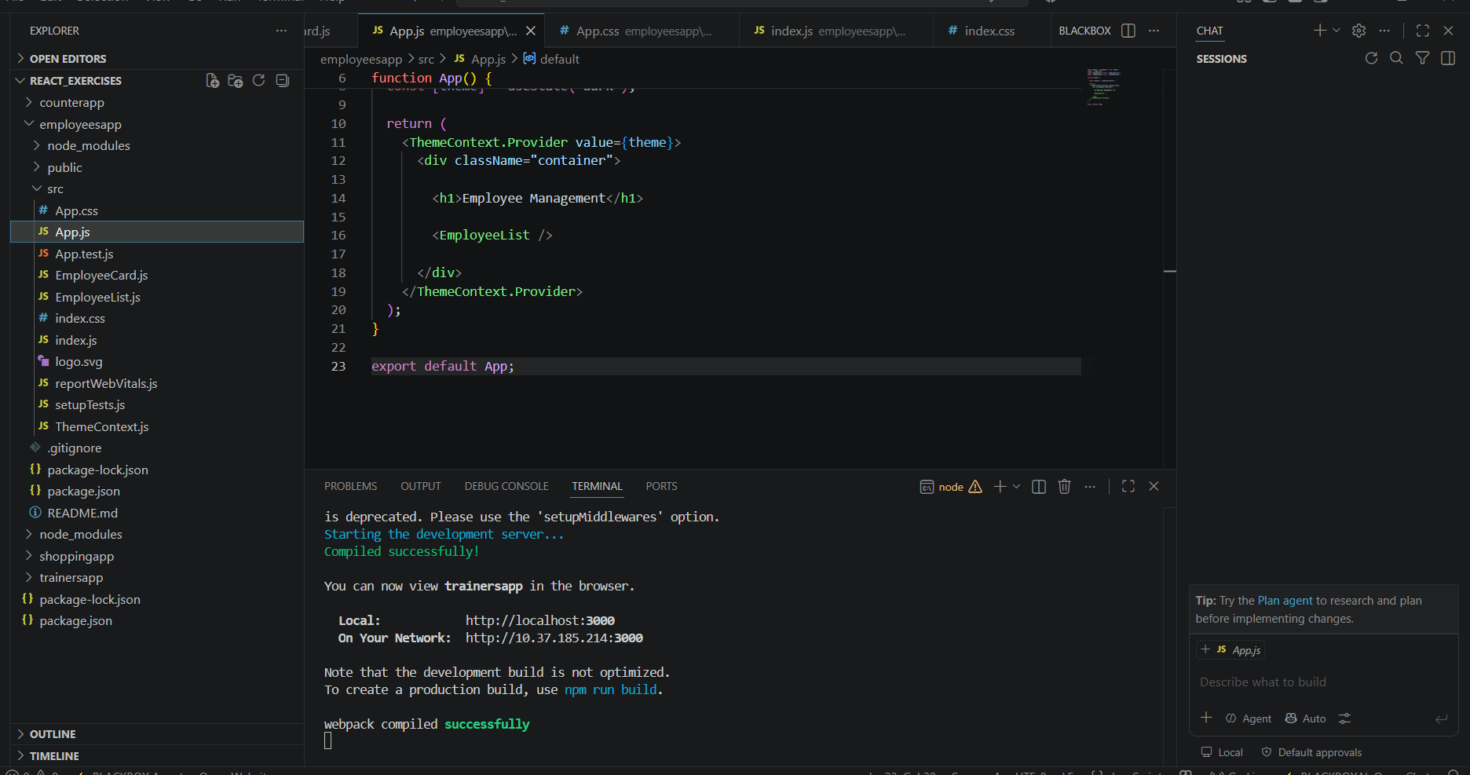

Figure 2: Browser output displaying employee cards with the theme applied using the React Context API.
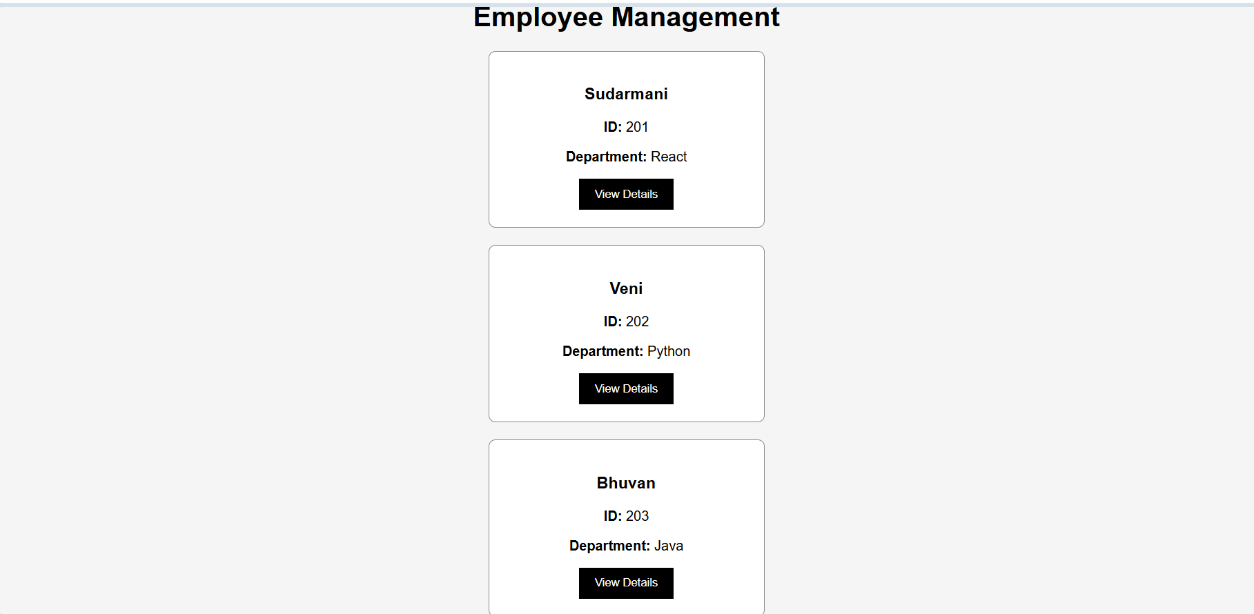

Result
The Employee Management application was implemented successfully. The application correctly demonstrated the use of the React Context API by sharing theme information across components without prop drilling. The employee details were displayed correctly, and the theme was successfully applied using the useContext() hook.

