ReactJS Hands-On Lab
Week : 6
15 – Complaint Register App
Name :Sudarmani
Superset ID : 6737805

Experiment
Exercise 15 – Complaint Register App

Status
The Complaint Register application was implemented successfully using React. The application compiled without errors and demonstrated React form handling using the useState Hook. Users were able to enter their employee name and complaint details. When the Submit button was clicked, the application displayed an alert box containing the employee name, complaint submission confirmation, and a randomly generated reference ID.

Objective
To develop a React application that demonstrates form handling using React Hooks. The application should allow users to enter an employee name and complaint, manage the input using the useState Hook, and generate a unique reference ID after the complaint is submitted.

Steps Performed
Created a new React application named ticketraisingapp and opened it in Visual Studio Code. Created the ComplaintRegister component and added input fields for employee name and complaint description using controlled components. Managed the form data using the useState Hook. Implemented a Submit button that generated a random reference ID and displayed the employee name, complaint submission message, and reference ID in an alert box. Executed the application using npm start and verified the output in the browser.

Screenshots
Figure 1: VS Code showing the project structure and successful compilation.
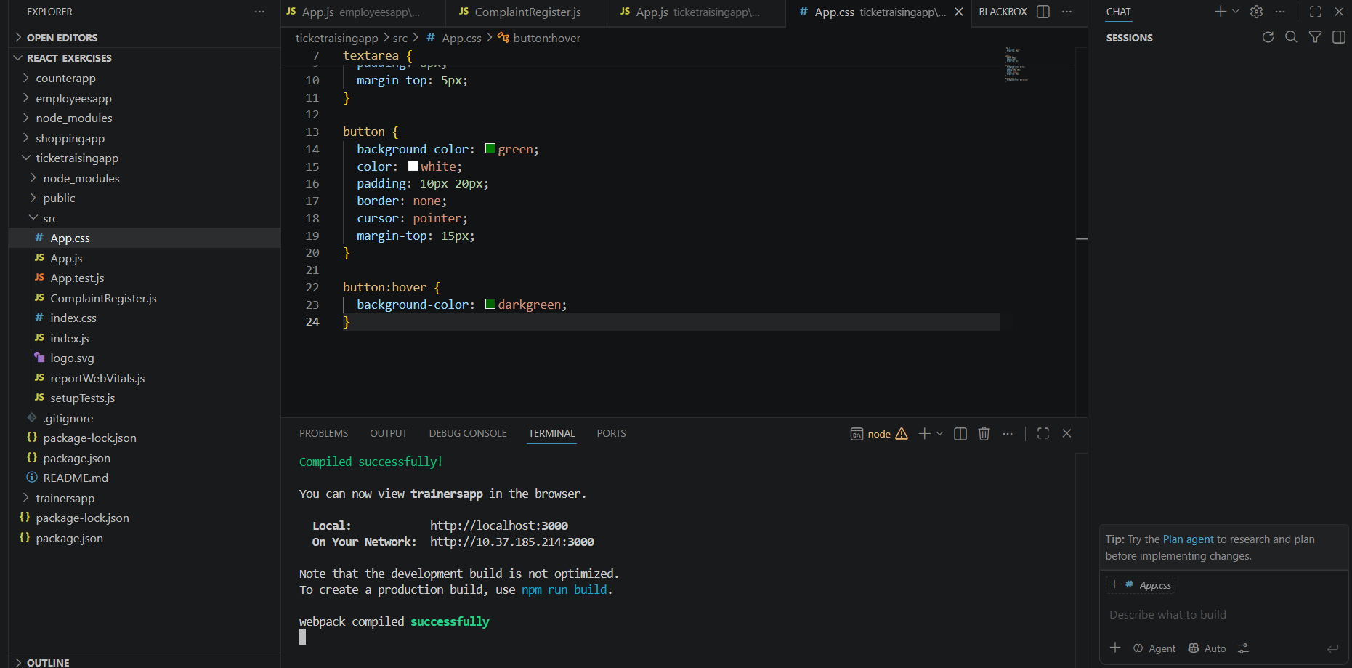

Figure 2: Browser displaying the Complaint Register form.
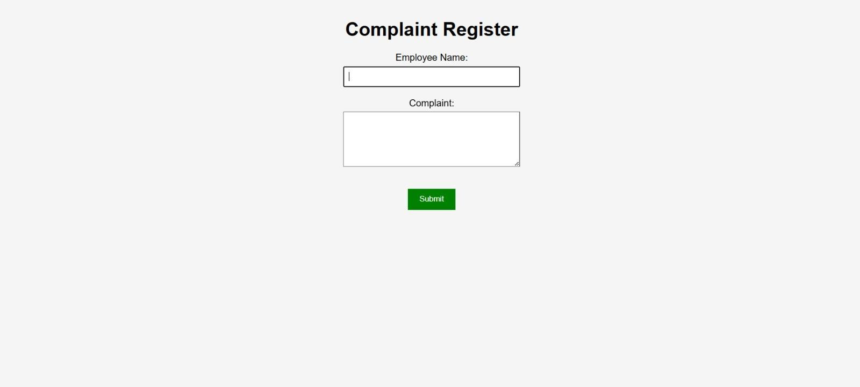

Figure 3: Alert box displaying the employee name, complaint submission confirmation, and generated reference ID.
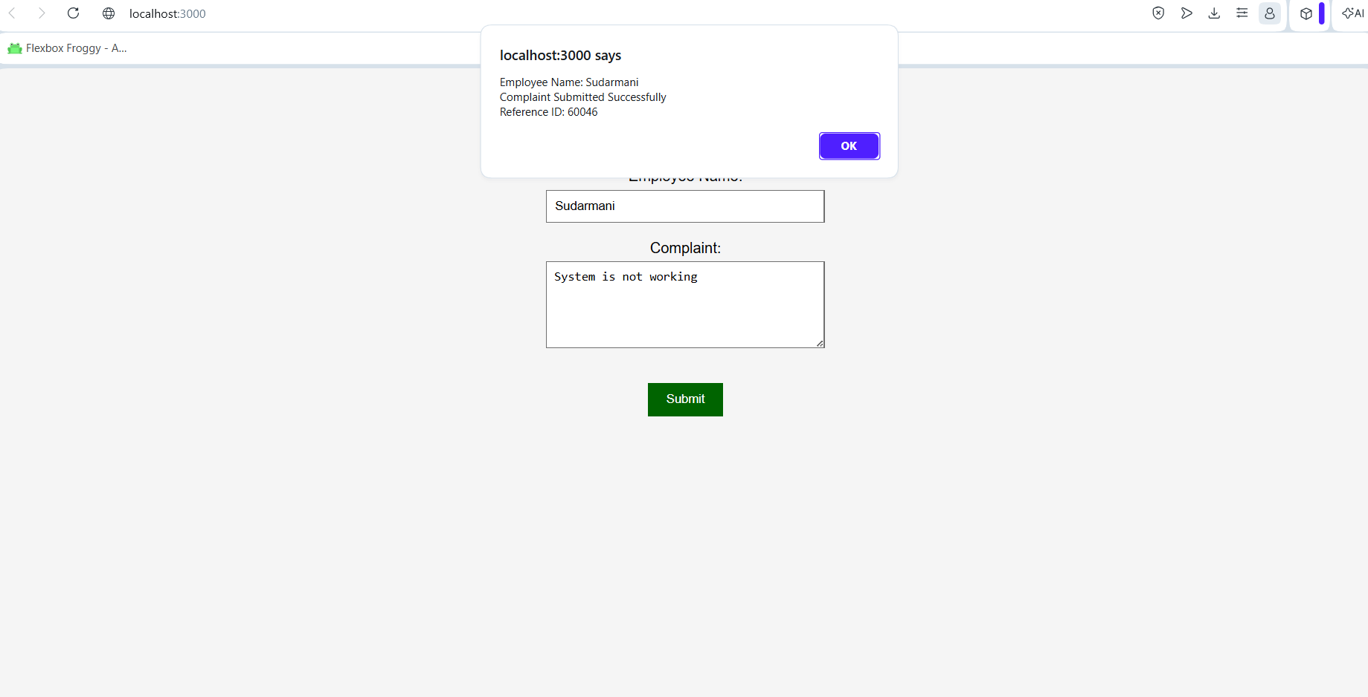

Result
The Complaint Register application was implemented successfully. The application correctly demonstrated React form handling using the useState Hook by accepting user input, generating a random reference ID, and displaying the complaint details in an alert message. The objectives of the experiment were achieved successfully.

