ReactJS Hands-On Lab
Week : 6
Exercise : 16 – React Form Validation
Name :Sudarmani
Superset ID : 6737805

Experiment
Exercise 16 – React Form Validation

Status
The React Form Validation application was implemented successfully. The application validated the Name, Email, and Password fields using React event handling. Appropriate alert messages were displayed for invalid inputs, and a success message was shown when all validations were satisfied.

Objective
Created a new React application named mailregisterapp and implemented a Register component. Added input fields for Name, Email, and Password using controlled components. Implemented form validation through onChange and onSubmit event handlers. Verified that the application displayed appropriate validation messages for invalid input and a success message for valid input.

Steps Performed
Created a new React application named mailregisterapp and opened it in Visual Studio Code. Created the required Register.js component and integrated it with App.js. Designed a registration form with input fields for Name, Email, and Password using React controlled components. Implemented form validation using onChange and onSubmit event handlers to verify that the Name contains at least 5 characters, the Email contains both @ and ., and the Password contains at least 8 characters. Displayed appropriate alert messages for invalid input and a success message when all validation conditions were satisfied. Executed the application using npm start and verified the output in the browser.

Screenshots
Figure 1: VS Code showing project structure and successful compilation.
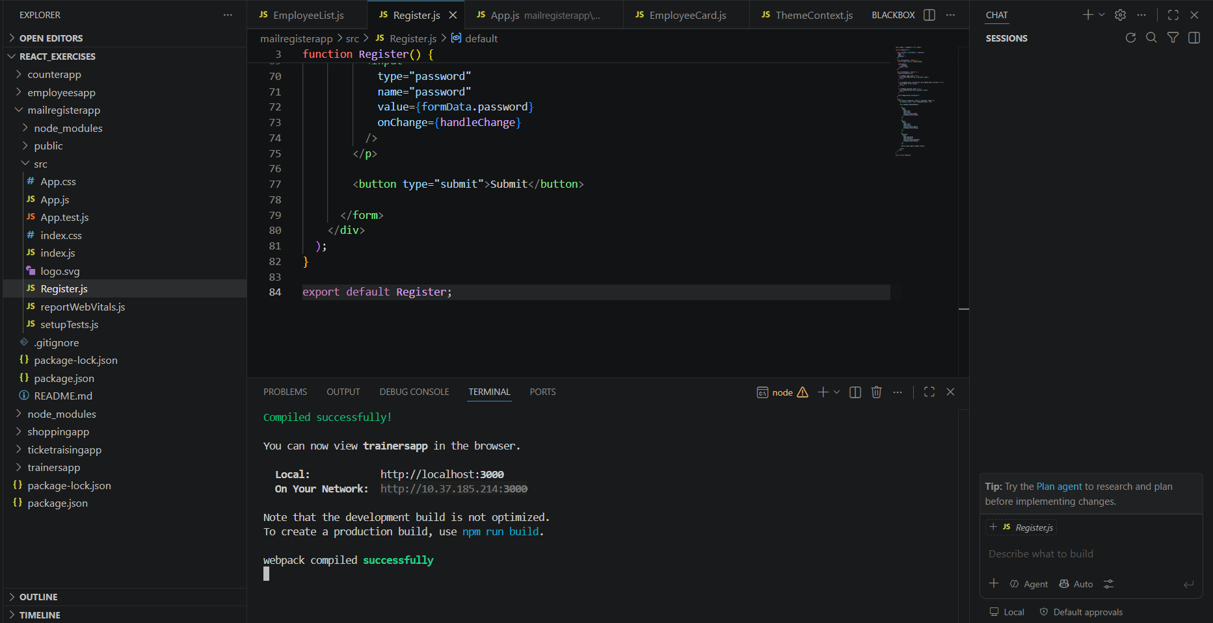

Figure 2: Name validation displaying an alert when the entered name contains fewer than 5 characters.
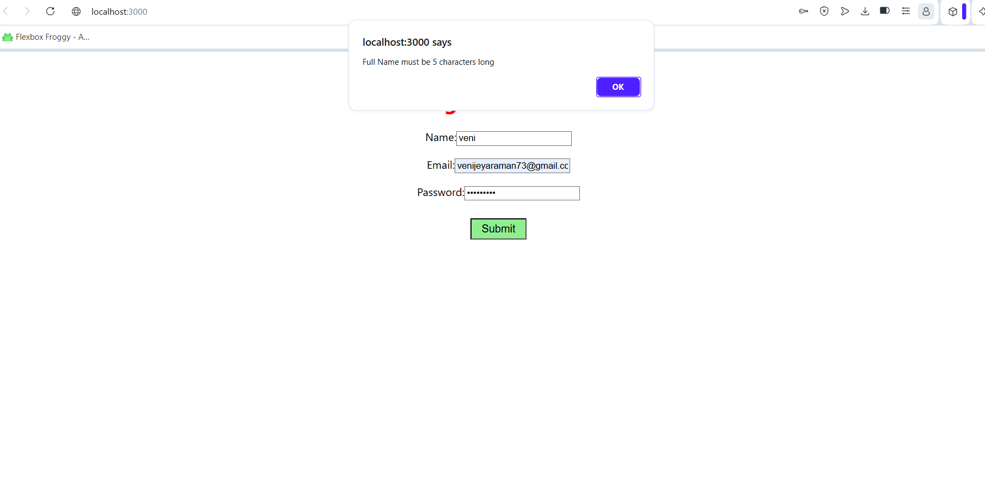

Figure 3: Email validation displaying an alert for an invalid email address.
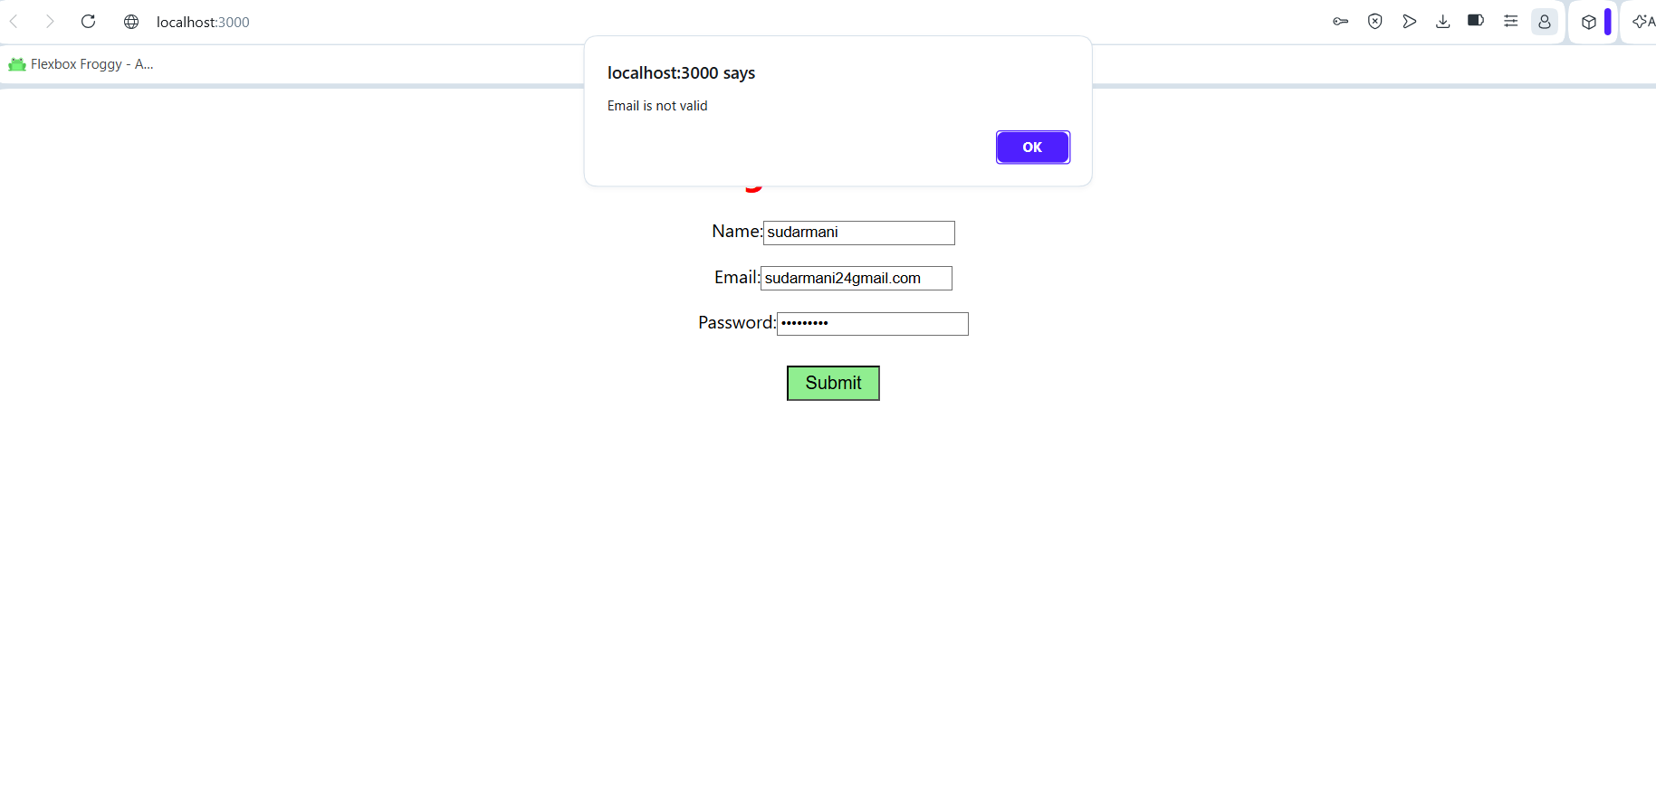

Figure 4: Password validation displaying an alert when the password contains fewer than 8 characters.
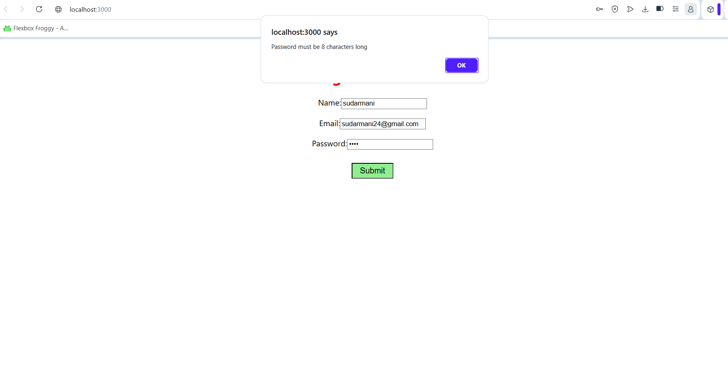

Figure 5: Successful registration displaying a confirmation message after entering valid details.
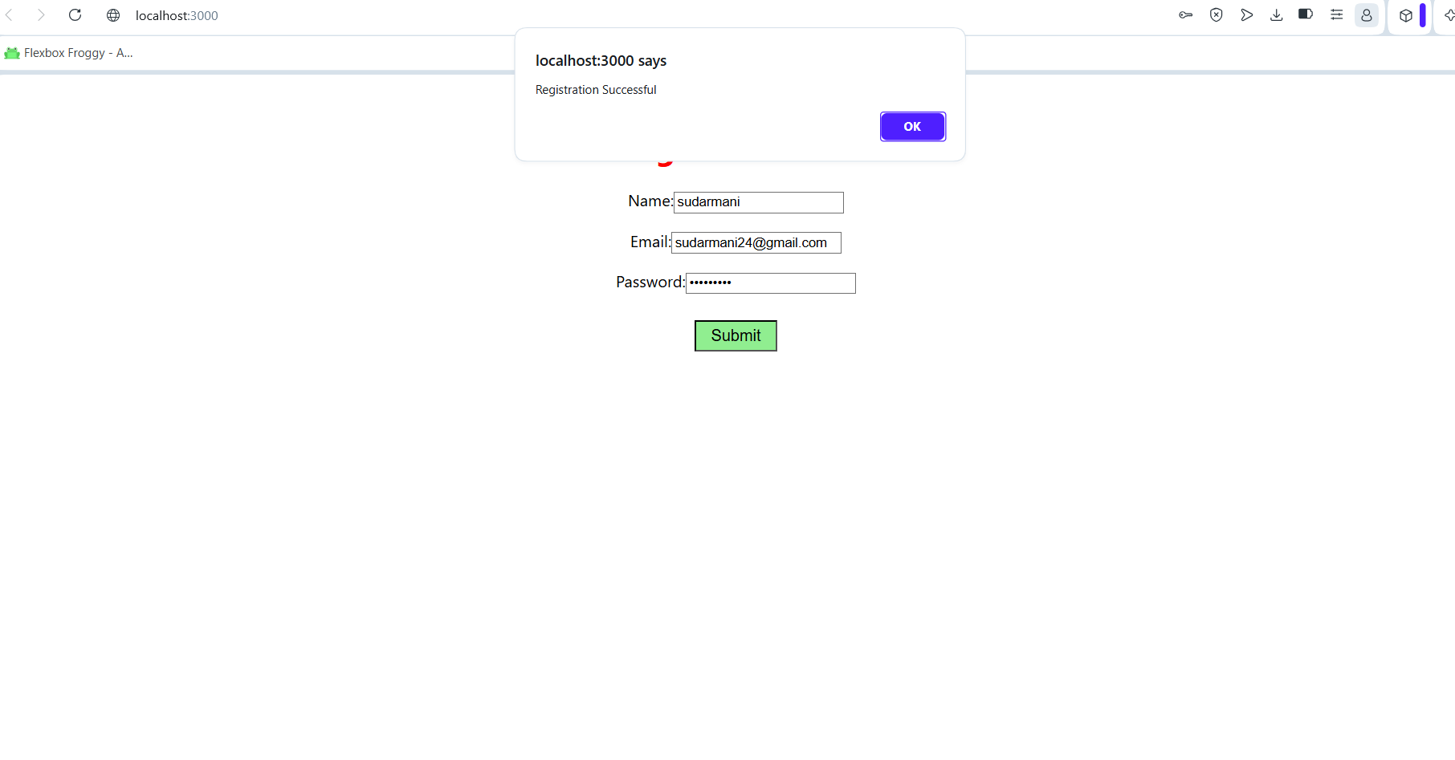

Result
The React Form Validation application was implemented successfully. The application validated all user inputs correctly and displayed appropriate validation messages using React event handling. A success message was shown when all validation conditions were satisfied.

