ReactJS Hands-On Lab
Week : 6
Exercise : 17 – Fetch User Details Using REST API
Name :Sudarmani
Superset ID : 6737805

Experiment
Exercise 17 – Fetch User Details Using REST API

Status
The React application was implemented successfully. The application invoked the Random User REST API using the fetch() method inside the componentDidMount() lifecycle method. The fetched user details, including the title, first name, and profile image, were displayed successfully in the browser

Objective
To develop a React application that consumes a REST API using the fetch() method and displays the retrieved user details, including the user's title, first name, and profile image.

Steps Performed
Created a new React application named fetchuserapp and opened it in Visual Studio Code. Created the Getuser.js component and integrated it with App.js. Implemented the componentDidMount() lifecycle method to invoke the Random User REST API using the fetch() method. Retrieved the user details from the API response and stored them in the component state. Displayed the user's title, first name, and profile image in the browser. Executed the application using npm start and verified the output successfully.

Screenshots
Figure 1: VS Code showing project structure and successful compilation.
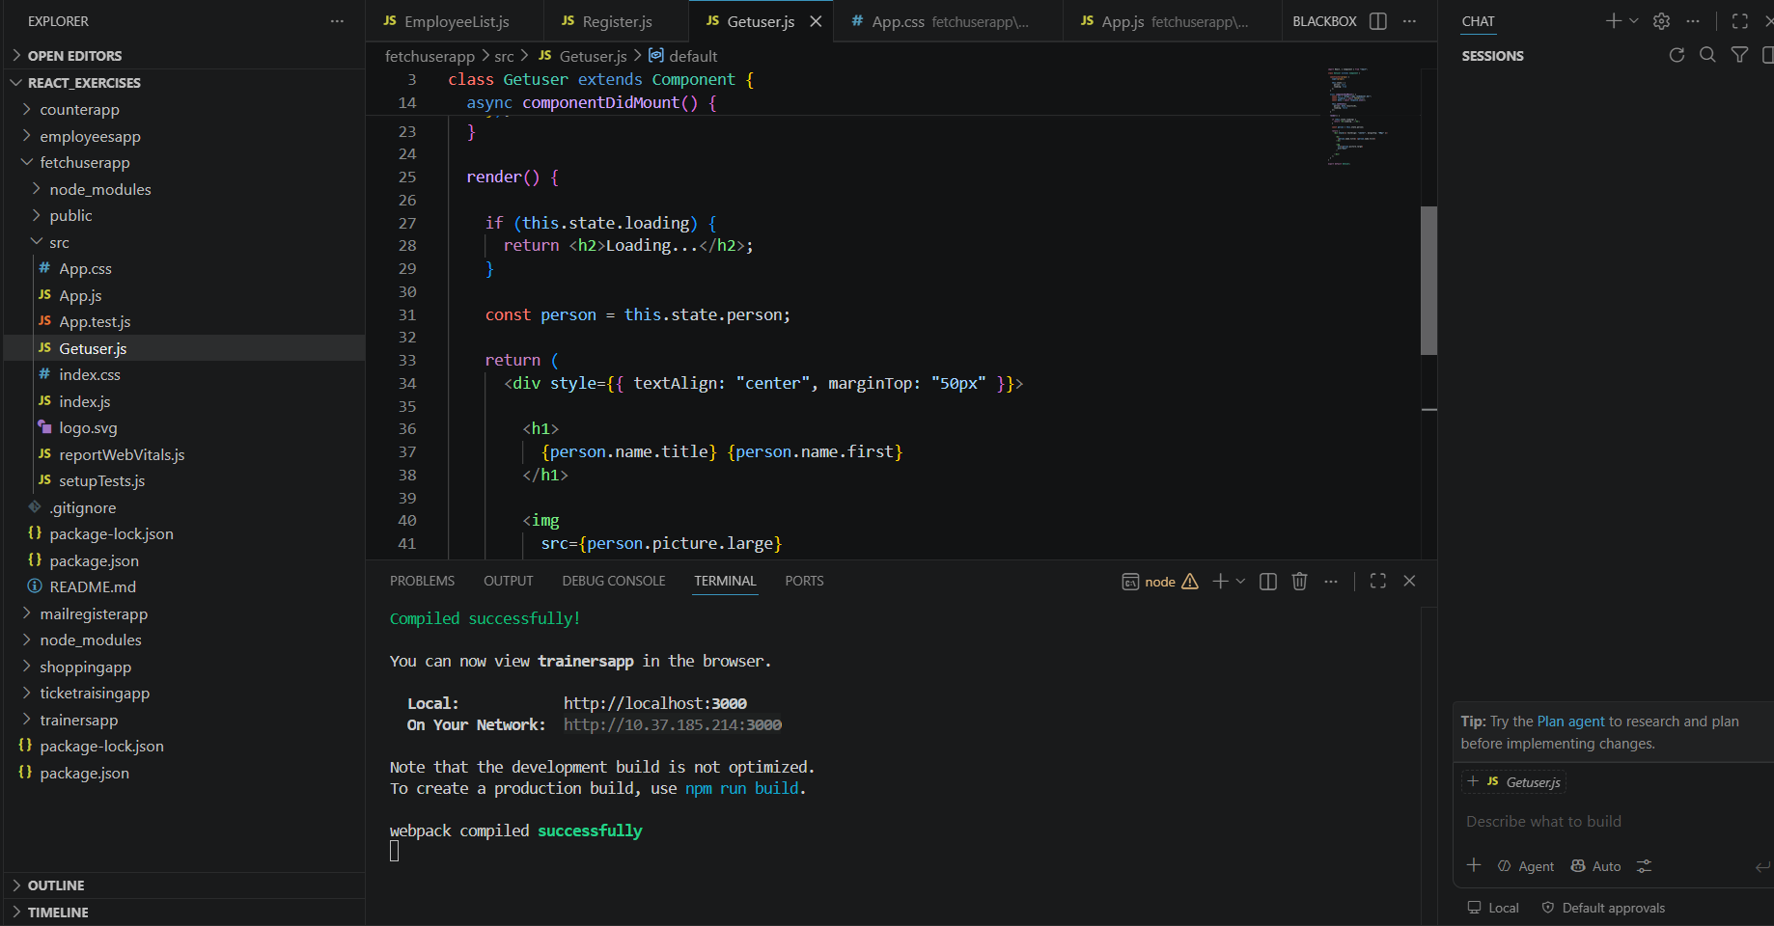

Figure 2: React application displaying the fetched user title, first name, and profile image retrieved from the Random User REST API.


Result
The React application was implemented successfully. The application consumed the Random User REST API and displayed the fetched user details, including the title, first name, and profile image, confirming successful API integration and data rendering in React.

