ReactJS Hands-On Lab
Week : 6
Exercise :6 – Trainers App using React Router
Name :Sudarmani
Superset ID : 6737805

Experiment
Exercise 6 – Trainers App using React Router

Status
The Trainers App was implemented successfully using React Router. The application compiled without errors and demonstrated client-side routing between multiple pages. The Home page, Trainers List page, and Trainer Details page were successfully displayed. Clicking on a trainer's name navigated to the corresponding trainer details page using URL parameters, confirming that routing and parameter passing worked correctly.

Objective
To develop a React application that demonstrates client-side routing using React Router. The application should provide navigation between different pages, display a list of trainers, and show trainer details by passing parameters through the URL.

Steps Performed
Created a new React application and opened it in Visual Studio Code. Installed the react-router-dom package to enable routing functionality. Created the required components namely Home, Trainer, TrainersMock, TrainersList, and TrainerDetails. Added mock trainer data and implemented routing using BrowserRouter, Routes, Route, and Link components. Used the useParams() hook to retrieve the trainer ID from the URL and display the selected trainer's details. Executed the application using npm start and verified the output in the browser.

Screenshots
Figure 1: VS Code showing the project structure and successful compilation.
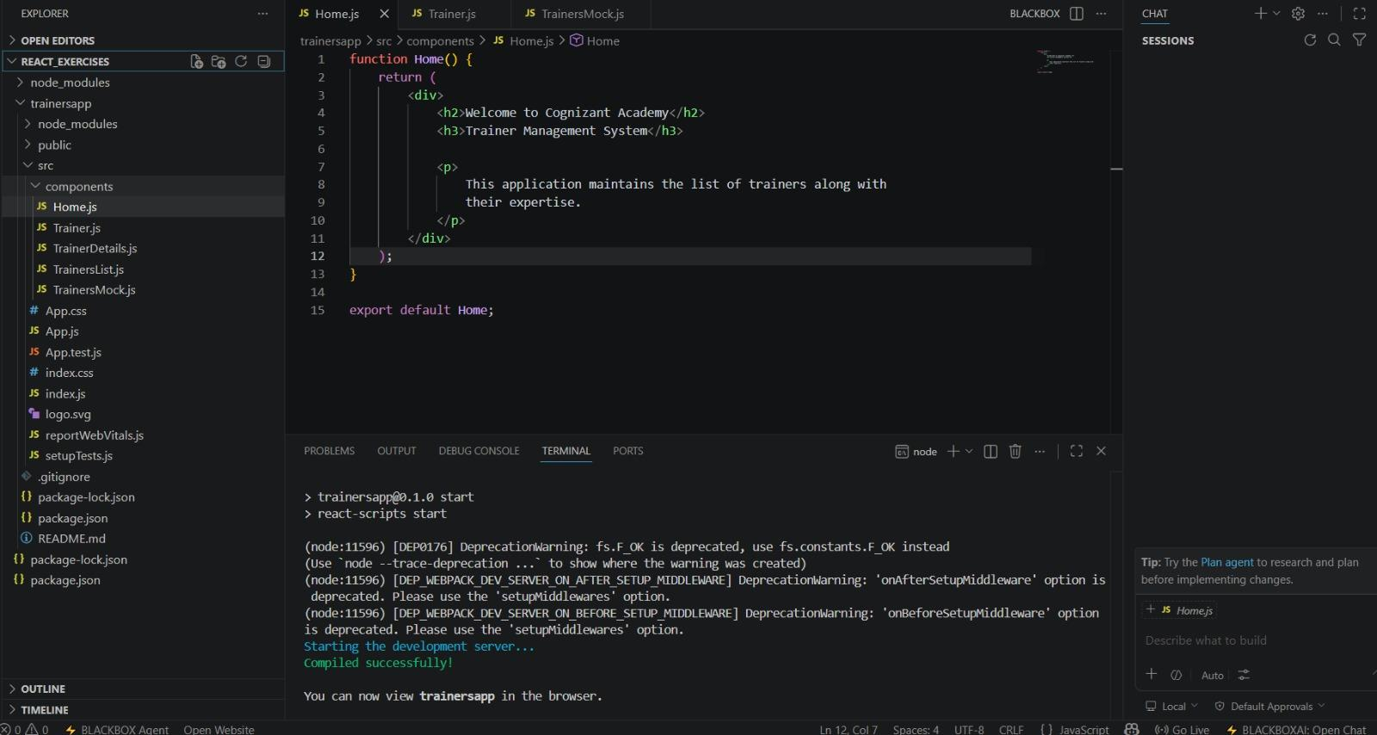
Figure 2: Home page displaying the Trainer Management System with navigation links.
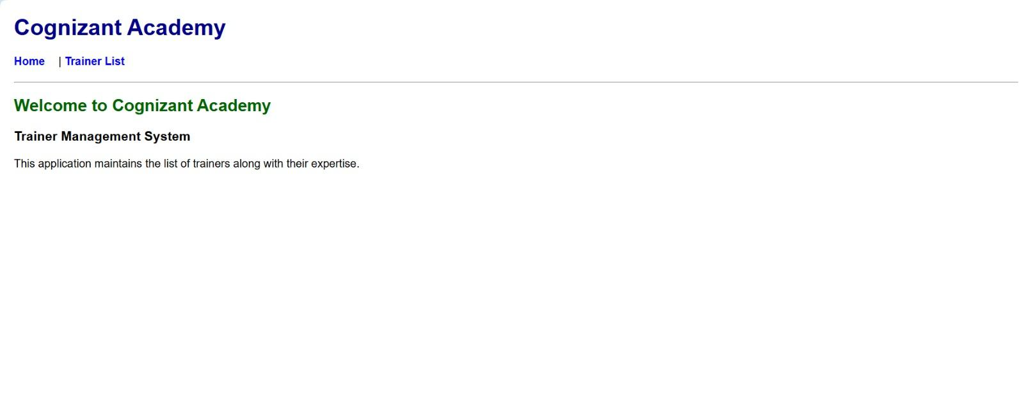
Figure 3: Trainers List page displaying trainer names as clickable links.
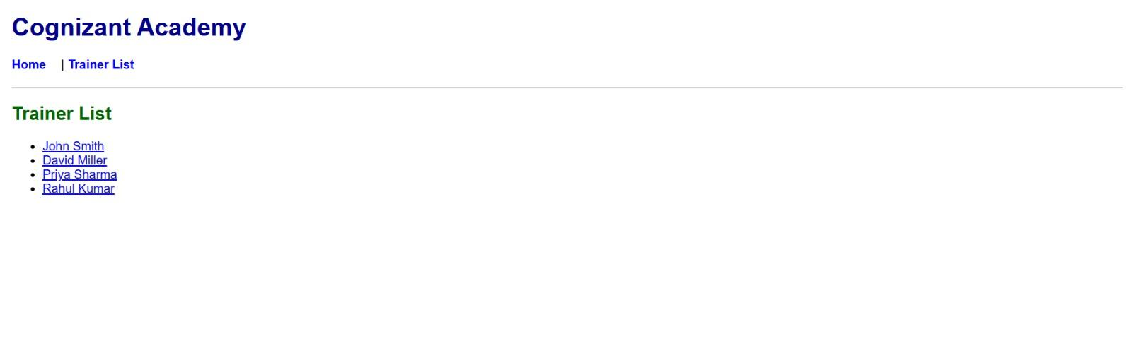
Figure 4: Trainer Details page displaying the selected trainer's information.
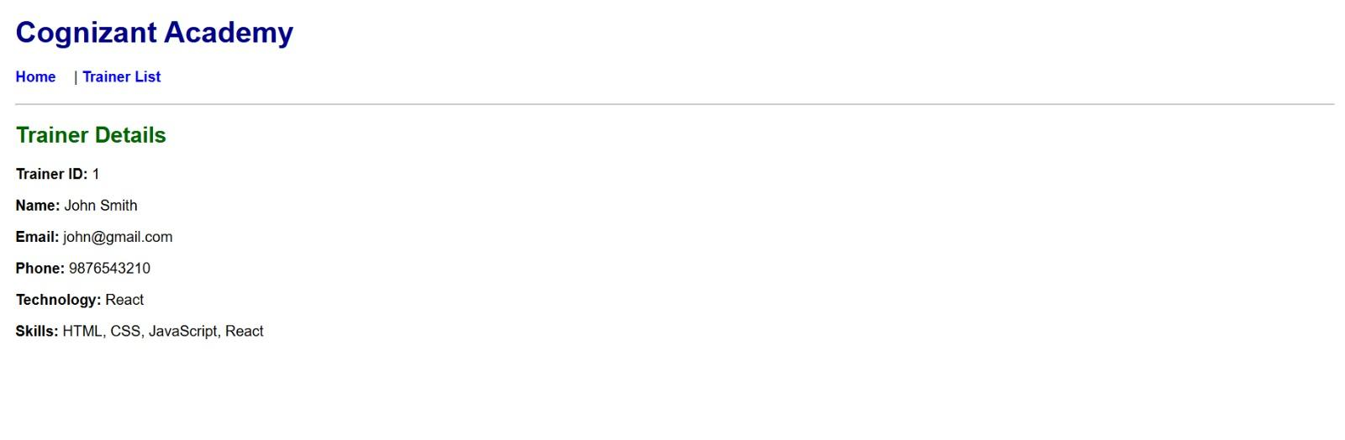

Result
The Trainers App was implemented successfully. The application correctly demonstrated client-side routing using React Router by navigating between multiple pages and displaying trainer details based on URL parameters. The objectives of implementing navigation, routing, and parameter passing in a Single Page Application (SPA) were achieved successfully.

