ReactJS Hands-On Lab
Week : 6
Exercise : 7 – Shopping App
Name :Sudarmani
Superset ID : 6737805

Experiment
Exercise 7 – Shopping App

Status
The Shopping App was implemented successfully using React class components. The application compiled without errors and demonstrated the use of props to pass data from the OnlineShopping component to the Cart component. The application displayed the list of ordered items in a tabular format.

Objective
To develop a React application that demonstrates the use of props in class components. The application should create an array of shopping items, pass the data as props to another component, and display the items in a table.

Steps Performed
Created a new React application named shoppingapp and opened it in Visual Studio Code. Created two class components named OnlineShopping and Cart. Initialized an array of five shopping items in the OnlineShopping component and passed the array to the Cart component using props. Displayed the item name and price in a table by iterating through the array using the map() function. Executed the application using npm start and verified the output in the browser.

Screenshots
Figure 1: VS Code showing the project structure and successful compilation.
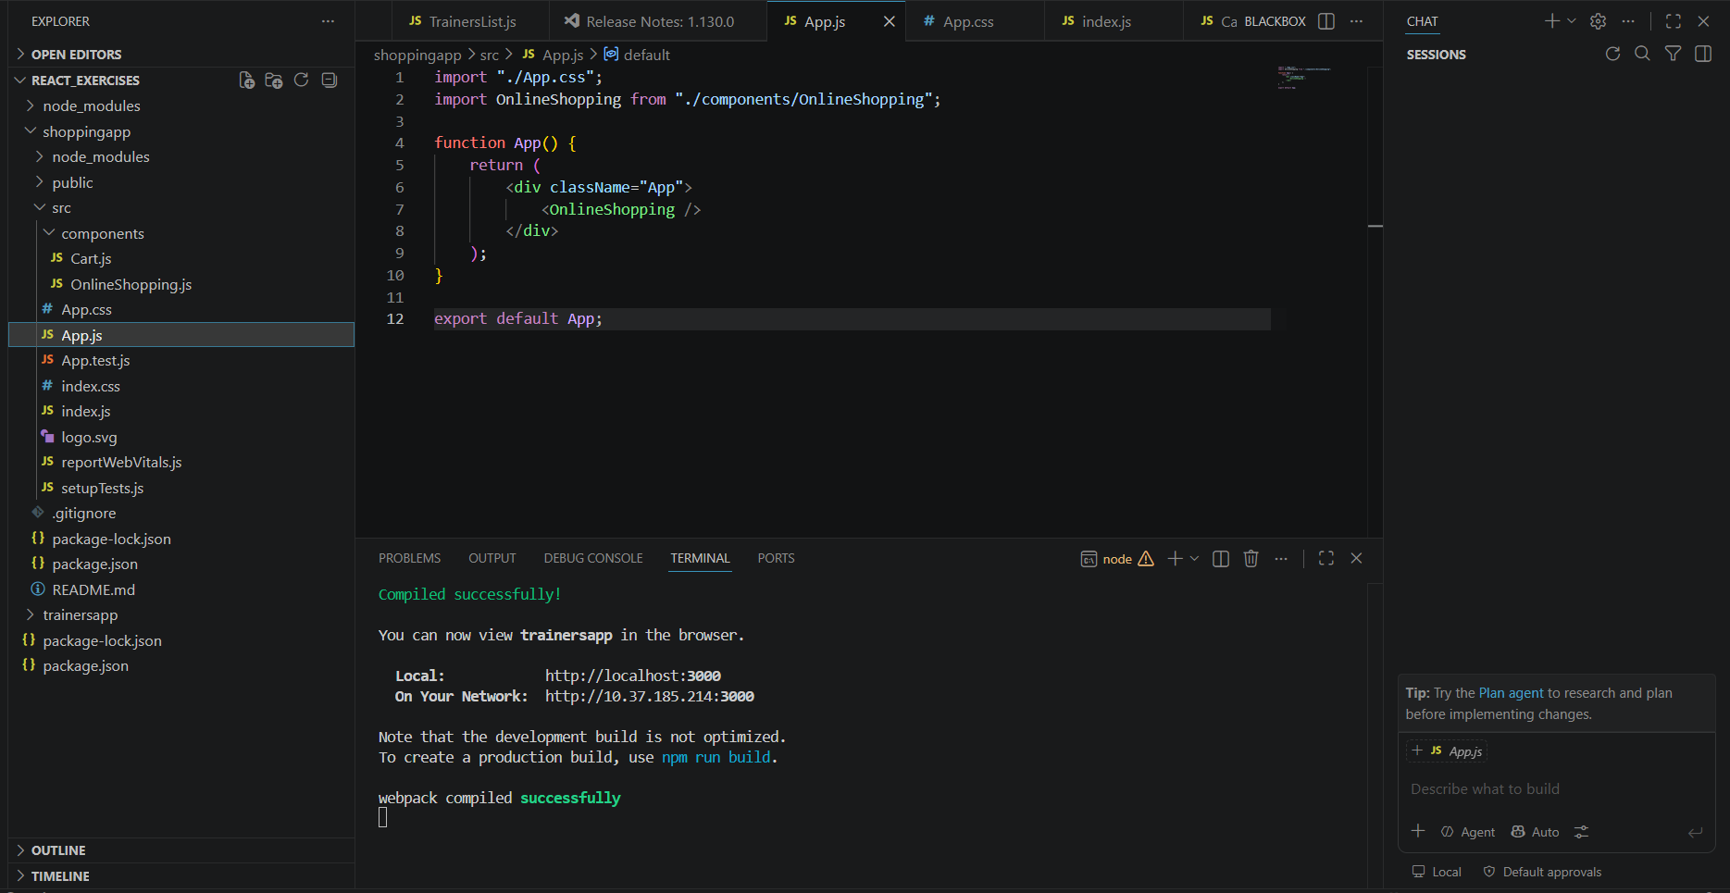
Figure 2: Browser output displaying the list of ordered items in a table using props.
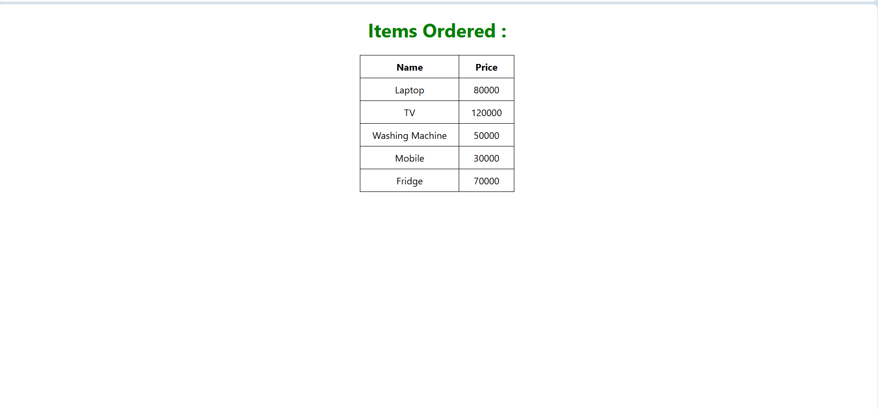

Result
The Shopping App was implemented successfully. The application correctly demonstrated the use of props in React by passing data between class components and displaying the shopping items dynamically in a table. The objectives of implementing props and rendering data using the map() function were achieved successfully.

