ReactJS Hands-On Lab
Week : 6
Exercise : 8 – Counter App
Name :Sudarmani
Superset ID : 6737805

Experiment
Exercise 8 – Counter App

Status
The Counter App was implemented successfully using React State. The application compiled without errors and demonstrated state management by updating the number of people entering and exiting the mall. The Login and Exit buttons correctly incremented the respective counters.

Objective
To develop a React application that demonstrates the use of the React State object. The application should maintain the count of people entering and exiting the mall and update the values dynamically when the corresponding buttons are clicked.

Steps Performed
Created a new React application named counterapp and opened it in Visual Studio Code. Created a class component named CountPeople. Initialized the entrycount and exitcount values using the constructor and state. Implemented the updateEntry() and updateExit() methods to increment the respective counts using setState(). Added Login and Exit buttons to trigger the update methods. Executed the application using npm start and verified the output in the browser.

Screenshots
Figure 1: VS Code showing the project structure and successful compilation.
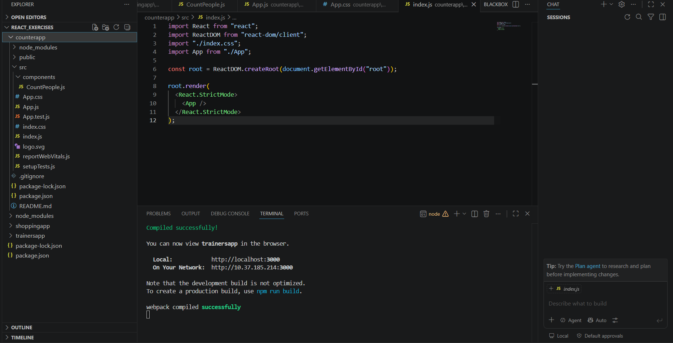
Figure 2: Browser output displaying the Login and Exit buttons with the updated entry and exit counts.
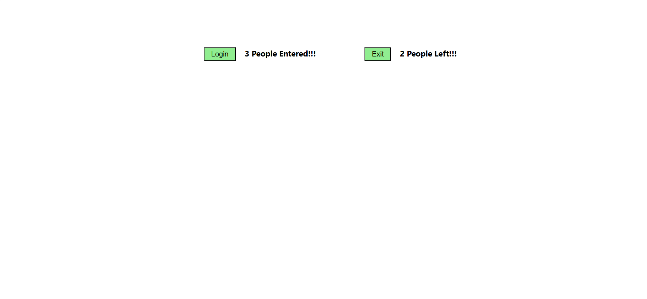

Result
The Counter App was implemented successfully. The application correctly demonstrated the use of React State by updating the entry and exit counts dynamically using setState(). The objectives of implementing state management and event handling in React were achieved successfully.

