WEEK 3
SPRING REST USING SPRING BOOT
Name : Sudarmani V
Superset Id :6737805
Spring Rest Hands
Exercise 1: Hello World RESTful Web Service
AIM
To create a RESTful web service that returns "Hello World!!".
CODE
HelloController.java
package com.cognizant.spring_learn.controller;

import org.slf4j.Logger;
import org.slf4j.LoggerFactory;
import org.springframework.web.bind.annotation.GetMapping;
import org.springframework.web.bind.annotation.RestController;

@RestController
public class HelloController {

private static final Logger LOGGER =
LoggerFactory.getLogger(HelloController.class);

@GetMapping("/hello")
public String sayHello() {

LOGGER.info("START");

LOGGER.info("END");

return "Hello World!!";
}
}
OUTPUT
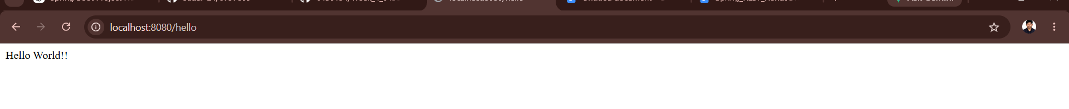

CONSOLE OUTPUT
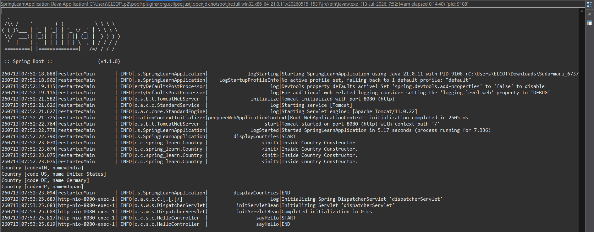
RESULT
The Hello World RESTful Web Service was created and executed successfully.
Exercise 2 – Country RESTful Web Service
AIM
To create a RESTful web service that returns the details of a country in JSON format.
CODE
CountryController.java
package com.cognizant.spring_learn.controller;

import org.springframework.context.support.ClassPathXmlApplicationContext;
import org.springframework.web.bind.annotation.GetMapping;
import org.springframework.web.bind.annotation.RestController;

import com.cognizant.spring_learn.Country;

@RestController
public class CountryController {

@GetMapping("/country")
public Country getCountry() {

ClassPathXmlApplicationContext context =
new ClassPathXmlApplicationContext("country.xml");

Country country = (Country) context.getBean("in");

context.close();

return country;
}
}
OUTPUT
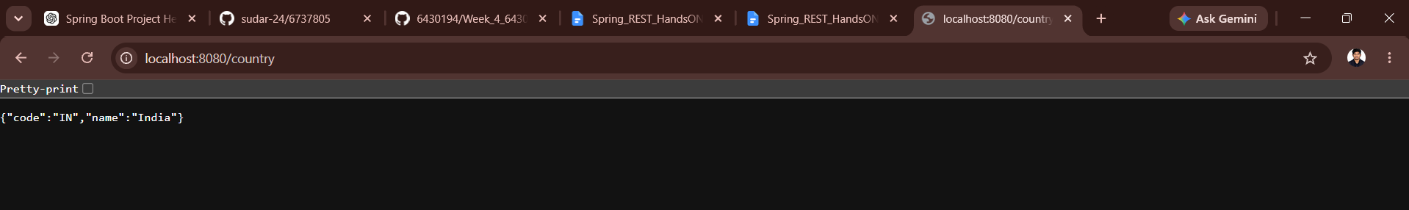
CONSOLE OUTPUT
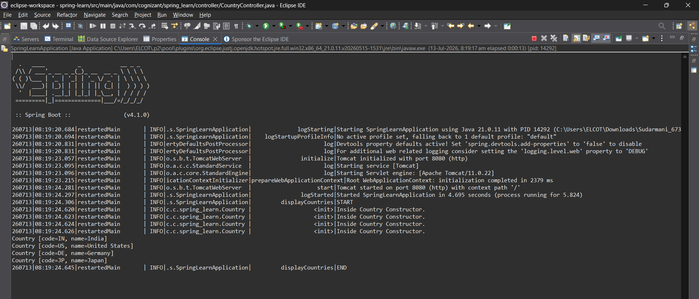
RESULT
The Country RESTful Web Service was created and executed successfully.
Exercise 3: Get All Countries RESTful Web Service
AIM
To create a RESTful web service that returns the list of all countries in JSON format.
Code:
package com.cognizant.spring_learn.controller;
import java.util.ArrayList;
import org.springframework.context.support.ClassPathXmlApplicationContext;
import org.springframework.web.bind.annotation.GetMapping;
import org.springframework.web.bind.annotation.RestController;

import com.cognizant.spring_learn.Country;

@RestController
public class CountryController {

@GetMapping("/country")
public Country getCountry() {

ClassPathXmlApplicationContext context =
new ClassPathXmlApplicationContext("country.xml");

Country country = (Country) context.getBean("in");

context.close();

return country;
}
@GetMapping("/countries")
public ArrayList<Country> getCountries() {

ClassPathXmlApplicationContext context =
new ClassPathXmlApplicationContext("country.xml");

ArrayList<Country> countryList =
(ArrayList<Country>) context.getBean("countryList");

context.close();

return countryList;
}
}

OUTPUT
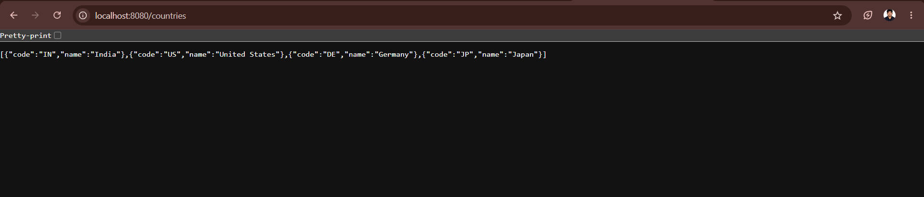
CONSOLE OUTPUT
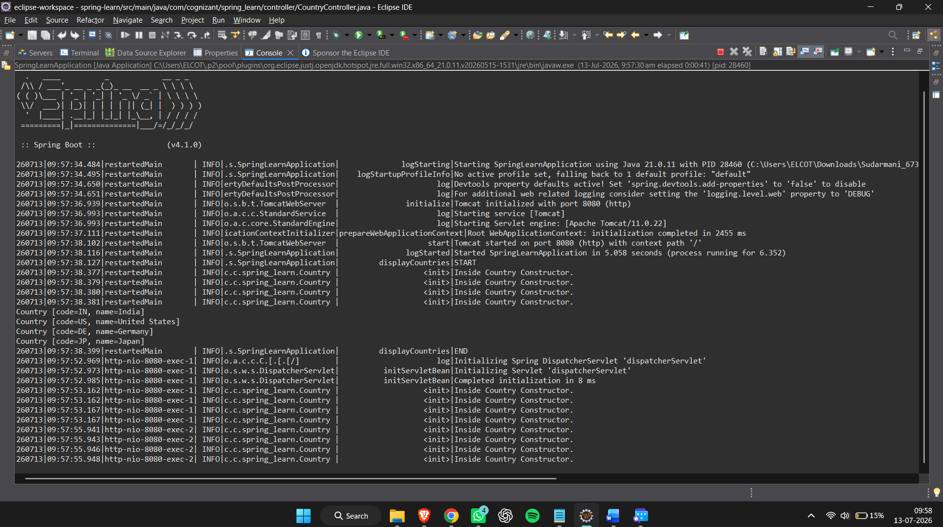
RESULT
Successfully created a RESTful web service that returns all countries in JSON format.
Exercise 4: REST - Get Country Based on Country Code
CODE
To create a RESTful web service that returns a specific country based on the country code (case-insensitive).
CountryController.java
package com.cognizant.spring_learn.controller;
import java.util.ArrayList;
import org.springframework.beans.factory.annotation.Autowired;
import org.springframework.context.support.ClassPathXmlApplicationContext;
import org.springframework.web.bind.annotation.GetMapping;
import org.springframework.web.bind.annotation.PathVariable;
import org.springframework.web.bind.annotation.RestController;
import com.cognizant.spring_learn.Country;
import com.cognizant.spring_learn.service.CountryService;
@RestController
public class CountryController {
@Autowired
private CountryService countryService;
@GetMapping("/country")
public Country getCountry() {
ClassPathXmlApplicationContext context =
new ClassPathXmlApplicationContext("country.xml");
Country country = (Country) context.getBean("in");
context.close();
return country;
}
@GetMapping("/countries")
@SuppressWarnings("unchecked")
public ArrayList<Country> getCountries() {
ClassPathXmlApplicationContext context =
new ClassPathXmlApplicationContext("country.xml");
ArrayList<Country> countryList =
(ArrayList<Country>) context.getBean("countryList");
context.close();
return countryList;
}
@GetMapping("/countries/{code}")
public Country getCountry(@PathVariable String code) {
return countryService.getCountry(code);
}
}
CountryService.java
package com.cognizant.spring_learn.service;
import java.util.ArrayList;
import org.springframework.context.support.ClassPathXmlApplicationContext;
import org.springframework.stereotype.Service;
import com.cognizant.spring_learn.Country;
@Service
public class CountryService {
@SuppressWarnings("unchecked")
public Country getCountry(String code) {
ClassPathXmlApplicationContext context =
new ClassPathXmlApplicationContext("country.xml");
ArrayList<Country> countryList =
(ArrayList<Country>) context.getBean("countryList");
for (Country country : countryList) {
if (country.getCode().equalsIgnoreCase(code)) {
context.close();
return country;
}
}
context.close();
return null;
}
}
OUTPUT
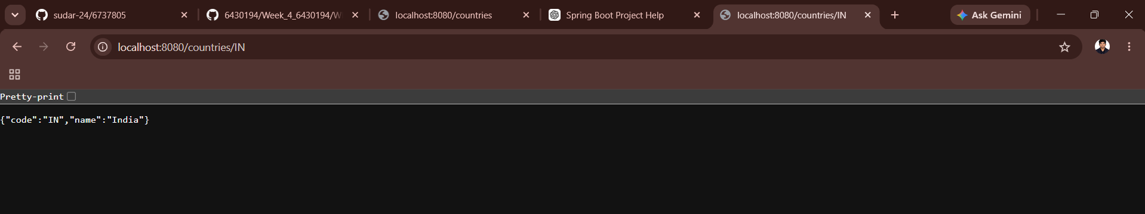
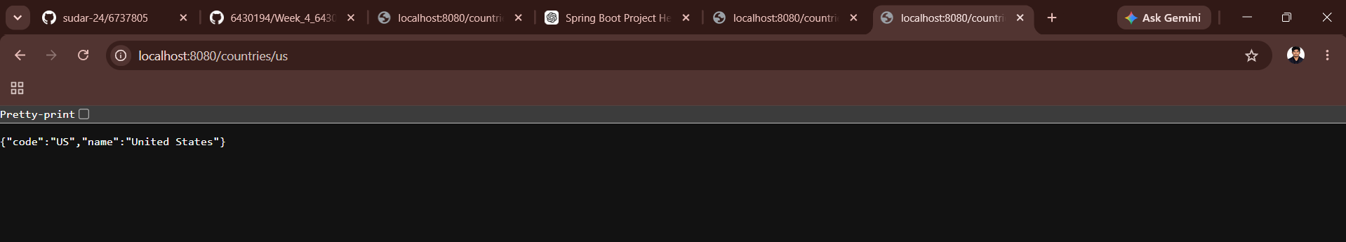
RESULT
Successfully created a RESTful web service that returns a country based on the given country code.

Exercise 5: REST – Get Country Exceptional Scenario
CODE
CountryNotFoundException.java
package com.cognizant.spring_learn.exception;
import org.springframework.http.HttpStatus;
import org.springframework.web.bind.annotation.ResponseStatus;
@ResponseStatus(value = HttpStatus.NOT_FOUND, reason = "Country not found")
public class CountryNotFoundException extends RuntimeException {
private static final long serialVersionUID = 1L;
}
CountryService.java
package com.cognizant.spring_learn.service;
import com.cognizant.spring_learn.exception.CountryNotFoundException;
import java.util.ArrayList;
import org.springframework.context.support.ClassPathXmlApplicationContext;
import org.springframework.stereotype.Service;
import com.cognizant.spring_learn.Country;
@Service
public class CountryService {
@SuppressWarnings("unchecked")
public Country getCountry(String code) {
ClassPathXmlApplicationContext context =
new ClassPathXmlApplicationContext("country.xml");
ArrayList<Country> countryList =
(ArrayList<Country>) context.getBean("countryList");
for (Country country : countryList) {
if (country.getCode().equalsIgnoreCase(code)) {
context.close();
return country;
}
}
context.close();
throw new CountryNotFoundException();
}
}
CountryController.java
package com.cognizant.spring_learn.controller;
import java.util.ArrayList;
import com.cognizant.spring_learn.exception.CountryNotFoundException;
import org.springframework.beans.factory.annotation.Autowired;
import org.springframework.context.support.ClassPathXmlApplicationContext;
import org.springframework.web.bind.annotation.GetMapping;
import org.springframework.web.bind.annotation.PathVariable;
import org.springframework.web.bind.annotation.RestController;
import com.cognizant.spring_learn.Country;
import com.cognizant.spring_learn.service.CountryService;
@RestController
public class CountryController {
@Autowired
private CountryService countryService;
@GetMapping("/country")
public Country getCountry() {
ClassPathXmlApplicationContext context =
new ClassPathXmlApplicationContext("country.xml");
Country country = (Country) context.getBean("in");
context.close();
return country;
}
@GetMapping("/countries")
@SuppressWarnings("unchecked")
public ArrayList<Country> getCountries() {
ClassPathXmlApplicationContext context =
new ClassPathXmlApplicationContext("country.xml");
ArrayList<Country> countryList =
(ArrayList<Country>) context.getBean("countryList");
context.close();
return countryList;
}
@GetMapping("/countries/{code}")
public Country getCountry(@PathVariable String code) throws CountryNotFoundException {
return countryService.getCountry(code);
}
}
OUTPUT
1.Valid Request:
http://localhost:8080/countries/IN

2.Invalid Request:
http://localhost:8080/countries/AZ
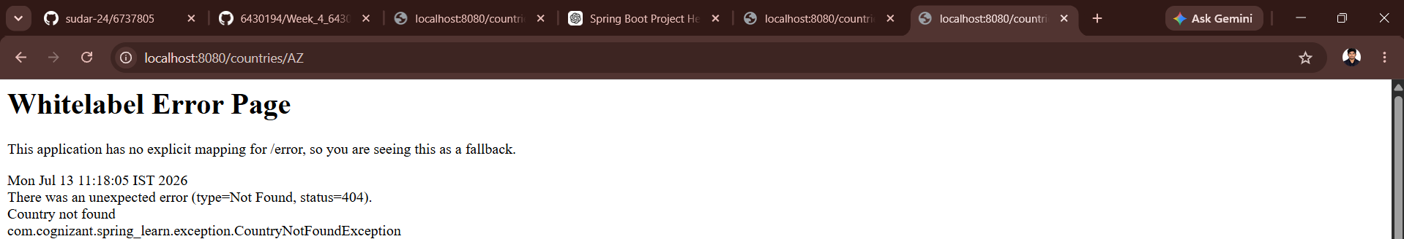
Result
Successfully handled the invalid country code by throwing CountryNotFoundException and returning a 404 Not Found response.

