WEEK 1
MODULE 1 : Data Structures and Algorithm Hands ON
Name : Sudarmani V
Superset Id : 6737805

Exercise 1: Inventory Management System
In a warehouse inventory system, thousands of products may be stored. Efficient data structures and algorithms help to:
- Store product information effectively.
- Search products quickly.
- Update stock details efficiently.
- Reduce processing time and memory usage.
- Improve overall system performance.

Suitable Data Structures:
ArrayList
- Easy to store and access product details.
- Suitable for small inventories.
HashMap
- Provides faster search, update, and delete operations.
- Uses Product ID as the key for direct access.
LinkedList
- Useful when products are frequently added or removed.
- Efficient for insertion and deletion operations.
For this inventory management system, HashMap is selected because it allows faster access to
products using their Product ID.
Implementation:
Product :
class Product {
int productId;
String productName;
int quantity;
double price;

Product(int productId, String productName, int quantity, double price) {
this.productId = productId;
this.productName = productName;
this.quantity = quantity;
this.price = price;
}
public String toString() {
return "ID: " + productId +
", Name: " + productName +
", Quantity: " + quantity +
", Price: ₹" + price;
}
}
Inventory Management System:
import java.util.HashMap;

public class InventoryManagementSystem {

private HashMap<Integer, Product> inventory = new HashMap<>();

public void addProduct(Product product) {
inventory.put(product.productId, product);
System.out.println("Product Added");
}

public void updateProduct(int id, int quantity, double price) {
Product product = inventory.get(id);

if (product != null) {
product.quantity = quantity;
product.price = price;
System.out.println("Product Updated");
} else {
System.out.println("Product Not Found");
}
}

public void deleteProduct(int id) {
if (inventory.remove(id) != null) {
System.out.println("Product Deleted");
} else {
System.out.println("Product Not Found");
}
}

public void displayProducts() {
for (Product product : inventory.values()) {
System.out.println(product);
}
}

public static void main(String[] args) {

InventoryManagementSystem ims =
new InventoryManagementSystem();

ims.addProduct(
new Product(101, "Laptop", 10, 50000));

ims.addProduct(
new Product(102, "Mouse", 50, 500));

ims.updateProduct(101, 15, 52000);

ims.deleteProduct(102);

System.out.println("\nInventory Details:");
ims.displayProducts();
}
}
Output:
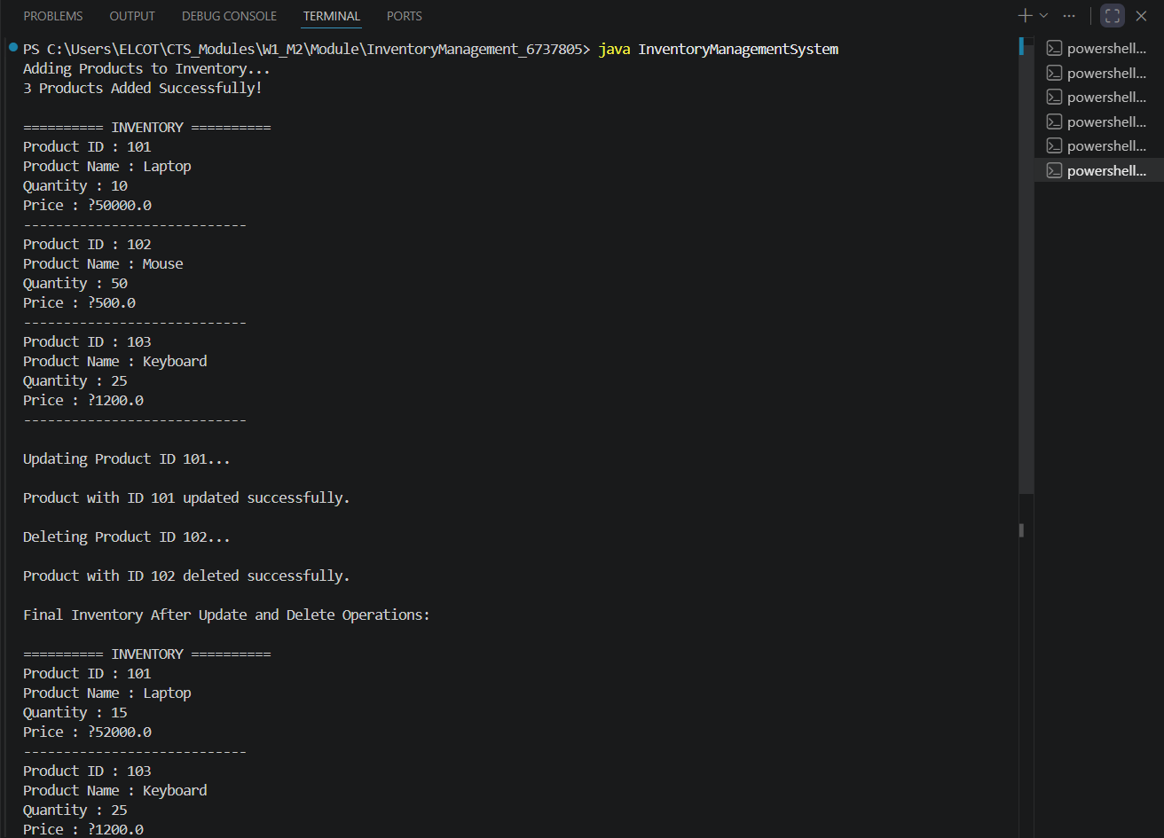
Time Complexity:
The inventory management system uses a HashMap to store products, providing efficient performance. The add, update, delete, and search operations all have an average time complexity of O(1) because products can be accessed directly using their product IDs as keys. This makes HashMap an ideal choice for managing large inventories quickly and efficiently.
Exercise 2: E-Commerce Platform Search Function

Asymptotic Notation :
Big O Notation is used to measure the efficiency of an algorithm by describing how its execution time grows as the input size increases. It helps developers compare algorithms and choose the most efficient one.
Search Operation Cases:
- Best Case: Element found at the first position.
- Average Case: Element found somewhere in the middle.
Worst Case: Element found at the last position or not found at all.
Setup :
class Product {
int productId;
String productName;
String category;

Product(int productId, String productName, String category) {
this.productId = productId;
this.productName = productName;
this.category = category;
}
}
Implementation :
class Product {
int productId;
String productName;
String category;

Product(int productId, String productName, String category) {
this.productId = productId;
this.productName = productName;
this.category = category;
}
}

public class EcommerceSearch {

public static int linearSearch(Product[] products, int targetId) {
for (int i = 0; i < products.length; i++) {
if (products[i].productId == targetId) {
return i;
}
}
return -1;
}

public static int binarySearch(Product[] products, int targetId) {
int left = 0;
int right = products.length - 1;

while (left <= right) {
int mid = (left + right) / 2;

if (products[mid].productId == targetId)
return mid;

if (products[mid].productId < targetId)
left = mid + 1;
else
right = mid - 1;
}

return -1;
}

public static void main(String[] args) {

Product[] products = {
new Product(101, "Laptop", "Electronics"),
new Product(102, "Mouse", "Accessories"),
new Product(103, "Keyboard", "Accessories"),
new Product(104, "Monitor", "Electronics"),
new Product(105, "Printer", "Office")
};

System.out.println("Product List Loaded Successfully!");
System.out.println("Total Products: " + products.length);

int searchId = 104;

int linearResult = linearSearch(products, searchId);

if (linearResult != -1)
System.out.println("\nLinear Search: Product Found at Index " + linearResult);
else
System.out.println("\nLinear Search: Product Not Found");

int binaryResult = binarySearch(products, searchId);

if (binaryResult != -1)
System.out.println("Binary Search: Product Found at Index " + binaryResult);
else
System.out.println("Binary Search: Product Not Found");

System.out.println("\nSearch Operation Completed Successfully.");
}
}

Output :
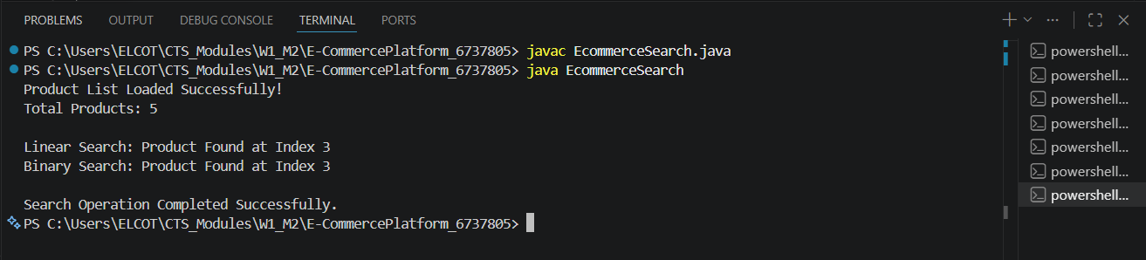

Linear Search checks each product one by one, resulting in a time complexity of O(n) in the average and worst cases.
Binary Search repeatedly divides the sorted array into halves, resulting in a much faster time complexity of O(log n).
For an e-commerce platform with a large number of products, Binary Search is more suitable because it provides faster search performance and improves the user experience by reducing search time.

Exercise 3 : Sorting Customer Orders
Sorting Algorithms :
Bubble Sort: Repeatedly compares adjacent elements and swaps them if they are in the wrong order.
Insertion Sort: Builds the sorted list one element at a time by inserting elements into their correct positions.
Quick Sort: Selects a pivot element and partitions the array into smaller subarrays, then recursively sorts them.
Merge Sort: Divides the array into halves, sorts each half, and merges them back together.
Setup :
class Order {
int orderId;
String customerName;
double totalPrice;

Order(int orderId, String customerName, double totalPrice) {
this.orderId = orderId;
this.customerName = customerName;
this.totalPrice = totalPrice;
}
}
Implementation :
class Order {
int orderId;
String customerName;
double totalPrice;

Order(int orderId, String customerName, double totalPrice) {
this.orderId = orderId;
this.customerName = customerName;
this.totalPrice = totalPrice;
}

public String toString() {
return "Order ID: " + orderId +
", Customer: " + customerName +
", Total Price: ₹" + totalPrice;
}
}

public class OrderSorting {

public static void bubbleSort(Order[] orders) {
int n = orders.length;

for (int i = 0; i < n - 1; i++) {
for (int j = 0; j < n - i - 1; j++) {
if (orders[j].totalPrice > orders[j + 1].totalPrice) {
Order temp = orders[j];
orders[j] = orders[j + 1];
orders[j + 1] = temp;
}
}
}
}

public static void quickSort(Order[] orders, int low, int high) {
if (low < high) {
int pivotIndex = partition(orders, low, high);

quickSort(orders, low, pivotIndex - 1);
quickSort(orders, pivotIndex + 1, high);
}
}

public static int partition(Order[] orders, int low, int high) {
double pivot = orders[high].totalPrice;
int i = low - 1;

for (int j = low; j < high; j++) {
if (orders[j].totalPrice < pivot) {
i++;

Order temp = orders[i];
orders[i] = orders[j];
orders[j] = temp;
}
}

Order temp = orders[i + 1];
orders[i + 1] = orders[high];
orders[high] = temp;

return i + 1;
}

public static void displayOrders(Order[] orders) {
for (Order order : orders) {
System.out.println(order);
}
}

public static void main(String[] args) {

Order[] orders = {
new Order(101, "Arun", 5000),
new Order(102, "Priya", 2500),
new Order(103, "Karthik", 8000),
new Order(104, "Divya", 3500)
};

System.out.println("Customer Orders Loaded Successfully!");

System.out.println("\nOrders Before Sorting:");
displayOrders(orders);

bubbleSort(orders);

System.out.println("\nOrders After Bubble Sort:");
displayOrders(orders);

quickSort(orders, 0, orders.length - 1);

System.out.println("\nOrders After Quick Sort:");
displayOrders(orders);

System.out.println("\nOrder Sorting Completed Successfully.");
}
}

Output:
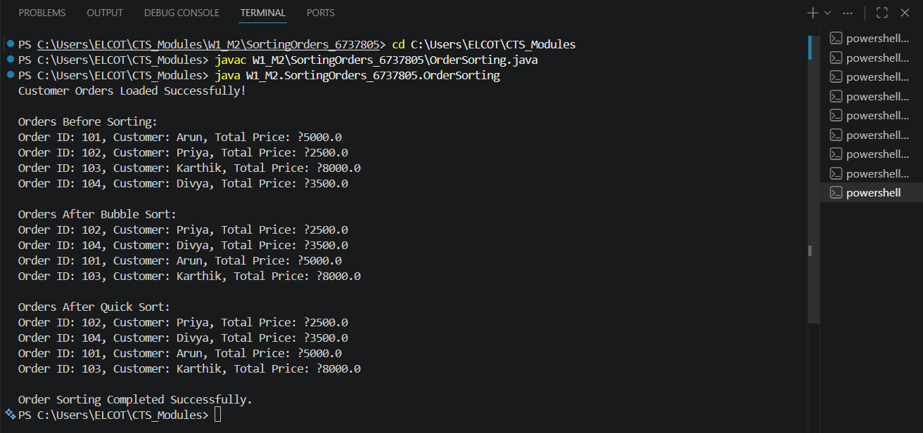

Bubble Sort has a time complexity of O(n²) because it repeatedly compares and swaps adjacent elements.
Quick Sort has an average time complexity of O(n log n), making it much faster for large datasets.
Quick Sort is generally preferred because it performs significantly better than Bubble Sort when sorting a large number of customer orders, reducing processing time and improving system efficiency.

Exercise 4 : Employee Management System

Array Representation:
Arrays store elements in contiguous memory locations, allowing direct access to elements using their index. The main advantages of arrays are fast access to elements, simple implementation, and efficient memory usage for storing a fixed number of records.

Setup:
class Employee {
int employeeId;
String name;
String position;
double salary;

Employee(int employeeId, String name, String position, double salary) {
this.employeeId = employeeId;
this.name = name;
this.position = position;
this.salary = salary;
}
}

Implementation:
class Employee {
int employeeId;
String name;
String position;
double salary;

Employee(int employeeId, String name, String position, double salary) {
this.employeeId = employeeId;
this.name = name;
this.position = position;
this.salary = salary;
}

public String toString() {
return "Employee ID: " + employeeId +
", Name: " + name +
", Position: " + position +
", Salary: ₹" + salary;
}
}

public class EmployeeManagementSystem {

static Employee[] employees = new Employee[10];
static int count = 0;

public static void addEmployee(Employee employee) {
employees[count++] = employee;
}

public static void searchEmployee(int id) {
for (int i = 0; i < count; i++) {
if (employees[i].employeeId == id) {
System.out.println("\nEmployee Found:");
System.out.println(employees[i]);
return;
}
}
System.out.println("\nEmployee Not Found");
}

public static void traverseEmployees() {
System.out.println("\nEmployee Records:");
for (int i = 0; i < count; i++) {
System.out.println(employees[i]);
}
}

public static void deleteEmployee(int id) {
for (int i = 0; i < count; i++) {
if (employees[i].employeeId == id) {
for (int j = i; j < count - 1; j++) {
employees[j] = employees[j + 1];
}
count--;
System.out.println("\nEmployee Deleted Successfully");
return;
}
}
System.out.println("\nEmployee Not Found");
}

public static void main(String[] args) {

System.out.println("Adding Employee Records...");

addEmployee(new Employee(101, "Sudar", "AI Engineer", 50000));
addEmployee(new Employee(102, "Arun", "Developer", 45000));
addEmployee(new Employee(103, "Priya", "Tester", 40000));

System.out.println("3 Employees Added Successfully!");

traverseEmployees();

searchEmployee(102);

deleteEmployee(103);

System.out.println("\nFinal Employee Records:");
traverseEmployees();

System.out.println("\nEmployee Management Completed Successfully.");
}
}

Output:
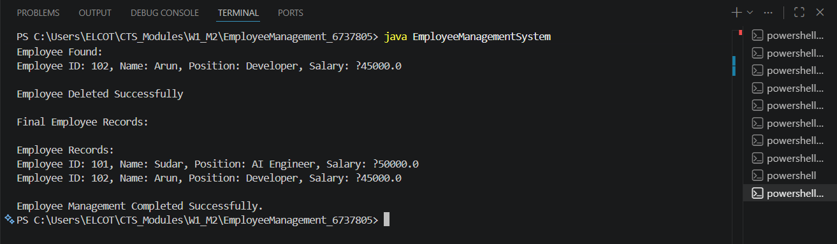

Analysis :
- Add Employee: O(1) – Employee is added directly if space is available.
- Search Employee: O(n) – May need to check all employee records.
- Traverse Employees: O(n) – Visits every employee in the array.
- Delete Employee: O(n) – Remaining elements must be shifted after deletion.
- Limitation: Arrays have a fixed size and are not suitable when records change frequently.

Exercise 5: Task Management System

Linked Lists:
Singly Linked List: Each node contains data and a reference to the next node.
Doubly Linked List: Each node contains data, a reference to the next node, and a reference to the previous node.
Setup:
class Task {
int taskId;
String taskName;
String status;

Task(int taskId, String taskName, String status) {
this.taskId = taskId;
this.taskName = taskName;
this.status = status;
}
}

Implementation :
class Task {

int taskId;
String taskName;
String status;
Task next;

Task(int taskId, String taskName, String status) {
this.taskId = taskId;
this.taskName = taskName;
this.status = status;
this.next = null;
}
}

public class TaskManagementSystem {

private Task head;

public void addTask(int id, String name, String status) {
Task newTask = new Task(id, name, status);

if (head == null) {
head = newTask;
} else {
Task temp = head;
while (temp.next != null) {
temp = temp.next;
}
temp.next = newTask;
}
}

public void searchTask(int id) {
Task temp = head;

while (temp != null) {
if (temp.taskId == id) {
System.out.println("\nTask Found:");
System.out.println("Task ID: " + temp.taskId);
System.out.println("Task Name: " + temp.taskName);
System.out.println("Status: " + temp.status);
return;
}
temp = temp.next;
}

System.out.println("\nTask Not Found");
}

public void deleteTask(int id) {

if (head == null)
return;

if (head.taskId == id) {
head = head.next;
System.out.println("\nTask Deleted Successfully");
return;
}

Task temp = head;

while (temp.next != null && temp.next.taskId != id) {
temp = temp.next;
}

if (temp.next != null) {
temp.next = temp.next.next;
System.out.println("\nTask Deleted Successfully");
} else {
System.out.println("\nTask Not Found");
}
}

public void traverseTasks() {

Task temp = head;

System.out.println("\nTask List:");

while (temp != null) {
System.out.println(
"Task ID: " + temp.taskId +
", Task Name: " + temp.taskName +
", Status: " + temp.status
);
temp = temp.next;
}
}

public static void main(String[] args) {

TaskManagementSystem tms =
new TaskManagementSystem();

System.out.println("Adding Tasks...");

tms.addTask(101, "Design UI", "Pending");
tms.addTask(102, "Develop Backend", "In Progress");
tms.addTask(103, "Testing", "Pending");

System.out.println("3 Tasks Added Successfully!");

tms.traverseTasks();

tms.searchTask(102);

tms.deleteTask(103);

System.out.println("\nFinal Task List:");
tms.traverseTasks();

System.out.println("\nTask Management Completed Successfully.");
}
}
Output:
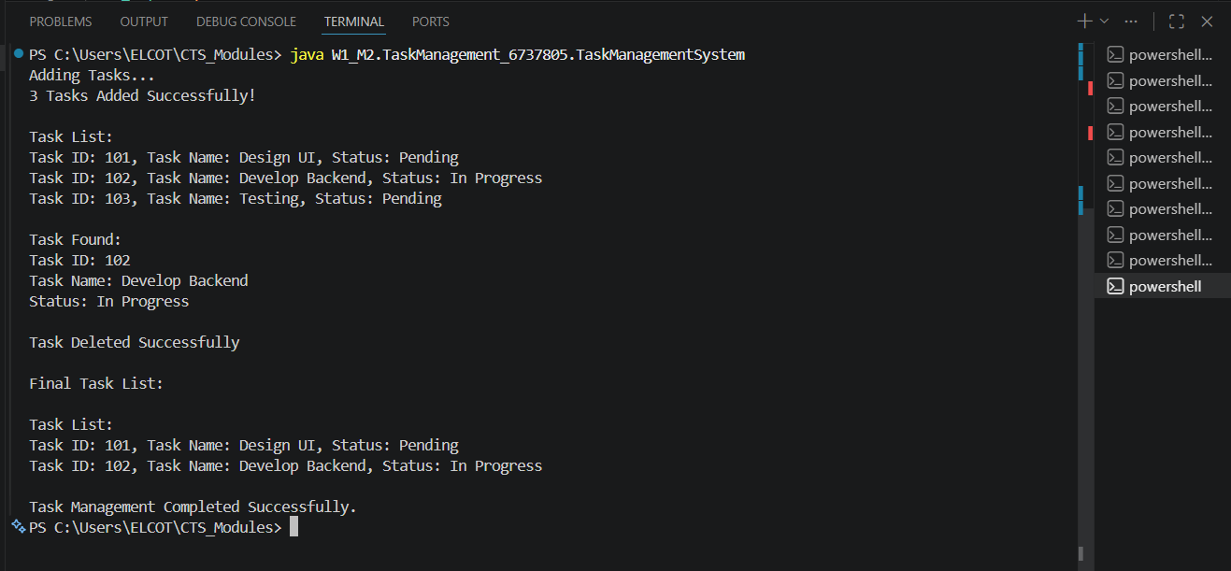
Analysis:

Add Task: O(n) – Traverses to the end of the list before inserting.
Search Task: O(n) – Checks nodes one by one.
Traverse Tasks: O(n) – Visits every node in the list.
Delete Task: O(n) – Searches for the task before deleting it.
Advantage: Linked lists are dynamic in size and allow easy insertion and deletion without shifting elements, making them more suitable than arrays for frequently changing data.

Exercise 6: Library Management System

Search Algorithms:
Linear Search: Checks each book one by one until the required book is found.
Binary Search: Repeatedly divides a sorted list into halves to find the required book more quickly.
Setup:
class Book {
int bookId;
String title;
String author;

Book(int bookId, String title, String author) {
this.bookId = bookId;
this.title = title;
this.author = author;
}
}
Implementation:
class Book {
int bookId;
String title;
String author;
Book(int bookId, String title, String author) {
this.bookId = bookId;
this.title = title;
this.author = author;
}
}

public class LibraryManagementSystem {
public static int linearSearch(Book[] books, String title) {
for (int i = 0; i < books.length; i++) {
if (books[i].title.equalsIgnoreCase(title)) {
return i;
}
}
return -1;
}
public static int binarySearch(Book[] books, String title) {
int left = 0;
int right = books.length - 1;
while (left <= right) {
int mid = (left + right) / 2;
int result =
books[mid].title.compareToIgnoreCase(title);
if (result == 0)
return mid;
if (result < 0)
left = mid + 1;
else
right = mid - 1;
}
return -1;
}
public static void main(String[] args) {
Book[] books = {
new Book(101, "C Programming", "Dennis Ritchie"),
new Book(102, "Data Structures", "Mark Allen"),
new Book(103, "Java Programming", "James Gosling"),
new Book(104, "Python Basics", "Guido van Rossum"),
new Book(105, "Web Development", "John Smith")
};
System.out.println("Library Books Loaded Successfully!");
System.out.println("Total Books: " + books.length);
String searchTitle = "Python Basics";
int linearResult =
linearSearch(books, searchTitle);
if (linearResult != -1)
System.out.println(
"\nLinear Search: Book Found - " +
books[linearResult].title);
else
System.out.println(
"\nLinear Search: Book Not Found");
int binaryResult =
binarySearch(books, searchTitle);
if (binaryResult != -1)
System.out.println(
"Binary Search: Book Found - " +
books[binaryResult].title);
else
System.out.println(
"Binary Search: Book Not Found");
System.out.println(
"\nLibrary Search Completed Successfully.");
}
}
Output:
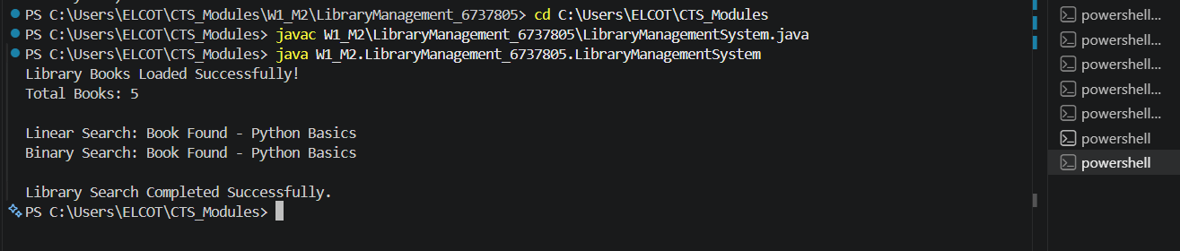

Analysis:
- Linear Search: O(n) – Checks each book one by one.
- Binary Search: O(log n) – Repeatedly divides the sorted list into halves.
- Use Linear Search: For small or unsorted datasets.
- Use Binary Search: For large, sorted datasets because it is much faster and more efficient.

Exercise 7: Financial Forecasting

Recursive Algorithms
Recursion is a programming technique in which a method calls itself to solve a problem. A recursive function works by breaking a large problem into smaller subproblems and continues calling itself until a base condition is reached. Recursion makes code simpler and easier to understand for problems that have repetitive patterns, such as financial forecasting, factorial calculation, and tree traversal.

Setup:
Create a method to calculate the future value based on an initial value, growth rate, and number of years.
Implementation:
public class FinancialForecasting {

public static double predictFutureValue(
double currentValue,
double growthRate,
int years) {

if (years == 0) {
return currentValue;
}

return predictFutureValue(
currentValue * (1 + growthRate),
growthRate,
years - 1);
}

public static void main(String[] args) {

double currentValue = 10000;
double growthRate = 0.10;
int years = 5;

System.out.println("Financial Forecasting Started...");

double futureValue =
predictFutureValue(
currentValue,
growthRate,
years);

System.out.println("Current Value : ₹" + currentValue);
System.out.println("Growth Rate : 10%");
System.out.println("Years : " + years);
System.out.println("Future Value : ₹" + futureValue);

System.out.println("\nForecasting Completed Successfully.");
}
}

Output:
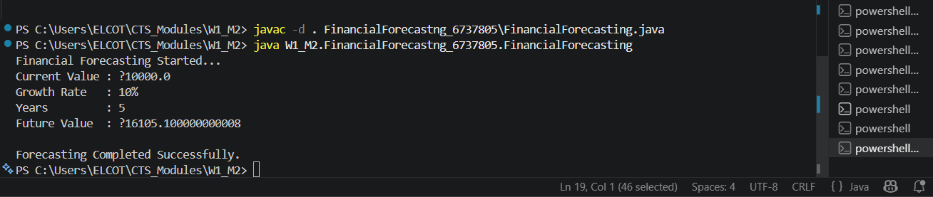

Analysis:
- Time Complexity: O(n) because the recursive method is called once for each year until the base condition is reached.
- Space Complexity: O(n) because each recursive call is stored in the call stack, increasing memory usage as the number of years grows.
- Optimization: The recursive solution can be optimized using an iterative approach or memoization, which reduces memory consumption and avoids unnecessary recursive calls.
- Advantage: Recursion provides a simple and easy-to-understand solution for financial forecasting by breaking the problem into smaller subproblems.
- Limitation: For very large numbers of years, recursion may lead to increased memory usage and stack overflow errors, making iterative solutions more suitable.

