**Sri Lanka Institute of Information**

**Technology**



**Data Warehousing & Business Intelligence**

**Assignment 01**

**Submitted by:**

**Gunathilaka U.K.R.S.W(it20188818)**

Contents

1.Data Set Selection. 3

Background 3

Content 3

ER Diagram 4

2. Preparation of Data Sources. 5

3. Solution Architecture. 6

4. Data warehouse design & development. 8

5. ETL Development. 9

5.1 ETL –Source To Staging 9

5.1.1 Load data User to staging 9

5.1.2 Load data Review to staging 10

5.1.3 Load data Hotel to staging 10

5.1.4 Load data Hotel Category to staging 11

5.1.5 Load data location to staging(.txt file) 11

5.1.6 Load data accm_txn_complete_time to staging 12

6. Staging To DW. 13

6.1 ETL System to Datawarehouse 13

6.1.1. Transfer and Load DimUser Data from staging 13

6.1.2. Transfer and Load DimReview Data from staging 14

6.1.3. Transfer and Load DimHotelCategory Data from staging 14

6.1.4. Transfer and Load DimLocation Data from staging (Slowly changing diamention) 15

6.1.5. Load FactHotel Data from staging 16

7. Datawarehouse Updating 17

7.1. Datawarehouse updating 17

7.1.1 Update factHotel accm_txn_complete_time 18

7.1.2 Update factHotel txn_process_time_hours 18

7.2 Accumulated Fact Table (FactHotel) 19

# 1.Data Set Selection.

## Background

This is a list of 1,000 hotels and their reviews provided by [Datafiniti's Business Database](https://datafiniti.co/products/business-data/). The dataset includes hotel location, name, rating, review data, title, username, and more. You can use this data to [compare hotel reviews on a state-by-state basis](https://datafiniti.co/state-state-comparison-hotel-reviews/); experiment with sentiment scoring and other natural language processing techniques. The review data lets you correlate keywords in the review text with ratings. E.g.:

* What are the bottom and top states for hotel reviews by average rating?
* What is the correlation between a state’s population and their number of hotel reviews?
* What is the correlation between a state’s tourism budget and their number of hotel reviews?

## Content

The data set was downloaded from -:

[**https://www.kaggle.com/datasets/datafiniti/hotel-reviews?select=Datafiniti_Hotel_Reviews.csv**](https://www.kaggle.com/datasets/datafiniti/hotel-reviews?select=Datafiniti_Hotel_Reviews.csv)

## Diagram Description automatically generatedER Diagram

# Preparation of Data Sources.

In order to data extraction need to prepare the data sources. From my main data source, I have extracted to type of data sources.

1. Text file (.txt)

* Location text file

1. CSV files (.csv)
   * Hotel CSV File.
   * Hotel Category CSV File.
   * User CSV File.
   * Review CSV File.
   * accm_txn_complete_time CSV

From these dataset, I import above csv files to SQL SERVER MANAGEMENT STUDIO and create the database called **IT20188818_sourceDB** Database.

**IT20188818_sourceDB** have following tables -:

* + accm_txn_complete_time table.
  + Hoteltbl Table.
  + HotelCategorytbl Table.
  + Usertbl Table.
  + Reviewtbl Table.

**Text file** –This text file include all the hotel address details including address, Postal code ,city, province and the country.

**ETL**

IT20188818_SourceDB

**S**

**T**

**A**

**G**

**I**

**N**

**G**

**ETL**

**ETL**

Location.txt

**ETL**

DatawareHouse

(IT20188818_DW )

accm_txn_complete_time.csv

IT20188818_Staging

# Solution Architecture.

**3.1 IT20188818_StagingDB.**

* accm_txn_complete_time
* stgHotel
* stgHotalCategory
* stgReview
* StgUser
* stgLocation

**3.2 IT20188818_DW**

* DimDate.
* DimHotelCategory.
* DimLocation.
* DimReview.
* DimUser.
* FactHotel.

**3.3 Architure Components.**

* Data Sources.

Operational System(**Accumulating**).

External Sources.

* Extract ,Transform and Load.

Extract – reading data from source systems.

Transform – Combine data from multiple sources, De-duplicating.

* Data Warehouse

EDW and Data Mart.

Dimensional Modeling- Facts and Dimensions.

Many schemas – In here I use star schema.

# Data warehouse design & development.

**4.1 Relational Diagram – Star Schema.**

**DimLocation** is **slowly changing dimention**. Address and city may be changed in future.Therefore, I get it as slowly changing attribute.

**Address -> PostalCode -> City -> Province ->Country This is the Hierachies (Location table.)**

# ETL Development.

## 5.1 ETL –Source To Staging

## 5.1.1 Load data User to staging

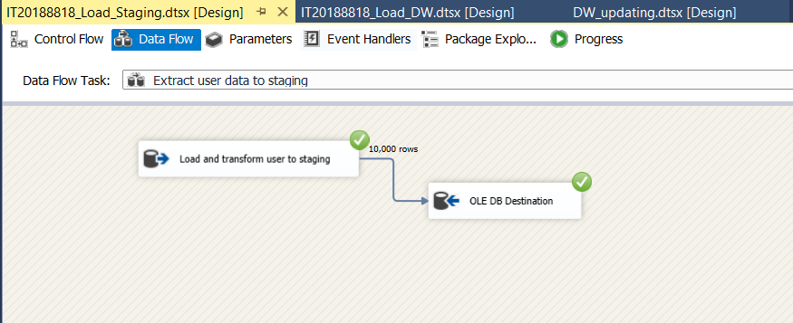

## 5.1.2 Load data Review to staging

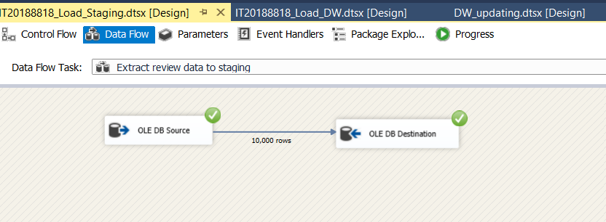

## 5.1.3 Load data Hotel to staging

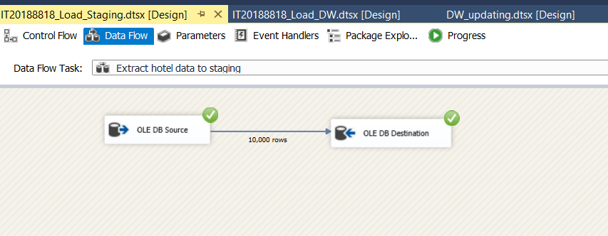

## 5.1.4 Load data Hotel Category to staging

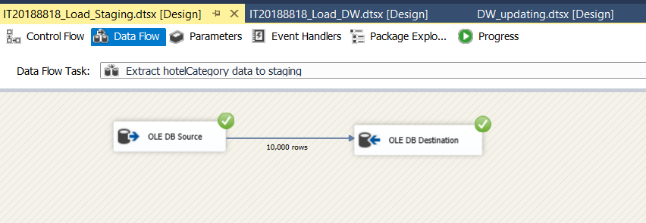

## 5.1.5 Load data location to staging(.txt file)

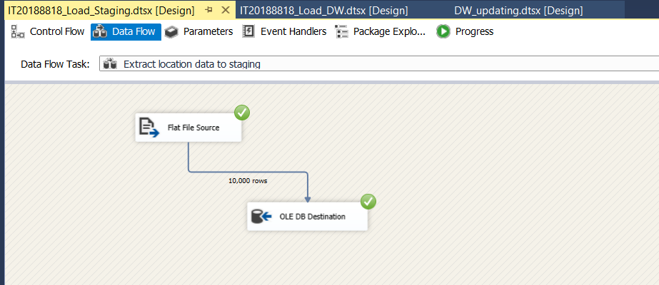

## 5.1.6 Load data accm_txn_complete_time to staging

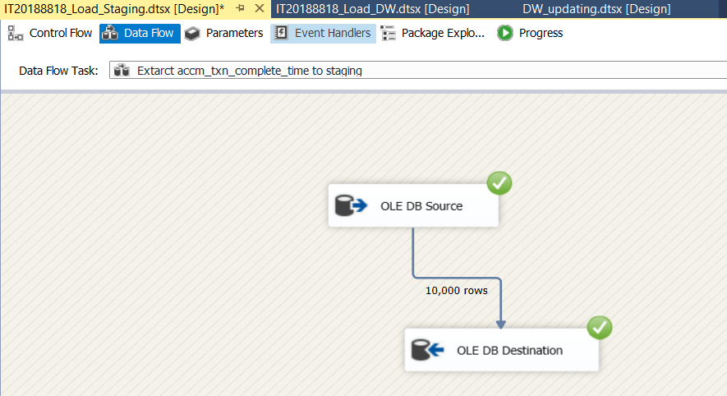

# Staging To DW.

## 6.1 ETL System to Datawarehouse

## 6.1.1. Transfer and Load DimUser Data from staging

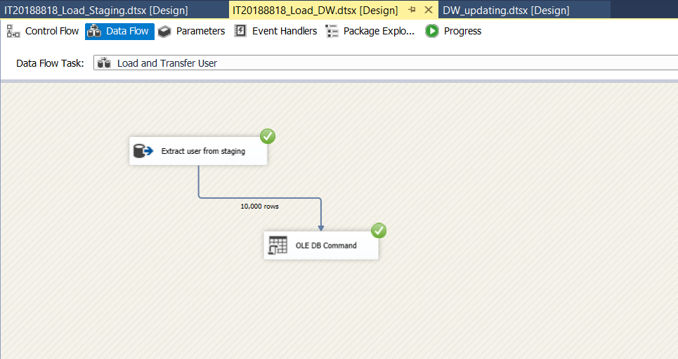

## 6.1.2. Transfer and Load DimReview Data from staging

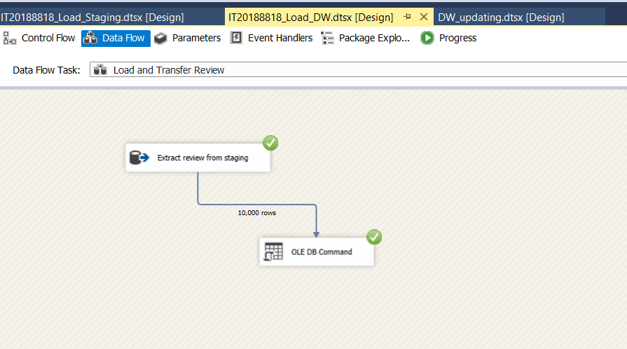

## 6.1.3. Transfer and Load DimHotelCategory Data from staging

## 6.1.4. Transfer and Load DimLocation Data from staging (Slowly changing dimension)

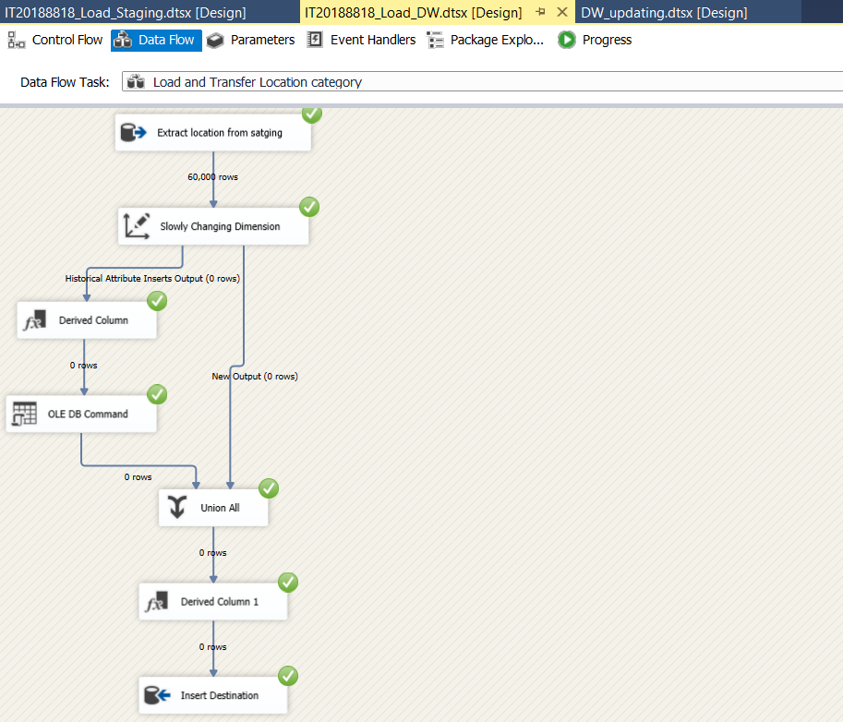

## 6.1.5. Load FactHotel Data from staging

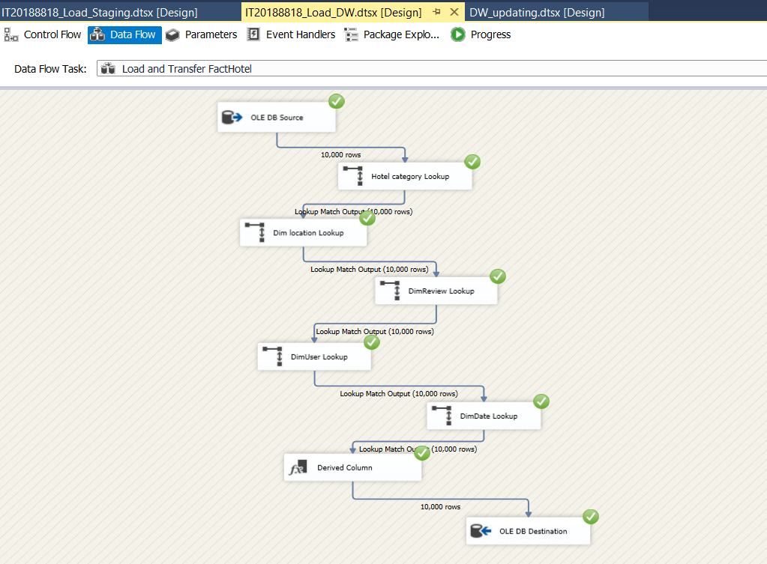

# Datawarehouse Updating

In order to creating Accumulated fact table I created a new SSIS package and updated accm_txn_complete_time and txn_process_time_hours.

## 7.1. Datawarehouse updating

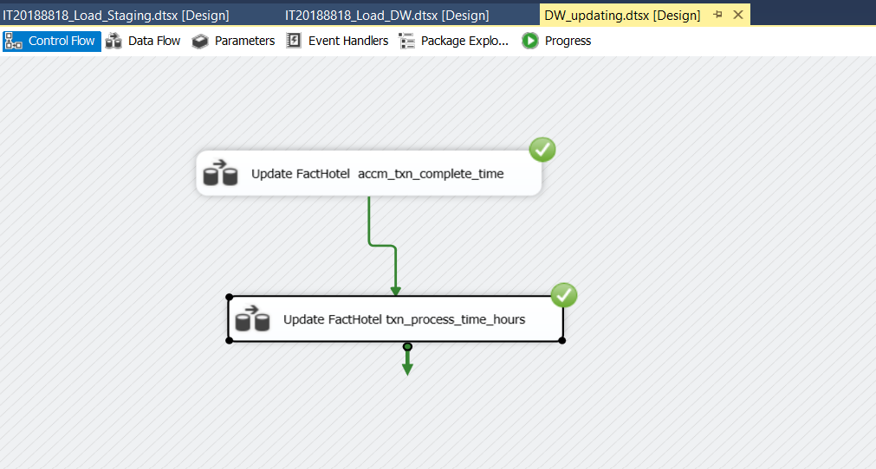

## 7.1.1 Update factHotel accm_txn_complete_time

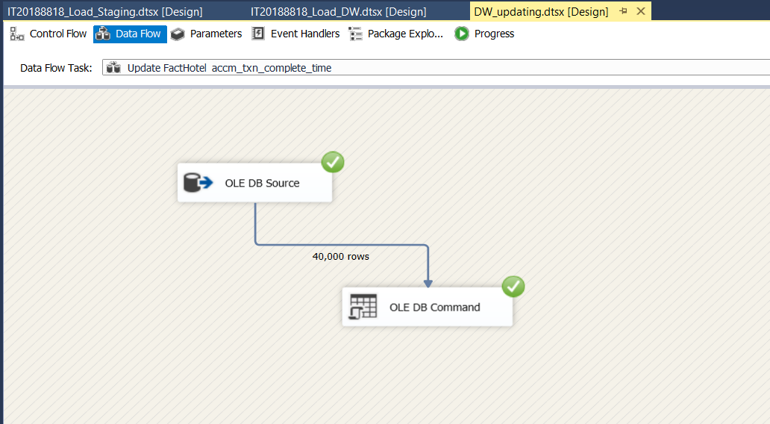

## 7.1.2 Update factHotel txn_process_time_hours

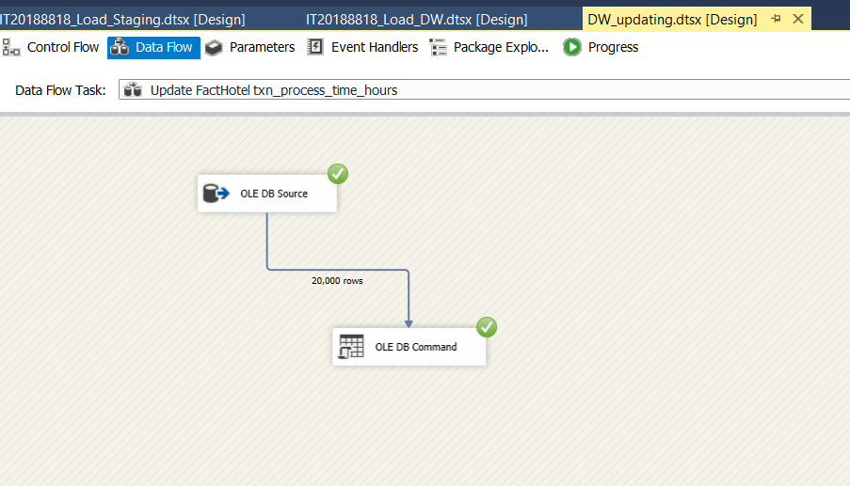

## 7.2 Accumulated Fact Table (FactHotel)

