**SRI LANKA INSTITUTE OF INFORMATION TECHNOLOGY Malabe**



**Data Warehousing And Business Intelligence**

**IT 3021**

**Assignment 02**

**Name : Gunathilaka U.K.R.S.W**

**Reg No : IT 20188818**

Contents

Data Source 3

SSAS Cube 3

OLAP Operation 9

• Roll Up 9

• Slicing 10

• Dice 11

SSRS Reports 12

# 

# Data Source

For this purpose use IT20188818_DW as Data warehouse which implemented in last Assignment (Assignment1).

## SSAS Cube

In here first create data source view using previous implemented data dimensions and fact table.

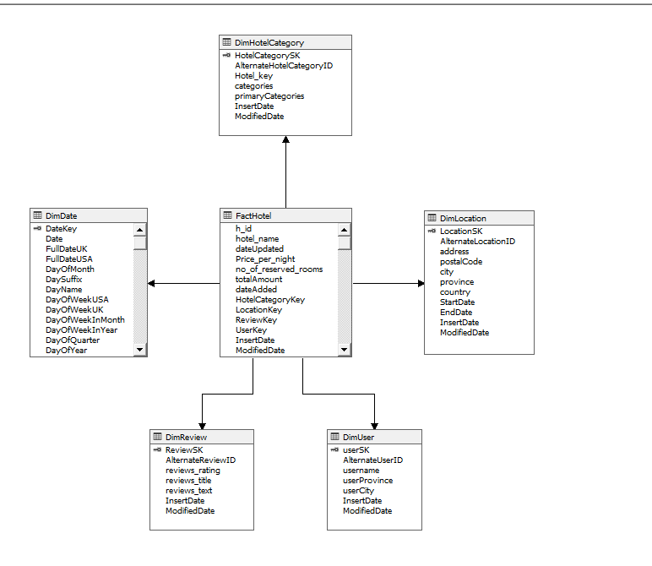

Then create Data Cube,

In here I choose FactHotel as measure group, DimDate, DimLocation, DimHotelcategory, DimUser and DimReview as dimensions.

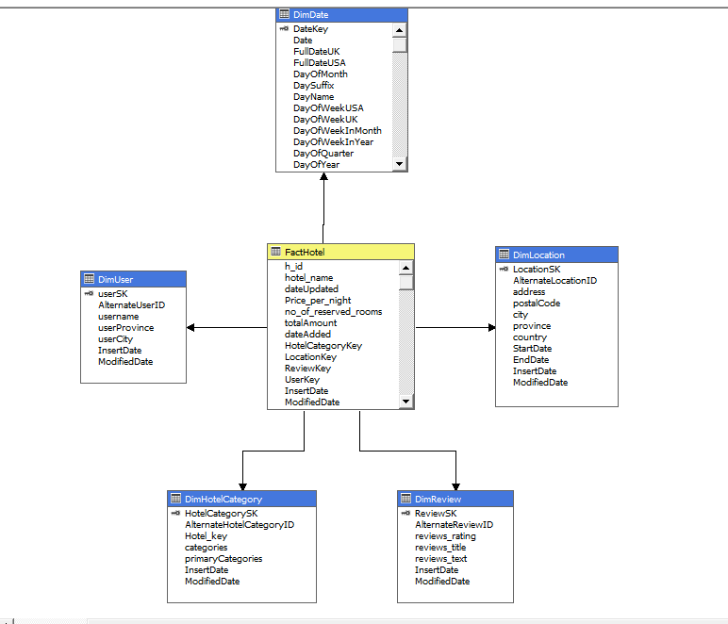

After that configure all the dimension with proper way.

* DimDate

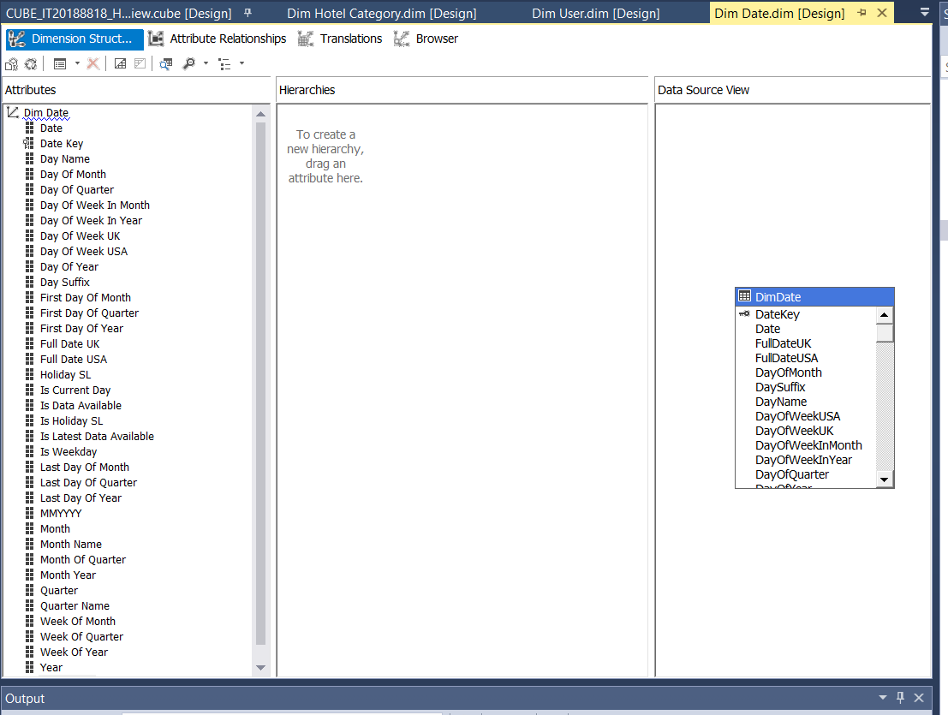

* DimUser

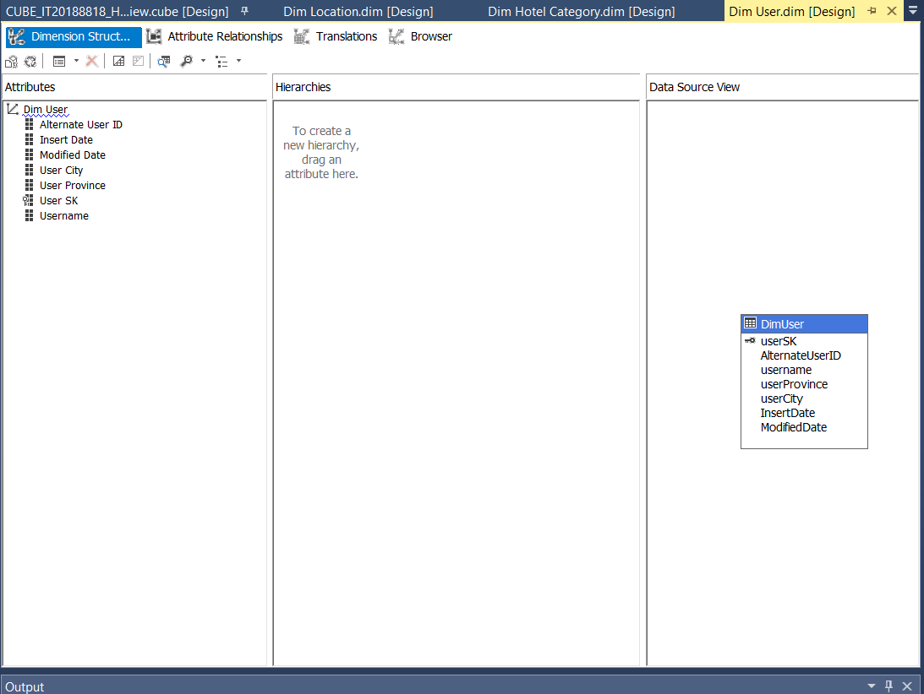

* DimHotelCategory

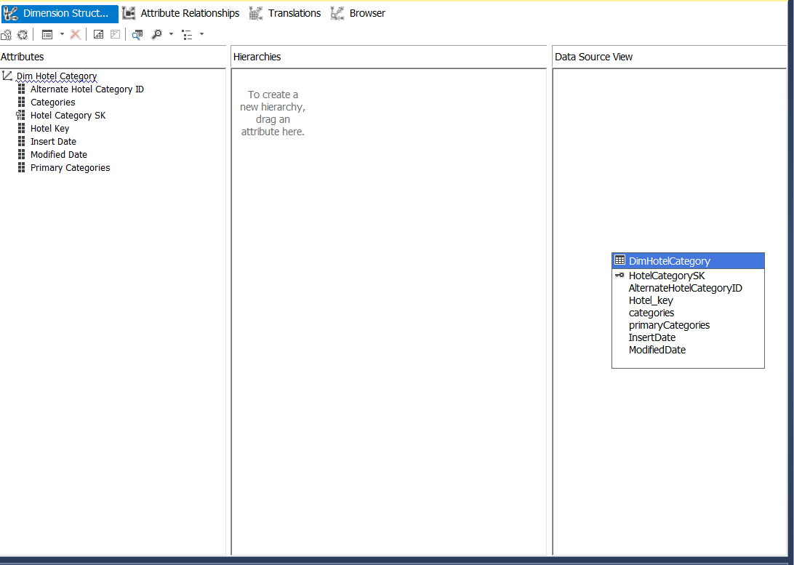

* DimLocation

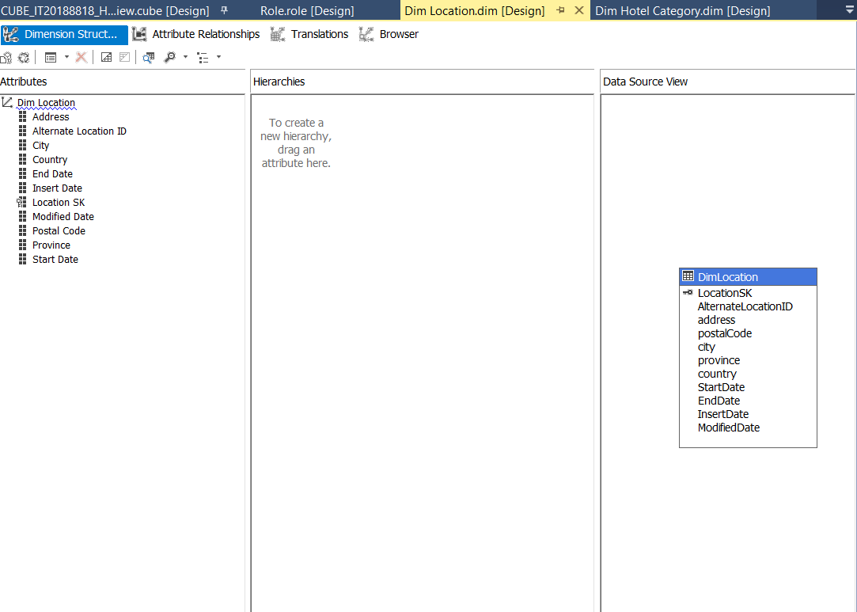

Then Deploy the Cube.

**Create KPI**

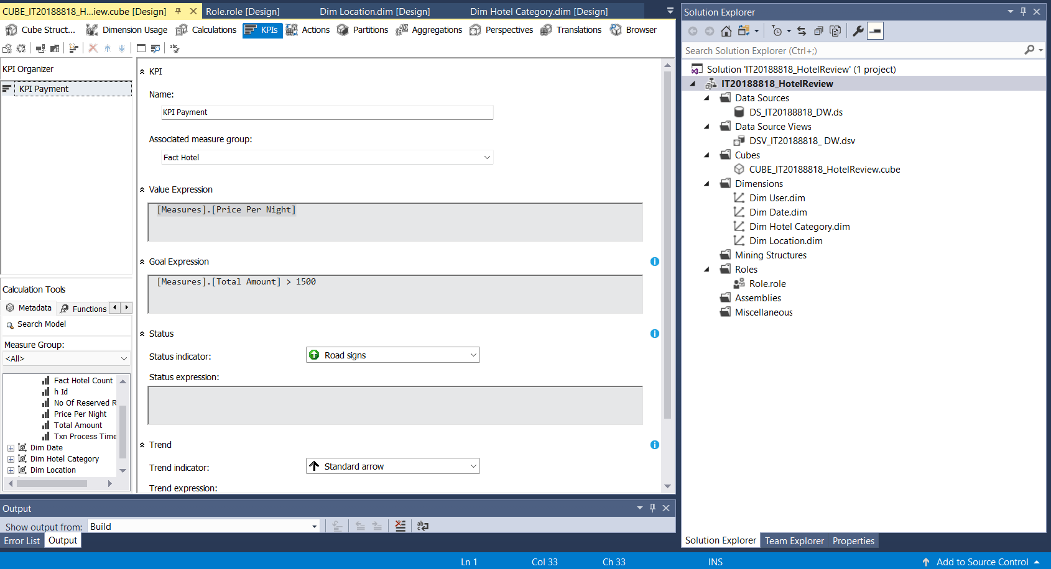KPI Use for monitoring measures.

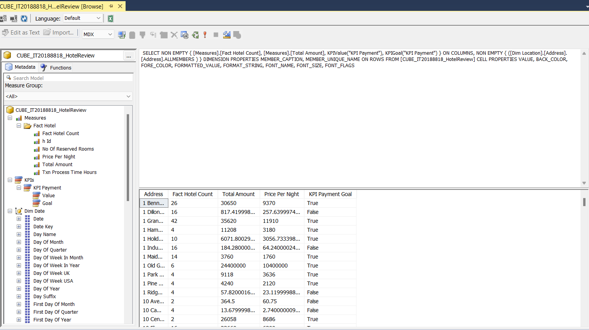After deploying of this Cube look like this,

# OLAP Operation

Using Excel Power Pivot, we can do all OLAP operation

## • Roll Up

The roll-up operation performs aggregation on a data cube, either by climbing up a hierarchy or by climbing down a hierarchy**.**

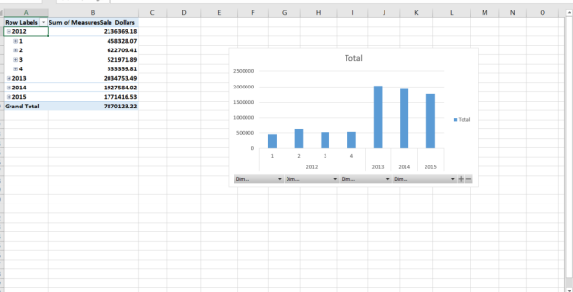

• **Drill-Down**

The Drill down operation is the reverse of roll up. It navigates from less detailed data to more detailed data.

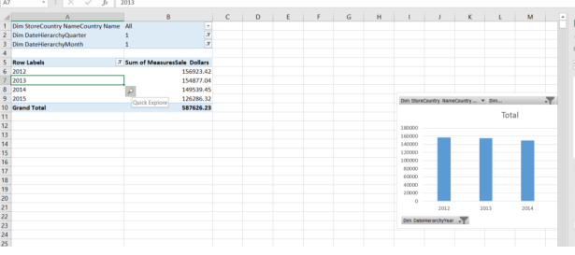

## • Slicing

Slice performs a selection on one dimension of the given cube, thus resulting in a sub cube.

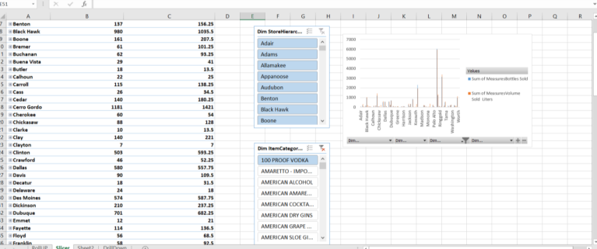

## • Dice

The dice operation defines a sub cube by performing a selection on two or more dimensions.

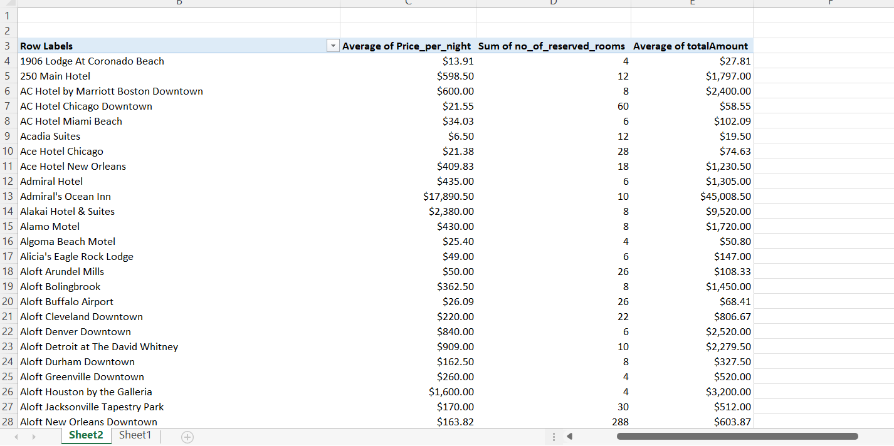

## SSRS Reports

**Report 01:**

Report with Matrix

In here yearly Hotel report TotalPrice vs HotelName, more than 10000 USD had. And there is one parameter called HotelCategory.

**Report 2:**

Report with more than one parameter This report has 3 parameters

* Country name
* City name
* Hotel ID

**Report 3:**

SSRS drill-down report

This report is yearly total price of the hotel.

**Report 4:**

SSRS drill-through report

In this repot link through the category