Exp-9
Real time monitoring of traffic in youtube data streaming using wireshark
Resolution
- 192*144
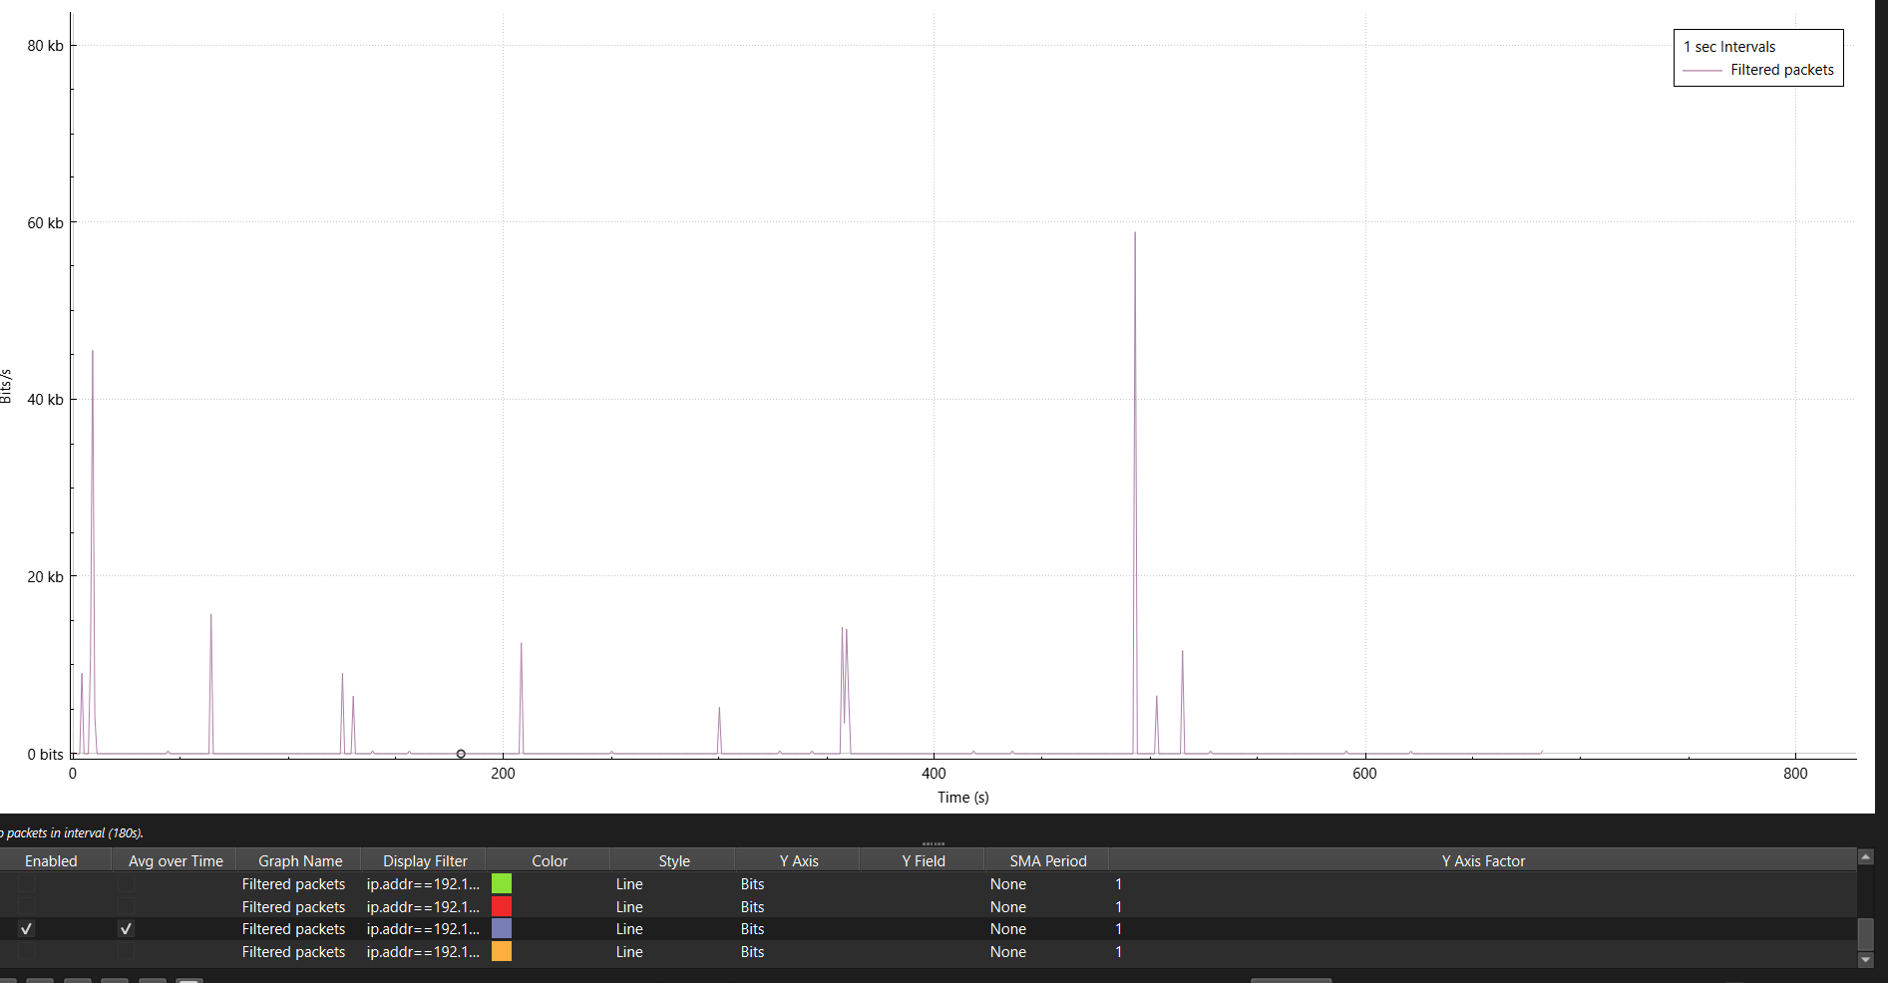

- 1280*720
