

**BSc Sports Performance Analysis and Talent Identification**

The School of Sport, Exercise and Applied Science welcomes all students irrespective of gender, ethnicity, cultural background of faith perspective and supports achievement of the highest educational outcomes.

PAI5003: Professional Placement

Placement Handbook 2024 – 2025

Full Name of Student:

Student Reg Number:

Full Name of Placement Organisation:

Role on Placement:

Placement Supervisor:

1.0 Module information

2.0 Information for placement providers

3.0 Voluntary Work Placement Agreement

4.0 PAI5003 Placement Contract

5.0 Placement Provider Health and Safety Checklist

6.0 Student Time sheet

# 1.0 Module Information

## 1.1 St Marys Contact Details

Module Convenor: Marc Turner

Marc.Turner@stmarys.ac.uk

L106

Placement manager & Course Lead: Rhiana Galvin

Rhi.Galvin@stmarys.ac.uk L106

Subject Lead: Mike Gilham

Mike.Gilham@stmarys.ac.uk L104

## 1.2 Management Structure

Placements are managed by the Placements Supervisor. This is overseen by the BSc Sport Performance Analysis & Talent ID Course Lead. Students are directly supported academically by their module convenor.

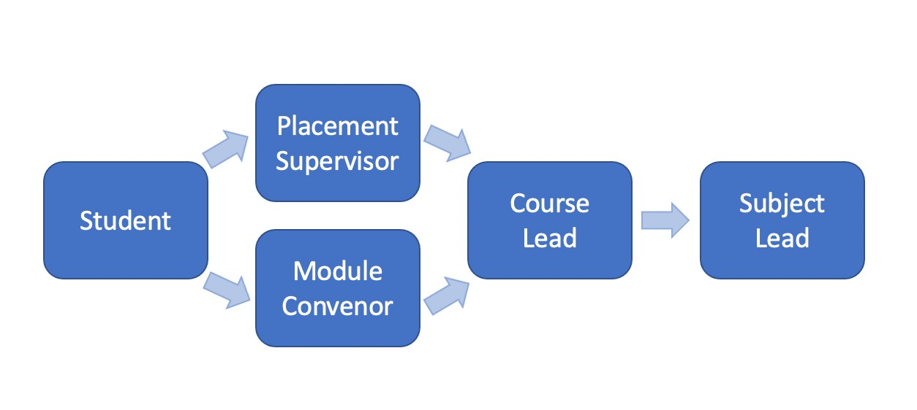

### 1.3 Module Description

This module will support the identification of student’s professional development needs and will inform their future employment decisions through providing a more longitudinal placement experience which will develop over time.

The module will have the capacity for students to work within professional sports environments across a full season long placement, and consequently gain experience in strategic yearlong planning and delivery.

This module will be delivered across two semesters (*3 and* 1) and will also include personal tutoring opportunities to support student’s professional development and lifelong learning to effectively support their transition into employment post- graduation.

### 1.4 Module Aims

This module aims to:

1. Provide students with the opportunity to engage with long term professional development planning, and identification of key individual development needs.
2. Develop students’ knowledge and understanding of performance analysis and talent identification reflective of the specific professional context and develop a critical appreciation of how to apply appropriate concepts and theories for the specific delivery focus of the department.
3. Provide an opportunity for students to develop a critical appreciation of how to monitor, report and evaluate key organisational performance indicators, to plan and implement an appropriate strategy.

## 1.5 Practice Based Learning

Practice-based learning forms an indispensable part of the Sport Performance Analysis and Talent ID learning process. Learning gained in practice settings is vital to students’ educational and professional development. Experience gained enables the acquisition of new knowledge and skills as well as the application, consolidation and reflection upon the learning gained in the university environment. Therefore, the aim is to offer students opportunities to develop core skills within an applied environment. Within practice learning teaching and supervision must be designed to encourage safe and effective practice, independent learning, and professional conduct.

The courses integrate practice placements into the academic curriculum to provide students with the opportunity to gain the experience to develop, apply and reflect upon practice across a variety of areas of contemporary performance analysts.

The total time allocated to placement is minimum of 250 hours per student. Students are scheduled to undertake the hours over the course of Semester 3 and 1 and to continue into Semester 2. Students will keep a cumulative record on completed hours to ensure that students meet the requirement.

# 2.0 Information for Placement Providers

Students on the BSc Sports Performance Analysis and Talent Identification programme are required to undertake a Work Placement as part of their Professional Placement module. This module will require students to attend bi-weekly online lectures and complete assignments which will enable them to reflect upon their personal and professional development throughout the placement itself.

The Professional Placement is a 40-credit module and will provide a valuable opportunity for students to gain knowledge, skills and experience relevant to their career interests and prepare them for future employment.

## 2.1 Benefits

For the Student:

1. Experiencing a sector relevant to their course and/or career interests.
2. Gaining an insight into what it is like to work in the industry and the roles available.
3. Learning from experienced applied professionals.
4. Contributing to the output of an organisation.
5. Developing an understanding of their skill set and how they may need to develop it.

For the Placement Provider:

1. An additional resource bringing a different perspective and fresh ideas.
2. Opportunity to identify and nurture talent for future recruitment drives.
3. Providing a valuable learning experience to a student and contributing to their personal and professional development.

## 2.2 Key Requirements

Key Requirements of the Placement:

* Students must complete a minimum of 250 hours in total, spread through the months of June 2024 – May 2025. The placement must be completed alongside other programme commitments.
* There are no obligations for the placement provider to pay the student, but we encourage travel expenses be offered.
* We do stipulate that the placement is a role within a Performance Analysis, Data or Talent ID fields. In addition, the work must be challenging and providing students with opportunities to develop their experience and skill set (‘shadowing’ for the entire placement is not suitable).
* Students will need work with the placement provider and module convenor to set targets to measure their achievement whilst on placement.
* Regular in situ support will be provided by the module convenor from St Mary’s University to ensure the student and placement provider are meeting the requirements set out in the agreement and contract.

## 2.3 The Placement Supervisor Role

We ask that the student is assigned a Placement Supervisor, who should ideally be someone working closely with them as they will be asked to provide feedback about the student during placement.

Before the placement:

* To support the University with adhering to QAA guidelines by completing and returning the documents within the placement handbook; Work Placement Agreement, Contract, Provider Checklist (with health and safety form).

* To attend one placement mentoring training workshop with the Placement Manager and Subject Lead.

During the Placement (Supporting the Student):

* Discuss, agree and document agreed targets for the student throughout the placement and their progress towards achieving them and to consider the students’ PDP.
* Verify the student’s hours that have been completed by signing their timesheet.
* At the end of the placement (Student Feedback): We ask that you complete a brief feedback form to provide the student and the University with comments surrounding the performance of the individual during their professional placement.
* Feedback on the student will include communication (both written and verbal), working with others, task competency and a willingness to learn and accept advice.

## 2.4 Uniform and Appearance

Students must wear appropriate uniform while on placement with suitable footwear. Uniform must be clean and tidy, in line with the placement provider requirements. Students can wear that of the organisation. The University will not supply students with uniform. Ordering uniform for placement is available via Kukri Sports St Mary’s University – Sport, Health, App Science and via the following link: https://www.kukrisports.co.uk/teamshop/shasacademickit/productNavListNg.action

**You will have a designated point of contact within the programme team (Placement Manager & Course Lead, Rhiana Galvin) who will support you and the student throughout the placement.**

**For module content, theory learning and assessments, you should content the module convenor (Patrick Oxenham).**

**We look forward to working with you to create a mutually beneficial partnership.**

# 3.0 Voluntary Work Placement Agreement

Voluntary Work Placement Agreement

This is a three-way agreement between St Mary’s University, the Placement Provider, and the student.

## 3.1 Introduction

This agreement is made between: Parties

1. St Mary’s University, BSc Sports Performance Analysis and Talent Identification Programme and
2. The Placement Provider and
3. The student

This agreement seeks to clarify the arrangements between the parties for students undertaking a Work Placement as part of their studies at St Mary’s University.

The placement provider will be given a guide containing detailed information about the objectives of the placement and the policies and procedures involved.

This agreement will take effect on the date that the student begins their placement.

3.2 Responsibilities of St Mary’s University

To the Student:

1. Assist the student in ensuring they are adequately prepared to undertake placement.
2. Assistthestudentinsettingtheirgoalsforplacementandidentifyingtheir existing strengths and areas for development through the placement.
3. Appoint a ‘Work Placement Supervisor ’who will liaise with the host organisation during the placement.
4. Monitor the performance of the student in the workplace via communication with the Placement Provider.
5. Assist the student in any matters of concern that may arise during the placement.
6. Provide confidential counselling for the student in relation to their work placement.
7. Conduct assessment as required in the module descriptor.

To the Placement Provider:

1. Guide the Placement Provider in the assessment criteria used by St Mary’s University.
2. Encourage the student’s productive contribution to the overall mission of the Placement Provider.
3. Maintain communication with the Workplace Supervisor and provide on-going support to the setting during the placement.
4. Provide adequate guidance and advice to enable the Placement Provider to provide a successful placement experience.
5. Respect the confidentiality of any information designated as being so by the Placement Provider.

## 3.3 Responsibilities of the Placement Provider

1. Offer a placement within the specified duration and in accordance with the agreed terms of the placement.
2. Nominate a ‘Workplace Supervisor’ who will conduct or decide for day-to-day supervision of the student.
3. Plan the training and work programme to be undertaken by the student in consultation with the Programme Director and Module Convenor of the BSc Sports Performance Analysis and Talent Identification Programme.
4. Complete the Health and Safety Check list supplied by St Mary’s University and ensure a safe working environment, conforming to Health and Safety legislation (Section 5.0).
5. Providethestudentwithafullandclearinductiontotheorganisationandits working practices and conventions.
6. Ensure that the student is adequately trained for the job role and specific tasks that he/she/they are required to do.
7. Provide the same level of liability and other insurance cover provided for comparable employees.
8. Facilitate access to the Workplace Supervisor for a visit by the Placement Manager (where appropriate) from St Mary’s University to discuss student progress.
9. Facilitate and participate in the assessment of the student under the guidance of the BSc Sports Performance Analysis and Talent Identification Programme.
10. Sign the student’s timesheet on a regular basis and when the student completes their hours.
11. Inform and consult the Course Lead and Subject Lead in cases of serious accidents or incidents involving the student or breaches of discipline by the student.
12. Adhere to providing the students with flexibility to attend ALL timetabled sessions and to two study and learning time per week, with one of the days minima being a weekday.

# 4.0 PAI5003 Placement Contract

**BSc Sports Performance Analysis and Talent Identification PAI5003 Professional Placement Contract**

Please read this legal document very carefully. By signing it, you are acknowledging that you have read and understood all the contents. St Mary’s University has determined that the professional placement opportunity is an appropriate academic credit option. St Mary’s University does not control the way in which the Work Placement is structured. You are responsible for all travel and living arrangements that you make for the Work Placement. You agree to assume the responsibility of all risks associated with the Work Placement.

## 4.1 Section One - To be read and understood by SMU student

I accept the responsibility that comes with this Work Placement and recognise that I represent, and I am an ambassador for, St Mary’s University.

I agree to negotiate dates and times of attendance at the workplace with the Placement Provider and to discuss with them any request for holidays or to change our agreed work times and dates.

I agree to attend the placement punctually and regularly at the times established at the beginning of the placement and agree to have the time sheet signed on a regular basis by the Workplace Supervisor.

I understand the importance of keeping the specific information about the host organisation’s business (contracts, projects, ideas, work, decisions, etc) strictly private and confidential from people outside my workplace. I agree to receive approval for any use of information to which I have access prior to using it in reports, reflective logs, etc.

In the event of my being unwell and subsequently unable to report to work at the expected time, I agree to telephone the Workplace Supervisor, first thing in the morning. I agree to provide a doctor’s certificate/note upon return to work for an absence of more than seven consecutive days including weekends.

In the case of complete incompatibility with the host organisation, I agree to discuss the problem with the BSc Sports Performance Analysis and Talent Identification Programme first before taking any action. Should the host organisation wish to terminate my placement prior to the end of the agreed period of work experience as a result of my inadequate or unhelpful participation, I understand that I will have failed the module.

I agree to notify St Mary’s University Registry and the BSc Sports Performance Analysis and Talent Identification Programme in writing if I withdraw from the Work Placement module.

I understand that successful completion of the Work Placement module includes:

* Completion of the minimum number of required hours, as stated in the placement handbook.
* Completion of all necessary paperwork and submission of this by the set deadlines.
* Attendance at the mandatory lectures/seminars/workshops/tutorials.
* Completion of all formative and summative assessments.
* Submission of all coursework and attendance at the presentation.
* Mid-term and final evaluations by the Placement Provider.
* I understand and accept that any hours completed above the 250 hours required for the module are for my own professional development and do not count towards the module.

I understand that St Mary’s University will award 40 credits for successful completion of the module according to the above criteria. A percentage grade is assigned based on an overall evaluation of all the agreed elements.

I understand that the BSc Sports Performance Analysis and Talent Identification Programme is available to assist in matters of concern during the placement. I will inform my Personal Tutor at St Mary’s/ the Module Convenor of any matters needing their intervention or assistance on my behalf.

## 4.2 Section Two

I understand that if I use my personal vehicle for the benefit of the Placement Provider with whom I carry out my Work Placement, St Mary’s University has no liability for personal injury or property damage which may result from that use.

I acknowledge that the module is for educational purposes and has a set termination date. Therefore, I understand that I will not be entitled to unemployment compensation benefits for termination of contract. Further, I understand that the work experience is not necessarily an offer of employment. I acknowledge that St Mary’s University assumes no liability for personal injury that I may suffer in the course of my work experience. I agree to be responsible for ascertaining whether the organisation will or will not provide monetary compensation.

I understand that St Mary’s University prohibits discrimination based on age, disability, gender, race, religious beliefs, or sexual orientation.

I understand that I may be withdrawn from the module by the Module Convenor and Course Lead in the event of inappropriate behaviour or conduct. I acknowledge that this decision is final and may result in loss of academic credit for the module, and student disciplinary proceedings.

I understand that St Mary’s University reserves the right to make changes in the general interest of the

Work Placement module. I understand that the BSc Sports Performance Analysis and Talent Identification Programme Leadership may take any actions considered to be warranted under the circumstances and to guard the integrity of the programme, including termination of the placement and appropriate student disciplinary action.

I expressly agree that working with the Placement Provider and the use of any of its facilities shall be undertaken by me at my sole risk and that St Mary’s University will not be liable for all claims whatsoever arising out of or connected with the work placement.

I confirm that I have disclosed all relevant, pertinent information that could affect my ability to successfully complete the placement.

## 4.3 Section Three

St Mary’s warrants to the Placement Provider that, for the purposes of regulation 53 of the National

Minimum Wage Regulations 2015, the placement described more fully at Schedule 1 and generally in this

Agreement is required as part of the Student’s course of Higher Education with St Mary’s University, and St Mary’s shall indemnify the Placement Provider in full and on demand in respect of any losses, liabilities, fines, damages, expenses or legal costs incurred by the Placement Provider as a result of any breach of the warranty provided under this clause.

Nothing in this this Agreement shall exclude, restrict or limit the liability of any party for death or personal injury caused by that party’s negligence or for fraud.

No party shall be deemed to be in default under this Agreement if it is unable to perform all or any of its obligations under this Agreement by reason of force majeure, Act of God or the death, illness or incapacity of any employee of the party in question.

This Agreement shall be governed in accordance with the laws of England and Wales and the parties submit to the exclusive jurisdiction of the English Courts.

## 4.4 Contract Signatures

I have read and understood the Professional Placement Contract for PAI5003 in its entirety. I agree with the terms and conditions here above and accept this period of work experience.

Student Name:

Student Regnum:

Student Signature:

Date:

Placement Provider Name:

Address:

Tel. No:

ENTER ORGANISATION NAME:

Have agreed that

STUDENT NAME:

May undertake a 250-hour placement with

ENTER ORGANISATION NAME:

All hours which exceed the 250 hours required for the module are for the professional development of the student.

Signed on behalf of the Placement Provider:

Full Name:

Position:

Agreed by St Mary’s University Placement Manager:

Date:

5.0 Placement Provider Health and Safety Checklist

Health and Safety Checklist

(To be completed by the Placement Provider)

To the employer: St Mary’s University is obliged to carry out certain checks to ensure that students will be safe whilst on work placements. Your cooperation is appreciated in allowing us to do this and we ask that you complete and return this form to us prior to the placement.

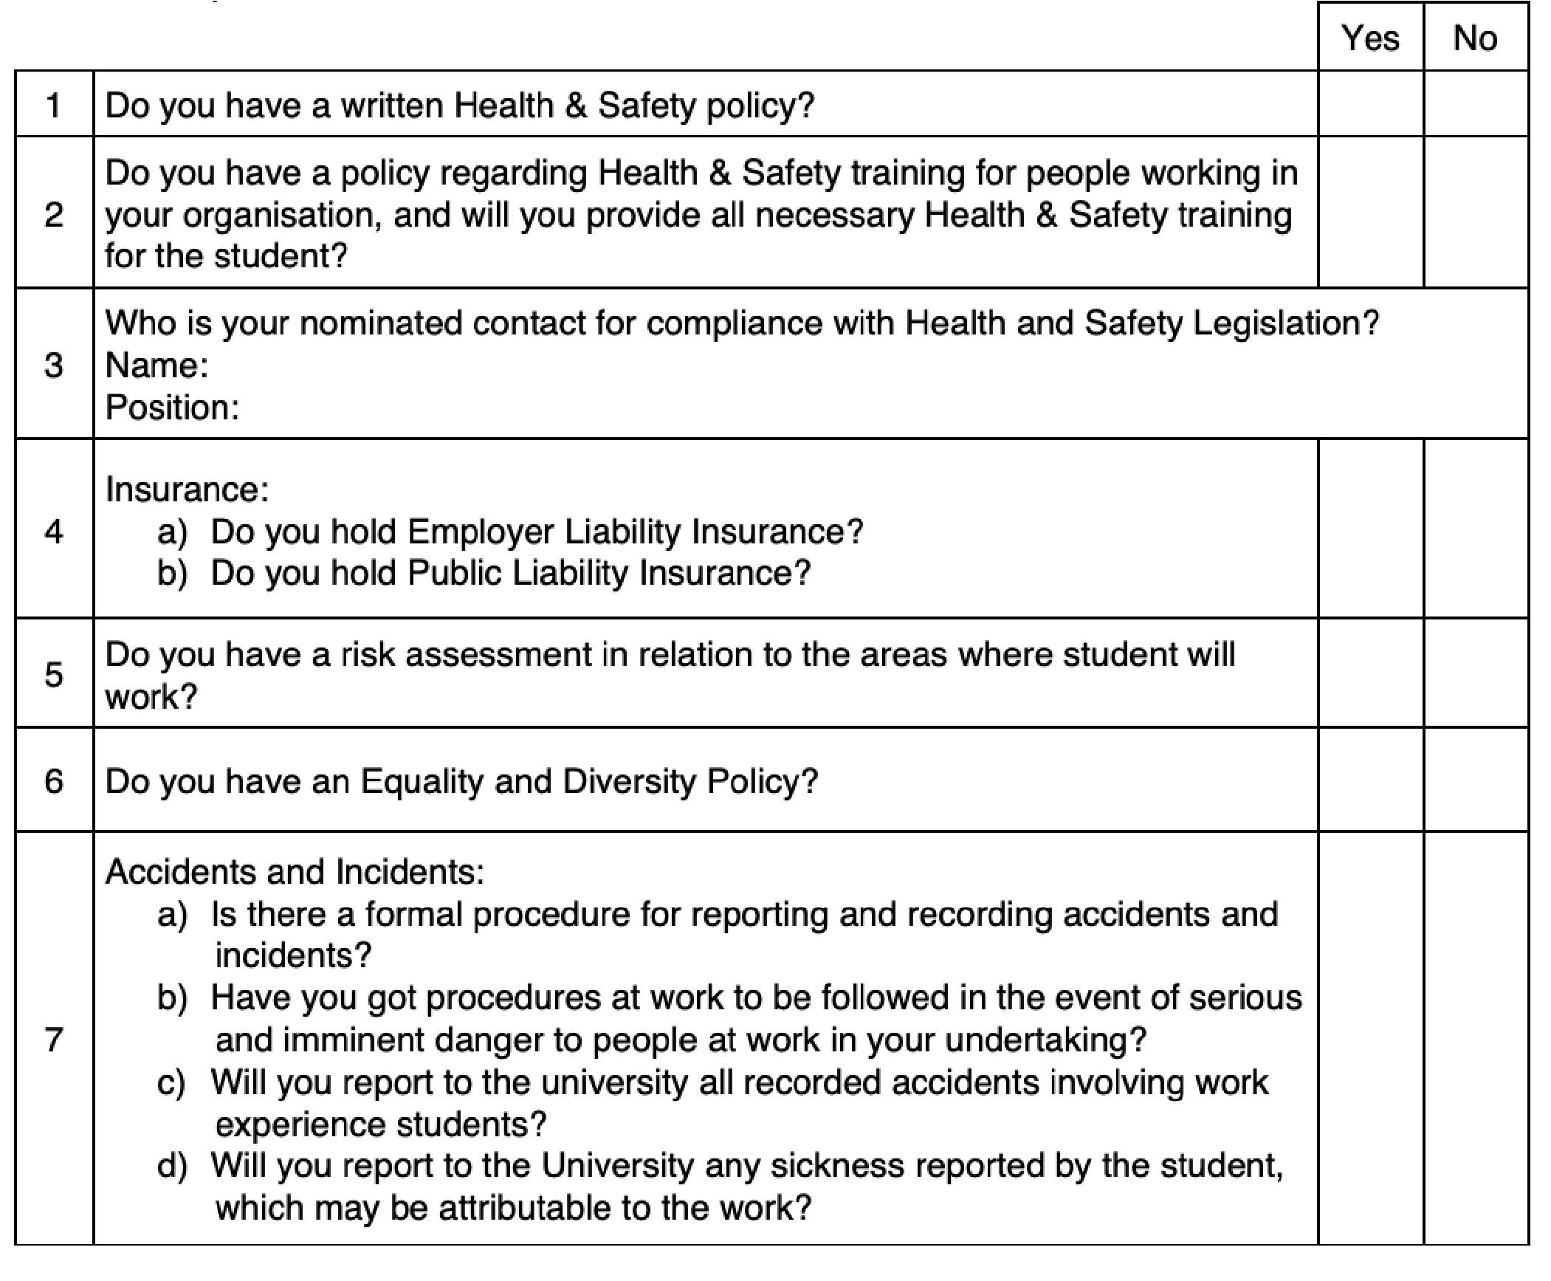

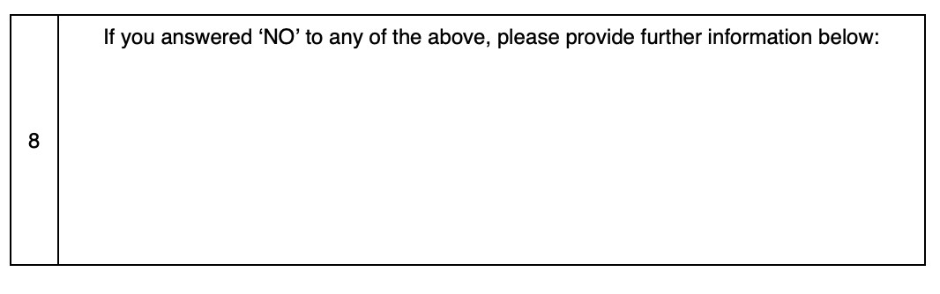

## 5.1 Placement Declaration

*For Placement Supervisor Use Only:*

The above statements are true to the best of my knowledge and belief.

Signed:

Full Name:

Date:

Thank you for completing this checklist.

*For St Mary’s University Use Only:*

Student Name:

Placement Provider:

Follow up action required:

Reviewed by:

Date:

# 6.0 Student Timesheet

Work Placement Student Timesheet

**IMPORTANT:** Do not give this form to your Workplace Supervisor to keep. Take or send to him/her to sign, at the end of each month you work.

This form must be kept up-to-date and signed regularly by your ‘Workplace Supervisor’, the same person who will complete the feedback at the end.

At the end of your Professional Placement, the total number of hours must be signed for and you need to hand in the completed sheet to the Module Convenor, either in person or by scanning and emailing it directly.

**N.B. Failure to complete these requirements will mean the Professional Placement cannot be validated and no credits will be awarded.**

Module Code:

Student name:

Regnum:

Full Name of Placement Provider:

Name of Workplace Supervisor:

