**B.M.S COLLEGE OF ENGINEERING**

**Department of Electronics and Communication Engineering**

Bull Temple Road, Basavanagudi, Bangalore - 560 019



**ADVANCED MICROCONTROLLERS AND APPLICATIONS (16EC6GE1AM)**

**AAT REPORT**

On

**SWARM EMBEDDED ROBOTIC PLATFORM**

Submitted By:

|  |  |
| --- | --- |
| **Name of the Student** | **USN** |
| Sudarshan S Harithas | 1BM16EC109 |
| Prajwal Vishwanath | 1BM16EC080 |
| Pankaj N Teradale | 1BM16EC075 |
| Abhay Bhargav K M | 1BM16EC152 |

**Name Of The Faculty In Charge:**

Dr. Geetishree Mishra

Assistant Professor, BMSCE

**CONTENTS:**

**Topic Page No**

1. Abstract 03
2. Literature Survey 04
3. Introduction 05
4. Problem Statement 06
5. Proposed Solution 06
6. Implementation

* Implementation Of Obstacle Avoider 07
* Implementation Of Bluetooth Controlled RC car 11

1. Results And Conclusion 15
2. References 16

**ABSTRACT**

In this project we aim to build a Swarm Embedded Robotic Platform (SERP), which is essentially a platform for interfacing different components with the robot to make the job of an external user to utilise the SERP for any other application easier. The SERP features an Ultrasound Sensor, Bluetooth Module and an IR Sensor Array. The STM32 Blue Pill Microcontroller has been used for this purpose. Programming has been done through the Arduino IDE. Interfacing has been done for the Ultrasound Sensor to achieve collision avoidance, and for the Bluetooth Module to achieve remote control of the robot through a remote which can be used on any smartphone.

**LITERATURE SURVEY**

The STM32 line of 32-bit microcontrollers from ST Microelectronics is one of the most popular choices for use in commercial products. The STM32 line is quite expansive with numerous combinations of performance, peripherals, power, memory, and packages available. In this project we explore the STM32 Blue Pill microcontroller for interfacing different components onto the Swarm Embedded Robotic Platform (SERP).

SERP is inspired by the Spark V Robot which has been jointly designed by NEX Robotics with Department of Computer Science and Engineering, IIT Bombay. The Spark V robot has a wide range of features including directional light intensity sensors, Ultrasonic Sensors, on board socket for Xbee wireless module for multi robot and Robot to PC communication.

The Definitive Guide To The ARM Cortex-M3 By Joseph Yiu is an excellent book covering the whole of Cortex M3 series microcontrollers. It gives us important information regarding the architecture and operation of the Cortex M3, and also gave us critical information regarding interfacing components with the STM32 Blue Pill microcontroller.

A wide range of tutorials are available from renowned websites like circuitdigest and homemechatronics gave us valuable information regarding the interfacing steps of Bluetooth module and ultrasound sensor with the STM32 Blue Pill. There were other websites/blogs written by authors which provided us critical information for implementing the same.

**INTRODUCTION**

Swarm Embedded Robotic Platform (SERP) is a low cost robot designed for robotics hobbyists and enthusiasts. It is inspired by the Spark V Robot which has been jointly designed by NEX Robotics with Department of Computer Science and Engineering, IIT Bombay. SERP will help you get acquainted with the world of robotics and embedded systems. With SERP, instead of building the robot with the different components from scratch, one will be able to create and contribute to complex applications that run on this platform, helping you acquire expertise as you spend more time with them.

SERP robot is based on Cortex M3 microcontroller. The STM32 Blue Pill development board has been used. Robot is powered by 8 cell 12V 2A rechargeable NiMH (Nickel Metal Hydride) batteries. It has an IR sensor array consisting of 7 IR sensors which can be used for the purpose of line following, an ultrasound sensor which can be used for the purpose of obstacle avoidance and distance measurement, and a Bluetooth module which is interfaced with the phone app for controlling the robot.

Robot requires regulated 12V DC supply for the battery charging. You can use 12V, 2A SMPS. Do not apply more than 12V DC at the charging point of the robot.

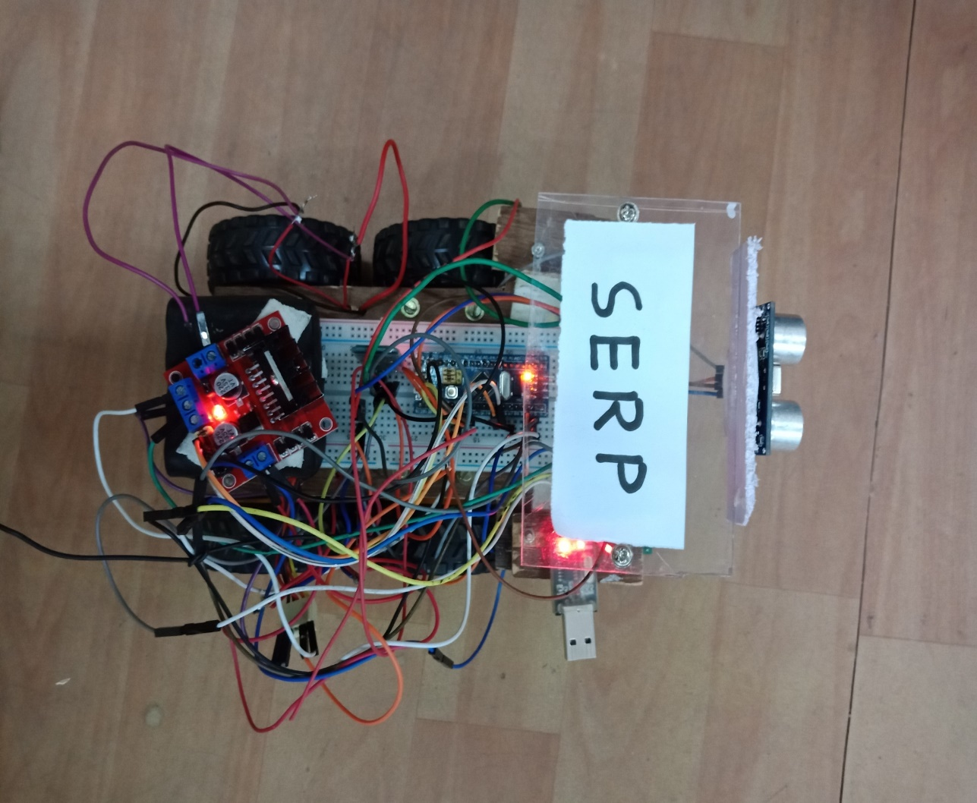 **PROBLEM STATEMENT**

To develop a robust embedded robotic platform with different components interfaced on it, enabling it to be ready for swarm applications and development of other applications for hobbyists and enthusiasts.

**PROPOSED SOLUTION**

To achieve the described robotic platform, we use the STM32 Blue Pill Microcontroller from the Cortex M3 series. We interface an ultrasound sensor that can be used for obstacle avoidance and distance measurements. We interface a Bluetooth module which is used for controlling the robot via an app which can be installed on any smartphone. Further, as an additional feature, we add an IR sensor array which can be used for the purpose of line following or maze solving. The code used to interface the components with the STM32 Blue Pill is done using the Arduino IDE. These different components on the robot can be used for different purposes as desired by the user.

////////////////////// **ADD CIRCUIT DIAGRAM ////////////////////**

**IMPLEMENTATION**

The implementation of the problem statement is done in two phases as described below:

IMPLEMENTATION OF OBSTACLE AVOIDER

The ultrasonic sensor HC-SR04 has been chosen for this robot. It emits an ultrasound at 40,000 Hz which travels through the air. If there is an object or obstacle on its path it will bounce back to the module. Considering the travel time and the speed of the sound you can calculate the distance.

The HC-SR04 Ultrasonic Module has 4 pins, Ground, VCC, Trig and Echo. The Ground and the VCC pins of the module needs to be connected to the Ground and the 5 volts pins on the Arduino Board respectively and the trig and echo pins to any Digital I/O pin on the Arduino Board.

In order to generate the ultrasound you need to set the Trig on a High State for 10 µs. That will send out an 8 cycle sonic burst which will travel at the speed sound and it will be received in the Echo pin. The Echo pin will output the time in microseconds the sound wave travelled.

For example, if the object is 10 cm away from the sensor, and the speed of the sound is 340 m/s or 0.034 cm/µs the sound wave will need to travel about 294 u seconds. But what you will get from the Echo pin will be double that number because the sound wave needs to travel forward and bounce backward.  So in order to get the distance in cm we need to multiply the received travel time value from the echo pin by 0.034 and divide it by 2.

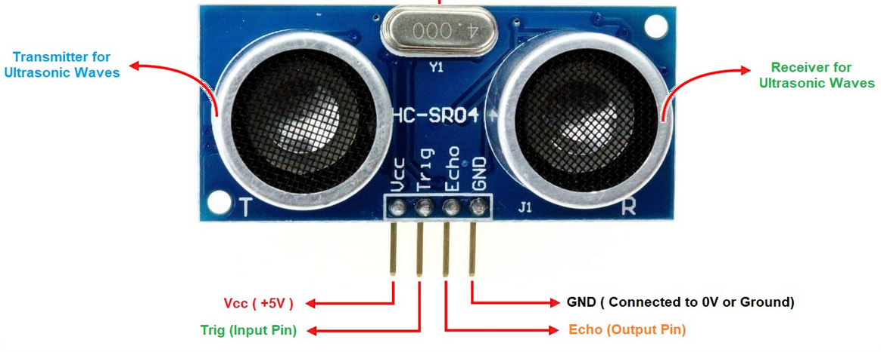

The Complete Code Used For Implementing Obstacle Avoider Is As Follows:

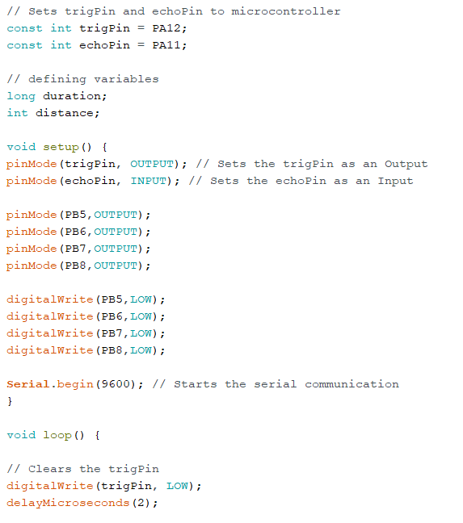

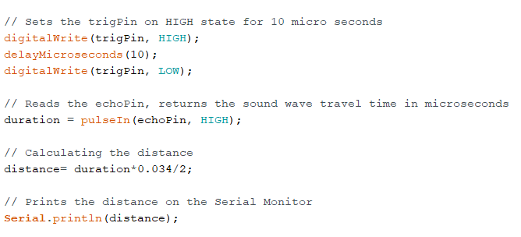

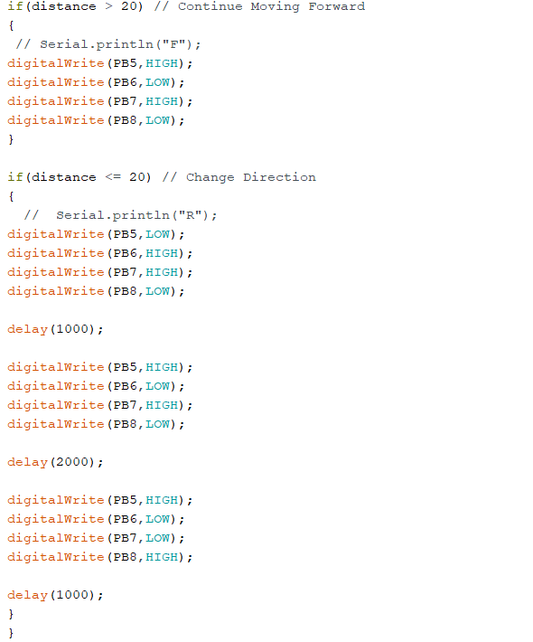

The Final Implementation Of The Ultrasound Sensor Looks Like This:

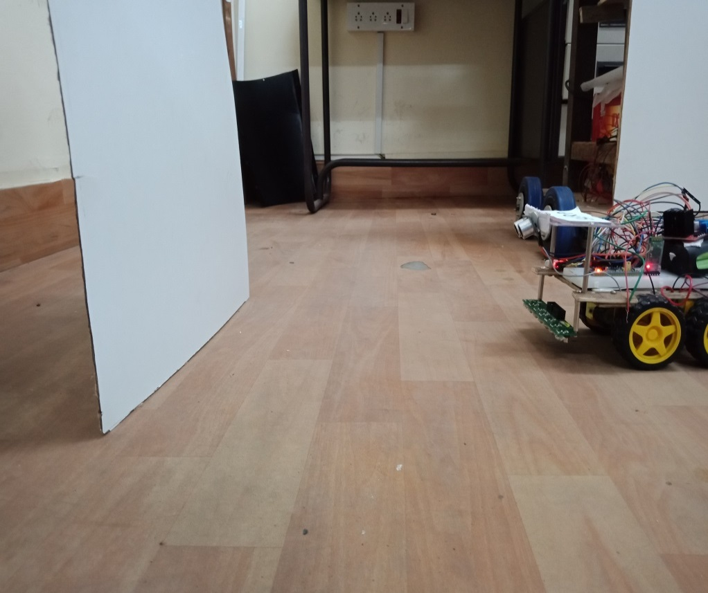

*Robot detecting an obstacle through ultrasound sensor*

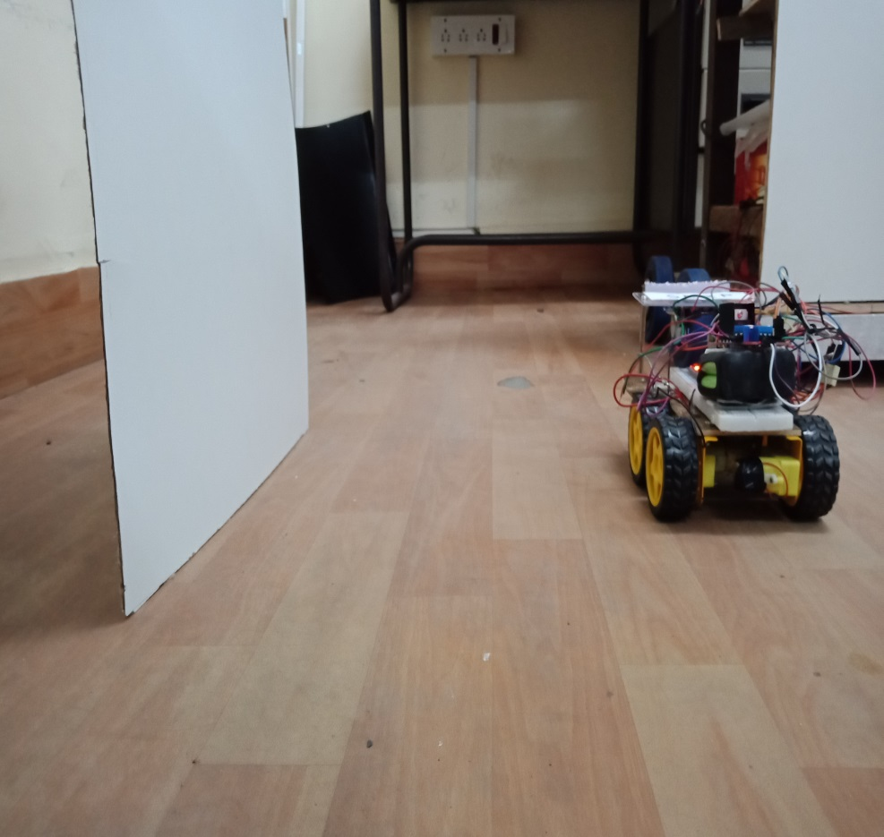

*Robot turning to avoid the obstacle*

IMPLEMENTATION OF BLUETOOTH CONTROLLED RC CAR

Bluetooth is a wireless technology that works on the frequency of 2.4GHz. Normal Bluetooth signal is in range of 10 meter radius. Bluetooth is most commonly used wireless technology in embedded projects provided that the range of communication is limited. Bluetooth has added advantage of its low power consumption and low cost operation. It is generally used for interfacing microcontrollers with Smart Phones by using Bluetooth applications.

We have chosen the Bluetooth module HC-05 for this project. It is a serial Bluetooth module that uses serial communication having range less than 100m and operates at 5V (3.3V minimum). It can be used to connect two microcontrollers wirelessly and also with mobile phone and laptops. As there are many android applications are available, it is very useful for making wireless Bluetooth controlled projects.

It uses USART communication and can be interfaced with microcontrollers having USART communication protocol.

It has **two** modes, AT Command Mode & Data Mode:

When Bluetooth is powered up it enters **data mode default**. This mode can be used for data transfers. To enter into **AT Command mode** during power up we need to press the button present in module to change the default settings of the module like master/slave configurations.

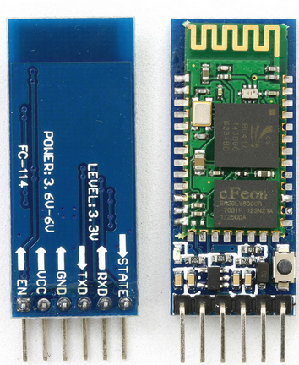

*HC05 Bluetooth Module*

The Complete Code Used For Interfacing The Bluetooth Module Is As Follows:

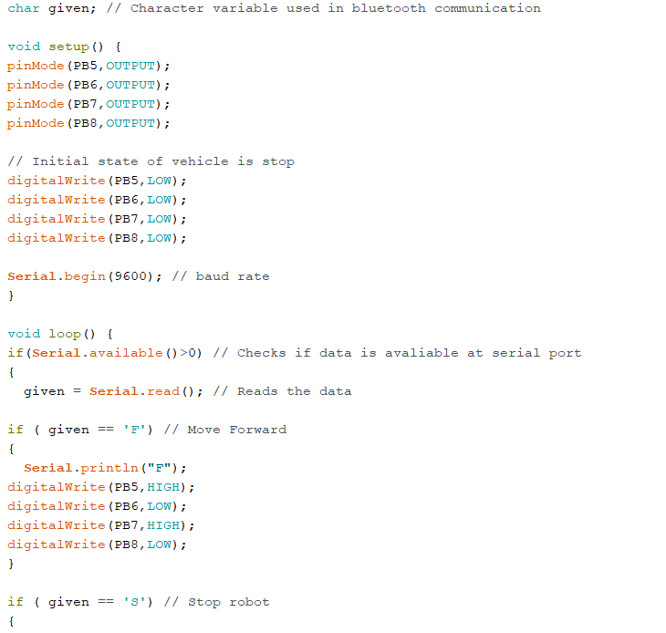

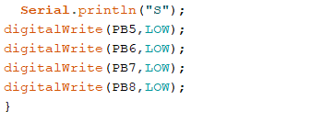

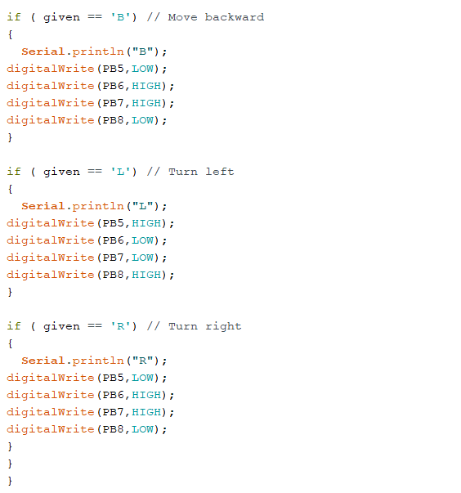

The Final Implementation Of The Bluetooth Module Looks Like This:

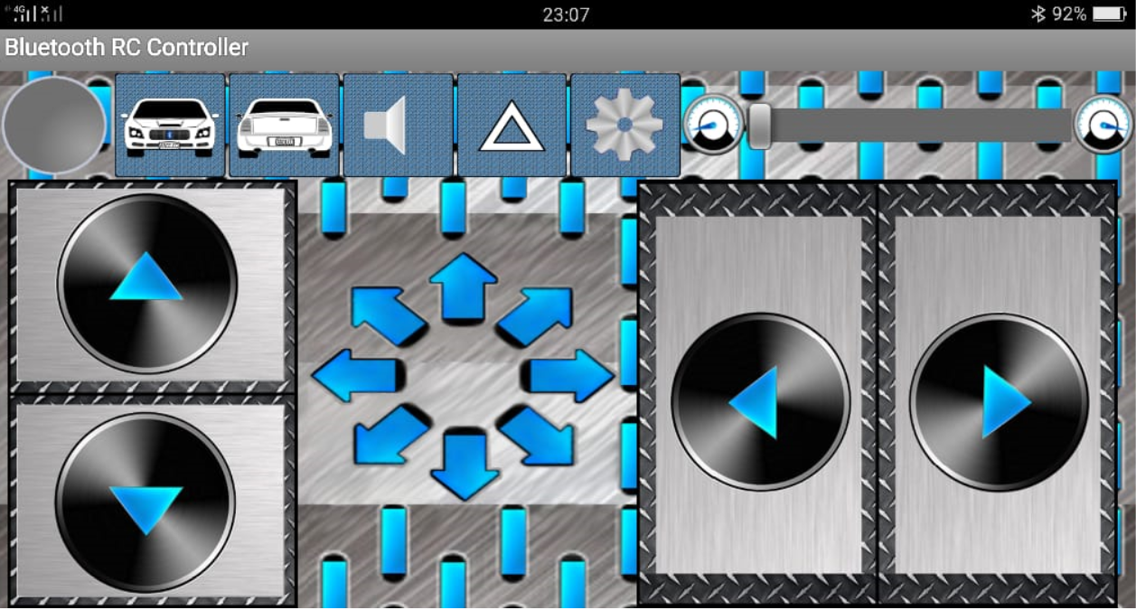

*Android App for remote control of robot through Bluetooth*

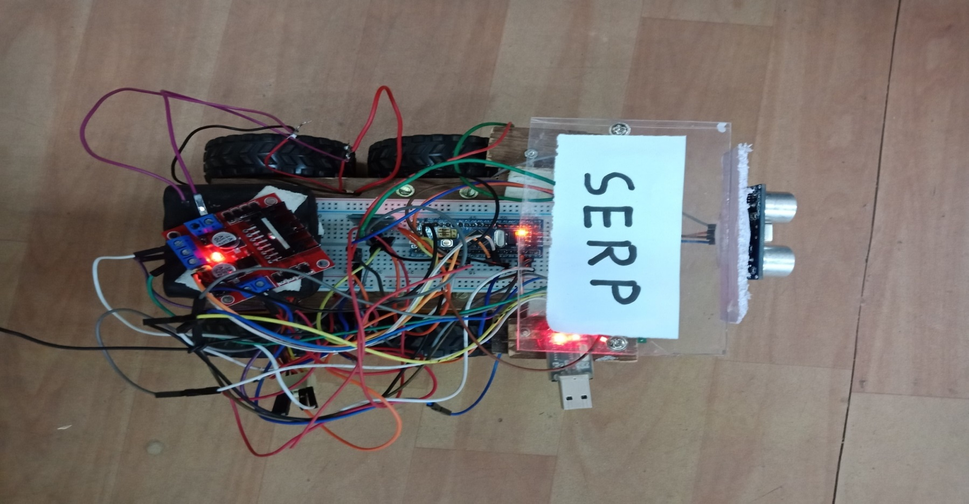

*Robot being controlled by the Bluetooth*

**CONCLUSION**

The interface of the STM32 Blue Pill microcontroller with HC-05 Bluetooth module and SR-04 ultrasonic sensor has been successfully implemented and their respective applications in aiding for obstacle avoidance or for distance measurements from obstacles in the case of ultrasound sensor and remote control operability for control of robot in the case of Bluetooth module has been successfully tested. Further, additional features such as an IR sensor array for line following or maze solving purposes have been successfully integrated with the robot.

With all the following features, the Swarm Embedded Robotic Platform is ready to be used for any other applications by hobbyists or enthusiasts.

**FUTURE ENHANCEMENTS:**

Some of the future enhancements that can be made to the Swarm Embedded Robotic Platform (SERP) are as follows:

* Implementation of the whole Swarm Embedded Robotic Platform (SERP) on a Printed Circuit Board (PCB). This will make the robot much more robust, and the commonly encountered problems of faulty connections and glitches can be avoided.
* The robot is currently running on a 4-wheel drive. However, a 4-wheel drive is not always the best option as it consumes more power and drains out the battery supply quickly. A 2-wheel drive can be implemented as easily with lesser power consumption.

**REFERENCES:**

ONLINE LINKS:

* <http://www.nex-robotics.com/products/spark-v-robot/spark-v.html>
* <https://circuitdigest.com/microcontroller-projects/hc-05-bluetooth-module-interfacing-with-STM32F103C8-blue-pill>
* <https://howtomechatronics.com/tutorials/arduino/ultrasonic-sensor-hc-sr04/>

BOOKS:

* The Definitive Guide To The ARM Cortex-M3 By Joseph Yiu