G SUDARSHAN SASTRY

**AI Project Report: Personalized Content Writing Engine for Riddhi Deorah**

# System Overview

The project aims to automate Riddhi Deorah’s **daily content ideation pipeline** through **data aggregation, competitor analysis, and AI script generation** using Google Sheets, RSS feeds, Apify, and Gemini LLM.

# Workflow Summary

| **Component** | **Description** | **Tool/Node Used** |
| --- | --- | --- |
| **1. Scheduler** | Triggers workflow daily at 10 AM | n8n-nodes-base.scheduleTrigger |
| **2. Data Source** | Google Sheet with competitor details (influencers in parenting niche) | Google Sheets Node |
| **3. News Fetching** | Pulls latest viral parenting/lifestyle news | RSS Feed Read Node |
| **4. Competitor Scraping** | Scrapes recent Instagram posts via Apify Actor Task | HTTP Request Node |
| **5. Data Aggregation** | Aggregates all fetched content into structured fields | Aggregate + Merge Nodes |
| **6. Data Formatting** | Formats persona, viral news, and competitor data | Code Node (data formatter) |
| **7. AI Ideation** | Generates viral reel scripts (news, competitor, and unique) | Google Gemini Model Node |
| **8. Output Structuring** | Parses AI response into clean JSON array of ideas | Code Node (final ideas) |

# Input Data Sources

**Persona Source**

Data stored in a **Google Sheet** with the following columns:

| **Name** | **Instagram Handle** | **Followers** | **Location** | **Key Content Focus** | **Instagram URL** |
| --- | --- | --- | --- | --- | --- |
| Neha Dhupia | @nehadhupia | 7.1M | India | Parenting, lifestyle, fitness | [Link](https://www.instagram.com/nehadhupia/) |
| Mandira Bedi | @mandirabedi | 2M | India | Parenting, wellness, fitness | [Link](https://www.instagram.com/mandirabedi/) |
| Sameera Reddy | @reddysameera | 1.9M | Goa | Mom hacks, podcasts, family | [Link](https://www.instagram.com/reddysameera/) |
| Etc … | Etc … | Etc … | Etc … | Etc … | Etc … |

These represent **competitor accounts** used to extract inspiration and engagement trends.

# N8N workflow:

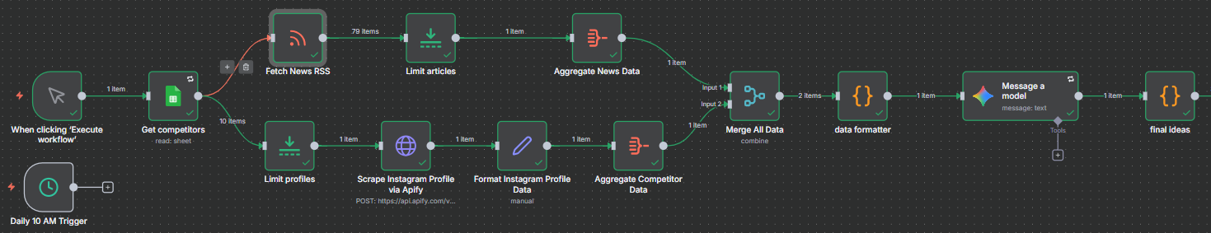

# Response:

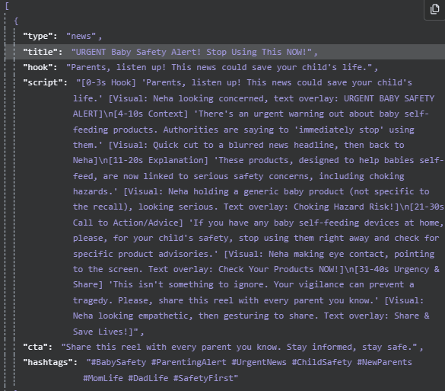

**Future Enhancements**

* Using multiple data sources for knowing about industry rather than single source
* Creating a proper target market and competitors list