Big Mart Sales Analysis Report

Objective:

This report provides an analysis of the sales data from Big Mart. The project focuses on Exploratory Data Analysis (EDA), revealing insights into sales trends, product performance, and customer behavior.
The following sections highlight the key findings from the analysis.

1. Sales Distribution
- The sales data was analyzed for different stores, products, and locations. There is a clear variation in sales based on the outlet size and outlet type.
- Most sales are concentrated in larger outlet types such as Supermarket Type1, which contributes significantly to the total revenue.

2. Product Performance
- The data analysis reveals that products with higher visibility tend to perform better in terms of sales.
- There are certain product categories, such as staple foods and household items, that have consistently high sales.
- The average selling price across all products varies significantly. Higher-priced products are not always the best sellers.

3. Outlet Size vs Sales
- Larger outlets tend to generate more sales, especially in urban locations where consumer demand is higher.
- Medium-sized outlets also contribute significantly to overall sales, particularly in semi-urban areas.

4. Geographical Insights
- Stores located in Tier 1 cities have the highest sales performance compared to stores in smaller towns.
- Urban consumer behavior suggests a preference for specific product categories, including groceries and electronics.

Dataset Overview:
The dataset contains 8,523 entries and 12 columns, and it appears to be related to sales data for a retail store. Here’s an overview of the columns:
Item_Identifier: Unique identifier for each product.
Item_Fat_Content: Indicates the fat content category of the product (e.g., Low Fat, Regular).
Item_Type: Describes the type or category of the product (e.g., Dairy, Soft Drinks).
Item_MRP: Maximum Retail Price of the product.
Outlet_Identifier: Unique identifier for each store.
Outlet_Establishment_Year: Year the outlet was established.
Outlet_Size: Size of the outlet (e.g., Small, Medium, High).
Outlet_Location_Type: Indicates the outlet's location tier (e.g., Tier 1, Tier 3).
Outlet_Type: Type of the outlet (e.g., Supermarket Type1, Grocery Store).
Item_Outlet_Sales: Total sales of the product in a particular outlet.
Item_Weight_interploate: Interpolated weight of the item.
Item_Visibility_interpolate: Interpolated visibility of the item.

Database Connectivity
If the dataset were stored in a MySQL database, you could connect to the database and load the data using the following code:
import mysql.connector
import pandas as pd

connection = mysql.connector.connect(
user='root',
password='123456',
host='localhost',
database='big_mart'
)
# Create a cursor object to execute SQL queries
cursor = connection.cursor()

# After fetching data from the database, we are storing it into a Pandas DataFrame
cursor.execute('SELECT * FROM big_mart_sales
big_mart_sales_data = pd.DataFrame(cursor.fetchall(), columns=[desc[0] for desc in cursor.description])
# Preview the data
big_mart_sales_data.head()
This will allow you to connect to the database and load the necessary data into a Pandas DataFrame for further analysis.

Output:
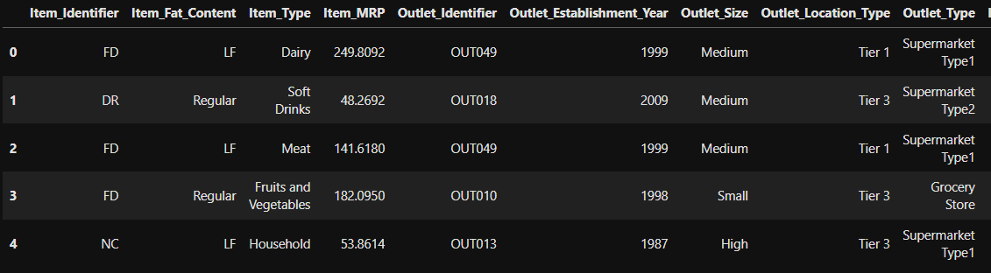
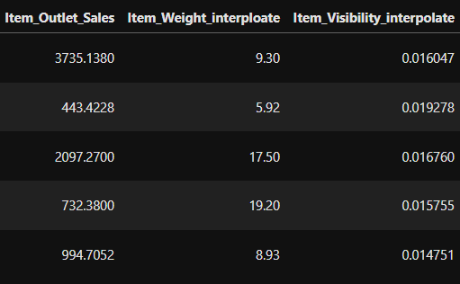

Data Cleaning:
Before proceeding with the analysis, let's perform some basic data cleaning:

- Check for missing values in each table.
- Ensure data types are appropriate for each column.
- Removed any duplicate entries and handled outliers in Item_Visibility by capping extreme values

Exploratory Data Analysis (EDA) and Visualization:
Distribution of Item Outlet Sales

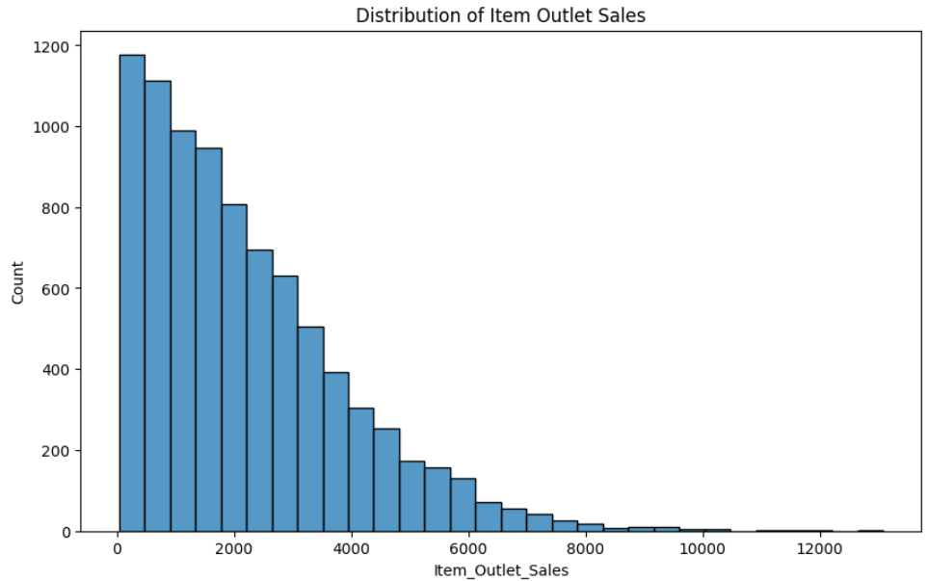

Item Weight Distribution

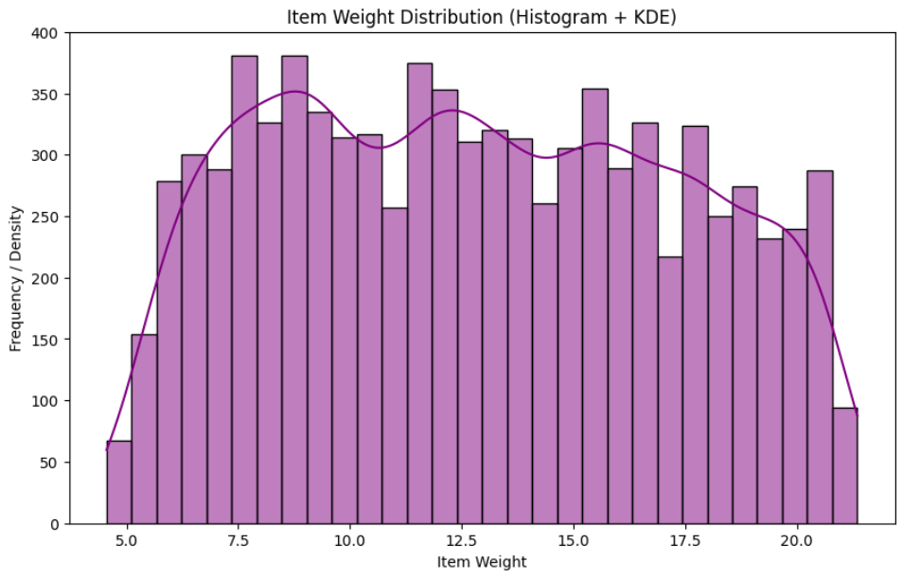

Item Visibility Distribution

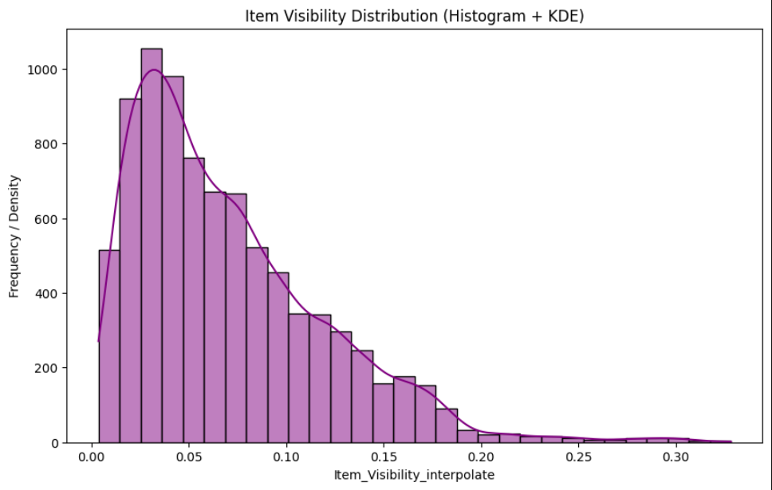

Count of Outlets by Location Type

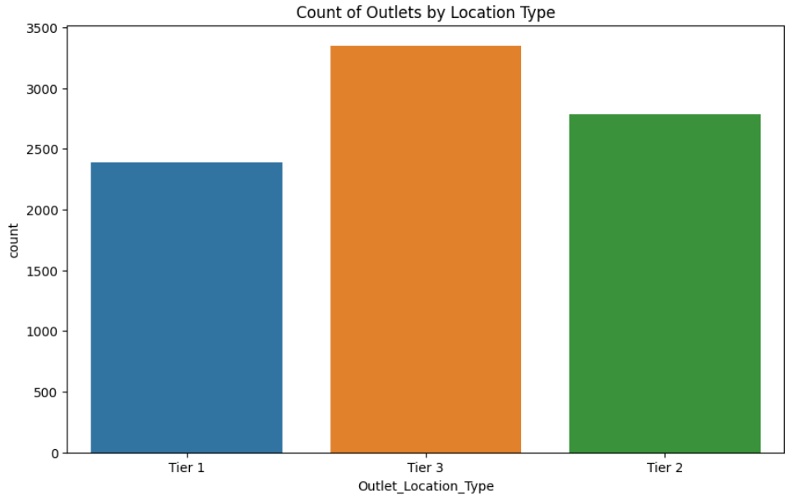

Total Sales by Outlet Type

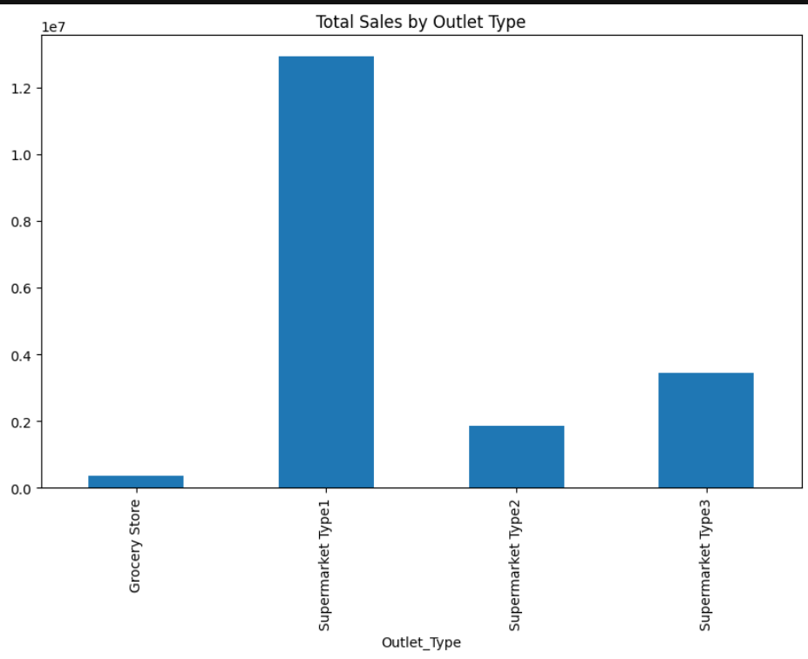
Item_Fat_Content

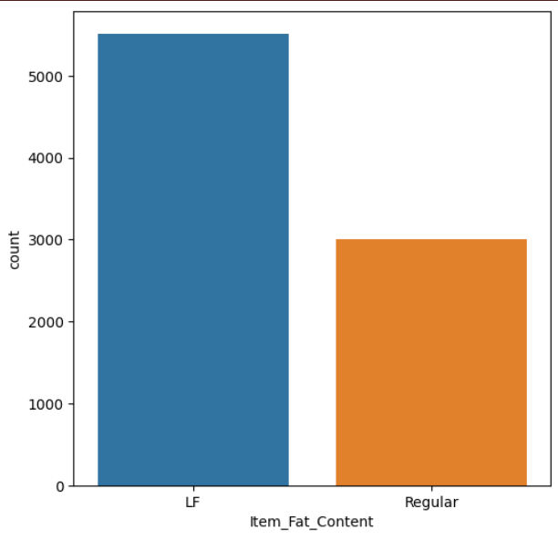

Boxplot of Item Type vs Sales

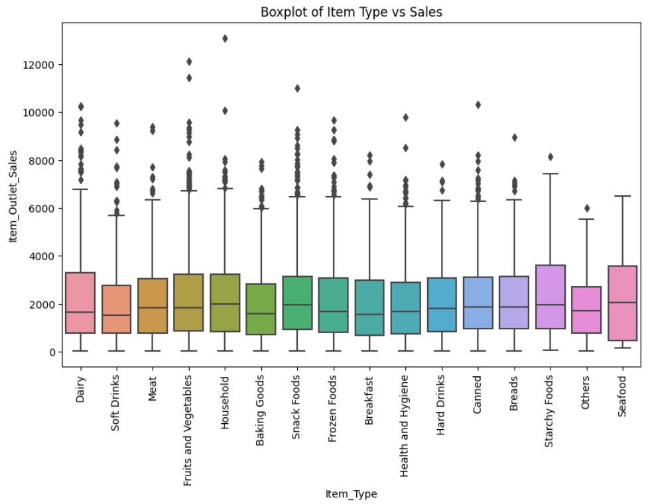

Conclusion
The analysis provides clear insights into Big Mart's sales patterns. High-performing products, larger outlets, and urban locations play a critical role in driving sales. Additionally, increasing product visibility and maintaining a diverse product portfolio will likely enhance revenue further.
This EDA forms the foundation for more complex predictive modeling and deeper business s insights.

