**README DOCUMENT**

**Project Title:** Temp Analysis

**Description:**

* A web application which takes the following input:
* User's name
* City of preference
* Model of their smart phone
* These inputs are taken via a HTML form and is sent to the backend server to display the weather conditions in the specified city and the temperature of the battery of the specified smartphone.

**Please download the files in the repository and run it on local server such as localhost for viewing the functionalities of the applications without any errors.**

**Prerequisites:**

* An android application named 'Automate' is used to fetch the temperature of the battery. The flow diagram with the following blocks are created:

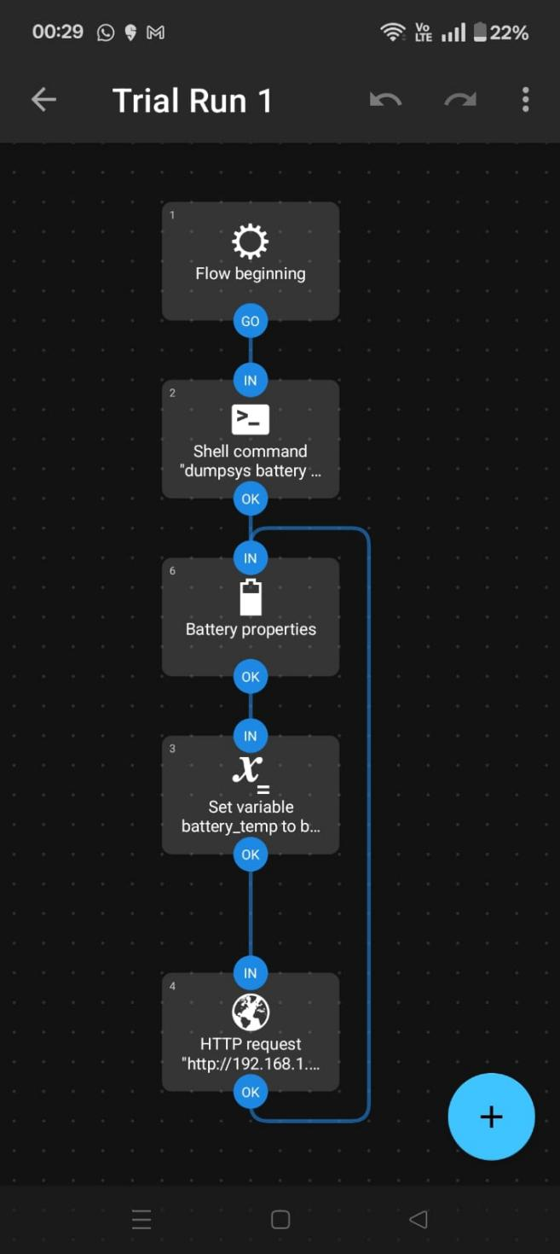

* In the Shell Command Block, the following tasks are done:

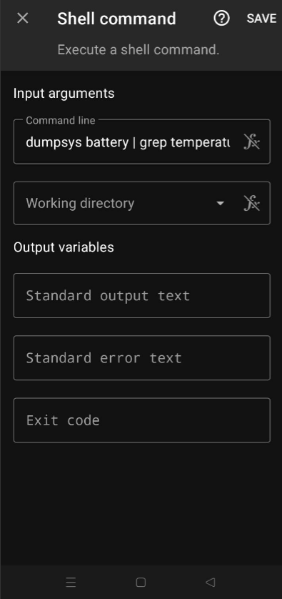

* The Battery Properties Block has the following:

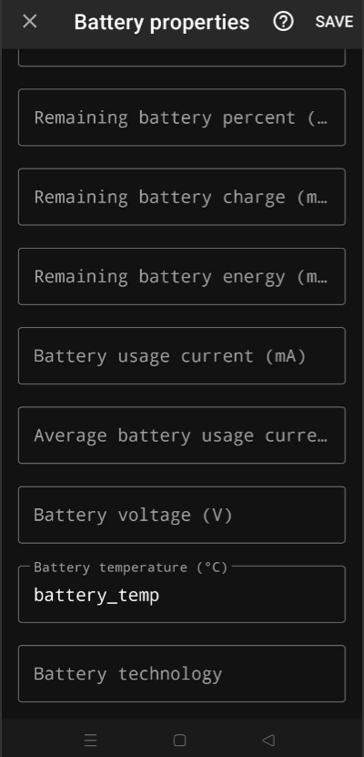

* The Variable Set Block has the following:

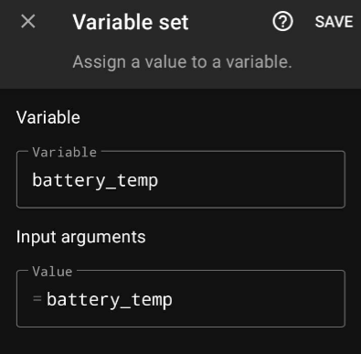

* The HTTP Request Block has the following:

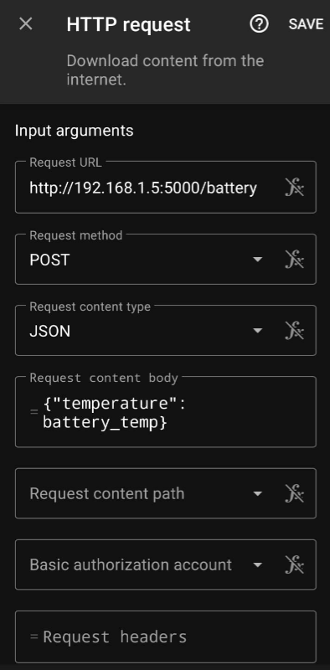

* The Request URL field must correspond to the IPv4 address in the computer or server in which the backend server is running.

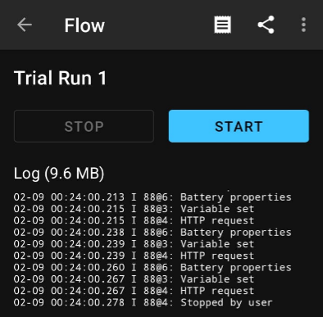

* The Flow must be in running mode while running the backend server using Node.js.
* The Weather API utilised in the project is OpenWeather which provides API calls for weather information for any city.
* After signing up with an account, generate a API key. Copy the API key and replace the value of ‘apiKey’ variable in the index.js file.

**Technology Stack:**

* **Front-End Technology:**

* HTML
* CSS
* JavaScript
* **Backend Technology:**
* Node.js
* Express.js
* **Middlware:**
* body-parser
* **API:**

* REST API:
* OpenWeather
* Automate Android Application
* **Deployment and Hosting:**
* Github
* **Version Control:**
* Git
* Github
* **Testing Tools:**
* Postman