WEEK - 1
- Implement Tic –Tac –Toe Game

Source code

import random

def print_board(board):
print("\n")
for i, row in enumerate(board):
print(" " + " | ".join(row))
if i < 2:
print("---" * 3)
print("\n")

def check_winner(board, player):
# Check rows and columns
for i in range(3):
if all(board[i][j] == player for j in range(3)) or \
all(board[j][i] == player for j in range(3)):
return True

# Check diagonals
if all(board[i][i] == player for i in range(3)) or \
all(board[i][2 - i] == player for i in range(3)):
return True

return False

def is_full(board):
return all(cell != " " for row in board for cell in row)

def play_game():
board = [[" " for _ in range(3)] for _ in range(3)]
user_symbol = "X"
computer_symbol = "O"

print("Welcome to Tic-Tac-Toe!")
print("Positions are entered as row and column (0-2), separated by a space. Example: '0 2'")

while True:
print_board(board)

# User Move
while True:
try:
move = input("Enter your move (row col): ").split()
r, c = int(move[0]), int(move[1])
if 0 <= r <= 2 and 0 <= c <= 2 and board[r][c] == " ":
board[r][c] = user_symbol
break
else:
print("Invalid move or cell occupied. Try again.")
except (ValueError, IndexError):
print("Invalid input format. Enter two numbers between 0 and 2.")

if check_winner(board, user_symbol):
print_board(board)
print("Congratulations! You win!")
break

if is_full(board):
print_board(board)
print("It's a draw!")
break

# Computer Move (Random)
empty_cells = [(r, c) for r in range(3) for c in range(3) if board[r][c] == " "]
comp_r, comp_c = random.choice(empty_cells)
board[comp_r][comp_c] = computer_symbol
print(f"Computer placed '{computer_symbol}' at position ({comp_r}, {comp_c})")

if check_winner(board, computer_symbol):
print_board(board)
print("Computer wins! Better luck next time.")
break

if is_full(board):
print_board(board)
print("It's a draw!")
break

if __name__ == "__main__":
play_game()

OUTPUT
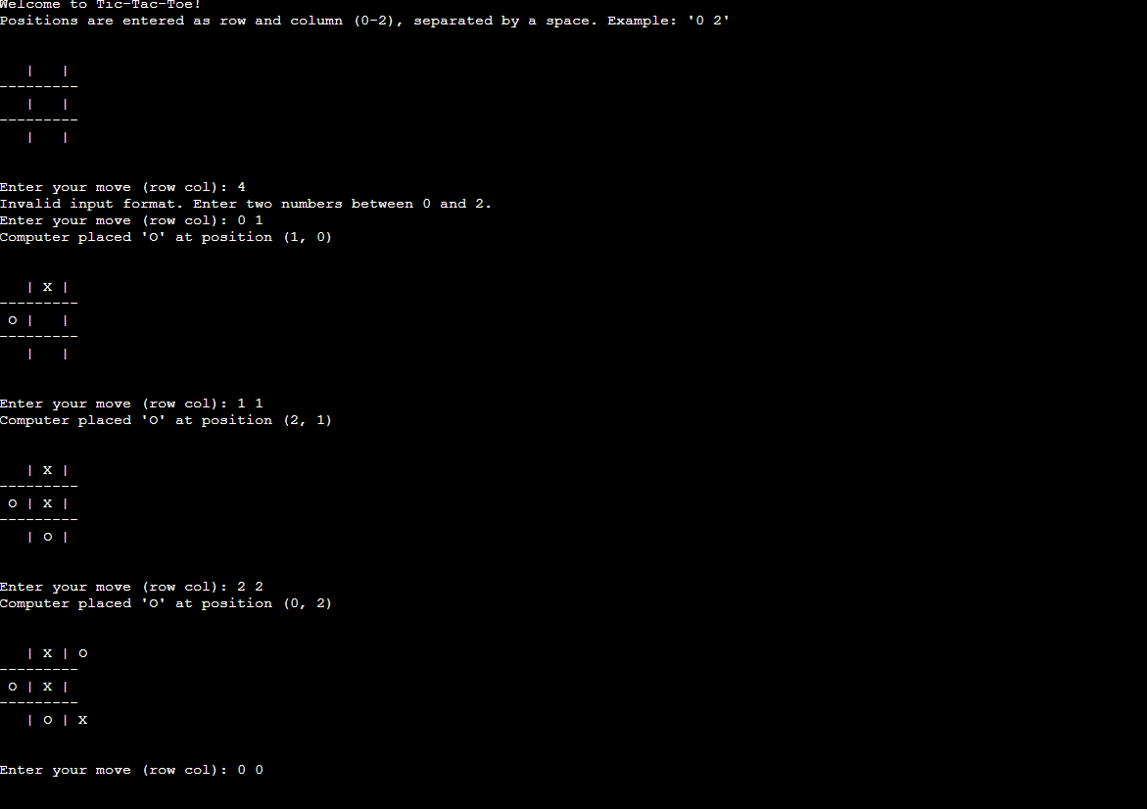

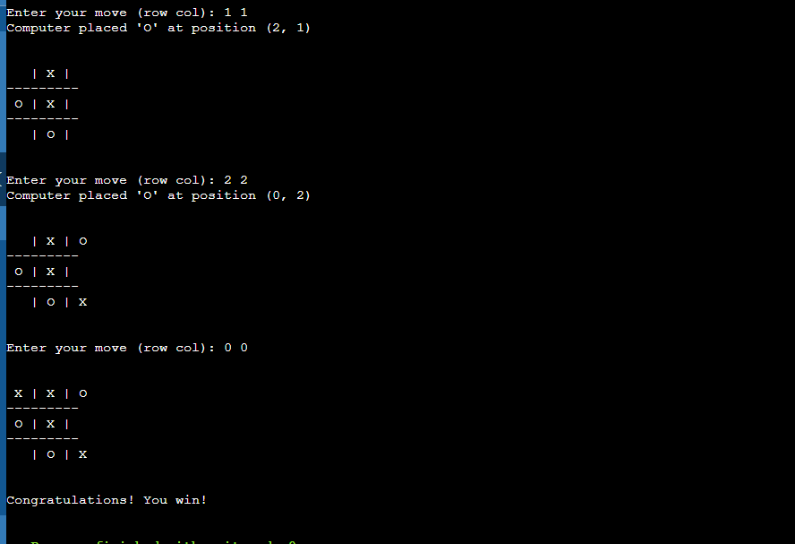

- Implement vacuum cleaner agent
Implement "Vacuum Cleaner Agent" using the concept of "Simple Reflex agent and Goal based" architecture
SOURCE CODE
import random
import time

class Environment:
"""Represents the 2D grid environment containing Clean (0) or Dirty (1) cells."""

def __init__(self, width=3, height=3):
self.width = width
self.height = height
# Randomly generate grid with Dirt (1) or Clean (0)
self.grid = [
[random.choice([0, 1]) for _ in range(width)] for _ in range(height)
]

def is_dirty(self, row, col):
return self.grid[row][col] == 1

def clean_cell(self, row, col):
self.grid[row][col] = 0

def display(self, agent_pos):
"""Displays grid status and vacuum agent position."""
print("\n" + "=" * 25)
for r in range(self.height):
row_str = ""
for c in range(self.width):
if (r, c) == agent_pos:
row_str += " [V] " # Vacuum Cleaner Agent
elif self.grid[r][c] == 1:
row_str += " D " # Dirt
else:
row_str += " . " # Clean Cell
print(row_str)
print("=" * 25)

# =====================================================================
# 1. SIMPLE REFLEX AGENT ARCHITECTURE
# =====================================================================
class SimpleReflexAgent:
"""Acts purely on current percept (If Dirty -> Suck; Else -> Move).

Has no long-term goal memory or internal state tracking.
"""

def __init__(self, env):
self.env = env
self.row = 0
self.col = 0

def perceive_and_act(self):
# Rule 1: Condition-Action (Dirty -> Clean)
if self.env.is_dirty(self.row, self.col):
print(
f"[Reflex Agent] Position ({self.row}, {self.col}): Cell is DIRTY -> Action: SUCK"
)
self.env.clean_cell(self.row, self.col)
# Rule 2: Condition-Action (Clean -> Move)
else:
print(
f"[Reflex Agent] Position ({self.row}, {self.col}): Cell is CLEAN -> Action: MOVE"
)
self.move()

def move(self):
# Fixed raster scan pathing without goal state awareness
self.col += 1
if self.col >= self.env.width:
self.col = 0
self.row = (self.row + 1) % self.env.height

# =====================================================================
# 2. GOAL-BASED AGENT ARCHITECTURE
# =====================================================================
class GoalBasedAgent:
"""Maintains an internal goal state ("All cells clean") and plans pathing

to explicitly target dirty coordinates until the goal is satisfied.
"""

def __init__(self, env):
self.env = env
self.row = 0
self.col = 0
self.target_queue = []
self.scan_environment()

def scan_environment(self):
"""Evaluates initial world state to set up goal coordinates."""
self.target_queue = [
(r, c)
for r in range(self.env.height)
for c in range(self.env.width)
if self.env.is_dirty(r, c)
]

def is_goal_achieved(self):
return len(self.target_queue) == 0

def perceive_and_act(self):
# Check Goal Condition
if self.is_goal_achieved():
print(
f"\n[Goal Agent] Position ({self.row}, {self.col}): GOAL ACHIEVED! Entire environment is clean."
)
return True

# Check if standing on active target
if self.env.is_dirty(self.row, self.col):
print(
f"[Goal Agent] Position ({self.row}, {self.col}): TARGET REACHED -> Action: SUCK"
)
self.env.clean_cell(self.row, self.col)
if (self.row, self.col) in self.target_queue:
self.target_queue.remove((self.row, self.col))
return False

# Navigate toward current target goal
target_r, target_c = self.target_queue[0]
print(
f"[Goal Agent] Position ({self.row}, {self.col}): Current Target Goal -> ({target_r}, {target_c}) -> Action: MOVE"
)

if self.row < target_r:
self.row += 1
elif self.row > target_r:
self.row -= 1
elif self.col < target_c:
self.col += 1
elif self.col > target_c:
self.col -= 1

return False

# =====================================================================
# DRIVER EXECUTION
# =====================================================================
def run_simulation():
print("\n--- Vacuum Cleaner Agent Simulation ---")
print("1. Simple Reflex Agent")
print("2. Goal-Based Agent")

choice = input("Select Architecture (1 or 2): ").strip()

if choice == "1":
print("\n>>> INITIALIZING SIMPLE REFLEX AGENT <<<")
env = Environment(width=3, height=3)
agent = SimpleReflexAgent(env)

# Runs for fixed time-steps due to lack of goal awareness
for step in range(10):
env.display((agent.row, agent.col))
agent.perceive_and_act()
time.sleep(0.3)

elif choice == "2":
print("\n>>> INITIALIZING GOAL-BASED AGENT <<<")
env = Environment(width=3, height=3)
agent = GoalBasedAgent(env)

steps = 0
while not agent.is_goal_achieved() and steps < 15:
env.display((agent.row, agent.col))
if agent.perceive_and_act():
break
steps += 1
time.sleep(0.3)

env.display((agent.row, agent.col))
else:
print("Invalid choice! Exiting...")

if __name__ == "__main__":
run_simulation()

output
