Project Report
Project Title goes here

Team:
Name | Student ID

Use Case
- Problem statement
- Motivation
- Real-world relevance

UX Design and Target Group
Why this section exists: AI assistants make it cheap to generate some UI fast. They do not know who your app is for. This section is graded under App Complexity (“real problem solving”) and Polish (“UI/UX quality, overall user experience”) — both depend on you defining the user before you or your AI assistant designs anything.

Target Group
- Primary users: (who, specifically — not “everyone”)
- Secondary users: (user groups that interact with the app but aren’t the primary target)
- User needs: (what problem are they trying to solve, what’s their current workaround?)
- Key usage scenario / user story: (1 short narrative: who, where, why they open the app)

Mockups
- Include at least 2-3 key workflows (low-fidelity is fine: hand-drawn/scanned, Figma, Excalidraw, or AI-generated – tool is your choice, just report what you used).
- For each mockup, add one sentence: which user need (from 2.1) does this screen/workflow address?
- If AI was used to generate or refine mockups, name the tool here (detailed reflection goes in Section 4.2).

Screen | Mockup | Addresses which user need?

Design Rationale
- What did you deliberately leave out / simplify, and why?
- What’s one UX decision you made that an AI assistant suggested differently — and why did you override it (or not)?

System Architecture Diagram
Rules — read before submitting:
1. The diagram must be hand-built or hand-edited by you, not pasted unmodified from an AI assistant’s output. You may use AI to draft a first version, but you must be able to explain and modify every box and arrow.
2. Every component and connection must be labeled with its responsibility (e.g. not just “API2” but “WeatherAPI — fetches current conditions for map overlay”).
3. You must include a short written justification (5–8 sentences): why this structure? what alternatives did you consider? why did you reject it?
4. Be prepared to walk through the diagram live (e.g., in a short oral check-in or demo) and explain what happens, component by component, for one concrete user action from Section 2.1.
Example diagram structure (replace with your own):
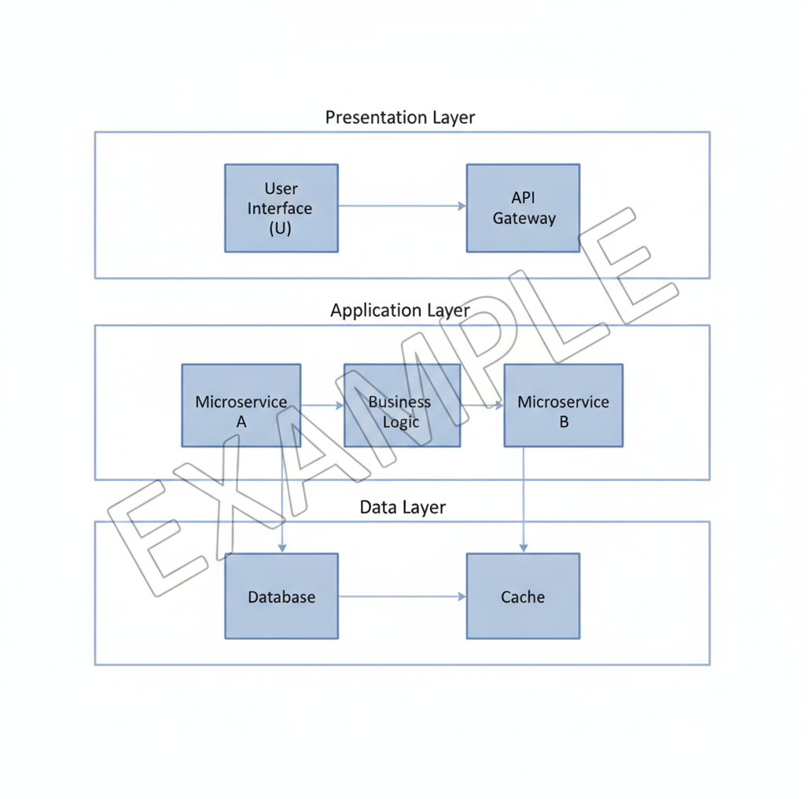

Architecture Justification
- Why this structure?
- What alternative did you consider, and why did you reject it?
- Walk-through: trace one user action (from 2.1) through every component in the diagram.

Third-Party Libraries
Provide a description of third-party libraries used. If no third-party libraries were used, just state so.
Library | Purpose | Why this one (over alternatives)?

Developer Diary
This section documents the development process and AI interaction.

Development Milestones
# | Date | Activity | Result | Issues
1.0 | 2026-06-20 | First architecture implementation | Code base | no validation considered
2.0 | 2026-06-21 | Integrated Weather API | first two endpoints integrated | missing status code handling
2.1 | 2026-06-22 | Refactor architecture | Considered validation | initial issues resolved

AI Interaction Log — Critical Incidents
Instead of a full prompt-by-prompt transcript, document the most consequential AI interactions of the project – the moments where AI accelerated you, misled you, or you had to push back / correct it. Reference the milestone (from 4.1) each incident belongs to.
Keep each entry to 3–5 sentences. Quote or paraphrase the relevant prompt/output briefly – you don’t need the full exchange.

# | Milestone | What happened | AI’s output (brief) | Your action / validation
1
2
3
4
5

The more detailed and honest this log is, the easier it is for us to understand what actually happened during development – vague entries (“AI helped with the UI”) are much harder to grade fairly than specific ones (“AI suggested using a RecyclerView with X, but this broke Y, so we switched to Z”).

Android Features Report
This section is graded under Android Features (25 points – proper use of Activities, Fragments, APIs, storage, lifecycle). Describe, concretely, which Android platform features you used and how – not just that you used them.

Features Used
List every relevant Android platform feature your app relies on (e.g., sensors, camera, location, local storage, notifications, permissions, lifecycle-aware components, etc.).
Feature | Where it’s used (screen/class) | Why this feature was needed

Implementation Details
- For at least three outstanding feature above, describe how you implemented it (key classes/APIs involved, lifecycle considerations, permission handling, etc.) in enough detail that someone could understand your approach without reading the code.
- Did you handle edge cases (e.g., permission denied, sensor unavailable, no network, configuration changes)? How?

AI’s Role in Android-Specific Code
- Did AI suggest correct usage of these Android APIs, or did you need to correct/research further?
- Were there any Android-specific hallucinations (e.g. deprecated APIs, incorrect lifecycle assumptions, wrong permission models)?

Lessons Learned
- Technical insights:
- Architectural insights:
- UX insights:
- AI-related insights:
- What would you do again or differently?

Future Work
- Possible refactoring:
- Possible extensions:

