Self-Study Assignment

Design of a 4-Bit Overlapping Sequence Detector Using FSM
Subject: Digital IC Design / Verilog HDL
Name of Student: _Sudarshan Anil Chaudhari__________
Roll No.: _06_______ Division: SEDA -G_______
Date: __________________

1. Aim
To design and simulate a 4-bit overlapping sequence detector for the binary sequence 1011 using a Finite State Machine (FSM) and Verilog HDL, and to verify its operation through behavioral simulation in Vivado.

2. Objectives
Write any three objectives of this experiment.
- To understand the working principle of a Finite State Machine used for sequence detection.
- To design the state diagram and state transition table for detecting the binary sequence 1011.
- To implement the overlapping sequence detector using Verilog HDL and verify its functionality using a testbench and simulation waveform.

3. Theory
Explain the following concepts in your own words:
a) What is a sequence detector?
b) What is a Finite State Machine (FSM)?
c) What is the difference between Mealy and Moore FSMs?
d) What is an overlapping sequence detector? Explain with an example.
Write your theory here:
a) What is a sequence detector?
A sequence detector is a digital circuit that monitors a serial input stream and generates an output when a particular sequence of binary bits is detected. In this experiment, the target sequence is 1011.
b) What is a Finite State Machine (FSM)?
A Finite State Machine (FSM) is a sequential digital circuit that consists of a finite number of states, inputs, outputs, and transitions. The FSM changes its state according to the current input and the clock signal. It is used to remember the partial sequence received so far.
c) What is the difference between Mealy and Moore FSMs?
In a Mealy FSM, the output depends on the present state and the current input. In a Moore FSM, the output depends only on the present state. A Mealy FSM can detect a sequence as soon as its final input bit is received, often using fewer states.
d) What is an overlapping sequence detector? Explain with an example.
An overlapping sequence detector detects repeated occurrences of a target sequence even when the occurrences share one or more bits. For example, the input stream 1011011 contains the sequence 1011 twice, at bit positions 1–4 and 4–7. The detector retains a useful partial match after the first detection to identify the second occurrence.
4. FSM Design
Target sequence: 1011
a) Draw the state diagram for the overlapping sequence detector.
b) Define the meaning of each state.
c) Prepare the state transition table for inputs 0 and 1.
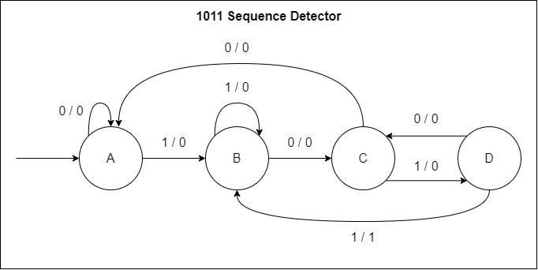
State definitions:
- S0: No matching bits detected; initial state.
- S1: The input 1 has been matched.
- S2: The input 10 has been matched
- S3: The input 101 has been matched.
State transition table:
Present State | Input | Next State | Output
S0 | 0 | S0 | 0
S0 | 1 | S1 | 0
S1 | 0 | S2 | 0
S1 | 1 | S1 | 0
S2 | 0 | S0 | 0
S2 | 1 | S3 | 0
S3 | 0 | S2 | 0
S3 | 1 | S1 | 1

5. Verilog HDL Program
Write the Verilog HDL code for the 4-bit overlapping sequence detector.
Include:
- Module declaration and input/output ports
- State declarations
- Reset operation
- State transition logic
- Sequence detection output
Program:
module sequence_detector (
input wire clk,
input wire reset,
input wire din,
output reg detected
);

// State encoding
parameter S0 = 2'b00,
S1 = 2'b01,
S2 = 2'b10,
S3 = 2'b11;
reg [1:0] state;

// FSM state transitions
always @(posedge clk) begin
if (reset) begin
state <= S0;
detected <= 1'b0;
end
else begin
detected <= 1'b0;
case (state)
S0: begin
if (din)
state <= S1;
else
state <= S0;
end
S1: begin
if (din)
state <= S1;
else
state <= S2;
end
S2: begin
if (din)
state <= S3;
else
state <= S0;
end
S3: begin
if (din) begin
detected <= 1'b1;
state <= S1;
end
else begin
state <= S2;
end
end
default: begin
state <= S0;
detected <= 1'b0;
end
endcase
end
end
endmodule

6. Testbench Program
Write a Verilog testbench to verify the design.
Include:
- Clock generation
- Reset generation
- Input sequence application
- Simulation termination
Use the input stream 1011011 to verify overlapping detection.
Testbench code:
`timescale 1ns / 1ps

module tb_sequence_detector;

reg clk;
reg reset;
reg din;

wire detected;

reg [6:0] stream;
integer i;
integer count;

// Design under test
sequence_detector uut (
.clk(clk),
.reset(reset),
.din(din),
.detected(detected)
);

// Clock: 10 ns period
initial begin
clk = 0;
forever #5 clk = ~clk;
end

// Test sequence
initial begin
reset = 1;
din = 0;
stream = 7'b1011011;
count = 0;

repeat (2) @(negedge clk);
reset = 0;

$display("Input Detected");

for (i = 6; i >= 0; i = i - 1) begin
@(negedge clk);
din = stream[i];

@(posedge clk);
#1;

$display(" %b %b", din, detected);

if (detected)
count = count + 1;
end

$display("Total detections = %0d", count);

if (count == 2)
$display("TEST PASSED");
else
$display("TEST FAILED");

#10;
$finish;
end

endmodule

7. Simulation Results
a) Attach or draw the simulation waveform.
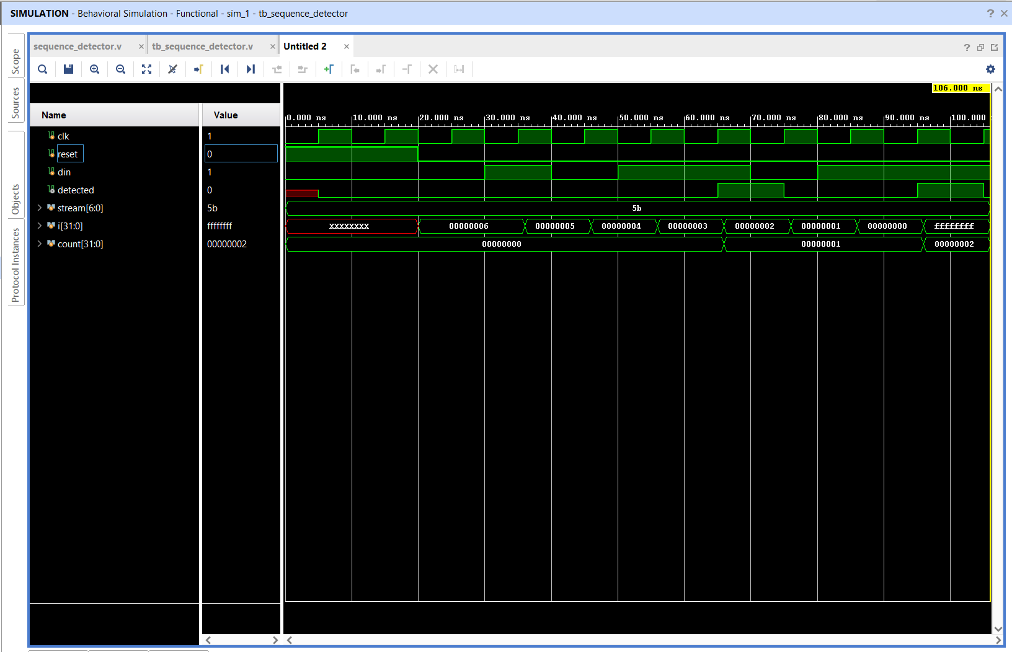
The target sequence 1011 is detected two times in the input stream 1011011.
b) Prepare the expected output table.
Input bit | Expected output | Observed output
1 | 0 | 0
0 | 0 | 0
1 | 0 | 0
1 | 1 | 1
0 | 0 | 0
1 | 0 | 0
1 | 1 | 1
c) State how many times the sequence is detected.
Answer: The target sequence 1011 is detected two times in the input stream 1011011.
8. Result and Conclusion.

The 4-bit overlapping sequence detector for the binary sequence 1011 was successfully designed using a Finite State Machine (FSM) and implemented in Verilog HDL. The design was verified using a testbench in Vivado behavioral simulation. The input stream 1011011 was applied to the detector, and the simulation produced two detection pulses, confirming that the target sequence was detected twice.

Overlapping detection is achieved by transitioning from state S3 to state S1 after detecting the sequence. This retains the final input bit as a possible starting bit for the next occurrence.

9. Viva Questions
1. What is the purpose of an FSM in a sequence detector?
An FSM stores the partial sequence received and determines the next state based on the current state and input bit.
2. Why is the sequence detector called an overlapping detector?
It is called an overlapping detector because it can detect repeated occurrences of a sequence that share one or more bits.
3. What is the function of the reset signal?
The reset signal initializes the FSM to its initial state S0 and clears the detection output.
4. What is the role of the clock in a synchronous FSM?
The clock synchronizes state transitions. In this design, the FSM updates its state on the rising edge of the clock.
5. How can you verify the output of a sequence detector using a testbench?
A testbench applies the required input sequence, runs the simulation, observes the output waveform, and compares the observed output with the expected output.
Submission: Submit the completed theory, state diagram, transition table, Verilog program, testbench, and simulation waveform.

