Excel Assignment – 6

1. What are the various elements of the Excel interface? Describe how they're used.

The following are the basic parts of the Microsoft Excel Window:

* 1. File Tab

We can click it to check the Backstage view, where we can open or save files, create new sheets, print sheets, and perform other file-related operations.

* 1. Title Bar

The title bar of the spreadsheet is at the top of the window. It displays the active document's name.

* 1. Control Buttons

Control buttons are the symbols that are present in the upper-right side of the window, enabling us to change the labels, minimize, maximize, share, and close the sheet.

* 1. Menu Bar

Under the diskette or save icon or the excel icon (this will depend on the version of the program), labels or bars which enable changing the sheet which is shown. These are the menu bar and contain a File, Insert, Page Layout, Formulas, Data, Review, View, Help, and a Search Bar with a light bulb icon. These menus are divided into subcategories which simplify the distribution of information and analysis of calculations.

* 1. Ribbon/Toolbar

Each menu bar contains several different elements. On the selection of the menu, a sequence of command options/icons will show on a ribbon. For example, if we select the "Home" tab, we will see cut, copy, paste, bold, italic, underline, and more commands. In the same way; we can click on the "Insert" tab, we will see tables, illustrations, additional, recommended graphics, graphics maps, among others. On the other hand, if we select the "Formulas" option. Insert functions, auto sum recently used, finances, logic, text, time, date, etc.

Ribbon/Toolbar is a set of commands organized into three sections.

* Tabs

They are the Ribbon's top part, and they include groups of related commands. Ribbon tabs include Home, Insert, Page Layout, Formula, Data.

* Groups

They organize related commands; the name of each group is displayed below the Ribbon. For example, a set of commands related to fonts or a group of commands related to alignment, etc.

* Commands

They appear within each group, as previously stated.

* 1. Formula Bar

Formula bar permits us to observe, insert or edit the information/formula entered in the active cell.

* 1. Scroll Bars

Scrollbars are the tools that enable us to move the document's vertical and horizontal views. We can activate this by clicking on the platform's internal bar or the arrows we have on the sides. Additionally, we can use the mouse wheel in order to automatically scroll up or down: or use the directional keys.

* 1. Spreadsheet Area

It is the place where we enter our data. It includes all the rows, cells, columns, and built-in data in the spreadsheet. We can use shortcuts to perform toolbar activities or formulas of arithmetic operations (add, subtract, multiply, etc.). The insertion point is the blinking vertical bar known as the "cursor." It specifies the insertion location of the typing.

* 1. Leaf Bar

Leaf bar is present at the bottom of the spreadsheet, which says sheet1 is shown. This sheet bar describes the spreadsheet which is currently being worked on. Using this, we can alternate a number of sheets or add a new one as per our convenience.

* 1. Column Bar

Columns are a vertically ordered series of boxes across the full sheet. This column bar is located below the formula bar. The letters of the alphabet are used to label the columns. Begin with the letter A to Z, and then after Z, it will continue as AA, AB, and so on. The number of columns that can be used is limited to 16,384.

* 1. Row Bar Cells

The row bar is the left part of the sheet where a sequence of numbers is expressed. Begin with number one (1), and further rows will be added as we move the pointer down. There are a total of 1,048,576 rows available.

* 1. Cells

Cells are those parallelepipeds that divide the spreadsheet into many pieces, separating rows and columns. A spreadsheet's first cell is represented by the first letter of the alphabet and the number one (A1).

* 1. Status Bar

The status bar is present at the bottom of the window that displays critical information. It also indicates whether something is incorrect or whether the document is ready to be printed or delivered.

This shows the result of the selected digits such as sum, average, count, maximum, minimum, etc.

By right-clicking on the status bar, we can configure the status bar. Any command from the specified list can be added or removed.

1. Write down the various applications of Excel in the industry.

The main uses of Excel include:

* Data entry
* Data management
* Accounting
* Financial analysis
* Charting and graphing
* Programming
* Time management
* Task management
* Financial modelling
* Customer relationship management (CRM)

1. On the ribbon, make a new tab. Add some different groups, insert commands in the groups and name them according to their commands added. Copy and paste the screenshot of the steps you followed.

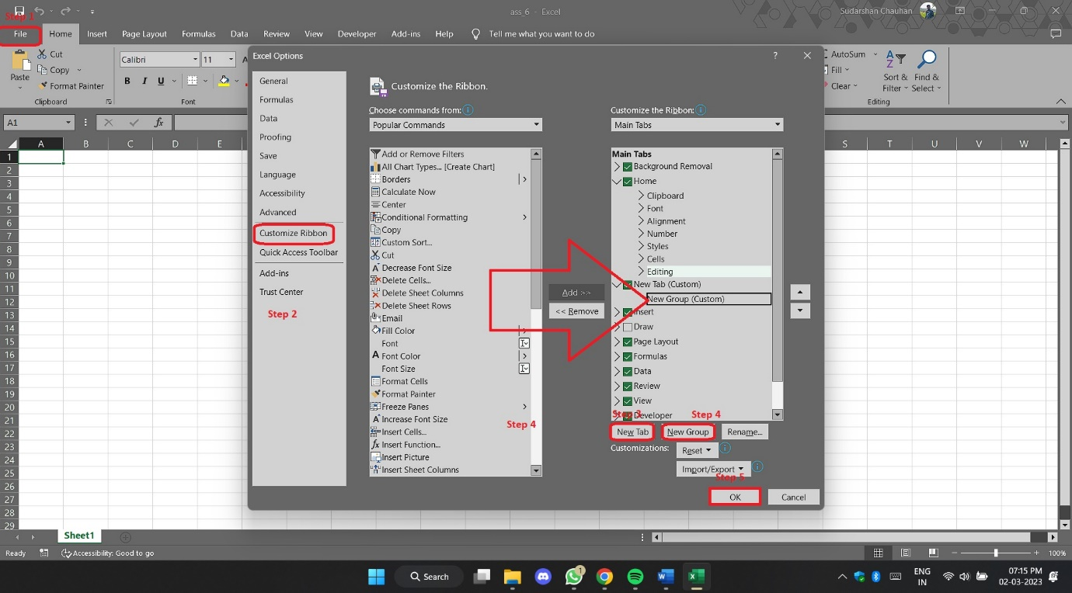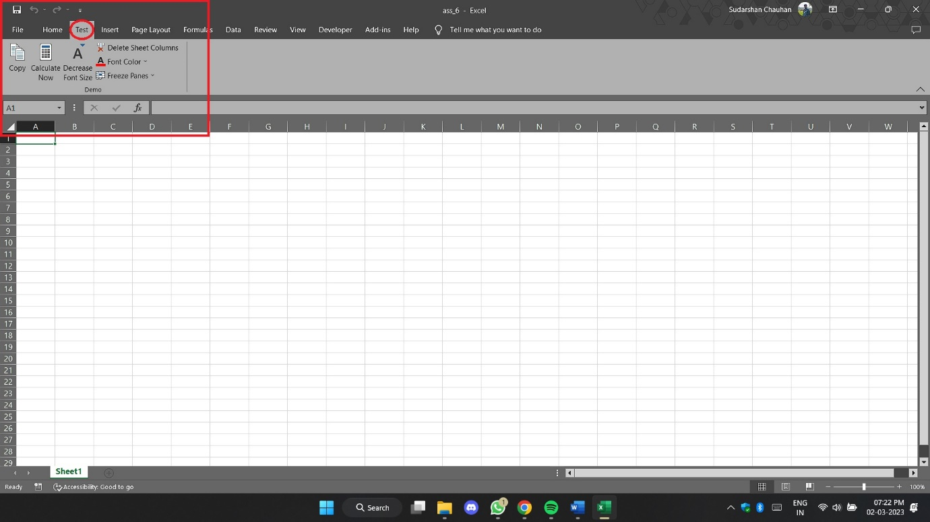

1. Make a list of different shortcut keys that are only connected to formatting with their functions.

Here is a list of different shortcut keys connected to formatting with their function from excel documentation made by Microsoft.

https://support.microsoft.com/en-us/office/keyboard-shortcuts-in-excel-1798d9d5-842a-42b8-9c99-9b7213f0040f

1. What distinguishes Excel from other analytical tools?

* The brilliant interface for users
* It’s easy to get started with Excel.
* The learning resources are very rich.
* You can do a lot of things with Excel: modelling, visualization, reports, dynamic charts, etc.
* It can help you understand the meaning of many operations before further learning other tools (such as Python and R).

1. Create a table and add a custom header and footer to your table.

