Excel Assignment – 7

1. Using Insert Function, give examples of any function available in the different dropdowns present in the function library. For example, AutoSum, Recently Used, Text, Date & Time, etc

You can search for any function by typing a brief description of what you want or select a category and select the function you want from the dropdown menu.

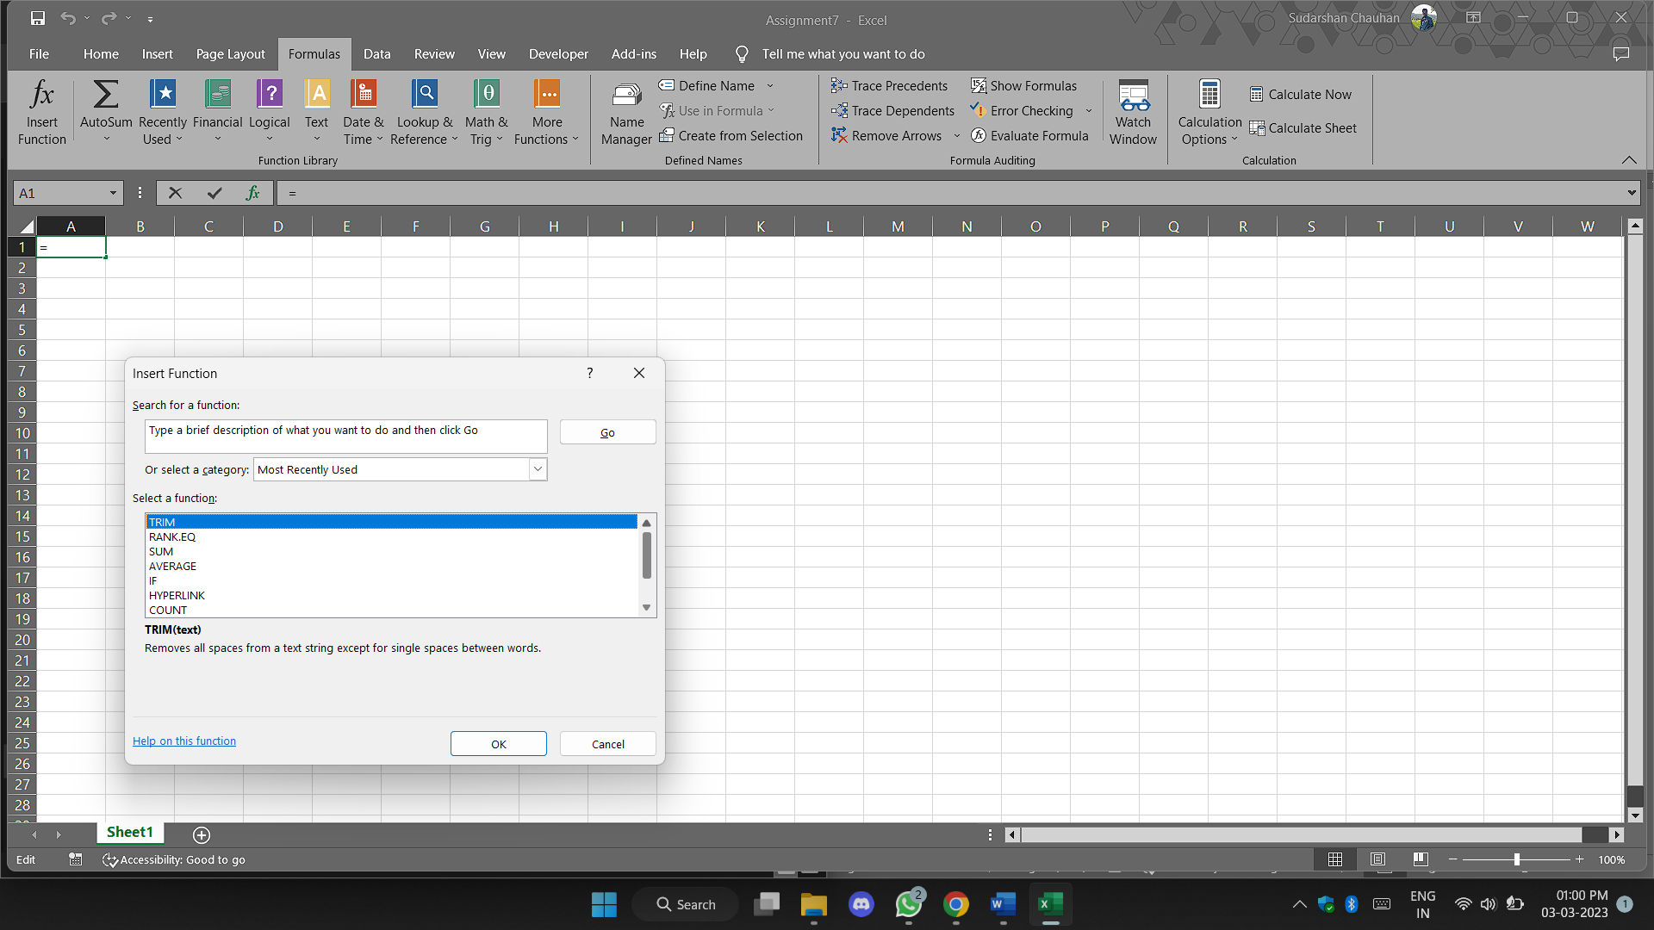

As you can see from picture above , some of the function are

Trim, RANK.EQ, SUM, AVERAGE, IF, HYPERLINK, COUNT.

1. What are the different ways you can select columns and rows?

1. Selecting a single cell:

<https://support.microsoft.com/en-us/office/select-cell-contents-in-excel-23f64223-2b6b-453a-8688-248355f10fa9>

2. Selecting multiple cells:

https://trumpexcel.com/select-multiple-cells-excel/#Select-Multiple-Cells-that-are-all-contiguous

1. What is AutoFit and why do we use it?

Excel's AutoFit feature is designed to automatically resize cells in a worksheet to accommodate different sized data without having to manually change the column width and row height. AutoFit Column Width - changes the column width to hold the largest value in the column

1. How can you insert new rows and columns into the existing table?

Add a row above or below

1. Click in a cell above or below where you want to add a row.

2. Under Table Tools, on the Layout tab, do one of the following:

* To add a row above the cell, click Insert Above in the Rows and Columns group.
* To add a row below the cell, click Insert Below in the Rows and Columns group.

Add a column to the left or right

1. Click in a cell to the left or right of where you want to add a column.

2. Under Table Tools, on the Layout tab, do one of the following:

* To add a column to the left of the cell, click Insert Left in the Rows and Columns group.
* To add a column to the right of the cell, click Insert Right in the Rows and Columns group.

1. How do you hide and unhide columns in excel?

On the Home tab, in the Cells group, click Format. Do one of the following: Under Visibility, click Hide & Unhide, and then click Unhide Rows or Unhide Columns.

1. Create an appropriate table within the worksheet and use different functions available in the AutoSum command.

