VIT BHOPAL SMART VEND
A Python-Based Smart Vending Machine Management and Purchase Assistant

1. Project Overview
VIT Bhopal Smart Vend is a Python-based vending machine management and purchase assistant designed for the VIT Bhopal campus.
The system provides users with information about vending machines, available products, inventory levels, prices, popular products, and unique products. Users can search for products, find the nearest vending machine, compare product prices, and receive smart recommendations according to their budget.
The system also provides a cart and purchase facility where users can select products, complete purchases, and view their order history.
An administrative panel is included to monitor inventory, low-stock products, orders, revenue, items sold, and machine-wise sales.
The project uses Python for application development and SQLite for persistent storage of inventory and transaction information.

2. Features
User Features
- View all vending machines
- View complete product catalogue
- View machine-wise inventory
- Search for products
- Find the nearest vending machine
- Display distance in kilometres
- Compare product prices
- View hot-selling products
- View unique products
- Get smart recommendations according to budget
- Get single-product recommendations
- Get product-combination recommendations
- View quantity possible within a budget
- Add products to cart
- Complete purchases
- View order history
Admin Features
- View low-stock products
- View database inventory
- View total orders
- View total items sold
- View total revenue
- View machine-wise sales
- Monitor vending machine inventory
- Analyse basic sales information

3. Technologies / Tools Used
Programming Language
- Python
Database
- SQLite
Python Modules
- sqlite3
- math
- random
- datetime
Development Tools
- Visual Studio Code / any Python-compatible IDE
- Python 3.x
- Git
- GitHub

4. Project Structure
VIT-SMART-VEND/
│
├── main.py
├── data.py
├── database.py
├── README.md
├── statement.md
├── requirements.txt
├── smart_vend.db
File Description
main.py
Contains the main application logic, menu system, product operations, recommendations, cart, purchase system, order history, and admin panel.
data.py
Contains the vending-machine, product, and initial inventory data.
database.py
Handles SQLite database creation, stock management, order storage, inventory updates, and sales statistics.
README.md
Contains project documentation, installation instructions, features, and testing instructions.
statement.md
Contains the project's problem statement, scope, target users, and high-level features.
requirements.txt
Contains the Python dependencies required to run the project.

5. Installation and Setup
Step 1: Install Python
Install Python 3.x on your computer.
Verify the installation using:
python --version
or:
python3 --version

Step 2: Clone the Repository
Clone this repository using:
git clone <YOUR-GITHUB-REPOSITORY-URL>
Move into the project directory:
cd VIT-SMART-VEND

Step 3: Create a Virtual Environment (Optional)
Create a virtual environment:
python -m venv venv
Activate it on Windows:
venv\Scripts\activate
For Linux/macOS:
source venv/bin/activate

Step 4: Install Dependencies
Install the required packages using:
pip install -r requirements.txt
The project mainly uses Python standard-library modules, so no large external packages are required.

6. Running the Project
Run the following command from the project directory:
python main.py
The application will display the main menu.
Example:
========================================
VIT BHOPAL SMART VEND
========================================

1. View All Vending Machines
2. View Product Catalogue
3. View Machine Inventory
4. Search Product
5. Find Nearest Machine
6. Compare Product Prices
7. View Hot Sellers
8. View Unique Products
9. Smart Budget Recommendation
10. Cart & Purchase
11. Order History
12. Admin Panel
13. Exit
Enter the number corresponding to the operation you want to perform.

7. Testing Instructions
The application can be tested using the following steps.
Test 1: View Vending Machines
Run the application and select:
1. View All Vending Machines
Verify that the vending-machine information is displayed correctly.

Test 2: View Products
Select:
2. View Product Catalogue
Verify that product names, categories, and prices are displayed.

Test 3: Check Inventory
Select:
3. View Machine Inventory
Select a vending machine and verify its available products and stock status.

Test 4: Search Product
Select:
4. Search Product
Enter a valid product name and verify that matching products are displayed.

Test 5: Find Nearest Machine
Select:
5. Find Nearest Machine
Provide the required location/coordinate information and verify that the nearest machine and distance are displayed.

Test 6: Price Comparison
Select:
6. Compare Product Prices
Select a product and verify the displayed price information.

Test 7: Budget Recommendation
Select:
9. Smart Budget Recommendation
Enter a budget such as:
120
Verify that the system displays products and combinations that can be purchased within the specified budget.

Test 8: Cart and Purchase
Select:
10. Cart & Purchase
Add products to the cart and complete the purchase.
Verify that:
- The correct total is calculated.
- Stock is reduced after purchase.
- The order is stored in the database.

Test 9: Order History
Select:
11. Order History
Verify that previously completed purchases are displayed.

Test 10: Admin Panel
Select:
12. Admin Panel
Verify that the system displays information such as:
- Low-stock products
- Total orders
- Total items sold
- Total revenue
- Machine-wise sales

8. Screenshots
Screenshots of the running application can be placed inside the screenshots folder.
Recommended screenshots include:
- Main Menu
- Vending Machine List
- Product Catalogue
- Machine Inventory
- Product Search
- Nearest Machine
- Price Comparison
- Smart Budget Recommendation
- Cart and Purchase
- Order History
- Admin Panel
Example Markdown syntax:
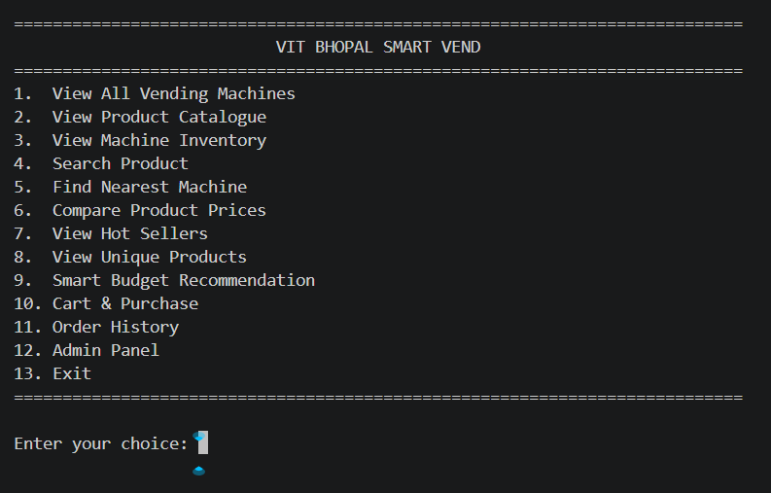

9. Expected Results
The system should successfully:
- Display vending machines
- Display products
- Display inventory
- Search products
- Find nearby vending machines
- Compare product prices
- Display popular products
- Display unique products
- Generate budget-based recommendations
- Manage shopping carts
- Complete purchases
- Update inventory
- Store order information
- Display order history
- Generate administrative sales information

10. Future Enhancements
Possible future improvements include:
- Machine-specific product pricing
- Graphical User Interface
- Web-based interface
- Mobile application
- Real-time inventory synchronization
- UPI and online payment integration
- QR-code based purchasing
- User authentication
- Notifications for low stock
- Advanced sales analytics
- AI-based personalized recommendations

11. Project Purpose
The main purpose of this project is to demonstrate the practical application of Python programming, database management, data structures, algorithms, modular programming, and software development concepts in a real-world campus vending-machine scenario.

12. Author
Student Name: SUDARSHAN CHHAPARWAL
Registration Number: 26BAI10714
Branch: B.Tech Artificial Intelligence and Machine Learning
University: VIT Bhopal University
Academic Year: 2026–27

