Simple Messaging Server

High Level Design

- SMServer:This class contains the main function for the server. It uses 3 different kinds of threads to respond to different requests from the clients.
  - ConnectionResponseThread: This thread accepts new connections from clients and saves them in a hashmap containing mapping from phone number to socket.
  - MessageQueuerLoop: This thread checks all sockets for new messages and puts them on a queue of messages to be sent.
  - MessageSenderLoop: This creates new threads which pick up messages from the message queue and send them to destinations.
- SMClient: This class contains the main function for the client.
  - After establishing the connection with the server it uses 2 threads:
  - ClientSendThread: this thread reads stdin and sends messages to the server.
  - ClientRecieveThread: this reads the socket from server and acts according to message from Server.

Protocol:
Server and client exchange info in form of JSON. This allows flexibility to client developers to use the programming languages/ framework of their choice.

A client sends the following JSON to server to request a new connection
{
"type":"connectionrequest",
"Id":"idstring"
}
The server responds with
{
"type":"response",
“responseType”:”connectionResponse”,
“state”:”pass/fail”,
“errorMessage”:”if failed reason for failure”
}

To send a new message client sends the following data to the server:
{
“type”:”message”,
"message":{
"srcId":"2222222222",
"destId":"3333333333",
"messageString":"Actual message sent to user.",
}
}

server responds with
{
"type": "response",
"responseType":"messageResponse",
"state", "pass/fail",
"message",”original message JSON”,
"errorMessage":”reason for failure in case of failure example duplicate messages”
}

Life Cycle of a message:

- Client sends message request to server using its socket
- MessageQueuerLoop: thread loops through all sockets and reads the message from the client socket.
- It adds the time at which the message was received at the server to the message and puts it on the messageQ.
- Several threads in the MessageSenderLoop process the message queue. They pick up messages and try to send them to destinations. If the socket for the destination is down or if it does not exist the message is put back on the queue.
- If the destination exists and socket is available, the duplicate message criteria is checked using a list of previous messages that were sent to the client.
- If the message is allowed according to the criteria(no duplicate message in the last 5 seconds) the message is sent to destination and confirmation is sent to the source that the message was sent.

Further Improvements for better fault tolerance:
Problem:
Current server design is able to handle clients which die and reconnect, but messages sent in this duration are lost as the current design does not check socket for acknowledgements.

Solution: we can add an additional response type which the client sends to the server after it receives a message. Using a timeout we can re queue such failed messages.

Problem: if a server crashes we lose all the messages and connections existing on the queue.
Solution:We can take regular backups of our messageQ and reload it while starting the server. This will enable us to send those messages.

Problem: The server does not authenticate clients, clients are free to assign their own Ids, if a new client arrives with the same Id we remove the original connection and use the new one.
This allows clients who had dropped for some reason to reconnect, but this design is prone to attack.
Solution:We need to create an authentication system and client should be required to authenticate using password or some other mechanism.

Scalability:
- There are 2 message sender threads which are run using an Executor Service, we can increase the number of these threads if the need arises.
- The MessageQueuer only has one thread which loops through all sockets looking for incoming messages. To scale better we can set a threshhold of number of sockets beyond which we add more threads to read the new sockets.

In order to test it out move to the directory containing :
SMMaven-1.0-SNAPSHOT-jar-with-dependencies.jar

Run the following command to start the server

java -cp SMMaven-1.0-SNAPSHOT-jar-with-dependencies.jar com.mycompany.smmaven.SMServer 1039

Run the following command to start as many clients as you need
The IP is for the host on which server is running and its port number, the 10 digit number is the phone number of the client.

java -cp SMMaven-1.0-SNAPSHOT-jar-with-dependencies.jar com.mycompany.smmaven.SMClient 127.0.0.1 1039 1111111111

java -cp SMMaven-1.0-SNAPSHOT-jar-with-dependencies.jar com.mycompany.smmaven.SMClient 127.0.0.1 1039 2222222222

To use the client the messages should be entered in the format
9898XXXXXX: actual message string

Below we can see repeated message hi was delivered the first time but it failed the second time.

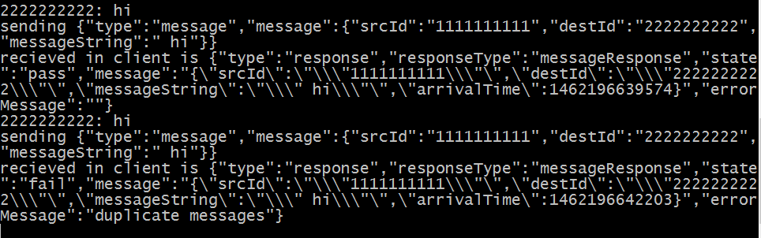
If clients send messages to a phone number which is not yet connected the messages stay in queue and when the client with the number joins, it receives all the messages together:

