**Topics: Normal distribution, Functions of Random Variables**

1. The time required for servicing transmissions is normally distributed with *μ* = 45 minutes and *σ* = 8 minutes. The service manager plans to have work begin on the transmission of a customer’s car 10 minutes after the car is dropped off and the customer is told that the car will be ready within 1 hour from drop-off. What is the probability that the service manager cannot meet his commitment?
2. 0.3875
3. 0.2676
4. 0.5
5. 0.6987   
   **ANS:**

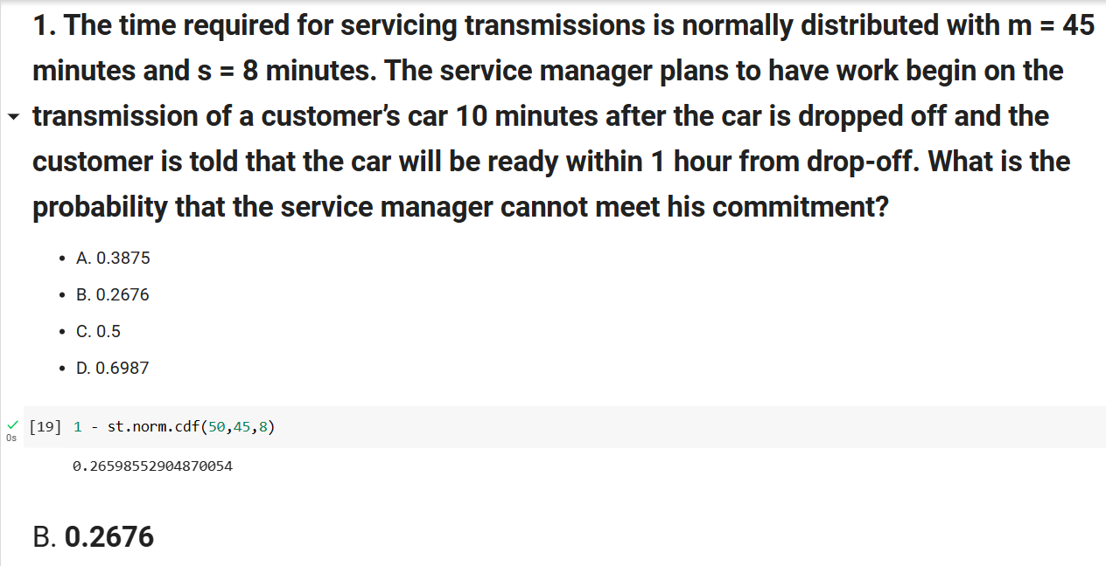

1. The current age (in years) of 400 clerical employees at an insurance claims processing center is normally distributed with mean *μ* = 38 and Standard deviation *σ* =6. For each statement below, please specify True/False. If false, briefly explain why.
2. More employees at the processing center are older than 44 than between 38 and 44.

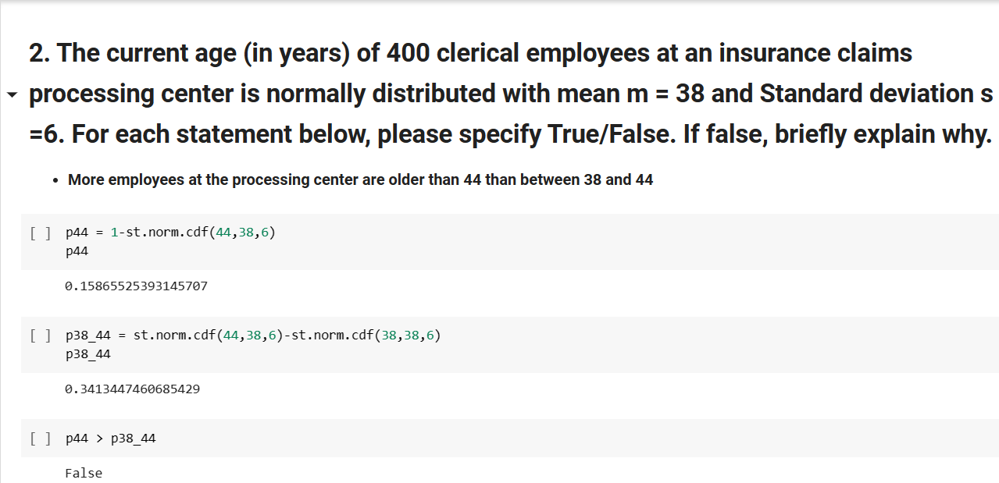

FALSE

1. A training program for employees under the age of 30 at the center would be expected to attract about 36 employees.

**ANS :** total = 400 # total no.of employees

b= norm.cdf(30, loc = mean, scale = std) # probabbility of employess age less than 30

x = b*total

print('A training program for employees under the age of 30 at the center would be expected to attract about',x.round(3),'employees')

**Output :**

A training program for employees under the age of 30 at the center would be expected to attract about 36.484 employees

Therefore, the statement is true.

TRUE

1. If *X1* ~ *N*(μ, σ2) and *X*2 ~ *N*(μ, σ2) are *iid* normal random variables, then what is the difference between 2 *X*1 and *X*1 + *X*2? Discuss both their distributions and parameters.

**ANS :** X1 and X2 follows normal distribution and X1,X2~ N (μ, σ2) are identically independent normal random variables.

2X1 = 2 N (μ, σ2) = N (2μ, 2σ2)

X1 + X2 = N (μ, σ2) + N (μ, σ2)

= N (2μ, 2σ2)

There is no significance difference between 2X1 and X1+X2

1. Let X ~ N(100, 202). Find two values, *a* and *b*, symmetric about the mean, such that the probability of the random variable taking a value between them is 0.99.
2. 90.5, 105.9
3. 80.2, 119.8
4. 22, 78
5. 48.5, 151.5
6. 90.1, 109.9

**ANS**:

x = norm.interval(0.99, loc = 100, scale = 20)

x = (x[0].round(1), x[1].round(1))

x

Output : (48.5, 151.5)

1. Consider a company that has two different divisions. The annual profits from the two divisions are independent and have distributions Profit1 ~ N(5, 32) and Profit2 ~ N(7, 42) respectively. Both the profits are in $ Million. Answer the following questions about the total profit of the company in Rupees. Assume that $1 = Rs. 45
2. Specify a Rupee range (centered on the mean) such that it contains 95% probability for the annual profit of the company.
3. Specify the 5th percentile of profit (in Rupees) for the company
4. Which of the two divisions has a larger probability of making a loss in a given year?
5. Specify a Rupee range (centered on the mean) such that it contains 95% probability for the annual profit of the company.

**ANS**: A= Specify a Rupee range (centered on the mean) such that it contains 95% probability for the annual profit of the company.

# For profit1

m1 = 5 * 45 # convert rupees

std1 = 3

prob1 = norm.interval(0.95, loc = m1, scale = std1)

prob1 = (prob1[0].round(0),prob1[1].round(0))

# For profit2

m2 = 7 * 45 # convert rupees

std2 = 4

prob2 = norm.interval(0.95, loc = m2, scale = std2)

prob2 = (prob2[0].round(0),prob2[1].round(0))

print('probability for the annual profit of the company with profit1 range', prob1, '\n probability for the annual profit of the company with profit 2 range', prob2)

**ANS:** C= Which of the two divisions has a larger probability of making a loss in a given year?

Output :

probability for the annual profit of the company with profit1 range (219.0, 231.0)

probability for the annual profit of the company with profit 2 range (307.0.0, 323.0)

**ANS**: B= Specify the 5th percentile of profit (in Rupees) for the company

ppf1 = norm.ppf(0.05, loc= m1, scale = std1)

ppf1 = ppf1.round(2)

ppf2 = norm.ppf(0.05, loc= m2, scale = std2)

ppf2 = ppf2.round(2)

print('the 5th percentile of profit1 :',ppf1,'\n the 5th percentile of profit2 :',ppf2)

Output :

the 5th percentile of profit1: 220.07

the 5th percentile of profit2: 308.42

**ANS:** C= Which of the two divisions has a larger probability of making a loss in a given year?

z_score_loss_profit1 = (0 - m1) / std1

z_score_loss_profit2 = (0 - m2) / std2

prob_loss_profit1 = norm.cdf(z_score_loss_profit1)

prob_loss_profit2 = norm.cdf(z_score_loss_profit2)

print('Company 1 loss probability: ',prob_loss_profit1,'\nCompany 2 loss probability: ',prob_loss_profit2 )

Output :

Company 1 loss probability: 0.0

Company 2 loss probability: 0.0