ARCHITECTURE DETAILED DESIGN
AlphaOpen Tennis League Progressive Web Application
Control | Value
Document status | Proposed for Architecture Review Board
Version | 1.0
Review date | July 26, 2026
System | AlphaOpen Tennis League
Production project | alphaopen-development-2026
Current hosting | https://alphaopen-development-2026.web.app
Architecture posture | Firebase Spark-safe, client-mediated transactions

ARB recommendation: Approve the current Spark-safe architecture as an interim operating model, subject to the controls and remediation plan in Section 15. The design is suitable for a trusted, small league administration model but is not the recommended final state for high-assurance or materially scaled operations.

Decision requested
- Approve the current Firebase Hosting, Authentication, Firestore, and PWA architecture for controlled production use.
- Approve the team-level lineup workflow and the Spark-safe transaction pattern as the current system of record behavior.
- Accept the documented residual risks of privileged client execution, especially exceptional lineup reset validation.
- Approve the future Blaze migration pattern without requiring a Firestore data migration.
- Assign owners and target dates for the conditions of approval.

Document purpose and evidence base
This document describes the as-built application architecture, data model, security model, operational workflows, deployment topology, and planned evolution. It is based on the deployed source configuration and the repository artifacts ALPHAOPEN_APP_SPEC.md, FIRESTORE_DATA_MODEL.md, firebase.json, firestore.rules, firestore.indexes.json, manifest.webmanifest, the route and feature modules, and the Spark-safe lineup workflow implementation.

1. Executive architecture summary
AlphaOpen is a mobile-first, single-page Progressive Web Application for public league information and authenticated league operations. Static HTML, CSS, JavaScript modules, images, and the service worker are served by Firebase Hosting. Google Authentication establishes identity. Cloud Firestore is the operational and public data store. Firestore Security Rules are the primary authorization and workflow enforcement layer.
The application currently operates on the Firebase Spark plan. There is no deployed trusted application server. Standard create, update, approval, publication, and reset actions execute in the browser using Firestore transactions or batched writes. The security design therefore combines role data, immutable snapshots on matchup records, strict document transition rules, and create-only audit/revision records.
Layer | Current design | Assessment
Presentation | Responsive SPA/PWA using HTML, CSS, JavaScript modules and route-based lazy loading | Production
Identity | Google Sign-In through Firebase Authentication; verified-email player linking and admin approval | Production
Application services | Browser modules and Firestore transactions; no deployed Cloud Functions | Interim
Data | Cloud Firestore, default database, nam5 multi-region | Production
Authorization | Firestore Security Rules plus client route visibility | Production
Hosting | Firebase Hosting with SPA rewrite and no-cache code headers | Production
Offline | Service worker app-shell cache; operational writes still require Firestore connectivity | Limited
Delivery | Manual Firebase CLI deployment to one Firebase project | Needs hardening

Architecture quality assessment
Category | Assessment
Strengths | Simple deployment, low operating cost, responsive PWA, direct real-time reads, strong document ownership model, immutable lineup revisions, transaction-based concurrency.
Constraints | No trusted execution tier, no scheduled/background processing, no centralized secrets, limited server-side validation, manual cache versioning, one environment.
Highest residual risk | A privileged user can attempt direct SDK writes. Rules control status transitions, but application-level checks such as score inspection during exceptional reset cannot be independently queried by Firestore Rules.
Recommended disposition | Approve with conditions and define explicit triggers for a Blaze/server migration.

2. Scope, principles, and design decisions

2.1 In-scope capabilities
- Public home, season, match, standings, history, rules, venue, and community content.
- Google authentication, user registration, Player Master identity matching, and Super Admin approval.
- Season, team, roster, venue, matchup, approver, and player administration.
- Captain, EC, Neutral Approver, and Super Admin lineup submission.
- Independent Home/Away team-level approval, rejection, and self-approval tracking.
- Full lineup publication, match scheduling, score entry, calculated points, and standings publication.
- Exceptional reset of both fully approved lineups when no score activity is detected.
- PWA installation and app-shell offline behavior.

2.2 Governing principles
Principle | Application
Canonical identity | Firebase UID identifies the account; Player ID identifies the person across seasons and history.
Season isolation | Operational data is nested below a season and is governed by active season membership.
Least privilege | Guest, Player, Captain, EC, Neutral Approver, and Super Admin access is evaluated separately.
Immutable history | Submitted lineup revisions and workflow actions are create-only.
Atomic state change | Cross-document workflow state is committed in one transaction or batch.
Public/private separation | Public projections are separate from operational and private player records.
Snapshot history | Names, ranks, teams, and actor details are copied into official records to preserve historical meaning.
Plan portability | UI and schema contracts remain stable when protected mutations move to Cloud Functions.

2.3 Key architecture decisions
ID | Decision | Rationale
ADR-001 | Progressive Web App | One responsive codebase for phone, tablet, and desktop; avoids native app distribution.
ADR-002 | Firebase managed platform | Use Hosting, Authentication, and Firestore to minimize operational overhead.
ADR-003 | Spark-safe workflow | Use browser-side Firestore transactions while Blaze is unavailable.
ADR-004 | Team-level lineup states | Track Home and Away independently and derive matchup approval status.
ADR-005 | Immutable lineup revisions | Never overwrite submitted history; current lineup points to a numbered revision.
ADR-006 | Separate reset exception | Fully approved lineups cannot be changed through normal approval; reset always affects both.
ADR-007 | On-demand score inspection | Do not maintain scoreActivityStarted; query and re-read line records only when reset is requested.
ADR-008 | Future trusted service seam | Expose workflow operations through one client service so Cloud Functions can replace transaction internals.

3. System context
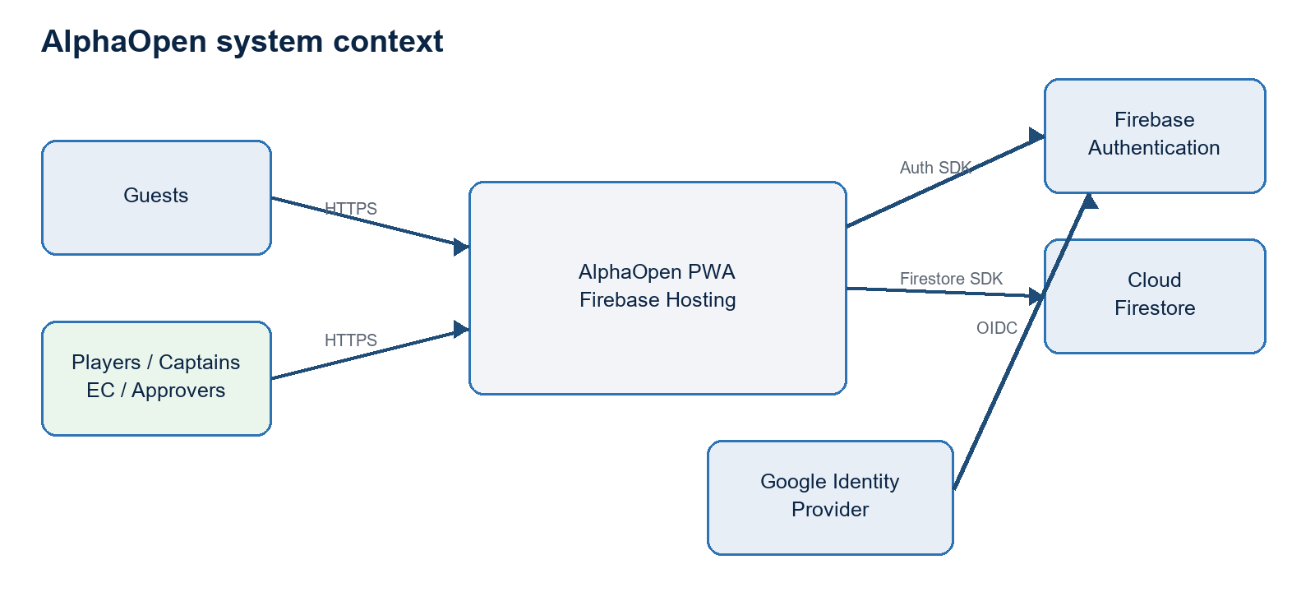
Figure 1. System context and managed-service boundaries

3.1 Actors and trust boundaries
Actor | Trust classification | Primary access
Guest | Untrusted anonymous browser | Published/public documents only
Player | Authenticated active user | Own account, membership, availability, permitted history
Captain | Authenticated operational user | Own team lineup, scheduling, and score responsibilities
EC | Season administrator | Rosters, season structure, venues, disputes, operational visibility
Neutral Approver | Privileged seasonal assignment | Either team submission; independent approval/rejection; reset exception
Super Admin | Highest privilege | Global administration and all operational actions
Firebase services | Managed trusted platform | Identity tokens, rule evaluation, transactions, persistence, hosting

3.2 External dependencies
- Google Identity Provider for interactive account authentication.
- Firebase JavaScript SDK version 12.16.0 loaded from the Google CDN.
- Firebase Hosting, Authentication, and Cloud Firestore in project alphaopen-development-2026.
- Browser platform services: service workers, Cache API, local/session persistence, dialogs, canvas, and clipboard.
- Firebase CLI for rules and hosting deployment.

4. Logical application architecture
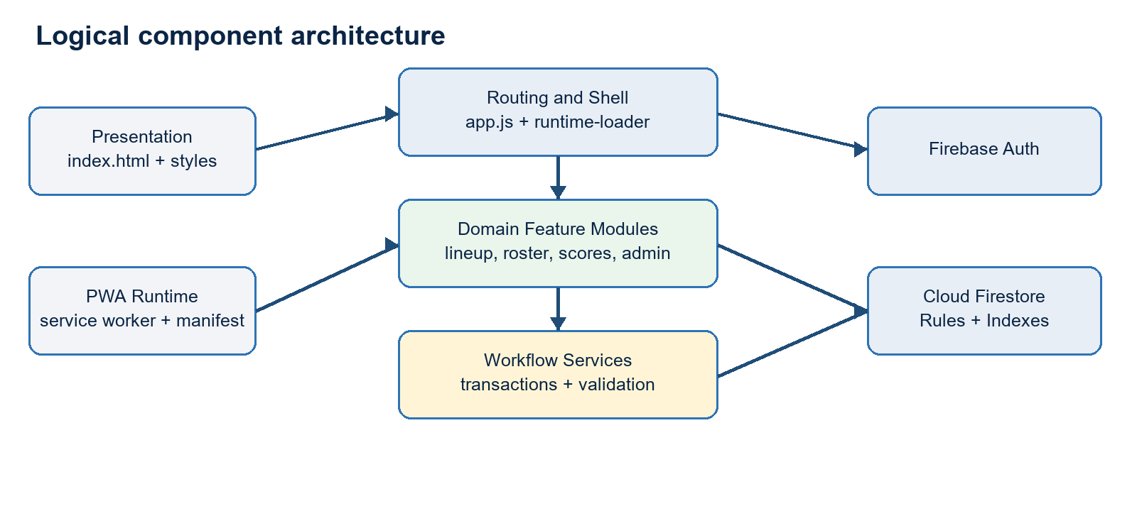
Figure 2. Browser modules and Firebase service boundaries

4.1 Component catalog
Component | Primary modules | Responsibility
Application shell | index.html, styles.css, app.js | Routes, navigation, responsive views, dialogs, common rendering.
Runtime loader | runtime-loader.js and feature bootstraps | Loads core Firebase modules and route-specific modules on demand.
Identity | firebase-auth.js, player-identity.js | Google sign-in, verified email matching, profile provisioning, authorization context.
Data access | firebase-client.js, firebase-data.js | Firebase initialization, public/operational reads, UI data hydration.
Lineup workflow | lineup-submit.js, lineup-approve.js, lineup-reset.js, lineup-workflow-client.js | Draft, submit, approve, reject, publish, and reset transactions.
Match operations | match-management.js, score-rules.js | Schedule entry, score validation, points, completion locking.
Season administration | season-*.js, roster-admin-v3.js, venue-admin.js | Season import, teams, matchups, rosters, venues, reset.
Public projection | public-season-dashboard.js | Publishes guest-safe season data after authorized operational changes.
Offline shell | service-worker.js, manifest.webmanifest, pwa.js | Installability, cache lifecycle, offline navigation fallback.
Security policy | firestore.rules, firestore.indexes.json | Authorization, transition constraints, query support.

4.2 Routing and module lifecycle
The application is a hash-routed SPA. Views are declared as sections in index.html and activated by app.js. The runtime loader imports Firebase core modules and loads route-specific administrative modules only when their route or admin panel becomes active. Separate small bootstrap modules initialize lineup, approval, reset, EC status, and match-management features.
Code assets use explicit query-string versions. Firebase Hosting sets no-cache headers for JavaScript and CSS. The service worker uses a versioned cache, applies network-first behavior to app code, and deletes earlier cache versions during activation.

5. Deployment and runtime topology
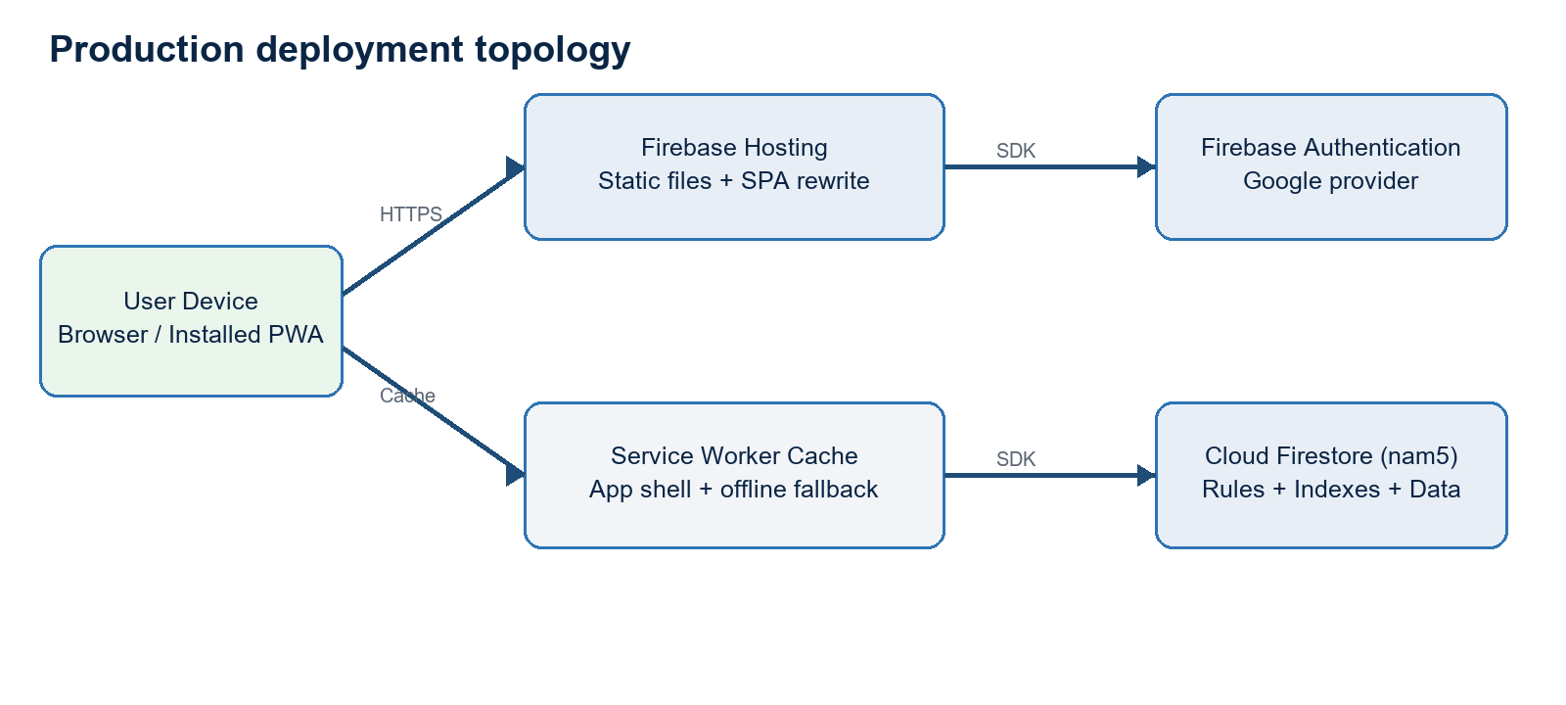
Figure 3. Current Spark-plan production topology
Element | Configuration | Architecture note
Firebase project | alphaopen-development-2026 | Single project currently serves production.
Hosting URL | alphaopen-development-2026.web.app | Public endpoint; all paths rewrite to index.html.
Firestore | (default), nam5 | Operational, private, and public documents.
Functions | Not configured for deployment | Functions source is retained for future migration but excluded from Spark deployment.
Headers | No-cache for HTML, JS, CSS, manifest | Reduces stale-code risk; service worker provides controlled cache fallback.
Emulators | Auth 9099, Firestore 8080, Hosting 5000 | Local validation and security-rule testing.

5.1 Environment and release management
The repository currently targets one Firebase project and contains the Firebase client configuration directly in browser code, which is normal for Firebase clients. Production deployment is performed with the Firebase CLI for Hosting and Firestore Rules. There is no separate staging project, automated promotion workflow, or infrastructure-as-code pipeline.
Condition of approval: Create separate development/test and production Firebase projects, automate rule tests in CI, and require reviewed deployment promotion before operational scale increases.

6. Identity, authorization, and security architecture

6.1 Authentication and registration
- User signs in with Google through Firebase Authentication.
- The application requires a verified Google email.
- The normalized email must match an active Player Master email index.
- A new user record is created as pending and linked to the canonical Player ID.
- Super Admin approves the registration and assigns active season membership and roles.
- The application derives route access from global roles plus current-season member roles.

6.2 Authorization layers
Layer | Mechanism | Security role
Navigation visibility | data-access, data-access-any, data-nav-roles, data-super-admin | User experience only; not a security boundary.
Client guard clauses | Feature modules validate authorization context and team scope | Prevents accidental actions and provides clear errors.
Firestore Rules | Identity, active status, season role, team scope, allowed fields, and transition checks | Primary security boundary.
Transaction invariants | Current revision, current status, operation ID, actor UID, and multi-document state | Concurrency and workflow integrity.
Immutable records | Revision and review documents are create-only | Nonrepudiation and audit preservation.

6.3 Role access matrix
Capability | Guest | Player | Captain | EC | Approver | Super Admin
Public content | Read | Read | Read | Read | Read | Read/write
Own player/account data | - | Read/update limited | Read/update limited | Read | Read | All
Team lineup submit | - | - | Own team | Authorized scope | Either team | Any
Lineup approve/reject | - | - | - | - | Assigned scope | Any
Reset approved lineups | - | - | - | - | Assigned scope | Any
Roster/season operations | - | - | Request/view | Season scope | View | Any
Schedule/score | Published read | Assigned read | Team scope | Season scope | Read | Any
Security administration | - | - | - | - | - | Any

6.4 Security controls and residual risk
Control | Design | Status
Verified identity | Firebase ID token and verified Google email. | Implemented
Private data isolation | Separate playerPrivate and venuePrivate documents. | Implemented
Role enforcement | Rules read user, member, assignment, and matchup snapshots. | Implemented
Privilege snapshot | Matchups carry captain and approver UID lists for efficient rule evaluation. | Implemented
Workflow actor binding | Matchup stores operation ID and actor UID; related writes must match. | Implemented
Immutable workflow history | Submitted revisions and action records cannot be updated or deleted. | Implemented
Exceptional reset score check | Application queries line matches and transaction re-reads them. | Application-enforced
App Check | No enforced App Check attestation. | Gap
Central monitoring | No server event pipeline or alerting. | Gap
Bootstrap Super Admin | Protected email is embedded in client/rules until custom claims are introduced. | Accepted interim risk

7. Data architecture

7.1 Collection hierarchy
Domain | Collections | Purpose
Global identity | users, players, playerPrivate, playerEmailIndex, playerAccountLinks, registrationRequests | Account identity and canonical person records
Global reference | venues, venuePrivate, systemConfig, aoContent | Venues, active season control, public content
Season core | seasons/{seasonId} | Season configuration and status
Season access | members, approverAssignments | Season roles and approval scope
Competition setup | teams, rosterSlots, rosterAssignments, ruleVersions, weeks, matchups | Teams, ranks, rules, schedule structure
Lineup workflow | matchups/{matchupId}/lineups, revisions, lineupReviews | Current lineups, immutable submissions, actions
Match operations | lineMatches, scheduleProposals, scoreSubmissions, scoreDecisions | Line scheduling and scoring
League operations | availability, replacementRequests, latePassRequests, adjustments | Supporting workflows
Results | standings, standingsSnapshots, playoffBrackets | Calculated/public competition results
Audit/notification | auditEvents, users/{uid}/notifications | Operational trace and user messages

7.2 Identifier strategy
Identifier | Use
Firebase UID | Authentication account and role assignment
Player ID | Permanent person identity and historical linkage
Season ID | Partition key for competition operations
Team ID | Season team identity
Assignment ID | Immutable roster assignment interval
Matchup ID | Home-versus-Away team event
Line match ID | Matchup plus line number; normally {matchupId}-L1 through L5
Operation ID | Client-generated idempotency key for lineup action
Revision number | Monotonic lineup submission version within team/matchup

7.3 Public/private partitioning
Public pages must read only explicitly published fields. Operational season documents include member UIDs, internal status, lineup workflow state, and administrative metadata. Personally identifiable information is split into private collections. Official records carry display-name snapshots for historical readability without requiring broad access to private master records.
Data-governance note: Snapshot fields are intentionally denormalized. They preserve historical meaning but require defined correction procedures when an official record is wrong; changing the Player Master must not silently rewrite history.

8. Core schema design

8.1 Identity and master data
Document | Key fields | Purpose
users/{uid} | uid, email, status, profileType, playerId, globalRoles, displayName, lastLoginAt | Account authorization and profile
players/{playerId} | displayName, public fields, active status | Canonical public player identity
playerPrivate/{playerId} | emailNormalized, phone, private notes, status | Restricted PII and identity match
playerAccountLinks/{playerId} | uid, status, approval metadata, link method | One-account-to-player link
seasons/{seasonId}/members/{uid} | roles, teamIds, playerId, status | Season-scoped authorization
teams/{teamId} | name, captainUids, captainPlayerIds, status | Season team master
rosterSlots/{team_rank} | teamId, rankNumber, participation counters | Persistent team-rank slot
rosterAssignments/{assignmentId} | teamId, rankNumber, playerId, type, dates, eligibility, status | Effective-dated player assignment

8.2 Matchup master
Field group | Fields
Identity | matchupId, weekId, stage, homeTeamId, awayTeamId
Authorization snapshots | homeCaptainUids, awayCaptainUids, approverUids
Team states | homeLineupStatus, awayLineupStatus
Overall state | lineupApprovalStatus, bothLineupsSubmitted, lineupsPublished
Revision pointers | homeLineupRevisionNumber, awayLineupRevisionNumber
Actor tracking | homeLineupTracking, awayLineupTracking
Publication | fullyApprovedAt, lineupsPublishedAt
Concurrency/security | lineupWorkflowActorUid, lineupWorkflowOperationId
Reset | approvalCycleNumber, lastLineupReset
Competition | status, completedLineCount, homeTeamPoints, awayTeamPoints, standingsApplied

8.3 Lineup current document and revision
Field group | Definition
Identity | seasonId, matchupId, teamId, revisionNumber, ruleVersionId
State | draft | submitted | approved | rejected
Content | five lines; each has two player IDs/names/ranks and SOR
Validation | passed, errors, checkedAt, checkedBy, ruleVersionId
Submission | submittedByUid/playerId/name/role, submittedAt
Approval | approvedByUid/playerId/name/role, approvedAt
Rejection | rejectionReason, rejectedByUid/playerId/name/role, rejectedAt
Audit | updatedByUid, updatedAt
Revision copy | same payload plus immutable=true in revisions/{revisionNumber}

8.4 Line match
Field group | Definition
Identity | lineMatchId, matchupId, lineNumber, seasonId
Teams/players | homeTeamId, awayTeamId, homePlayers[2], awayPlayers[2], rank snapshots
Lineup linkage | homeLineupRevisionNumber, awayLineupRevisionNumber, lineupState, scoreEntryAllowed
Schedule | venueId/name/address, scheduledAt, scheduleStatus
Score | sets, scoreStatus, winnerTeamId, homePoints, awayPoints, completedAt
Audit | createdAt, updatedAt

9. Lineup submission and approval detailed design

9.1 Status model
Team status | Meaning | Next action
pendingSubmission | No sealed submission is available for this team. | Captain/EC/Approver/Super Admin submits
submitted | Current revision is sealed and awaiting a decision. | Approver approves or rejects
approved | Current team revision is approved. | Other team approved or, before full approval, Approver rejects
rejected | Current revision was returned with a reason. | Authorized submitter submits a new revision

Matchup status | Derivation
awaitingSubmission | At least one team remains pending and neither team is rejected.
awaitingApproval | Both teams are submitted/approved but at least one submitted revision needs approval.
rejected | At least one team lineup is rejected.
fullyApproved | Both team lineup statuses are approved.

9.2 Submission transaction
- Validate request IDs, signed-in actor, role, team relationship, and five-line lineup.
- Read active roster assignments for the selected team and canonicalize player snapshots and ranks.
- Read the action, matchup, current lineup, and proposed revision inside a Firestore transaction.
- Reject replacement of a submitted or approved current lineup.
- Increment the revision number and write the current lineup plus immutable revision copy.
- Update the appropriate Home/Away status, revision pointer, tracking map, and derived matchup status.
- Set workflow actor UID and operation ID on the matchup.
- Create a write-once submitted action containing prior/new status and result.

9.3 Approval/rejection transaction
- Only a Neutral Approver assigned to the matchup/season or Super Admin may decide.
- The Approver may review one submitted team even while the opponent is pending.
- Approval requires the current status to be submitted; rejection permits submitted or approved before full approval.
- A rejection requires a reason and clears approval metadata.
- Self-approval is permitted for the current release and is recorded when submittedByUid equals approvedByUid.
- The matchup status is recalculated from both team states.
- When both teams become approved, five line-match records are created or refreshed and score entry is enabled.
- The decision and all publication writes are committed atomically with a create-only action record.

9.4 Visibility model
Role | Before full approval | After full approval
Captain | Own team lineup | Opponent team status only until publication
EC | Authorized season lineups | Operational status and roster context
Neutral Approver | Both current team lineups | Independent team decisions
Super Admin | All current and historical lineup data | All actions
Player/Guest | Published information only | No sealed drafts or internal decisions

9.5 Requirements variance from original specification
Topic | Earlier baseline | Current design | Disposition
Approver visibility | Original: wait for both submissions | Current: Approver can review the submitted team while the opponent is pending | Approved product decision
Approval granularity | Original: approve both together | Current: approve/reject each team independently; publish only when both approved | Approved product decision
Approver submission | Original: not allowed | Current: Neutral Approver may submit either team and self-approve with audit flag | Approved product decision
Time restrictions | Original: deadlines envisioned | Current: no approval time restrictions | Explicitly deferred
Post-approval change | Original: change/consent workflow | Current: no change request; separate reset-both exception | Approved simplification

10. Reset Approved Lineup exception

10.1 Access and selection
Reset Approved Lineup is a separate screen available only to Neutral Approvers and Super Admins. The user selects Season, Week, and Home Team/matchup. Both approved lineups, submitter/approver metadata, and all five line matches are displayed before reset.

10.2 Eligibility validation
- Matchup must be fullyApproved, or both stored team statuses must be approved.
- Both current lineup documents must exist.
- The application queries every line match and blocks when it finds in-progress/completed states, submitted/confirmed/disputed/published score states, nonzero set scores, nonzero points, a winner, or completedAt.
- The reset transaction re-reads the discovered line documents plus the five canonical line IDs immediately before writing.
- The user must enter a reason, acknowledge the effect, and type the exact Matchup ID.

10.3 Reset transaction result
Record | Result
Home lineup | Delete current document; preserve revisions
Away lineup | Delete current document; preserve revisions
Team statuses | Both pendingSubmission
Matchup status | awaitingSubmission
Publication | lineupsPublished=false; timestamps cleared
Approval cycle | Increment by one
Line matches | Retain schedule documents; set lineupState=awaitingReapproval and scoreEntryAllowed=false
Audit | Create resetBothApprovedLineups action with actor, reason, previous revisions, and cycle

Residual risk: Firestore Rules cannot issue an authorization-time collection query proving that no scored line exists. The application performs the score inspection and transaction re-read. This is reasonable for a rare action restricted to trusted Approvers and Super Admins, but it is the strongest trigger for future trusted-server migration.

11. Scheduling, scoring, and publication

11.1 Match schedule and score
Each fully approved matchup produces five operational line-match documents. Captains may update lines involving their teams; EC and Super Admin users have season-wide management scope. A reset line with scoreEntryAllowed=false or lineupState=awaitingReapproval cannot be scored until both new lineups are fully approved.

11.2 Score validation
- Set scores are structured numeric values rather than free-form result text.
- The scoring module validates completeness and determines the winner.
- Straight-set completion does not permit a third set.
- Split first and second sets require a deciding set.
- Winner receives 14 league points; loser points follow the configured two-set or three-set rules.
- Final score entry requires explicit user confirmation and then disables further normal score update.

11.3 Public projection
Operational writes are followed by publication of guest-safe season dashboard data. The public projection must contain only approved schedules, published lineups, results, standings, and approved venue fields. Private contact details, registration state, availability, sealed lineups, internal notes, and dispute information remain outside the public projection.

11.4 Consistency considerations
Boundary | Mechanism | Implication
Within a workflow | Firestore transaction/batch | Atomic current state, revision, matchup, line records, and action.
Public projection | Follow-on client publication | Eventual consistency; a failed projection may leave public data stale.
Standings | Client/server-derived documents depending workflow | Must be idempotent and protected from duplicate application.
Offline writes | Firestore client behavior | Operational flows should surface connectivity and avoid assuming immediate publication.

12. Transaction, concurrency, and integrity design
Integrity concern | Control
Idempotency | Every official lineup operation carries a random operation ID; duplicate action reads return the prior result.
Optimistic concurrency | Firestore transaction retries when read documents change.
Revision monotonicity | Next revision is max(current lineup revision, matchup pointer) + 1.
Sealed state | Submitted and approved current lineups cannot be overwritten by normal submission.
Cross-document binding | Matchup actor UID and operation ID bind related write permissions in Rules.
State derivation | Matchup approval status is recalculated from Home and Away statuses.
Immutable evidence | Revisions and review actions are create-only.
Reset safety | Known line documents are re-read before reset; score activity causes application failure.

12.1 Rule-evaluation budget
Firestore Rules have expression and document-access limits. Workflow rules use matchup authorization snapshots and a single operation actor binding to avoid repeatedly loading user, member, and assignment records for every write in a multi-document transaction. Emulator tests validate the complete submission, one-sided approval, second-team approval with five line records, unauthorized Captain denial, and reset transaction.

12.2 Failure behavior
Failure | Expected behavior
Validation failure | No official write; display exact lineup or score error.
Authorization failure | Firestore permission-denied; UI restores controls and displays failure.
Concurrent update | Firestore retries transaction; stale state is rejected on re-evaluation.
Partial network failure | Atomic transaction does not partially commit.
Public projection failure | Operational state may commit while public projection remains stale; requires retry/monitoring.
Service worker stale asset | Network-first app code and no-cache hosting headers reduce risk; versioned cache activates on update.

13. Nonfunctional architecture
Quality attribute | Current design | Required control
Availability | Firebase managed services; static hosting remains available independently of custom servers. | Define service objective and status monitoring.
Performance | Static CDN delivery, lazy modules, Firestore direct reads, indexed queries. | Add query budgets and representative device testing.
Scalability | Adequate for a small league; denormalized documents and direct reads scale horizontally. | Review read amplification and public projection strategy before multi-league expansion.
Security | Firebase Auth + Rules + immutable records. | Add App Check, environment separation, custom claims/server controls.
Privacy | Public/private collections and limited contact access. | Document retention, deletion, and incident procedures.
Accessibility | Responsive semantic HTML and mobile layout. | Perform formal WCAG 2.2 AA audit and keyboard/screen-reader testing.
Maintainability | Feature modules and shared workflow service. | Introduce build tooling, linting, typed contracts, and module tests.
Observability | Browser errors and Firebase console. | Add structured event/error monitoring and deployment traceability.
Recoverability | Firestore managed durability; immutable history. | Schedule exports/backups and test restore.
Compatibility | Modern iOS/Android/desktop browsers; PWA manifest. | Maintain supported-browser matrix.

13.1 Data retention and recovery
- Submitted lineup revisions and official workflow actions should be retained for the full league-history period.
- Private player data should follow a documented retention and correction policy.
- Season reset must preserve the season root and immutable audit evidence while deleting explicitly scoped descendants.
- Production Firestore export and restore procedures should be exercised before the next season launch.

14. Testing and architecture assurance
Assurance layer | Mechanism | Coverage
Static application contract | test-prototype.mjs | Routes, views, modules, PWA, encoding, score rules, lineup service usage.
Workflow logic | functions/test/workflow.test.js | Status derivation, five-line validation, score-activity detection.
Rules compilation | Firebase Firestore emulator | Production rules compile without errors.
Role/workflow integration | spark-workflow-rules-test.mjs | Submission, Captain approval denial, one-sided approval, full approval, reset.
Browser smoke test | Local hosted application | Required views and versioned modules load without console errors.
Production verification | Firebase deploy output and HTTPS request | Hosting/rules released; live response is HTTP 200.

14.1 Required pre-release gates
- All JavaScript syntax and static contract tests pass.
- Firestore Rules compile and the Spark workflow emulator test passes.
- Rules changes receive security-focused peer review.
- Representative Captain, Approver, EC, and Super Admin user journeys pass in a non-production Firebase project.
- PWA cache version and module query versions are advanced when deployable assets change.
- Production smoke test confirms route load, authentication, and read/write permission behavior.

15. Risks, conditions, and technical debt
ID | Rating | Risk | Impact | Treatment
R1 | High | Privileged workflow logic executes in browser | Direct SDK callers may attempt crafted writes; Rules are the only enforcement tier. | Retain emulator tests; migrate protected mutations to Cloud Functions when trigger is met.
R2 | High | Exceptional reset score check is application-enforced | A deliberately modified privileged client could omit a scored line. | Trusted-role restriction now; move validation to server on Blaze.
R3 | High | Single Firebase environment | Testing or administrative mistakes can affect production data. | Create separate dev/test and production projects.
R4 | Medium | Bootstrap Super Admin email embedded | Long-lived special-case privilege and account concentration. | Provision custom claim or server-managed global role; maintain two-person admin coverage.
R5 | Medium | Manual deployment and cache versioning | Human error may release mismatched assets or rules. | CI/CD, manifest generation, deployment approval, rollback procedure.
R6 | Medium | Public projection is follow-on client work | Operational and public views may temporarily diverge. | Add retry dashboard now; move projection to event-driven backend later.
R7 | Medium | No App Check or centralized telemetry | Abuse and client failures are harder to detect. | Enable App Check and error/event monitoring.
R8 | Medium | Specification drift | Earlier specification conflicts with current team-level approval decisions. | Approve this document as the architecture baseline and update product specification.
R9 | Low | CDN-loaded SDK and unbundled modules | Dependency or browser-loading behavior is less controlled. | Introduce lockfile/build pipeline and Subresource Integrity where feasible.
R10 | Low | No formal WCAG audit | Usability barriers may remain. | Perform WCAG 2.2 AA review before broad launch.

15.1 Conditions of approval
ID | Condition | Owner | Target
C1 | Approve and publish the updated product/design baseline reflecting team-level approval and reset-both behavior. | Product owner | Before next season configuration
C2 | Create a non-production Firebase project and run role-based end-to-end tests there. | Engineering | Before next material workflow change
C3 | Add CI gates for static tests and Firestore Rules emulator tests. | Engineering | Before multi-contributor development
C4 | Document backup/export and restore procedures. | Operations | Before production season launch
C5 | Define the Blaze migration trigger and budget owner. | ARB/Product | At architecture approval
C6 | Review bootstrap admin and App Check strategy. | Security owner | Within one release cycle

16. Future Blaze migration architecture
The application already isolates official lineup mutations behind lineup-workflow-client.js. The Firestore schema, UI payloads, status values, operation IDs, revisions, and audit documents can remain unchanged. A Blaze upgrade replaces the transaction implementation with callable Cloud Functions or HTTPS endpoints using the Firebase Admin SDK.
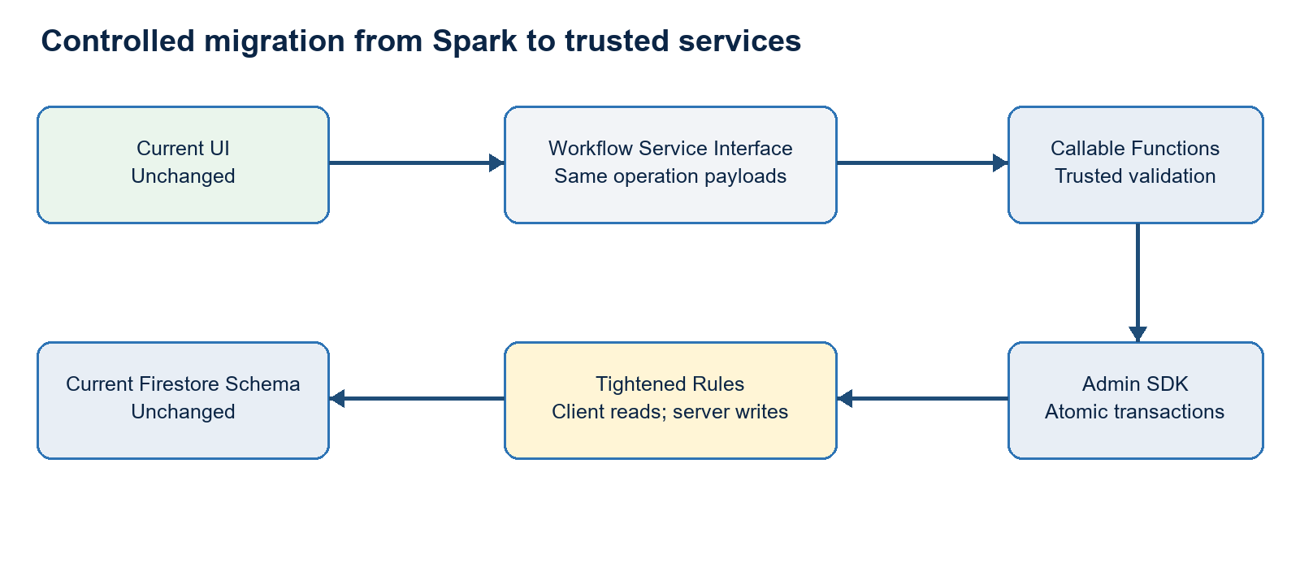
Figure 4. Future trusted mutation path

16.1 Migration steps
- Enable Blaze billing and required Cloud Functions, Cloud Build, and Artifact Registry APIs.
- Deploy callable operations for list seasons, submit lineup, decide team lineup, and reset both lineups.
- Move actor resolution, roster canonicalization, transition validation, score inspection, and publication into trusted code.
- Switch the workflow service implementation from Firestore transactions to callable requests.
- Tighten Rules so official workflow documents are read-only to browser clients; retain draft access where appropriate.
- Enable Firebase App Check enforcement after monitoring legitimate traffic.
- Add event-driven public projection, notification, and audit functions as separate idempotent handlers.
- Run dual-path test fixtures and cut over without data migration.

16.2 Recommended migration triggers
Trigger class | Threshold
Security | ARB requires server-side proof of no score activity or stronger nonrepudiation.
Scale | Multiple leagues/seasons, materially more users, or increasing direct-client abuse risk.
Automation | Need scheduled deadlines, notifications, penalties, projections, or background reconciliation.
Operations | Need centralized audit events, alerting, retry queues, or service-level objectives.
Integration | Need email/SMS, payments, court systems, or third-party APIs requiring secrets.

17. Open architecture decisions for ARB
ID | Question | Required decision
A1 | Is the Spark-safe privileged-client model acceptable through the next season? | Approve interim / require Blaze before launch
A2 | Is self-approval by a Neutral Approver acceptable when explicitly recorded? | Accept / require separate approver
A3 | Should a Neutral Approver be season-wide or restricted to matchup assignments? | Season / week / matchup policy
A4 | What event triggers mandatory Blaze migration? | Date, user volume, security control, or feature dependency
A5 | What are retention periods for private player data and immutable competition records? | Retention schedule
A6 | What RTO/RPO applies to season operations? | Recovery objectives
A7 | Who owns production deployment approval and emergency rollback? | Named operational owner
A8 | Which earlier specification clauses are formally superseded by this document? | Baseline reconciliation

17.1 Proposed ARB disposition
Proposed decision: Approve with conditions C1-C6. Permit Spark-safe operation for the current trusted league-administration scope. Require a Blaze migration before introducing untrusted delegated administrators, secret-bearing integrations, automated deadline enforcement, or a security requirement for server-side reset validation.

Appendix A. Lineup state transition reference
From | To | Actor | Guard/effect
pendingSubmission | submitted | Captain, EC, Approver, Super Admin | Valid five-line roster; new revision and action
rejected | submitted | Captain, EC, Approver, Super Admin | Corrected valid lineup; new revision
submitted | approved | Approver, Super Admin | Current revision; decision audit
submitted | rejected | Approver, Super Admin | Required reason
approved | rejected | Approver, Super Admin | Only before matchup is fullyApproved
approved + approved | fullyApproved | System transaction | Publish both and enable five line matches
fullyApproved | awaitingSubmission | Approver, Super Admin | Reset both, no detected score activity, reason and exact confirmation

Appendix B. Firestore Rules ownership summary
Path | Ownership rule
users | Owner limited profile updates; Super Admin account management
players / playerPrivate | Public active player read vs restricted PII
seasons / members | Active member reads; Super Admin writes
teams / rosters / weeks | Season members read; EC/Super Admin write
matchups | Workflow fields through validated role/status transitions; admin structural writes
lineups | Team-scoped draft/submission; reviewer decisions through operation binding
revisions / lineupReviews | Create-only official evidence
lineMatches | Reviewer publication/reset fields; Captain/EC schedule and score fields
approverAssignments | Authorized self/EC reads; Super Admin writes
standings / snapshots | Member reads; protected calculated writes
auditEvents | EC reads; protected writes
unmatched paths | Deny by default

Appendix C. Architecture evidence
Artifact | Evidence
ALPHAOPEN_APP_SPEC.md | Product scope, roles, nonfunctional requirements, original workflow baseline
FIRESTORE_DATA_MODEL.md | Canonical schema, identifiers, collections, ownership, indexes
firebase.json | Hosting, Firestore, emulator, and deployment configuration
firestore.rules | Authorization and workflow transition enforcement
firestore.indexes.json | Composite query support
firebase-auth.js | Authentication, registration, profile, and role derivation
runtime-loader.js / service-worker.js | Module lifecycle, caching, and PWA runtime
lineup-workflow-client.js | Spark-safe official workflow transactions
lineup-submit.js / lineup-approve.js / lineup-reset.js | Role-specific UI workflows
match-management.js / score-rules.js | Scheduling, scoring, locking, and points
test-prototype.mjs / emulator tests | Architecture and security assurance evidence

Appendix D. Glossary
Term | Definition
ARB | Architecture Review Board
EC | Executive Committee
PWA | Progressive Web Application
SOR | Sum of roster ranks for the two players on a doubles line
Spark | Firebase no-cost plan used by the current deployment
Blaze | Firebase pay-as-you-go plan required for the planned Cloud Functions tier
Current lineup | Mutable pointer/document representing the latest team revision and state
Revision | Immutable copy of a submitted lineup
Line match | One of five doubles matches within a team matchup
Public projection | Guest-safe derived document set published from operational data

