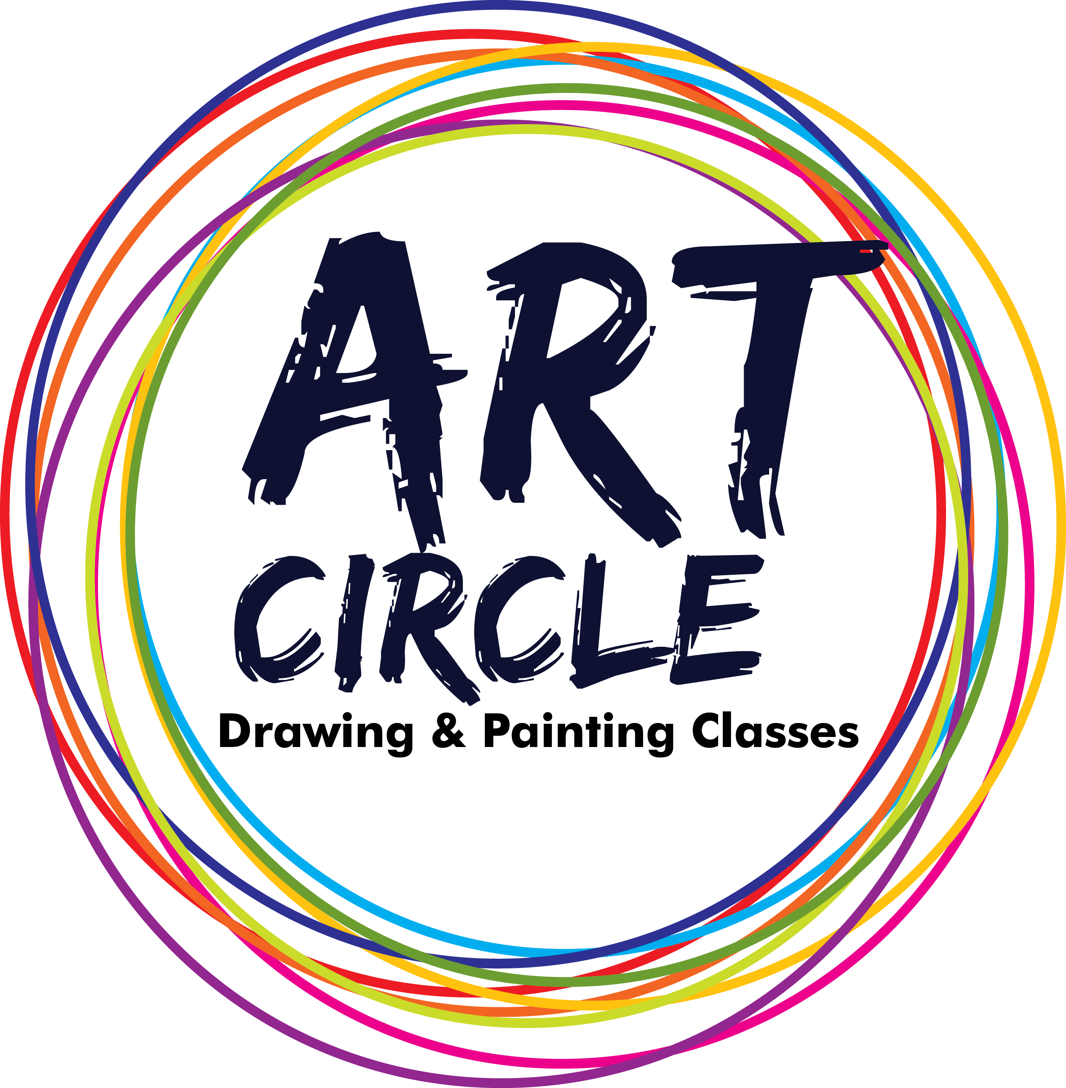 | ART CIRCLE “drawing & Painting classes”  Registration Form for Admission  ( All Entries to be filled in CAPITAL letters )  Photo  Govt.Registered

Name of candidate: …………………………………………………………………...

Date of birth: ………………….. Age: ………………..M/F : ……………………..

Name of School/College: ……………………………………………………………...

Standard : ……………………………………………………………………………...

Father/Mother’s Name: ……………………………………………….……………….

Occupation: …………..………………………………………………………………..

Mobile no : …………………………………………………………………….………

Email: …………………………………………………………………………..……...

Residential Address: …………………………………………………………..………

………………………………………………………………………………………….

Teacher’s Signature Parent/Guardian’s
Signature
………………………………………………………………………………………………………………………………………………..

Rules & Regulations

i) Art Circle take fees according to their terms, each term having 20 turns, having fees 12,000/-

ii) It is compulsory to pay whole fees in the starting of the term.

iii) Maximum 3 students are required in a batch. If any student wants to take an admission in same batch then that student have to pay 5000/- extra rather than fees.

iv) If class missed by student then teacher will not be responsible for that and according to academy’s rules that student will get only 2 cover-up and it will not going to calculated in next term.

v) If any student absent in a class then that student will not get special class.

vi) After paying fees it will not get return for any kind of reason and it will not be transferable.

vii) Art kit is available.

