Security:

I used in memory security and created two users.

1. [admin@gmail.com](mailto:admin@gmail.com) : password (All permissions)
2. [user@gmail.com](mailto:user@gmail.com) : password (View Permissions)

Scenarios:

1. Login credentials not provided gives the 401 error.

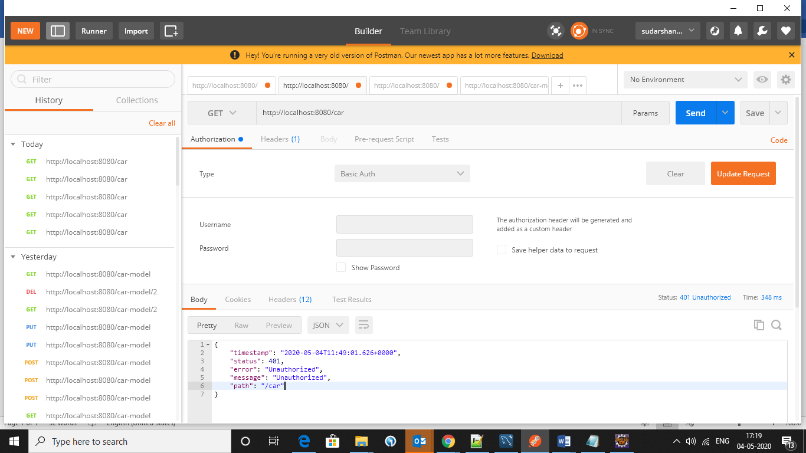

1. Get All the car details with user credentials.



1. Check with admin credentials. It’s retrieving the data.

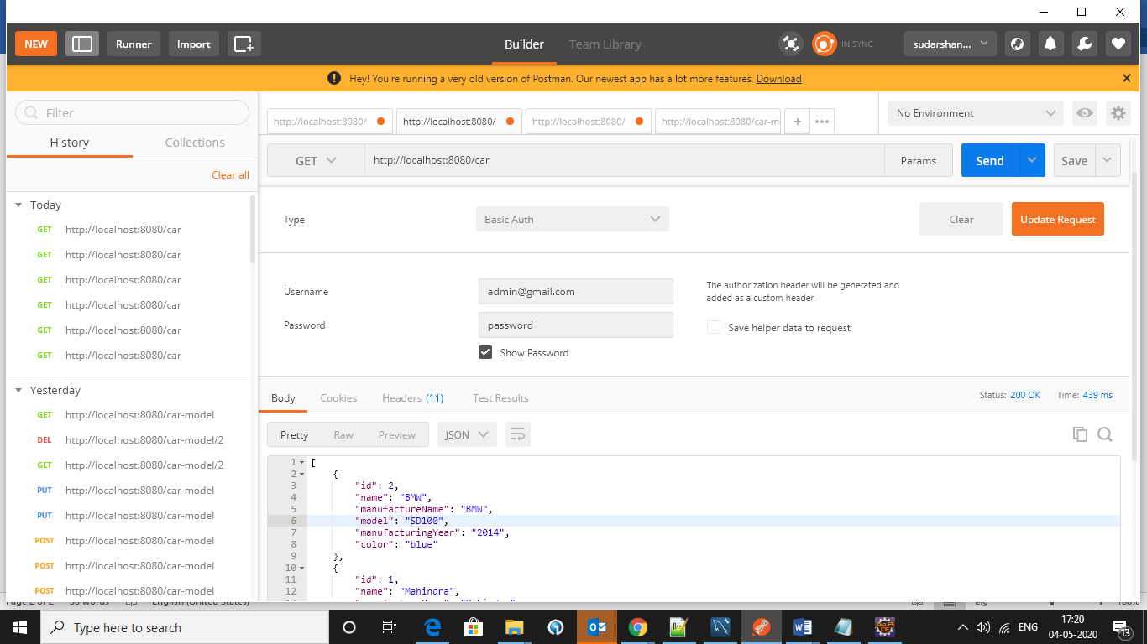

1. Get Car Details By Id. Pass user credentials.

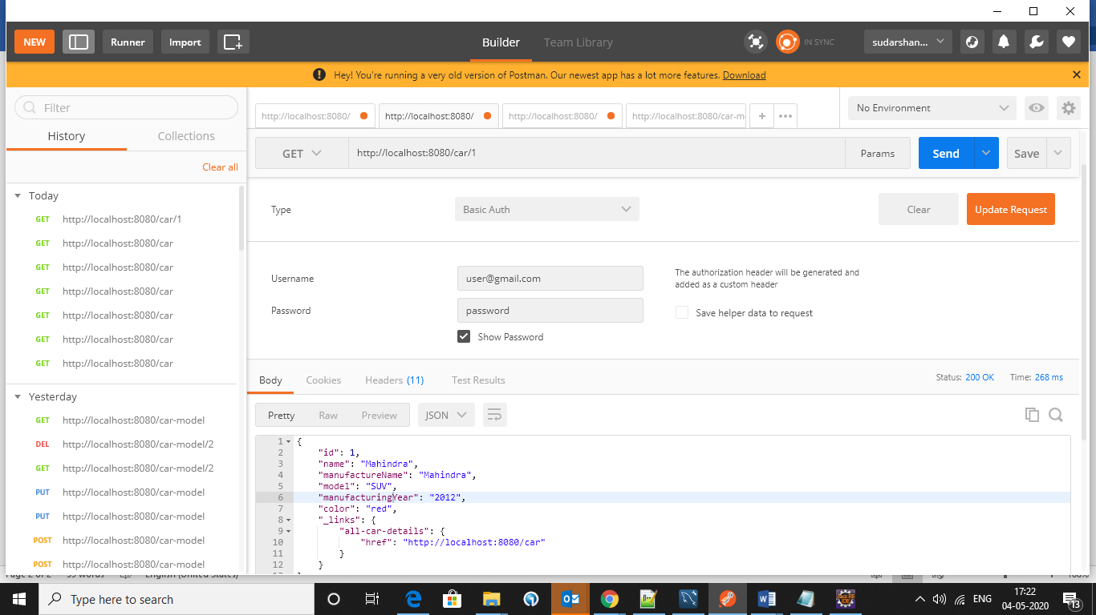

1. Get car details By Id. Check with admin credentials.

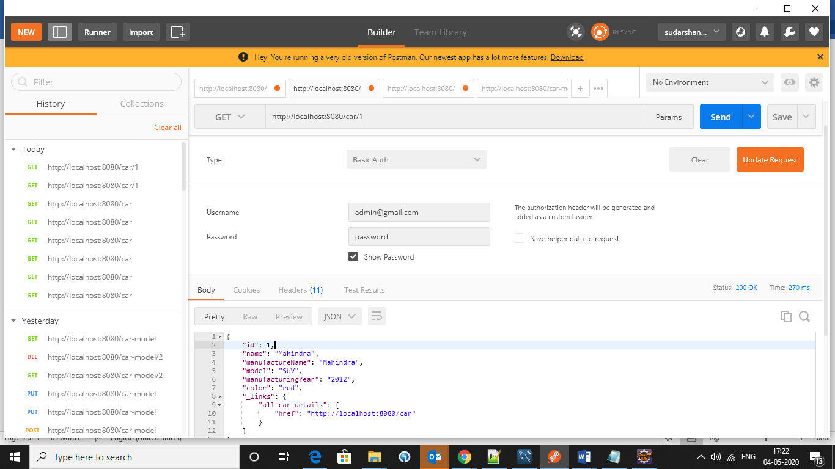

1. Pass invalid id and try to get the credentials.

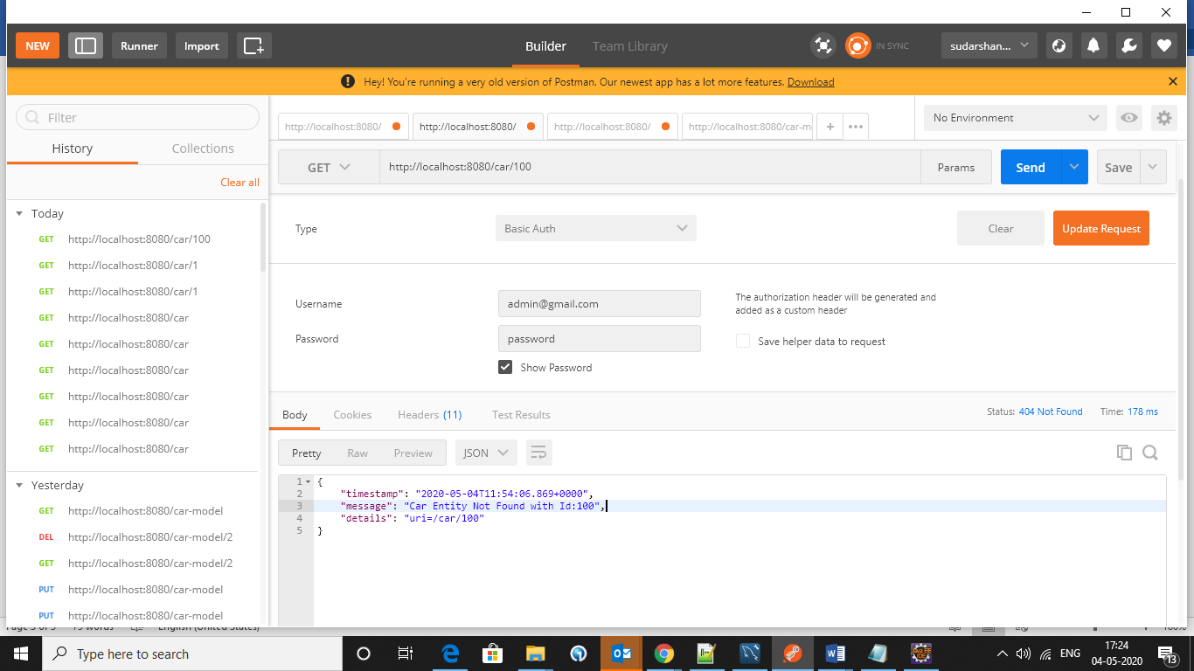

1. Save the car details with user credentials will give 403 error code and user don’t have rights to create the object.

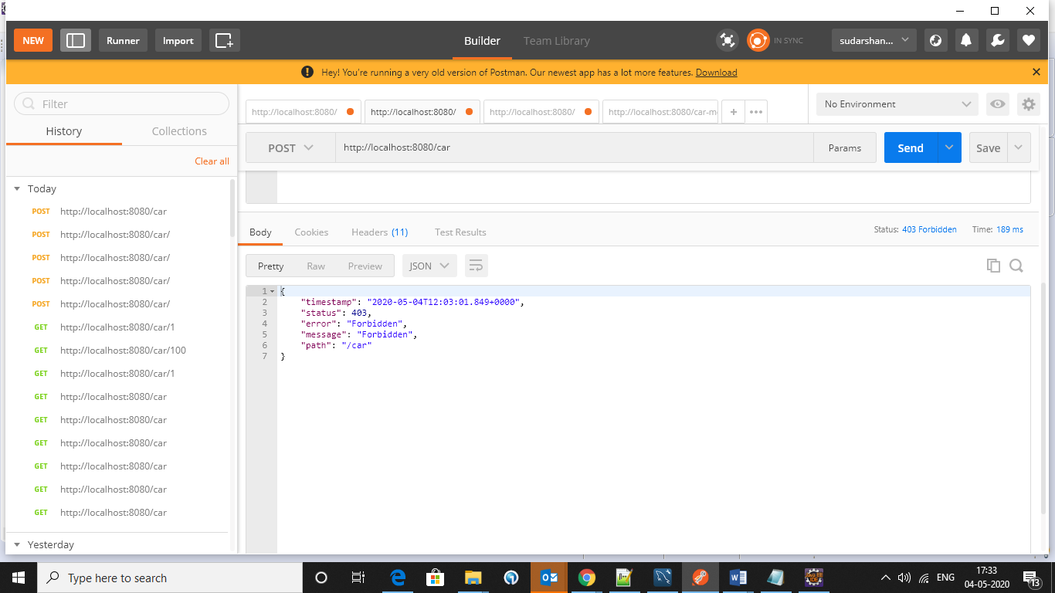

1. Save User details with admin credentials it will provide 201 status code and will return created resource id.

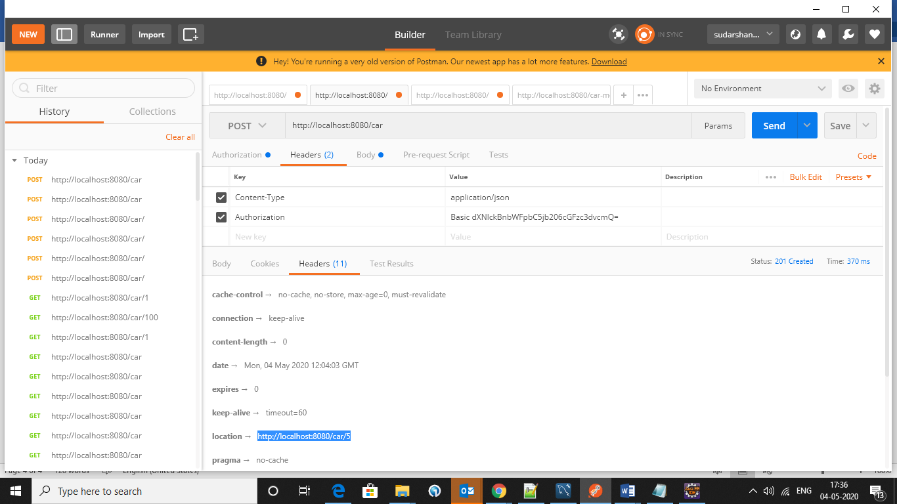

1. Update car details with user role it will give 403 error.

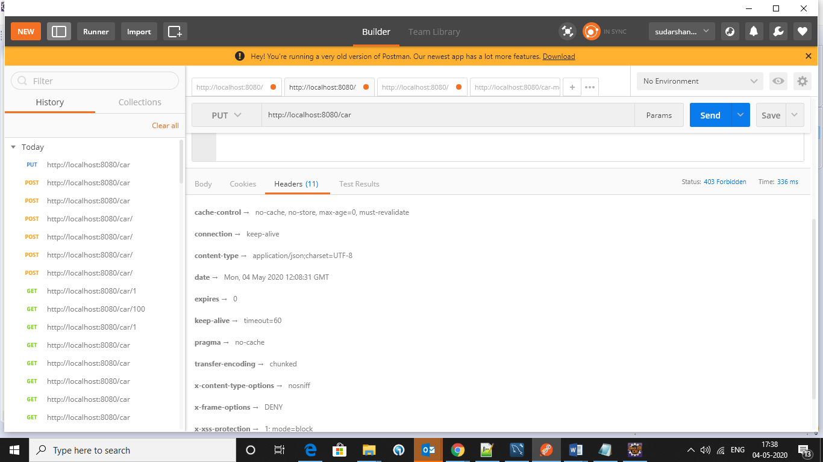

1. Update car details with admin credentials, successfully update the details and return 200 status code.

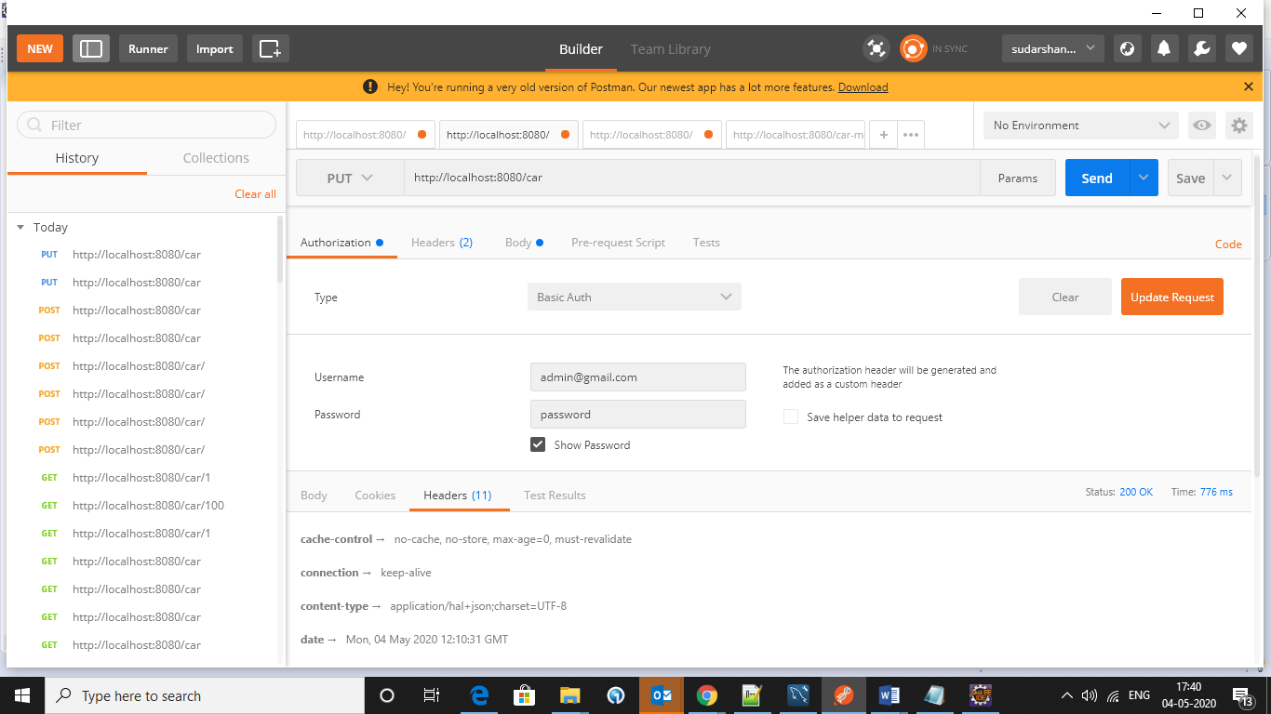

1. Delete car details with existing id. And use user credentials it will give 403 error. User don’t have rights to delete the item.

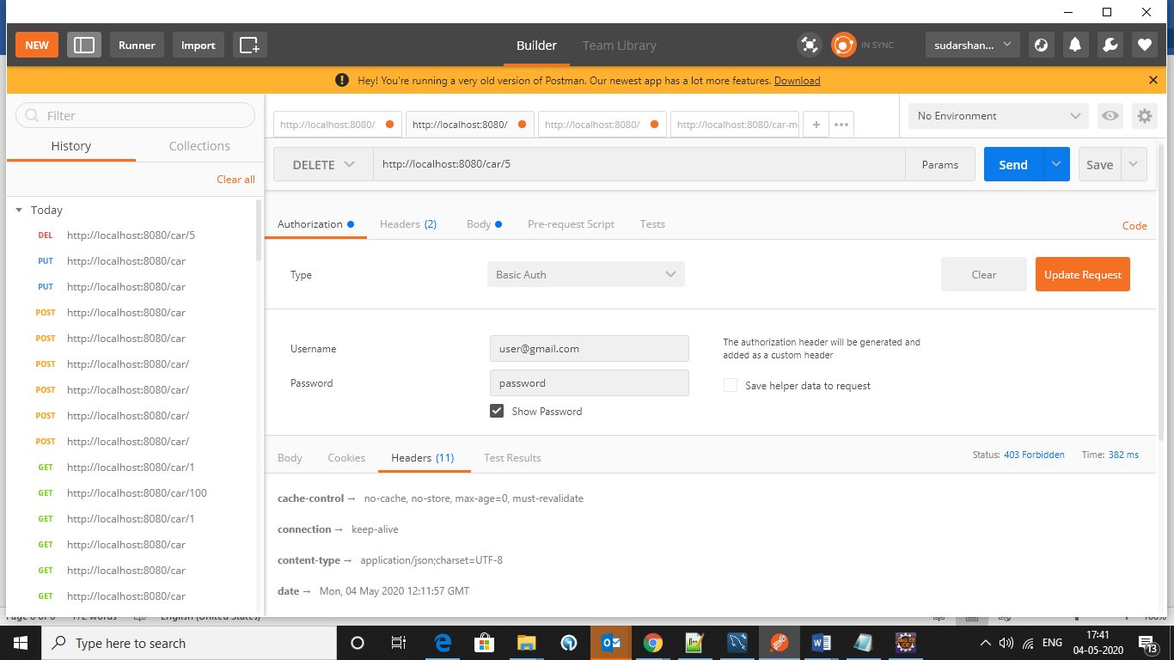

1. Delete car details with existing id. And use admin credentials it will give 200 success message.

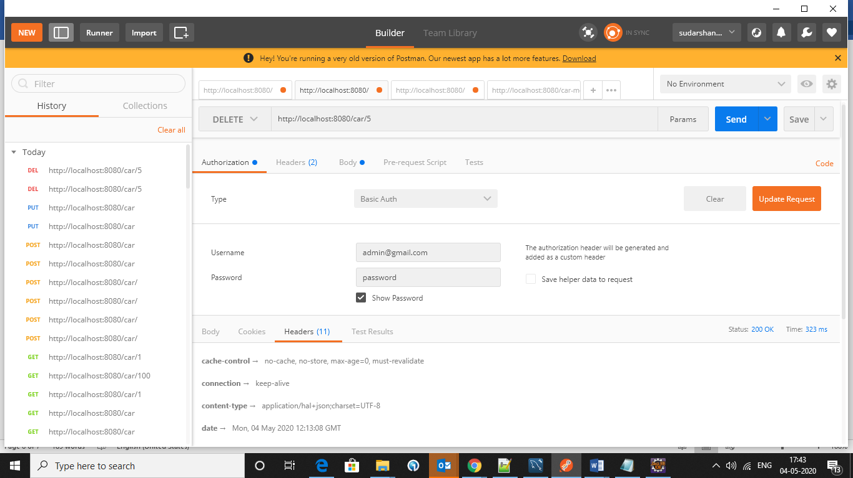

1. Try to delete non-exist id in the database it will give error 404.

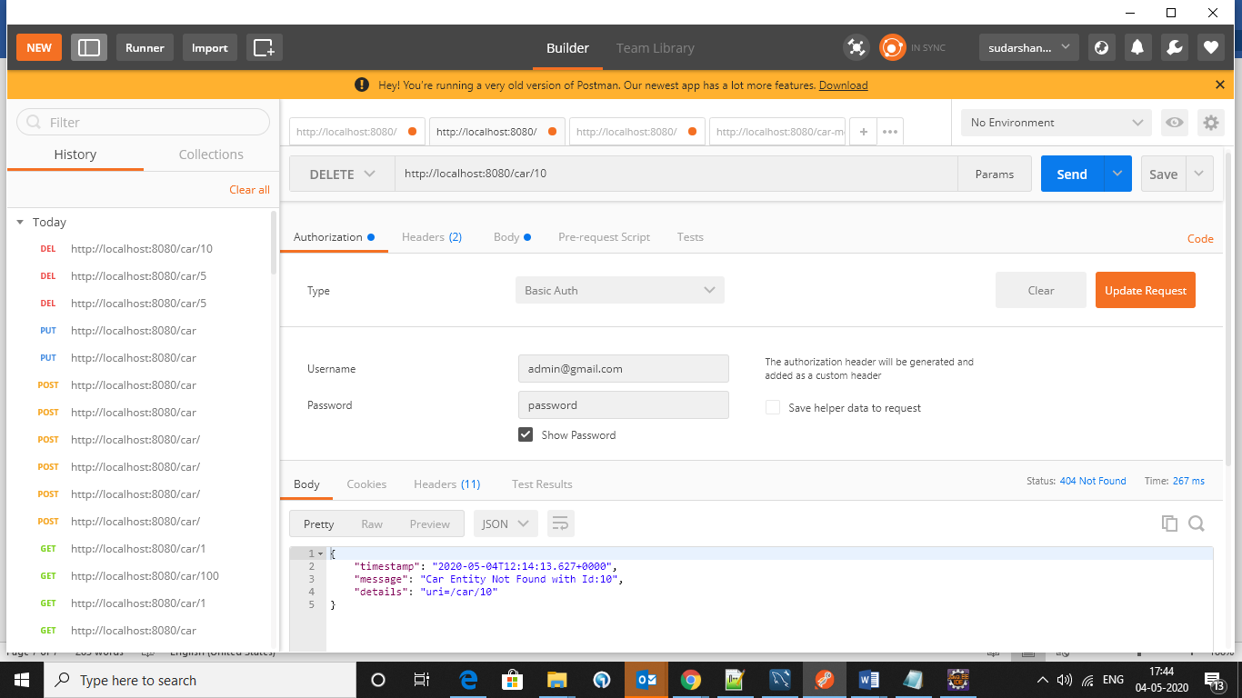

1. Search based on name, manufacture name, manufacturing year, model, color (or condition)

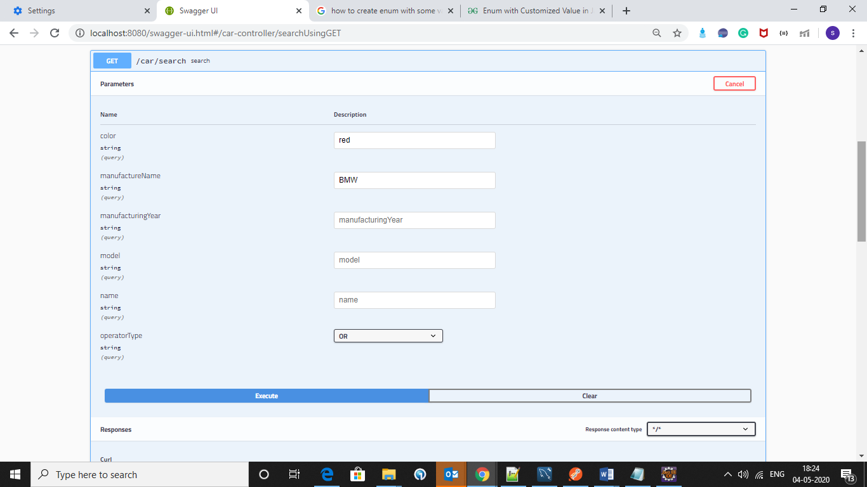

1. I am implemented swagger also.

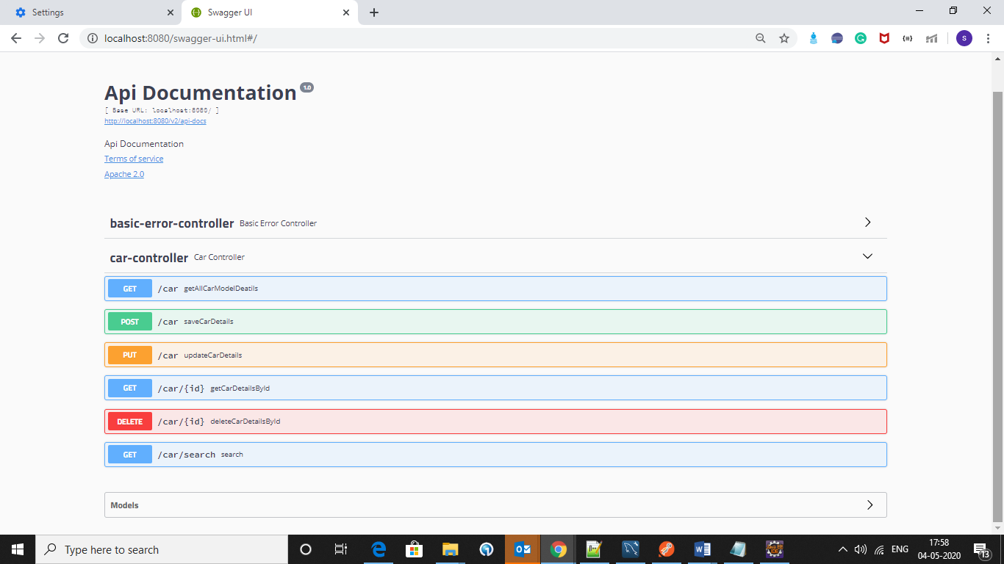

1. Test cases also executed successfully.

